**Trends in *Philosophical Studies***

Brian Weatherson 2024-11-13

*Philosophical Studies* has become one of the most important journals for work in several large topics in philosophy. This paper uses data from the word distributions in those papers, and the citations of the papers, to look at how it has changed over time, and how it became so central.

# Introduction

*Philosophical Studies* is the most cited journal in philosophy journals in recent times, so it is worthy of study both in its own right, and as a mirror of broader trends in philosophy. This paper mixes two techniques, topic modeling and citation analysis, to look at the nature of *Philosophical Studies*, and how it has changed over time, from 1980 to 2019.

In the first half of the paper, I look at the growth the citation rate (i.e., number of citations per article) in *Philosophical Studies*. If we take its peers to be the twenty philosophy journals with the highest citation rates over the last forty years, it has gone from having a citation rate 10-20 percent below the average, to a rate 10-20 percent above the average. And it’s done this despite increasing its publication volume, which one would normally expect to decrease citation rate. This is explained in part by the move to publishing more special issues, with the special issues from the Bellingham Summer Philosophy Conference being particularly important, and in part by the topic mix in *Philosophical Studies* changing in ways that prefigured changes in the broader philosophical community.

This leads to the second half of the paper, on just how the topic mix of the journal changed over the years. The short version of those changes is shown in Figure 1.

In the late twentieth century, *Philosophical Studies* was focussed on philosophy of language, and in particular on core analytic questions about reference and description. These were central to philosophy in the 1970s after *Naming and Necessity*, and stayed central to graduate education at top schools well into the twenty-first century. But the focus of other journals moved away from these questions possibly a bit earlier than *Philosophical Studies* did.

0.3

Epistemology



Ethics



Language

0.2

0.1

1990 2010



Metaphysics



Mind

0.3

0.2

0.1

1990 2010 1990 2010

Figure 1: Proportion of *Philosophical Studies* articles that are in each of these five topics, 1980- 2019.

After the turn of the century, the journal moved into two topics that did not hurt its citation rates. First, it was part of the enormous discussion on epistemology, and in particular on contextualism in epistemology, in the 2000s. Second, in the 2010s, it, along with much of the rest of the discipline, moved more strongly into social philosophy.

# Overview

## Editorial History

*Philosophical Studies* was founded by Herbert Feigl and Wilfrid Sellars, both then at the University of Minnesota, in 1950, as the “first American journal expressly devoted to analytic philosophy” (DeVries 2005, 1–2). They stayed as editors until Feigl’s retirement in 1971, though after 1954 Sellars was listed as the first editor. At Feigl’s retirement the journal moved from the University of Minnesota Press to Reidel, where it has stayed ever since.1 Sellars edited the journal alone until Keith Lehrer was brought on as associate editor in 1974, starting an association with the journal that would last nearly half a century.

In 1975 Lehrer, who had just moved from Rochester to Arizona, became editor. He stayed in that role until 1982, having been joined by John Pollock (also at Arizona) in 1979. From 1982,

1Springer is the current continuant of Reidel after several mergers and takeovers.

Pollock was Editor-in-Chief, and Lehrer went back to being Associate Editor.

In 1992 the journal moved 100 miles up I-10, as Stewart Cohen, then at Arizona State, took over as Editor.2 Cohen stayed as editor through the rest of the time covered in this study, eventually being an editor of the journal for longer than even Wilfrid Sellars.

Thomas Blackson joined as book symposium editor in 2003. In 2010, Cohen moved to the University of Arizona, and so the journal was edited out of Tuscon for a second time. Jennifer Lackey and Wayne Davis, who would eventually take over from Cohen, joined as Associate Editors in 2014. In 2016 Cohen was made Editor-in-Chief, while Davis and Lackey became Editors, and that was the arrangement that persisted through 2019, the end of the focus of this paper.

There are three things about this editorial history that will become important in what follows. One is that the names here include several of the most important epistemologists of the last half century. A second is that the journal has had a very stable editorial history; a summary like this for most other leading journals would take twice as long to write. And the third is that the biggest single change, the transition from John Pollock to Stewart Cohen as Editor in 1992, does not seem to have had an immediate impact on the journal. You see dramatic changes straight away at *Mind* when G. E. Moore takes over in 1921, and again when Gilbert Ryle takes over in 1947.3 The effects of the switch from Pollock to Cohen are much more delayed.

## Articles

*Philosophical Studies* increased its output considerably when it moved to Reidel, and then increased it again between 1980 and 2019. Figure 2 shows how many articles *Philosophical Studies* has published each year; Figure 3 shows the total word count for the journal each year; Figure 4 shows the count of the longest article each year; and Figure 5 shows the 25th, 50th, and 75th percentile article by word count for each year.

Some of these changes reflect wider disciplinary changes, but others do not. Most journals have a much more stable publication rate. Journals that are commercially published, like *Philosophical Studies*, have tended to increase their production in recent years, but this growth is still unusual.

Articles have been getting longer all across philosophy. What’s striking in Figure 5 is the 25th percentile rising to over 8000 words by the end of the 2010s. It used to be common for philosophy colloquia to include papers that were read out by the author. This was a bad practice, and it’s been mostly gone for several years. But starting in the mid-2010s it became

2While the journal was at Arizona, each year a grad student assistant was recognised on the title page as an editorial assistant. Many prominent philosophers had this role over the years, including, in 1983, Stewart Cohen.

3See Lewy (1976) on Moore, and Warnock (1976) on Ryle.

200

100

Number of Articles

0

1990 2000 2010

Figure 2: Number of articles published each year

2.5e+06

2.0e+06

1.5e+06

Number of Words

1.0e+06

5.0e+05

0.0e+00

1990 2000 2010

Figure 3: Number of words published each year

30000

20000

Number of Words

10000

0

1990 2000 2010

Figure 4: Longest article published each year

12000

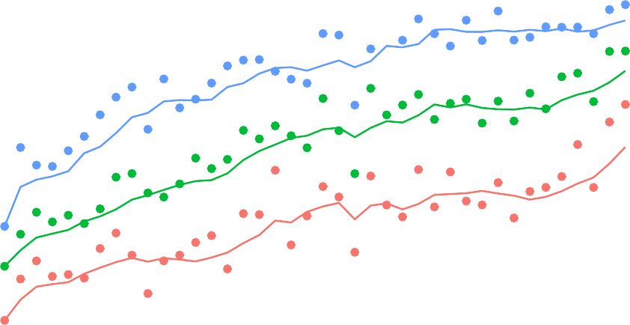

8000

Word Count

4000

0

1990 2000 2010

Figure 5: 25th, 50th, and 75th percentile word lengths each year.

an impractical practice. No one was writing papers that even could be read out in the length of a typical colloquium slot.

Everything I’ve said so far is about *articles* in *Philosophical Studies*. As I’ll go over in Section , this is a less clear category than we might like, in part because of the variety of kinds of issues *Philosophical Studies* puts out.

## Special Issues

*Philosophical Studies* has had many special issues, especially since the mid-1990s. These fall into four main categories. The first three are papers from three long-running conferences that *Philosophical Studies* published selected papers from:

1. The APA Pacific Divsion
2. The Oberlin Colloquium
3. The Bellingham Summer Philosophy Conference (BSPC)

The fourth category consists of one-off issues, either on a special topic, or, in two cases, conferences that *Philosophical Studies* published once but did not continue with. I’ll call all of these **One-off** issues.

Often these were double, or occasionally triple, issues. I’m counting these as 2, or 3, issues, because provides a better sense of what proportion of the papers in a year are from special issues. As Table 1 shows, the special issues become a big part of what *Philosophical Studies* does in the 1990s.

Table 1: How many of each type of special issue were published each decade.

|  |  |  |  |  |
| --- | --- | --- | --- | --- |
| Type | 1980s 1990s 2000s 2010s | | | |
| Normal | 62 | 79 | 111 | 107 |
| One-off | 4 | 14 | 13 | 10 |
| APA Pacific | 0 | 18 | 12 | 10 |
| Oberlin | 0 | 6 | 5 | 4 |
| BSPC | 0 | 0 | 8 | 5 |

The special issues differ from the normal issues in some striking ways, so it will be helpful to keep their presence in mind.

# Methods

## Sources

The studies here are primarily based on two sources: citation data from Web of Science, and word lists from JSTOR.

Through the University of Michigan I downloaded the Web of Science (hereafter, WoS) Core Collection in XML format. Within it, I selected 100 prominent philosophy journals that WoS indexes. The journals I selected are, like *Philosophical Studies* primarily English-language, analytic philosophy journals. I filtered the citations for just citations from and to those 100 journals.

WoS has a special way of recording citations in indexed articles to other articles that it has indexed. These records are easy to extract, and are considerably more reliable than citation records in general. That’s not to say they are perfect. They certainly have false negatives, especially when there are any errors in the original citation. As Petrovich (2024, 77n10) notes, they are more reliable when the citations are in a bibliography than when they are in footnotes. They also do badly with supplements. So for this study I’ve excluded all the supplemenmts to *Noûs*, i.e., those issues of *Philosophical Perspectives* and *Philosophical Issues* which were listed as supplements to *Noûs*. I did include the supplemental issue *Philosophical Studies* issued in 2013, because the data there looked reliable enough. What follows uses just those citations. So it is citations from indexed journals to indexed journals, where WoS recognised that both the cited and citing journal were in its database.

This is obviously a small subset of all citations. It excludes citations in academic journals in other fields, in books and edited volumes, and in many other places that Google Scholar indexes, such as dissertations, lecture notes, slides, and draft manuscripts. Losing that information is a cost, but there are three large upsides. First, these citations are much more accurate. Second, we can be more confident that our data set is relatively complete; finding a full list of philosophy journals is easier than finding a full list of edited volumes, or manuscripts on websites, in philosophy. Third, by looking at citations internal to philosophy, we can get a sense of philosophy’s self-image, and how it changes over time.

The downloadable citation data is not particularly up to date. I am including citations beyond 2019, because it’s helpful to get a sense of how some of these articles have been received in more recent years. But the data I have only goes through mid-2022.

The other source I used is JSTOR, and in particular the Data for Research (DfR) program that they provide through their Constellate project. This lets you download lists of the words used in various journal articles, along with a count of how often each word is used.4 It also provides word counts for the articles, which I have used in Section . The words an author

4It also provides bigrams and trigrams, which I’ve looked at in preparing this paper, but didn’t end up using.

uses are a pretty good guide to what they are talking about; if the word ‘denotation’ is used frequently, it’s probably a philosophy of language article.

## Articles?

I said I’m talking about articles here, but what exactly is an *article*? A more helpful question is, which things that philosophy journals publish are not articles?

Some things are easy. The table of contents is not an article. Nor is a correction, or a report on editorial change. Book reviews are not articles. If they were, *Philosophical Review* would have the lowest rate of citations per article, not the highest.5 Both WoS and JSTOR also distinguish articles from discussion notes, especially if the journal has a designated discussions section. Without this distinction, *Mind* would have a much lower rate of citations per article.

Both of these last two categories are relevant to *Philosophical Studies*, even though it does not run book reviews or have designated discussion sections. Although it has neither of those things, it does have many book symposia. The classifiers, WoS and JSTOR, struggle with how to classify articles in these symposia. They disagree with each other, and occasionally with their own past practice.

I have some sympathy for the classifiers; these are really borderline cases. Mostly what they settled on was that the précis and replies by the book author are not articles, and that the contributions by commentators are. But they did not stick precisely to this.

For the most part, I’ve gone with WoS’s classifications. It would be practical, just barely, to go through *Philosophical Studies* issue by issue and reclassify the book symposium entries so all and only the commentaries are articles. But it would not be practical to do this for all one hundred journals. And for this paper, we’re mostly interested in comparing articles in *Philosophical Studies* with articles in other journals, so it’s best to not modify only one journal.

There is one place we’re I’ve overridden WoS’s classifications. It has categories of Discussion, Note, and Review, each of which make up about 0.75% of the articles across the 100 journals. The three categories include similar enough pieces that I’ll treat them as a unified category. Mostly these are discussion notes, or longer book reviews, that we want to exclude. But, especially in *Philosophical Review*, they occasionally put ordinary articles here. So important articles by Stanley Cavell (1962), Jonathan Schaffer (2010), and Harvey Lederman (2022) all got listed as not being articles.6 I’ve counted any piece in these three categories 20 pages or longer as an article.

There is one last tricky category to flag. The special issues on the Oberlin Colloquium some- times include commentaries on the main articles. These are mostly not counted as articles,

5I’ll report on citations per article in Table 4.

6The Cavell article was in the discussion section of the January 1962 issue of the Review, so this classification is understandable. The other two are not.

and I think rightly so. Occasionally, as when Andy Egan (2011) was the commentator on an important paper by Tamar Szabò Gendler (2011), the commentary gets a reasonable number of citations. But mostly these commentaries are rarely if ever cited, and I think they aren’t really what most people think of as journal articles. So I’ve been happy to exclude them.7

# Outbound Citations

## Overview of Citations

Articles in *Philosophical Studies* get cited a lot. Table 2 shows the five journals with the largest number of citations of articles published between 1980 and 2019 in the 100 journals we’re looking at.

Table 2: Leading journals by total number of citations (Articles published 1980-2019).

|  |  |
| --- | --- |
| Journal | Citations |
| Philosophical Studies | 30424 |
| Synthese | 23280 |
| Journal Of Philosophy | 20023 |
| Noûs | 19716 |
| Philosophy Of Science | 18810 |

*Philosophical Studies* is in first place on that list in part, but only in part, because it publishes so much. Table 3 lists the top five journals by the number of articles they have published.

Table 3: Leading journals by total number of articles (Articles published 1980-2019).

|  |  |
| --- | --- |
| Journal | Articles |
| Synthese | 4525 |
| Philosophical Studies | 3776 |
| Journal Of Medical Ethics | 3518 |
| Journal Of Symbolic Logic | 3283 |
| Analysis | 2236 |

*Synthese* has 20% more articles, but 25% fewer citations. The other three journals on Table 3 are somewhat special cases. Two of them get a lot of citations outside of philosophy, and this is only a study of citations in philosophy journals. *Analysis* only publishes short papers, and

7If these aren’t articles, what are they? WoS classifies Egan’s paper as ‘Editorial-Matter’. That’s wrong, but I’m not sure what I would say in their position.

so while they get a lot of citations per page, they don’t get as many citations per article as other journals.8

Still, we’d expect on general principles that raw volume of publication wouldn’t make a big difference. Citations tend to follow something like a log-normal distribution (Brzezinski 2015). The bulk of the citations come from a handful of highly cited articles. Publishing more articles helps, but is no guarantee.

If we look not at total citations, but at citations per article as in Table 4, we get a list that looks a bit more like a familiar ranking of philosophy journals by prestige.

Table 4: Leading journals by citation rate (Articles published 1980-2019).

|  |  |  |  |  |
| --- | --- | --- | --- | --- |
| Rank | Journal | Articles | Citations | Citation Rate |
| 1 | Philosophical Review | 510 | 14706 | 28.84 |
| 2 | Journal Of Philosophy | 1221 | 20023 | 16.40 |
| 3 | Philosophy & Public Affairs | 521 | 8277 | 15.89 |
| 4 | Mind | 1071 | 14391 | 13.44 |
| 5 | Ethics | 1045 | 13040 | 12.48 |
|  | … |  |  |  |
| 13 | Philosophy And Phenomenological | 2165 | 17737 | 8.19 |
|  | Research |  |  |  |
| 14 | Philosophical Studies | 3776 | 30424 | 8.06 |

I’ve included *Philosophy and Phenomenological Research* there because, like *Philosophical Studies*, it publishes many book symposia. And, like *Philosophical Studies*, the articles in these symposia are typically not cited very much.

## Large Trend

There is a striking step-change in citations to *Philosophical Studies* that occurred in the mid- 2000s. Cross-temporal comparisons of citations are hard because changes in the number of journals, the number of articles in those journals, and citation norms, make most comparisons tricky. To try to screen off some of that noise, I’ll mostly compare citations to articles published in *Philosophical Studies* to citations to other articles published at the same time.

In particular, in this section I’ll compare *Philosophical Studies* to a list of nineteen other prominent philosophy journals. From the one hundred journals that I’m primarily looking at, I selected the twenty that have the highest rate of citations per published article, and which

8Recall that in Section I noted that some *Analysis* style papers in other journals are not even counted because they are classified as Discussions or Notes, not Articles. These excluded articles are cited at much lower rates than the typical *Analysis* article.

Web of Science has indexed every year since 1980.9 That list includes *Philosophical Studies*, and the other nineteen journals are the comparison class.

Figure 6 shows, for each year from 1980 to 2019, the average number of citations for articles published in *Philosophical Studies* (in blue), and in the other nineteen (in red). The figure is fairly noisy, but some trends are clear. Before 2000, the red dots, for the other journals, are mostly above the blue dots, for *Philosophical Studies*. After 2000, and especially from 2003 onwards, that is mostly reversed. Despite having less time to accrue citations, articles from the 2000s are cited more, on average, than articles published earlier. But articles published in the 2010s, especially the late 2010s, have many fewer cites largely because they haven’t been around as long.

15

10

Citations per article

5

1980 1990 2000 2010 2020

 Other top 20 journals  Philosophical Studies

Figure 6: Average citation rates for *Philosophical Studies* and peer journals.

Figure 7 smooths out some of the noise in Figure 6 in two ways. First, instead of measuring average citations per year, I measure average citations over a five-year rolling window. This doesn’t make a huge difference to the measure for the other nineteen, which is already fairly smooth, but it is useful for smoothing the values for *Philosophical Studies*. Second, instead of showing the red and blue dots separately, I’ve just displayed the ratio between them.

The difference in Figure 7 between the earlier and recent years is striking. By this one measure, citations per article, *Philosophical Studies* was doing ok before 2003, but was towards the lower end of the top 20 journals. After 2003, it is doing better than the average journal *in the top 20*.

9The last constraint notably rules out *Philosophers’ Imprint* and *Mind and Language*.

1.3

1.2

1.1

1.0

Ratio

0.9

0.8

1980 1990 2000 2010 2020

Figure 7: Ratio of citations to Philosophical Studies to citations to other journals, for five year rolling windows.

My very anecdotal impression is that *Philosophical Studies* is viewed as being more prestigious by younger philosophers than by older philosophers. A toy model of prestige, where it is heavily anchored to how often a journal was cited when one was in graduate school, would explain that difference. That said, I have not done (and am not going to do) a careful study of comparative prestige judgments to know if there is even an effect here to find, or whether my informal sample was not reflective of the wider population.

## Means, Medians and Quartiles

In some ways looking at the averages here understates the impact of *Philosophical Studies* in the 2000s. Average numbers of citations can be very misleading.10 Table 5 compares five year periods from two journals: the *Australasian Journal of Philosophy* (AJP) from 1980-1984, and *Philosophical Studies* (PS) from 2003-2007. Q1, Q2 and Q3 are the 25th, 50th, and 75th percentile citations, and Mean is the average number of citations.

10See Bornmann and Williams (2020), who also use percentiles, including the 75th percentile that I’ll focus on, to mitigate the misleadingness.

Table 5: Statistics for AJP 1980-1984, and PS 2003-2007.

|  |  |  |
| --- | --- | --- |
| Statistic | AJP 1980-1984 | PS 2003-2007 |
| Q1 | 0.0 | 2.0 |
| Q2 | 2.0 | 5.0 |
| Q3 | 7.0 | 14.0 |
| Mean | 16.7 | 13.5 |

The mean number of citations per article is higher for AJP 1980-1984 than for *Philosophical Studies* 2003-2007. But that’s because of the 1892 citations to articles from the AJP in those years, 1269 of them are to five articles by David Lewis. The citations to *Philosophical Studies* are much more widely spread around. Comparing the 75th percentiles is more indicative of what’s being published in the journals.

Part of the difference between AJP 1980-1984 and *Philosophical Studies* 2003-2007 is a general trend in the discipline to spread around the citations more. But it’s not just that. *Philosophical Studies* stands out for how widely spread around its citations are. Figure 8 shows this. I’ve taken the same 19 journals that I used in Figure 7, and calculated the same quartile statistics for *Philosophical Studies*, and for those 19 journals collectively, for five-year moving windows each year from 1980 to 2019. The results are shown in Figure 8. Note that the dot for each year is really the five-year window centrered on that year.

1.3

1.2

1.1

1.0

Ratio

0.9

0.8

0.7

1990 2000 2010

Figure 8: Ratio of 75 percentile of *Philosophical Studies* citations to 75th percentile of citations for other leading journals, five year rolling window.

The pattern is rather similar to Figure 7. Before 2000, the ratio was below one for 11 out of 20 years. After 2000, the only time it is below one is right at the end, where the data is very noisy. (The citation counts are very low for such recently published articles, so it’s hard to read too much into the numbers.) There is a particular peak in the mid-2000s, just as in Figure 7. Perhaps the biggest difference is that in the 1980s, the ratio of the means was below one, but the ratio of the 75th percentiles is sometimes above one. The explanation for that is that there were very few *Philosophical Studies* articles from those years with huge citation counts, even though a quarter of the articles were being fairly frequently cited.

In general, the 75th percentile of citations is close to the mean number of citations per article for sets of philosophy papers. If the citations are very unevenly distributed, as with the Australasian Journal in the early 1980s, the mean is much higher. If the citations are more evenly spread around, as we’ll see below happens with BSPC articles, the mean is much lower.

## Citations of Special Issues

Part of the explanation of the pattern in Figure 7 and Figure 8 is that the special issues that *Philosophical Studies* published in the 2000s were very heavily cited. Table 6 shows three summary statistics, mean, median, and 75th percentile (Q3), for the normal *Philosophical Studies* issues, and for the four classes of special issues. Table 7 shows the means for the five classes over each of the four decades from 1980-2019. (The blank cells mean that there aren’t any special issues of that type that decade.)

Table 6: Summary citation statistics for the five types of *Philosophical Studies* issues.

Type Median Q3 Mean

|  |  |  |  |
| --- | --- | --- | --- |
| BSPC | 12 | 39 | 22.0 |
| Oberlin | 4 | 12 | 15.6 |
| One-off | 4 | 12 | 11.0 |
| APA Pacific | 2 | 7 | 7.4 |
| Normal | 3 | 8 | 7.1 |

Table 7: Mean citations by decade for the five types of *Philosophical Studies* issues.

|  |  |  |  |  |
| --- | --- | --- | --- | --- |
| Type | 1980s | 1990s | 2000s | 2010s |
| Normal | 6.2 | 7.1 | 9.3 | 6.5 |
| One-off | 8.7 | 12.9 | 14.2 | 8.6 |
| APA Pacific |  | 4.7 | 14.6 | 5.3 |
| Oberlin |  | 16.5 | 19.2 | 13.0 |
| BSPC |  |  | 27.7 | 16.7 |

The numbers for BSPC are particularly striking. In the full set of articles I’m working from, i.e., all the indexed articles from 100 journals, only 1.1% of articles have 39 or more citations. But one quarter of the articles that *Philosophical Studies* published from BSPC are in that 1.1%. Surprisingly, given the numbers here, none of the 10 most cited articles in *Philosophical Studies*, and only one of the 30 most cited articles, was from a BSPC special issue. The high average isn’t being caused by outliers, but many BSPC articles being cited very frequently. By contrast, four of the ten most cited articles were from the Oberlin colloquium. This is why the Q3 numbers for BSPC and Oberlin are so different, even though the means aren’t that far apart.

The fact that the normal issues have such lower citation statistics than the special issues might make us think that the explanation of Figure 7 and Figure 8 can be found entirely in the special issues. Indeed, if we just compare the normal issues of *Philosophical Studies* to the other 19 journals, the effect we were seeing basically vanishes. This can be seen in Figure 9.

1.2

1.1

1.0

0.9

Ratio

0.8

0.7

1990 2000 2010

Figure 9: Ratio of 75 percentile of normal issues of *Philosophical Studies* citations to 75th percentile of citations for other leading journals, five year rolling window.

This is surely part of the explanation of what’s going on. But Figure 9 is not an apples-to- apples comparison; we’ve removed the special issues from *Philosophical Studies*, but not from the other 19. This could be a significant issue. I looked at the most cited article since 2005 in each of the 20 journals that go into Figure 9, and in 6 of them (including *Philosophical Studies*), the most cited article was in a special issue. (Or, in one case, a special unit in a regular issue.) It’s really hard to tell exactly which issues are special issues from the archival

record, and even harder to tell what the refereeing process was for those special issues.11 The best we can say is that special issues are suﬀiciently widespread, and suﬀiciently widely cited, that Figure 9 might be a misleading comparison. The success of special issues is part of why *Philosophical Studies* was so widely cited in the 2000s, but maybe not all of it.

Rather than go further down this rabbit hole, let’s turn to what was in *Philosophical Studies*

over the years, starting with its inbound citations.

# Inbound Citatations

This section looks at the papers cited in *Philosophical Studies* in each of the last four decades. For each decade, I find the 20 papers most cited in all philosophy journals over that decade. (They need not be published in the decade, indeed some of them are published nearly a half- century earlier.) I’ll then look at which of them have the highest and lowest proportion of their citations in *Philosophical Studies*, and comment on what that tells us about the journal, and the discipline as a whole.

## 1980s

Table 8: Highly cited articles in the 1980s.

…

|  |  |  |  |  |
| --- | --- | --- | --- | --- |
| Rank | Citation | PS Citations | All Citations | Percent |
| 1 | Lewis (1979b) | 8 | 36 | 22.22% |
| 2 | Perry (1979) | 13 | 59 | 22.03% |
| 3 | Lewis (1979a) | 7 | 34 | 20.59% |
| 4 | Perry (1977) | 6 | 33 | 18.18% |
| 5 | Donnellan (1966) | 9 | 55 | 16.36% |
| 16 Castañeda (1967) | | 2 | 38 | 5.26% |
| 17 Frankfurt (1971) | | 3 | 68 | 4.41% |
| 18 Grice (1957) | | 1 | 36 | 2.78% |
| 19 Dennett (1971) | | 0 | 30 | 0.00% |
| 20 Rawls (1980) | | 0 | 49 | 0.00% |

*Philosophical Studies* was founded to be a journal of *analytic* philosophy. There wasn’t a mission statement in the first edition, but the very first article might have served just as well. It was an article on analysis, by Morris (**Weitz1950?**), which starts with a reference to *Language, Truth and Logic*.

11BSPC selected almost all its papers via anonymous review, and then the papers were refereed again before going into *Philosophical Studies*. I have no idea how common that was for the other special issues.

In the 1980s, the focus is still very much on core analytic concerns. The five articles at the top of Table 8 are all in philosophy of language, broadly enough construed. That was obviously a big part of philosophy as a whole in the 1980s, but these articles were being cited in *Philosophical Studies* at a higher rate than in the rest of the discipline.

The bottom of Table 8 says more about the noisiness of the data than about the journal. The Dennett paper was cited in Lormand (1985), but the citation was to the reprint in *Brainstorms* not the original journal article, so it isn’t captured here. The Rawls paper is cited in Post (1984), with a slightly different title.12 I wouldn’t read much into that part of the table.13

## 1990s

Table 9: Highly cited articles in the 1990s.

…

|  |  |  |  |  |
| --- | --- | --- | --- | --- |
| Rank | Citation | PS Citations | All Citations | Percent |
| 1 | Perry (1979) | 13 | 62 | 20.97% |
| 2 | Kim (1984) | 13 | 74 | 17.57% |
| 3 | Donnellan (1966) | 8 | 46 | 17.39% |
| 4 | Lewis (1983) | 10 | 66 | 15.15% |
| 5 | Jackson (1982) | 8 | 63 | 12.70% |
| 16 Millikan (1989) | | 2 | 39 | 5.13% |
| 17 Goldman (1976) | | 2 | 44 | 4.55% |
| 18 Dworkin (1981) | | 1 | 40 | 2.50% |
| 19 Rawls (1985) | | 1 | 40 | 2.50% |
| 20 Cummins (1975) | | 1 | 53 | 1.89% |

The top of Table 9 still has a fair bit of philosophy of language, though we’re now seeing more metaphysics (Lewis), more philosophy of mind (Jackson), and in particular more metaphysics of mind (Kim).

The bottom of Table 9 brings out something that we’ll see a lot more going forward. *Philo- sophical Studies* does a lot less political philosophy (Dworkin, Rawls), and less philosophy of science (Millikan, Cummins) than the rest of the discipline.

There is one very odd entry there though: why are there so few citations to Goldman? We’ll come back to this in later sections, but it stands out given how central epistemology is about to become to the journal.

12The Rawls paper was in three parts, and WoS thought the parts were papers, and the title was the issue title, so the citations to it are particularly unreliable.

13I found these citations with Google Scholar, which has several false positives, but does track down some very

hard to find citations.

## 2000s

Table 10: Highly cited articles in the 2000s.

…

|  |  |  |  |  |
| --- | --- | --- | --- | --- |
| Rank | Citation | PS Citations | All Citations | Percent |
| 1 | DeRose (1995) | 25 | 135 | 18.519% |
| 2 | Goldman (1976) | 13 | 71 | 18.310% |
| 3 | Lewis (1996) | 29 | 166 | 17.470% |
| 4 | Lewis (1979b) | 13 | 76 | 17.105% |
| 5 | Lewis (1983) | 18 | 113 | 15.929% |
| 16 Kripke (1975) | | 5 | 86 | 5.814% |
| 17 G. A. Cohen (1989) | | 3 | 89 | 3.371% |
| 18 Machamer, Darden, and Craver (2000) | | 3 | 92 | 3.261% |
| 19 Anderson (1999) | | 1 | 81 | 1.235% |
| 20 Cummins (1975) | | 1 | 83 | 1.205% |

The story in Table 10 is the centrality of epistemology to what *Philosophical Studies* does in the 2000s. And in particular, it is the story of the centrality of epistemic contextualism to the journal. The two most important articles on contextualism are cited in *Philosophical Studies* more than 25 times in this decade alone, which is quite remarkable.

I think the three most important figures in the development of epistemic contextualism are Keith DeRose, David Lewis, and Stewart Cohen. The first two are on this list, and the third was editor of the journal through the 2000s. There are cases in the history of philosophy where a journal editor was cited more often in his journal than in the broader discipline.14 This isn’t what happened here. Cohen’s own papers are cited in *Philosophical Studies* at roughly the same rate as they are cited in peer journals. What does happen is that a topic Cohen works on, and which is being discussed a lot throughout philosophy, is discussed even more here.

The bottom of Table 10 continues a pattern we’ve seen already. *Philosophical Studies* does less political philosophy (Cohen, Anderson), and less philosophy of science (Cummins, Machamer et al) than similar journals.

## 2010s

14I use a male pronoun here because the editors I know of that fit this description were all male.

Table 11: Highly cited articles in the 2010s.

…

|  |  |  |  |  |
| --- | --- | --- | --- | --- |
| Rank | Citation | PS Citations | All Citations | Percent |
| 1 | Kolodny (2005) | 34 | 154 | 22.0779% |
| 2 | Schaffer (2010) | 38 | 179 | 21.2291% |
| 3 | Pryor (2000) | 47 | 228 | 20.6140% |
| 4 | Lewis (1996) | 36 | 227 | 15.8590% |
| 5 | Frankfurt (1969) | 39 | 246 | 15.8537% |
| 16 Perry (1979) | | 12 | 154 | 7.7922% |
| 17 Singer (1972) | | 9 | 204 | 4.4118% |
| 18 Clark and Chalmers (1998) | | 9 | 241 | 3.7344% |
| 19 Anderson (1999) | | 6 | 186 | 3.2258% |
| 20 Machamer, Darden, and Craver (2000) | | 8 | 279 | 2.8674% |

There are three related stories at the top of Table 11. The first is the appearance for the first time of ethics articles (Kolodny, Frankfurt) at the top of one of these lists. The second is the much broader spread of topics represented than in previous decades. And the third is the broader spread of years represented, with 41 years between the earliest and latest publication on the list.

There isn’t much new at the bottom of the list, with once again the most cited philosophy of science article of the last quarter century, and the most cited political philosophy of the last quarter century, trailing the pack. It is perhaps an interesting reflection on how the journal has changed to see “The Problem of the Essential Indexical”, which was near the top of Table 8 and Table 9, be near the bottom of Table 11.

## Summary

Just looking at the citations of very widely cited articles is a fairly crude measure. In sub- sequent sections we’ll use topic models, and citations of clusters of articles, to make more fine-grained measurements of what was going on in the journal. But these more sophisticated approaches have a downside: they are black boxes, and it is tricky to independently confirm what they say. Counting citations of a handful of articles is much easier. That means that when the more sophisticated approaches say that philosophy of language has become a smaller part of the journal, and that philosophy of science and political philosophy were always relatively small parts of the journal, we have independent reason to believe that they are correct.

**A Topic Model for *Philosophical Studies***

## The Model

Following the groundbreaking work of Christophe Malaterre and colleagues, I analysed the content of *Philosophical Studies* articles by building a five-category topic model.15 Without going too deep into the details of what topic modeling is, I’ll note four features of it that are relevant.

First, a topic model divides some texts into *k* categories, where *k* is given by the model builder. On the one hand, the model itself doesn’t tell you how many categories to use. On the other hand, the model builder doesn’t tell the model what those categories should be. I thought a five category model should work because the biggest topics in *Philosophical Studies* are epistemology, ethics, language, mind, and metaphysics. After asking the model to divide the articles into five categories, it more or less found those five groups. (Though with some caveats that will become clearer in what follows.) The model doesn’t give names to those categories; that’s something I did. But it does create the five groupings

Second, the model takes as input the words in an article, but not the order those words appear in. For this reason, it is poorly suited to determining which side of a debate an article is on. Articles on utilitarianism use different words to articles on mental content; articles for and against utilitarianism tend to use similar words. Possibly the next generation of language models, the kinds of classifiers that power ChatGPT, will do better on this score.

Third, the model doesn’t simply say that an article is in one or other category. For each of the five categories, it gives a probability to the article being in that category. This is helpful for classifying articles that don’t slot cleanly into one or other group. *Philosophical Studies* has published a lot of papers on physicalism. For many of these, it would be arbitrary to call them mind articles or metaphysics articles. The model doesn’t require that we choose. It gives a probability to the article being in metaphysics, and a probability to it being in mind. In some cases, such as “Chalmers on the Addition of Consciousness To the Physical World” (Latham 2000), the model gives almost equal probability to the two categories.

Often when topic models are used, articles are classified by their maximal probability. I prefer to use the actual probabilities. So the graph in Figure 1 shows the average probability that an article is in each category by year. I think it shouldn’t matter much whether Latham’s article is counted as 51% mind and 49% metaphysics or vice versa, and using the probabilities allows for that.

15This technique is used to analyse *Philosophy of Science* by Malaterre, Chartier, and Pulizzotto (2019), to analyse *Biology and Philosophy* by (**Malaterre2019a?**), and to analyse a family of eight philosophy of science journals by Malaterre et al. (2020). In Malaterre and Lareau (2022) the technique is extended to journals that don’t publish exclusively in one language, but that’s not relevant to *Philosophical Studies*.

Finally, the models are rather random. Somewhat metaphorically, they work by picking a random starting point, and scanning for a local maximum. The scanning procedure is deter- ministic, but the starting point is not. This can make a difference to individual articles. Every model I built was unsure how to classify “What Do Philosophers Believe?” (Bourget and Chalmers 2014). The one I’m using said it was 50% metaphysics, and 50% spread between the other four categories, but other models said it was 60% mind, or largely ethics. All this makes sense; the article cuts across all the fields.

But this randomness raises a problem: how do we choose which random starting point to use? We could just use the first one we run, but that might be a very idiosyncratic output. We could hand code the starting point, but that would introduce our own biases. We could build many models and just which one looks most like familiar categories, but that would introduce even more biases.

Here I got around this problem by using citation data. I had the computer build (or at least start building) several thousand models. I told it to focus on the ones where articles were classified in a similar way to articles that they cited. The results were similar to the last solution I mentioned: the ones which classified cited and citing articles in similar ways looked like familiar topics. (That is, they looked like PhilPapers classifications.) More precisely, the extreme cases matched familiar classifications: whenever the cited and citing were classified very similarly, the model looked familiar; whenever they were classified differently, the model looked like an arbitrary gerrymander. So rather than using my own judgment about the best model16, I used the one that best conformed to the citation data.

## The Five Categories

I picked five categories for the model hoping, correctly, that it would land on something like epistemology, ethics, language, mind, and metaphysics.

The only one of those labels that might be misleading is ‘ethics’. Really that category includes all papers on norms broadly construed. So it includes papers on decision theory17, on political philosophy (though there aren’t a lot of those), and even some papers on epistemic norms. The latter was a little confusing to me at first; I wasn’t sure why it thought of Kelly’s “The Rationality of Belief and Some Other Propositional Attitudes” (Kelly 2002) was 50% ethics and 50% epistemology.18 Why shouldn’t it be classified like “Justification and Truth” (S. Cohen 1984), which is classified as 99.3% epistemology. The answer is that anything explicitly about norms is counted as at least somewhat ethics. So when I talk about ethics in what

16If I had used my own judgment, I would have picked a model similar to, but not quite identical to, this one.

But I’d rather trust citation data than my idiosyncratic judgments.

17I think this is the right way to classify decision theory; it could sensibly be called ‘formal ethics’. But I’m not relying on my views here, just noting that the model was remarkably confident that decision theory papers go in ethics.

18The model I’m using actually had it at 51% ethics. Most models I looked at had it around 50/50, but usually

with a higher probability for epistemology. The precise numbers aren’t particularly meaningful.

follows, note that I’m referring to a category in a model that includes a wide range of papers concerned with norms.

Is having just five topics enough? There are certainly other major topics in philosophy, as well as several other smaller topics. Let’s set aside the smaller topics19, which are hard to detect by this method, and focus on the four largest topics that aren’t listed here: logic, history of philosophy, philosophy of science, and political philosophy.

The most casual flick through the tables of contents for *Philosophical Studies* is enough to see that logic and history of philosophy are not major parts of the journal. There are some papers on the boundary between logic and philosophy of language, and the model is happy to classify all of them with language papers. What few history papers there are get classified according to which part of philosophy they are from the history of. So “Was Kant a Nonconceptualist?” (Ginsborg 2008) is 99.98% likely to be a mind paper, and “Descartes’ Debt To Teresa of Avila, or Why We Should Work on Women in the History of Philosophy” (Mercer 2017) is 83% likely to be an epistemology paper.

There are very few political philosophy papers until recently. The few from earlier years, and the more frequent such papers from recent years, get slotted easily into ethics.

The one that’s a bit more complicated is philosophy of science. There is a good sense in which *Philosophical Studies* publishes a fair bit of philosophy of science; it publishes many papers that could easily appear in journals such as *Philosophy of Science*. Despite that, the five way classification used here makes sense. The important thing is that the philosophy of science articles that *Philosophical Studies* publish also fall into one of those five categories. So there are a lot of articles on Bayesian epistemology, e.g., “Belief and the Problem of Ulysses and the Sirens” (Fraassen 1995), but it makes sense to count them in epistemology. There are also a lot of articles on the metaphysics of science, e.g., “Realism, Anti-foundationalism and the Enthusiasm for Natural Kinds” (Boyd 1991), but we don’t lose much if we count these as metaphysics. What *Philosophical Studies* doesn’t have (or, more precisely, doesn’t have much of) are articles like “Thinking about Mechanisms” (Machamer, Darden, and Craver 2000), that are clearly philosophy of science articles but not in one of these five categories. So we aren’t losing much by not having a separate category for those articles. And we can see that by looking at the fact that “Thinking about Mechanisms”, and several others like it, are cited rather rarely in *Philosophical Studies*.

19By ‘smaller topic’ here, I just mean one that isn’t as large a part of analytic English-language philosophy as it is practiced. It’s arguable that philosophy of history, to pick one such topic, should be a large part of philosophy; it’s uncontroversial that it is not in fact a large part of the last half-century of analytic English-language philosophy.

**Categories and Special Issues** **Categories and Citations** **Words and Trends**

Four of the five categories of articles make up a relatively stable proportion of papers in *Philosophical Studies* over time, while philosophy of language falls away dramatically. It’s worth isolating that part of the graph to see how dramatic it is, as in Figure 10. I’ve also added a trend-line to make the pattern more visible.

0.3

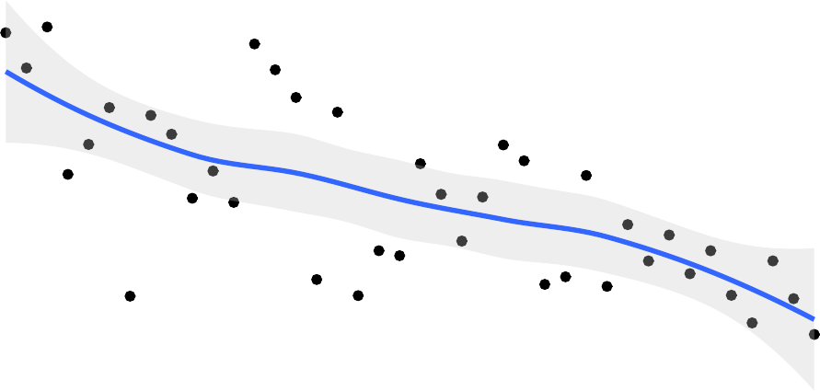

0.2

0.1

1990 2010

Figure 10: Proportion of *Philosophical Studies* articles in philosophy of language.

If you don’t trust black box methods like topic modeling, you can see a similar trend (possibly even more dramatic) just in the word usage. Figure 11 shows how often the words “description” and “reference” appear in *Philosophical Studies* each year, as a proportion of all the words in the articles.

The words don’t disappear, that would be strange given how many uses they have, but clearly these classic questions about the relationship between reference and description are less central to what the journal is publishing.

The aim of this section is to look at three questions. First, what more can we say about this fall in the frequency of philosophy of language articles? Second, what changes are there within

reference

9e-04



description



6e-04

3e-04

1990 2010 1990 2010

Figure 11: Frequency of the words ‘description’ and ‘reference’ in *Philosophical Studies*.

the other four categories? Third, how much are the answers to the first two questions specific to *Philosophical Studies*, and how much do they reflect broader trends in philosophy.

I first tried answering these questions by using more topic models, i.e., by making five fine- grained topic models for just the articles in each of these five categories. This revealed some interesting things that I’ll mention over the rest of the paper. But none of the models I built felt suﬀiciently stable to use as the center of the discussion; minor changes to the initial conditions led to dramatic changes in the outputs. That was not true for the model in Section , whose macro-properties were fairly stable in this sense. So I didn’t want to base the discussion around any one model.

Instead I’ll use two simpler properties of the distributions of words in *Philosophical Studies*.

First, I’ll look at the relative frequency of the roughly 6000 most common word types over the four decades from 1980-2019. For each word, and each decade, I’ll look at how far removed the word’s frequency in the decade differs from its overall frequency, and how improbably that deviation is. So consider the word “contextualism”, which you might expect would be more frequent in the 2000s than the other three decades. In fact that’s so; 984 of its 2282 appearances are in the 2000s. It does appear more often in the 2010s, but *Philosophical Studies* published more than twice as many words in the 2010s as the 2000s, so its appearance rate is lower. Overall, 26.48% of the words in *Philosophical Studies* from 1980-2019 were published in the 2000s. If those 2282 appearances of “contextualism” were distributed at random, the probability that 984 (or more) of them would be in the 2000s, given that each one has probability 0.2648 of being in the 2000s, is about 10-65. So, as expected, uses of

“contextualism” are heavily concentrated in the 2000s. In general, I’ll use this improbability of the word appearing this often at random as a measure of concentration. When the decade is clear, I’ll simply write the probability after the word, e.g., contextualism (10-65), to indicate how concentrated it is.

Second, I’ll look at the articles where a given word appears five or more times. If there are 10 or more such articles, I’ll look at how often those articles were cited in *Philosophical Studies*, and how often they were cited across the 100 philosophy journals. This is a measure of how much of the discussion of the topics associated with those words is centered in *Philosophical Studies*.

So consider the word “homeostatic”. It appears five or more times in precisely 10 *Philosophical Studies* articles. Those articles are fairly widely cited; between them they have 494 citations (in philosophy journals). Only 35 of those citations, or 7.1%, are in *Philosophical Studies*, indicating that the vast bulk of the discussion of them is elsewhere. A similar pattern occurs with “democratic”. The 14 articles where it is used 5 or more times have 525 citations, but only 43 of them, 8.2%, are in *Philosophical Studies*. At the other extreme, the word “Pereboom’s” appears five or more times in 14 articles, mostly discussing Derk Pereboom’s free will scepticism. Those articles (many of which are quite recent) have 223 citations, of which 57, or 25.6%, are in *Philosophical Studies*. So here the discussion of the articles is much more centered in *Philosophical Studies*.

On average, 13.8% of citations of *Philosophical Studies* articles are in *Philosophical Studies*, so we’re looking for whether this proportion of citations is above or below 13.8% to tell whether something is being discussed more inside or outside the journal, relative to its peers. In general, 7.1% of all citations of articles from 1980-2019 are in *Philosophical Studies*. But that’s not the right baseline. Every journal cites its own articles more commonly than it cites arbitrary other journals. This could be because articles in the same journal are guaranteed to be in the area the journal publishes in, and (especially outside the US), it is often because there are geographic correlations between the journal’s location, and the home institution of both the cited and citing authors. Articles in *Philosophical Studies* are typically cited about twice as often in the journal as you’d expect from a random distribution of citations; for most journals that multiple is well above two. Anyway, the main thing to know is that 13.8% is the baseline, and we can compare articles to that to see what’s distinctive to *Philosophical Studies*, and what’s a wider trend.

## Miscellany

Before getting into words that tell us about changes in the subject matter, I want to briefly note three small things we can see in the word count.

The JSTOR set includes all the words in the article, including headers, footnotes, and bibli- ography. *Philosophical Studies* gradually moved from footnote citations to author-text plus

bibliography. So ‘op’ and ‘cit’ appear primarily in the 1980s dataset. More strikingly, “Ox- ford” is concentrated in the 2010s, with 17159 of its 24239 appearances being in the 2010s. The probability of that happening by chance is less than 10-300. This is in part a result of longer bibliographies in the 2010s, in part a consequence of the proliferation of Oxford Hand- books and Oxford Studies publications, but largely a sign of the dominance of philosophy book publishing in the 2010s by Oxford University Press. It also doesn’t hurt that *Philosophical Studies* through 2019 used addresses in the entries for books, so “Oxford” appears twice in every entry for Oxford University Press.

Another word that appears a lot in the 2010s is “thanks” (10-60). As Petrovich (2024) notes, one pattern in the 2010s is that acknowledgements footnotes became more frequent, and more informal. So papers will cite “Theodore Sider” and thank “Ted Sider”. And they will not start with “I am grateful to…” but simply “Thanks to…”.

Finally, the trend in gender terms is remarkable. The word most concentrated in the 1980s (by the probability measure I’m using) is ‘which’; I think this just reflects stylistic changes. The second most concentrated is ‘he’. Figure 12 shows the frequency over time of male (he/him/his) and female (she/her/hers) pronouns over the years.

0.008

0.006

0.004

Gender

 Female  Male

0.002

0.000

1980 1990 2000 2010 2020

Figure 12: Frequency of gendered words in *Philosophical Studies*.

I’ll leave it for someone else to figure out what proportion of the change in Figure 12 is due to there being more references to particular women, and what proportion is due to philosophers using female pronouns for arbitrary or fictional characters.

## 1980s

From the 1990s to at least the mid 2010s, the bulk of ethics papers in *Philosophical Studies* were on fairly theoretical questions, with special focus on questions moral realism, moral motivation, and (a topic I’ll return to) moral responsibility. But in the 1980s the ethics papers in the journal had a different focus.

There were several papers on utilitarianism. So there was a lot of discussion of “utility” (10-15), “utilitarianism” (10-41) and “utilitarian” (10-45). One can use almost any philosophical term in a paper attacking the theory it names; indeed the 1980s paper with the most uses of “Kantian” (Terzis 1989) is an anti-Kantian paper. But most of these papers were supporting utilitarianism. (Some of the uses of “utility”, both in the 1980s and afterwards, were in decision theory papers.)

There were also many papers on abortion.20 These were largely *anti*-abortion arguments. They did not get much uptake in philosophy journals. The nine21 papers from the 1980s that use “abortion” five times or more average less than one citation per article in philosophy journals. Google Scholar tells me that some of them have more uptake elsewhere, including in bioethics journals outside this study, but they weren’t picked up on in philosophy.

But the big story of the 1980s is the centrality of philosophy of language to the journal, and how different this is to what the journal became in later years. The kind of philosophy of language *Philosophical Studies* published in the 1980s (and 1990s) was centered around issues about reference and description that became central to philosophy over the 1960s and 1970s.

Part of the evidence for that consists of which words were central to the journal in the 1980s. There was a lot of discussion of Donnellan’s distinction between referential and attributive uses of definite descriptions. The words “Donnellan” (10-72), “Donnellan’s” (10-58), “referential” (10-34) and “attributive” (10-23) appear much more often than they do in later decades. The 21 articles that use “Donnellan’s” five times or more are cited on average 15 times, which is a relatively high number given their publication year. Strikingly, over 25% of those citations are in *Philosophical Studies*. That shows discussion of this topic was playing a bigger role in *Philosophical Studies* than it was in the wider literature.

More generally, the story here is that while *Philosophical Studies* was publishing a lot of philosophy of language, it was not publishing the kind of philosophy of language that would become central to the next couple of decades.

There was very little on conditionals. The words “conditional”, “conditionals” and “counter- factuals” appear less frequently this decade than in later decades. There are no *Philosophical Studies* articles cited in Dorothy Edgington’s influential and comprehensive “On Conditionals” (**WOS:A1995QX94800001?**).

20One of these, (Gensler 1985, 1986), got printed twice because the pages were out of order the first time.

21Or ten, if you count both printings of the Gensler piece.

Similarly, there was very little on speech acts, or on context sensitivity. The words “assertion” and “Austin” appear at lower than average frequency, as do all the cognates of “context”.

Perhaps most significantly, despite the centrality of philosophy of language, there was very little interaction with linguistics, and especially not with linguists working on formal semantics. Here it helps to look at the 1980s and 1990s together, because this trend continues through the turn of the century. Before 2000, only one paper mentioned Irene Heim (King 1988), only two mentioned Angelika Kratzer (Cross 1986; Tichy 1984), and only three mentioned James McCawley (Asher and Bonevac 1985; Blackburn 1988; Ostertag 1999). As you can see from those dates, if anything there was even less engagement with linguists in the 1990s than there had been in the 1980s. There were more mentions of Chomsky, though they were mostly in passing, and as often in philosophy of mind papers as philosophy of language. Similarly, there were a few mentions of George Lakoff, but again not always in philosophy of language. The closest thing I see to interdisciplinary work are some applications of Montague grammar, e.g., by (Hazen 1984). But there is a much sharper division between philosophers of language and linguists working on semantics in *Philosophical Studies* before 2000 than you see in more recent work in philosophy of language.

In Figure 13 I show the frequency of some of the words mentioned in this subsection over time. I’ve put this in two graphs so the movement in the less frequently used words is easier to see.

## 1990s

* Still issues about content externalism. Now moved to mind, as ‘arthritis’, ‘Fodor’ and ‘mentalese’ show
* But really lagging here. ‘Arthritis’ is at 16.2%, ‘Mentalese’ at 19.4%.
* Big story is causation, and we’ll just word ‘causal’ to look at it. (Do graph just for it.)
* Very centered in 1990s - 7 of the 14 years where it most appears are in the 1990s, and 1991 is a weird outlier.
* Note “relevance” is because “causal relevance” is used a lot

Is this a trend specific to *Philosophical Studies*, or does it tell us something more broadly about philosophy journals? The answer is a bit of both, but mostly it is a general trend. The fact that “The Problem of the Essential Indexical” is near the top of Table 9, and near the bottom of Table 11 suggests that a certain kind of philosophy of language has declined more at *Philosophical Studies* than elsewhere. But some of the trends seem more widespread.

Ideally, we could build a topic model for all 100 of the journals, and see how many of them are language articles in this sense. But that would be computationally impractical. Fortunately, we can estimate it another way. The graph in Figure 10 starts turning downwards around 2005. If that was a phenomenon unique to *Philosophical Studies*, it should show up in the citation data. In particular, it should show up in philosophy of language articles having a lower than usual share of their citations in *Philosophical Studies*.

9e-04



description

reference



statement

6e-04

3e-04

1990 2010 1990 2010 1990 2010

1. More common words

2e-04



abortion



attributive



donnellan

1e-04

0e+00

2e-04



fetus

utilitarian

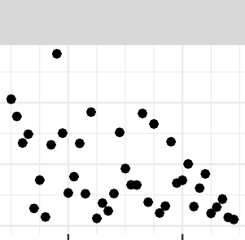

referential

1e-04

0e+00

1990 2010 1990 2010 1990 2010

1. Less common words

Figure 13: Words that appear more often in the 1980s.

0.0015

arthritis



language



sentence

0.0010

0.0005

0.0000

1990 2010 1990 2010 1990 2010

1. More common words

4e-04



burge



efficacy

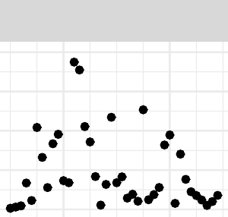

fodor

3e-04

2e-04

1e-04

0e+00

4e-04

3e-04

2e-04

1e-04

0e+00

1990 2010 1990 2010 1990 2010



hesperus



player

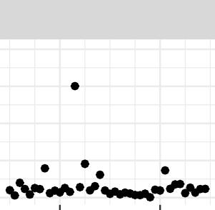

network

1. Less common words

Figure 14: Words that appear more often in the 1990s.

contextualism

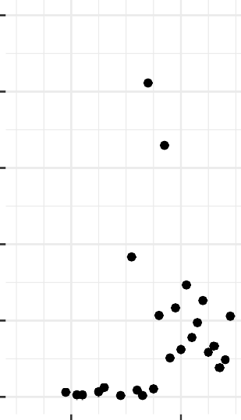5e-04

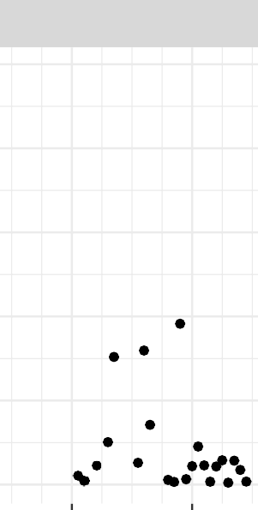

fictionalism

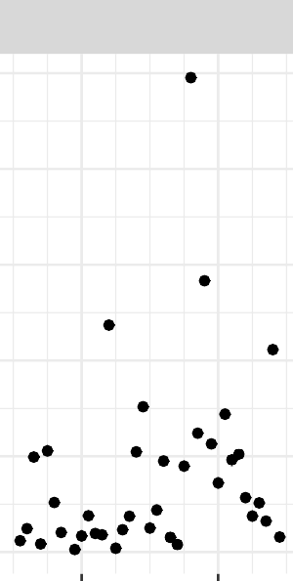

physicalism

4e-04

3e-04

2e-04

1e-04

0e+00

1990 2010 1990 2010

1. More common words

1990 2010

3e-04

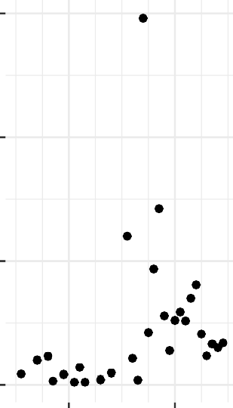

contextualist

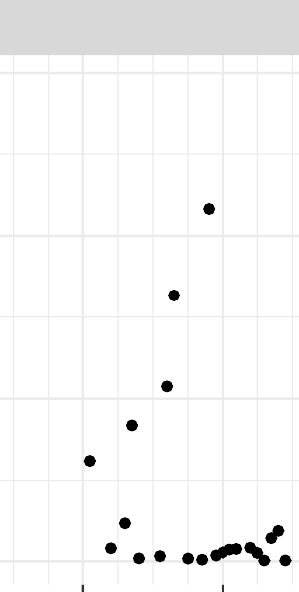

fictionalist

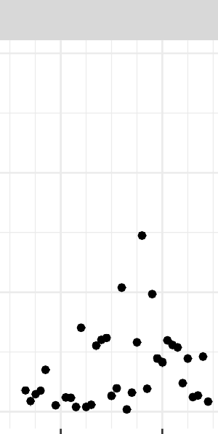

physicalist

2e-04

1e-04

0e+00

1990 2010 1990 2010

1. Less common words

1990 2010

demonstrative

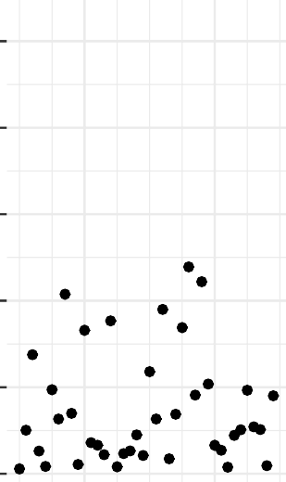5e-04

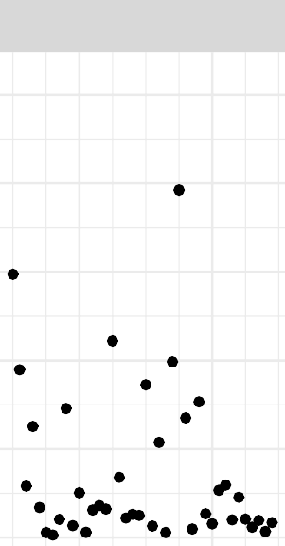

rigid

31

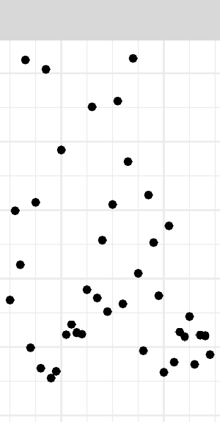

water

4e-04

3e-04

2e-04

1e-04

0e+00

0.0020



evidence

reasons

normative

epistemic

0.0015

0.0010

0.0005

0.0000

0.0020

0.0015

0.0010

0.0005

0.0000

1990 2010 1990 2010

1. More common words

0.0020

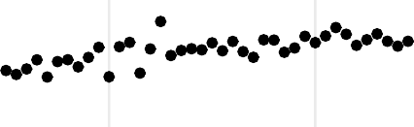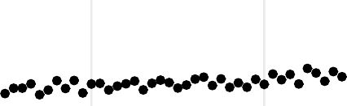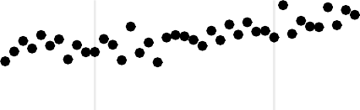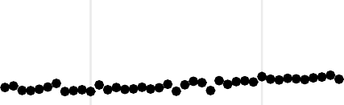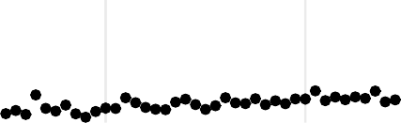

argue

response

1990

2010

view

explain

account

0.0015

0.0010

0.0005

0.0020

0.0015

0.0010

0.0005

0.0020

0.0015

0.0010

0.0005

1990 2010

1. Less common words

8e-04



gender



reactive

6e-04

4e-04

2e-04

0e+00

8e-04



32

social



testimony

6e-04

4e-04

2e-04

0e+00

So I found the 694 *Philosophical Studies* articles that the model said were at least 50% likely to be philosophy of language articles, and looked at what proportion of their citations, since 2005, were in *Philosophical Studies*. The answer was around 14.7%. Then I did the same thing for all *Philosophical Studies* articles, asking what percentage of their citations were in *Philosophical Studies*. The answer was 13.4%. The difference between these numbers isn’t significant. What is significant is that we don’t see evidence that philosophy of language, especially the kind of philosophy of language that *Philosophical Studies* published, was still a major part of the other journals, while dropping in importance in *Philosophical Studies* itself.

That last qualification, about the kind of philosophy of language that was published, is perhaps significant. Even when philosophy of language was the largest topic in the journal, there wasn’t much interaction with linguists working on formal semantics. Before 2000, only one paper mentioned Irene Heim (King 1988), and only two mentioned Angelika Kratzer (Cross 1986; Tichy 1984). There were more mentions of Chomsky, though they were mostly in passing, and in any case Chomsky is more significant as a syntactician than a semanticist. The closest thing I see to interdisciplinary work are some applications of Montague grammar, e.g., by (Hazen 1984). But there is a much sharper division between philosophers of language and linguists working on semantics in *Philosophical Studies* before 2000 than you see in more recent work in philosophy of language. As the field moved towards more interdisciplinary work, *Philosophical Studies* moved its focus onto other topics, especially epistemology.

I’ve focused largely on philosophy of language because the decline in importance of what were once core questions of analytic philosophy, about description and reference, is the single biggest story in the trends. But there are two other trends worth noting, although they are much smaller.

There is a small uptick in epistemology articles in the journal in the 2000s. Interestingly, this matches a finding by Eugenio Petrovich (2024), who (using a different method) sees a notable uptick in epistemology in five other leading journals starting around 2000. As we’ll see **?@sec- citations-topic**, this is related to the notable increase in citations to *Philosophical Studies* starting around the same time.

And there is a trend upwards in ethics over the last few years, though it’s only returning ethics to the position it was in earlier years. I’ll have more to say about this in **?@sec-social**; the short version is that what’s happening inside ethics, and in particular the focus on social questions, is more interesting than the size of the category.

**Trends**

# The LDA

Build the model Note the five categories Graph the trends Flag the methodology

# Language

Find the 40 most cited in each topic over the 40 years (i.e., most cited per year) Look how often they are cited in PS Look how often they are cited across the 100 See if the trends in PS track wider trends Find other journals that have similar trends (Analysis, PQ, AJP)

# Metaphysics

Note the two Schaffer papers, and differences in citing Schaffer (2016) Is that because little grounding There is some - see graph of words Maybe just count how ‘modal’ vs ‘postmodal’ the 2019 papers are Maybe do a small LDA of the metaphysics papers

# Ethics

Is there anything to say here? Does it go more political? Still not citing Anderson, but something?

Delicate. Even happening.

Anderson, Elizabeth S. 1999. “What Is the Point of Equality?” *Ethics* 109 (2): 287–337. <https://doi.org/10.1086/233897>.

Asher, N, and D Bonevac. 1985. “Situations and Events.” *Philosophical Studies* 47 (1): 57–77. <https://doi.org/10.1007/BF00355087>.

Blackburn, WK. 1988. “Wettstein on Definite Descriptions.” *Philosophical Studies* 53 (2): 263–78. <https://doi.org/10.1007/BF00354644>.

Bornmann, Lutz, and Richard Williams. 2020. “An Evaluation of Percentile Measures of Citation Impact, and a Proposal for Making Them Better.” *Scientometrics* 124 (2): 1457–

78. <https://doi.org/10.1007/s11192-020-03512-7>.

Bourget, David, and David J. Chalmers. 2014. “What Do Philosophers Believe?” *Philosophi- cal Studies* 170 (3): 465–500. <https://doi.org/10.1007/s11098-013-0259-7>.

Boyd, Richard. 1991. “Realism, Anti-Foundationalism and the Enthusiasm for Natural Kinds.”

*Philosophical Studies* 61 (1-2): 127–48. <https://doi.org/10.1007/BF00385837>.

Brzezinski, Michal. 2015. “Power Laws in Citation Distributions: Evidence from Scopus.”

*Scientometrics* 103 (1): 213–28. <https://doi.org/10.1007/s11192-014-1524-z>.

Castañeda, Hector-Neri. 1967. “Indicators and Quasi-Indicators.” *American Philosophical Quarterly* 4 (2): 85–100.

Cavell, S. 1962. “The Availability of Wittgenstein’s Later Philosophy.” *Philosophical Review*

71 (1): 67–93. <https://doi.org/10.2307/2183682>.

Clark, Andy, and David J. Chalmers. 1998. “The Extended Mind (Active Externalism).”

*Analysis* 58 (1): 7–19. <https://doi.org/10.1111/1467-8284.00096>.

Cohen, G. A. 1989. “On the Currency of Egalitarian Justice.” *Ethics* 99 (4): 906–44. [https:](https://doi.org/10.1086/293126)

[//doi.org/10.1086/293126](https://doi.org/10.1086/293126).

Cohen, Stewart. 1984. “Justification and Truth.” *Philosophical Studies* 46 (3): 279–95. [https:](https://doi.org/10.1007/BF00372907)

[//doi.org/10.1007/BF00372907](https://doi.org/10.1007/BF00372907).

Cross, CB. 1986. “Can and the Logic of Ability.” *Philosophical Studies* 50 (1): 53–64. [https:](https://doi.org/10.1007/BF00355160)

[//doi.org/10.1007/BF00355160](https://doi.org/10.1007/BF00355160).

Cummins, Robert. 1975. “Functional Analysis.” *Journal Of Philosophy* 72 (20): 741–65. <https://doi.org/10.2307/2024640>.

Dennett, D. C. 1971. “Intentional Systems.” *Journal Of Philosophy* 68 (4): 87–106.

DeRose, Keith. 1995. “Solving the Skeptical Problem.” *Philosophical Review* 104 (1): 1–52. <https://doi.org/10.2307/2186011>.

DeVries, Willem A. 2005. *Wilfrid Sellars*. Abingdon: Routledge.

Donnellan, Keith S. 1966. “Reference and Definite Descriptions.” *Philosophical Review* 75 (3): 281–304. <https://doi.org/10.2307/2183143>.

Dworkin, Ronald. 1981. “What Is Equality? Part 2: Equality of Resources.” *Philosophy & Public Affairs* 10 (4): 283–345.

Egan, Andy. 2011. “Comments on Gendler’s, ’the Epistemic Costs of Implicit Bias’.” *Philo- sophical Studies* 156 (1): 65–79. <https://doi.org/10.1007/s11098-011-9803-5>.

Fraassen, Bas C. van. 1995. “Belief and the Problem of Ulysses and the Sirens.” *Philosophical Studies* 77 (1): 7–37. <https://doi.org/10.1007/BF00996309>.

Frankfurt, Harry G. 1969. “Alternate Possibilities and Moral Responsibility.” *Journal Of Philosophy* 66 (23): 829–39. <https://doi.org/10.2307/2023833>.

———. 1971. “Freedom of the Will and the Concept of a Person.” *Journal Of Philosophy* 68

(1): 5–20.

Gendler, Tamar Szabo. 2011. “On the Epistemic Costs of Implicit Bias.” *Philosophical Studies*

156 (1): 33–63. <https://doi.org/10.1007/s11098-011-9801-7>.

Gensler, HJ. 1985. “A Kantian Argument Against Abortion.” *Philosophical Studies* 48 (1): 57–72. <https://doi.org/10.1007/BF00372407>.

———. 1986. “A Kantian Argument Against Abortion.” *Philosophical Studies* 49 (1): 83–98. <https://doi.org/10.1007/BF00372885>.

Ginsborg, Hannah. 2008. “Was Kant a Nonconceptualist?” *Philosophical Studies* 137 (1): 65–77. <https://doi.org/10.1007/s11098-007-9163-3>.

Goldman, Alvin I. 1976. “Discrimination and Perceptual Knowledge.” *Journal Of Philosophy*

73 (20): 771–91. <https://doi.org/10.2307/2025679>.

Grice, HP. 1957. “Meaning.” *Philosophical Review* 66 (3): 377–88. [https://doi.org/10.2307/](https://doi.org/10.2307/2182440)

[2182440](https://doi.org/10.2307/2182440).

Hazen, A. 1984. “Modality as Many Metalinguistic Predicates.” *Philosophical Studies* 46 (2): 271–77. <https://doi.org/10.1007/BF00373111>.

Jackson, Frank. 1982. “Epiphenomenal Qualia.” *Philosophical Quarterly* 32 (127): 127–36. <https://doi.org/10.2307/2960077>.

Kelly, Thomas. 2002. “The Rationality of Belief and Some Other Propositional Attitudes.”

*Philosophical Studies* 110 (2): 163–96. https://doi.org/10.1023/A:1020212716425.

Kim, Jaegwon. 1984. “Concepts of Supervenience.” *Philosophy And Phenomenological Re-*

*search* 45 (2): 153–76. <https://doi.org/10.2307/2107423>.

King, JC. 1988. “Are Indefinite Descriptions Ambiguous.” *Philosophical Studies* 53 (3): 417–

40. <https://doi.org/10.1007/BF00353515>.

Kolodny, Nico. 2005. “Why Be Rational?” *Mind* 114 (455): 509–63. [https://doi.org/10.1093/](https://doi.org/10.1093/mind/fzi509) [mind/fzi509](https://doi.org/10.1093/mind/fzi509).

Kripke, Saul. 1975. “Outline of a Theory of Truth.” *Journal Of Philosophy* 72 (19): 690–716. <https://doi.org/10.2307/2024634>.

Latham, N. 2000. “Chalmers on the Addition of Consciousness to the Physical World.” *Philo- sophical Studies* 98 (1): 71–97.

Lederman, Harvey. 2022. “The Introspective Model of Genuine Knowledge in Wang Yang- ming.” *Philosophical Review* 131 (2): 169–213. <https://doi.org/10.1215/00318108-9554691>. Lewis, David. 1979a. “Attitudes de Dicto and de Se.” *Philosophical Review* 88 (4): 513–43.

<https://doi.org/10.2307/2184843>.

———. 1979b. “Counterfactual Dependence and Time’s Arrow.” *Noûs* 13 (4): 455–76. [https:](https://doi.org/10.2307/2215339)

[//doi.org/10.2307/2215339](https://doi.org/10.2307/2215339).

———. 1983. “New Work for a Theory of Universals.” *Australasian Journal Of Philosophy*

61 (4): 343–77. <https://doi.org/10.1080/00048408312341131>.

———. 1996. “Elusive Knowledge.” *Australasian Journal Of Philosophy* 74 (4): 549–67. <https://doi.org/10.1080/00048409612347521>.

Lewy, C. 1976. “Mind Under G. E. Moore (1921-1947).” *Mind* 85 (337): 37–46. [https:](https://doi.org/10.1093/mind/LXXXV.337.37)

[//doi.org/10.1093/mind/LXXXV.337.37](https://doi.org/10.1093/mind/LXXXV.337.37).

Lormand, E. 1985. “Toward a Theory of Moods.” *Philosophical Studies* 47 (3): 385–407. <https://doi.org/10.1007/BF00355211>.

Machamer, Peter, Lindley Darden, and Carl F. Craver. 2000. “Thinking about Mechanisms.”

*Philosophy Of Science* 67 (1): 1–25. <https://doi.org/10.1086/392759>.

Malaterre, Christophe, Jean-François Chartier, and Davide Pulizzotto. 2019. “What Is This Thing Called Philosophy of Science? A Computational Topic-Modeling Perspective, 1934?2015.” *Hopos: The Journal of the International Society for the History of Philosophy of Science* 9 (2): 215–49. <https://doi.org/10.1086/704372>.

Malaterre, Christophe, and Francis Lareau. 2022. “The Early Days of Contemporary Phi- losophy of Science: Novel Insights from Machine Translation and Topic-Modeling of Non- Parallel Multilingual Corpora.” *Synthese* 200 (3): 1–33. [https://doi.org/10.1007/s11229-](https://doi.org/10.1007/s11229-022-03722-x) [022-03722-x](https://doi.org/10.1007/s11229-022-03722-x).

Malaterre, Christophe, Francis Lareau, Davide Pulizzotto, and Jonathan St-Onge. 2020. “Eight Journals over Eight Decades: A Computational Topic-Modeling Approach to Con- temporary Philosophy of Science.” *Synthese* 199 (1-2): 2883–923. [https://doi.org/10.1007/](https://doi.org/10.1007/s11229-020-02915-6) [s11229-020-02915-6](https://doi.org/10.1007/s11229-020-02915-6).

Mercer, Christia. 2017. “Descartes’ Debt to Teresa of Avila, or Why We Should Work on Women in the History of Philosophy.” *Philosophical Studies* 174 (10): 2539–55. [https:](https://doi.org/10.1007/s11098-016-0737-9)

[//doi.org/10.1007/s11098-016-0737-9](https://doi.org/10.1007/s11098-016-0737-9).

Millikan, Ruth Garrett. 1989. “In Defense of Proper Functions.” *Philosophy Of Science* 56

(2): 288–302. <https://doi.org/10.1086/289488>.

Ostertag, G. 1999. “A Scorekeeping Error.” *Philosophical Studies* 96 (2): 123–46. https:

//doi.org/10.1023/A:1004293605139.

Perry, John. 1977. “Frege on Demonstratives.” *Philosophical Review* 86 (4): 474–97. [https:](https://doi.org/10.2307/2184564)

[//doi.org/10.2307/2184564](https://doi.org/10.2307/2184564).

———. 1979. “The Problem of the Essential Indexical.” *Noûs* 13 (1): 3–21. [https://doi.org/](https://doi.org/10.2307/2214792) [10.2307/2214792](https://doi.org/10.2307/2214792).

Petrovich, Eugenio. 2024. *A Quantitative Portrait of Analytic Philosophy: Looking Through the Margins*. Cham: Springer.

Post, JF. 1984. “On the Determinacy of Valuation.” *Philosophical Studies* 45 (3): 315–33. <https://doi.org/10.1007/BF00355441>.

Pryor, James. 2000. “The Skeptic and the Dogmatist.” *Noûs* 34 (4): 517–49. [https://doi.org/](https://doi.org/10.1111/0029-4624.00277) [10.1111/0029-4624.00277](https://doi.org/10.1111/0029-4624.00277).

Rawls, John. 1980. “Kantian Constructivism in Moral Theory.” *Journal Of Philosophy* 77 (9): 515–35. <https://doi.org/10.2307/2025790>.

———. 1985. “Justice as Fairness: Political Not Metaphysical.” *Philosophy & Public Affairs*

14 (3): 223–51.

Schaffer, Jonathan. 2010. “Monism: The Priority of the Whole.” *Philosophical Review* 119

(1): 31–76. <https://doi.org/10.1215/00318108-2009-025>.

———. 2016. “Grounding in the Image of Causation.” *Philosophical Studies* 173 (1): 49–100. <https://doi.org/10.1007/s11098-014-0438-1>.

Singer, Peter. 1972. “Famine, Affluence, and Morality.” *Philosophy & Public Affairs* 1 (3): 229–43.

Terzis, GN. 1989. “An Objection to Kantian Ethical Rationalism.” *Philosophical Studies* 57

(3): 299–313. <https://doi.org/10.1007/BF00372699>.

Tichy, P. 1984. “Subjunctive Conditionals, 2 Parameters Vs 3.” *Philosophical Studies* 45 (2):

147–79. <https://doi.org/10.1007/BF00372476>.

Warnock, G. J. 1976. “Gilbert Ryle’s Editorship.” *Mind* 85 (337): 47–56. [https://doi.org/10.](https://doi.org/10.1093/mind/LXXXV.337.47)

[1093/mind/LXXXV.337.47](https://doi.org/10.1093/mind/LXXXV.337.47).