**Enterprise Architecture (EA)**

**Final Project**

**Online Apartment Booking System**

**Project Team Members**

**Brian Bwengye (610158)**

**Sagar Ghimire (610104)**

**Sunena Gwachha (109578)**

**Suresh Prajapati (109524)**

**Yubraj Ghimire (610143)**

**21th November 2019**

**Deployment Diagram**

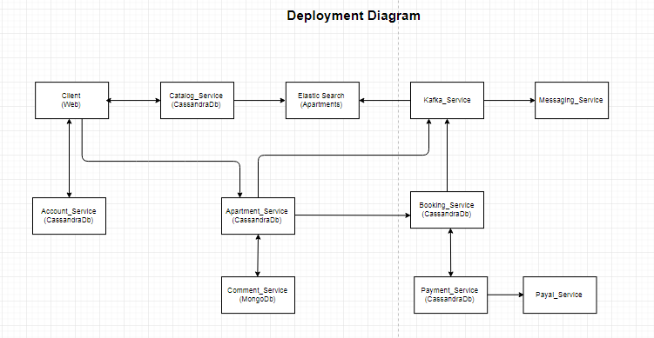

Fig: Architecture pattern of Online Apartment Booking System