SILLAGE
Instagram Content Library — Trust-First Grid
Goal: make the page read as a real, careful, trustworthy business to a cold visitor or new follower — not a legacy luxury house, not a dropshipping storefront. Grounded premium: confident, clean, honest. All product shots below are your actual generated assets — no new bottle designs, no new AI spend.

Carousel 1 — ROUGE, Slide by Slide
Product carousel. Job: make a cold visitor believe this is a real, considered product — not a reseller graphic. 4 slides.
SLIDE 1 — The Hero
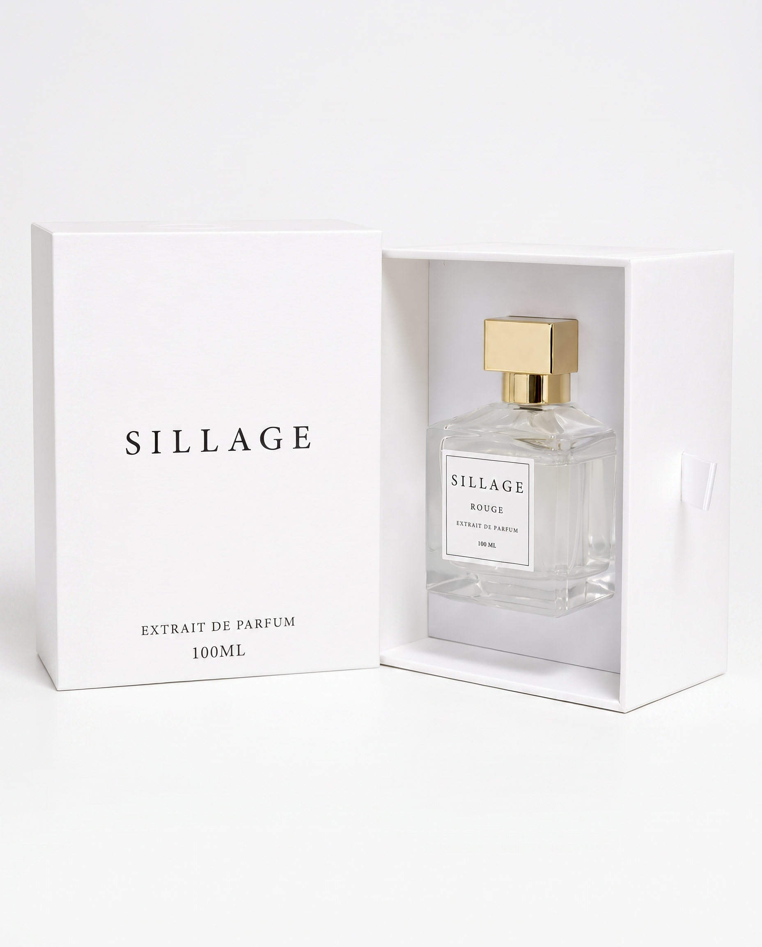
Image: your existing rouge_hero.png (box + bottle presentation shot, clean white background).
On-image text: None. The open box already tells the unboxing story — restraint reads as confidence.
Design note: Small caption bottom-left only: "Extrait de Parfum · 100ML" in thin grey uppercase, 10pt equivalent. Nothing else on the frame.
SLIDE 2 — The Notes
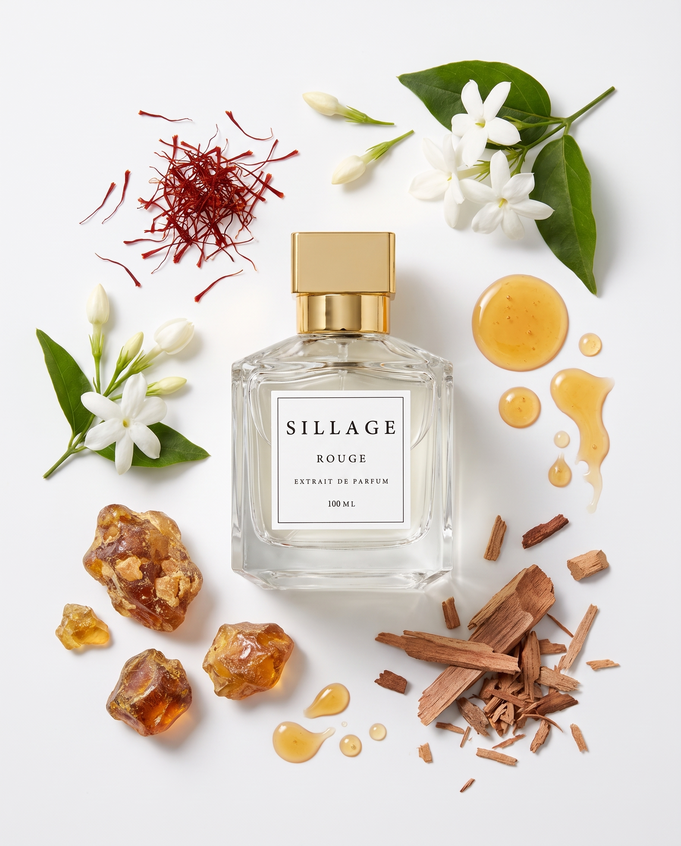
Image: your existing rouge_notes.png (real ingredient flat-lay — saffron, jasmine, amber, cedarwood, honey).
On-image text (Arabic, right-aligned overlay, top third of frame):
طبقات العطر
مقدمة: زعفران، ياسمين
قلب: عنبر، أمبروود
قاعدة: خشب الأرز، أمبروكسان
SLIDE 3 — The Feeling
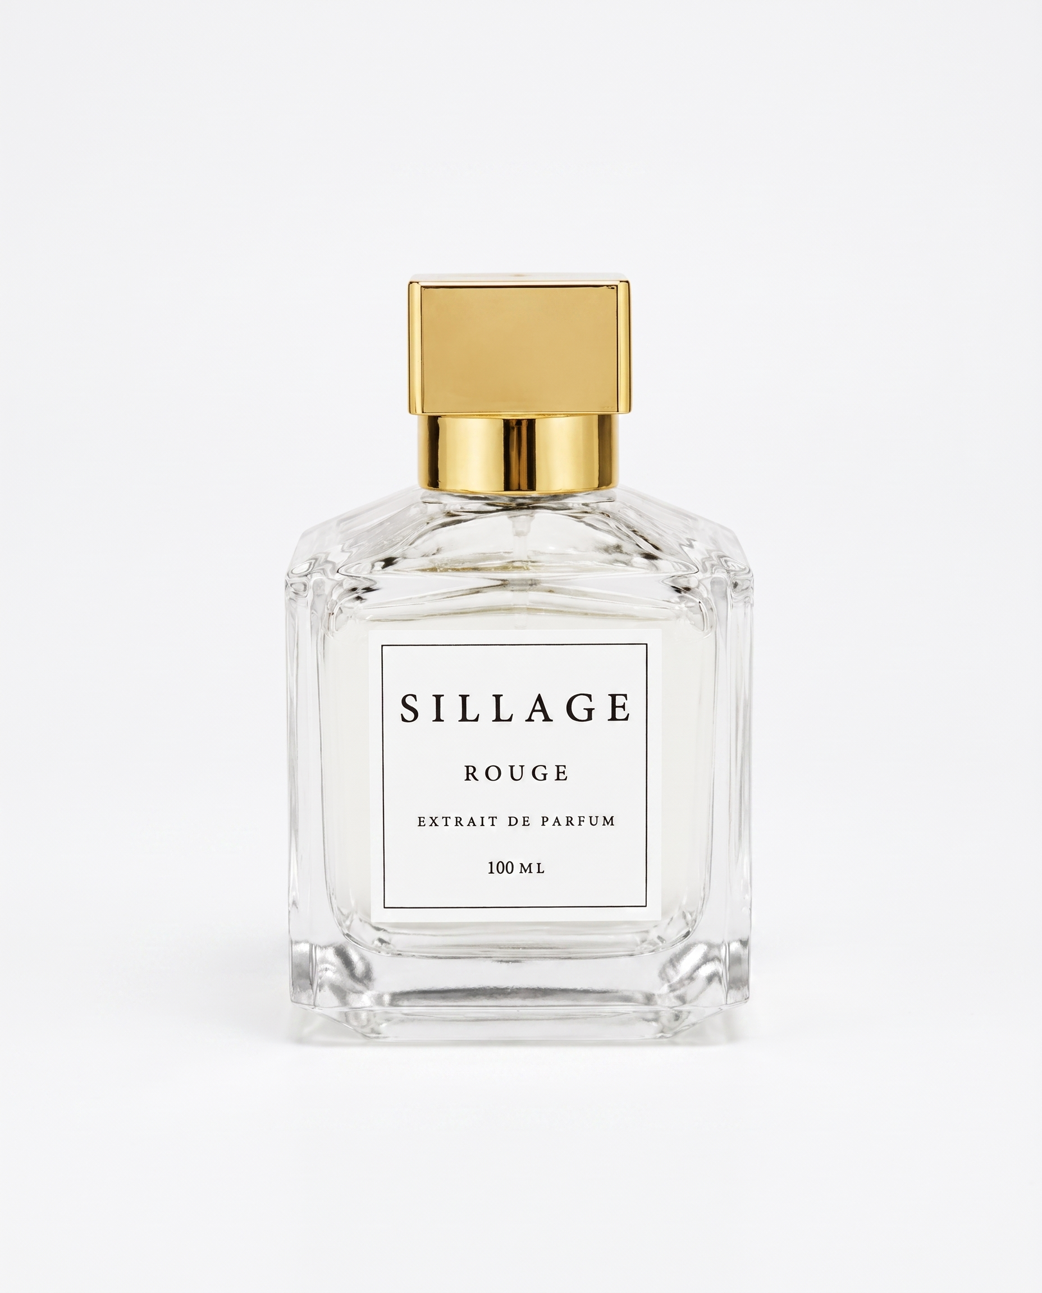
Image: your existing rouge_alt.png (second solo-bottle angle — reused, not regenerated).
On-image text (Arabic, centered, lower third):
حضور يُلاحظ من غير ما تتكلمي
Design note: One line only. This is the emotional beat of the carousel — do not add a second sentence.
SLIDE 4 — The Trust Close
No new image required — plain off-white background, gold hairline border matching the cap color, centered text block.
On-image text (Arabic, centered):
الدفع عند الاستلام
توصيل سريع
130 قطعة فقط — الكمية الحقيقية المتبقية
Design note: "130 قطعة" is a real inventory number, not a marketing invention — keep it exact, never round up.

Carousel 1 — Caption, Tags, CTA
Caption (Arabic):
سيلاج روج. زعفران وياسمين من فوق، عنبر وخشب من تحت. رائحة تدوم وتوصلك بدون ما تحسي فيها. 130 قطعة بس متوفرة، دفع عند الاستلام، توصيل سريع.
Hashtags:
#سيلاج_روج #عطور #عطر_نسائي #دفع_عند_الاستلام #عطور_اصلية #Sillage
CTA:
اطلبي من الرابط في البايو
Why this builds trust: Real notes, real inventory number, no invented review counts, no discount theater. A skeptical Arab-48 buyer's first filter is "is this a real business" — precision reads as real; hype reads as scam.

Carousel 2 — ليه سيلاج؟ (Why Sillage)
Brand-trust carousel, not product-specific. Job: answer the cold visitor's real objection — "why should I trust a page I've never heard of." 6 slides, mostly typographic.
SLIDE 1 — Open
Design: Plain cream/off-white background, no product. Centered wordmark + headline only.
ليه سيلاج؟
SLIDE 2 — Real Ingredients
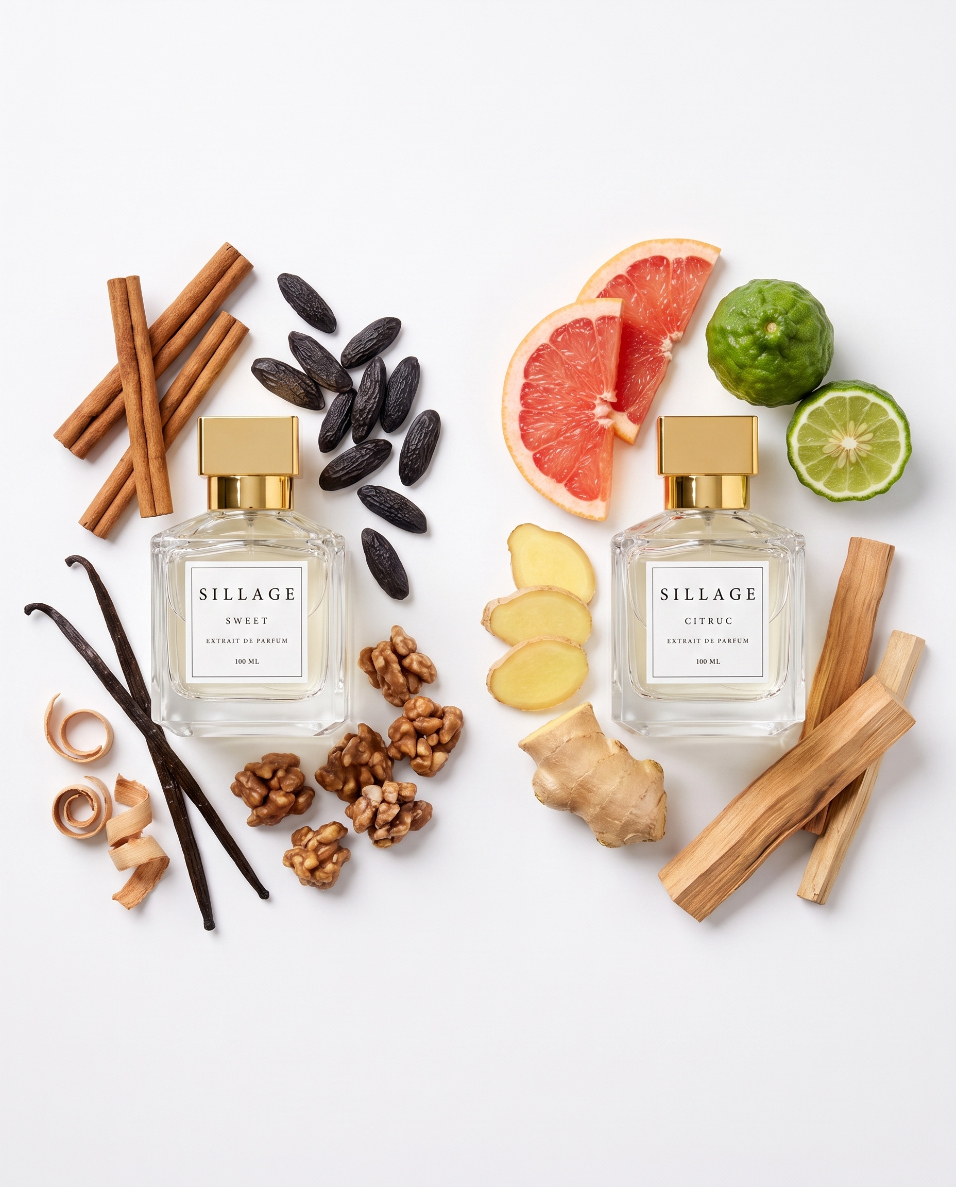
Image: your existing sweet_citruc_notes.png (real ingredient flat-lay, two fragrances side by side).
كل عطر عندنا مبني على مكونات حقيقية
مش خلطة عامة معاد تعبئتها
SLIDE 3 — Zero-Risk Payment
Design: plain background, single icon (hand + box outline, simple line art) + text.
الدفع عند الاستلام
تدفعي بس لما توصلك القطعة
SLIDE 4 — Origin
Design: plain background, restrained — this is a factual claim, not a luxury-heritage story. Do not embellish beyond what's true.
تركيبة عطورنا إيطالية الأصل
Note: Keep this line exactly this short until you give me one verifiable specific (city, perfumer, or supplier) to add. A vague luxury-country claim without a detail behind it is the kind of thing that erodes trust if someone asks a follow-up question.
SLIDE 5 — Real Scarcity
Design: plain background, numbers are the visual — large type, no icons needed.
130 قطعة روج، 40 طقم ديو بس
لما تخلص ما في تعبئة جديدة قريب
SLIDE 6 — Close
جربي سيلاج
Design: Same gold hairline border as Carousel 1 slide 4 — visual consistency across the grid matters more than novelty per slide.

Carousel 2 — Caption, Tags, CTA
Caption (Arabic):
مش بس عطر. سيلاج قصة مكونات حقيقية، توصيل سريع، ودفع عند الاستلام من غير أي مخاطرة. اطلبي وجربي بنفسك.
Hashtags:
#سيلاج #عطور_اصلية #دفع_عند_الاستلام #توصيل_سريع #Sillage
CTA:
اطلبي وجربي بنفسك — الرابط في البايو
Why this builds trust: This carousel exists to pre-answer objections before a visitor has to ask. Nothing here overclaims — no fabricated review count, no "as seen in," no invented awards. Every line is checkable against reality, which is exactly what a scam-wary buyer is unconsciously testing for.

Posting Notes
• Post Carousel 2 (Why Sillage) first if this is for a followers campaign — it answers trust objections before anyone sees a price.
• Post Carousel 1 (ROUGE) second, pinned or immediately after — converts the trust you just built into a specific product decision.
• Both carousels are built entirely from images you already have — zero new Higgsfield spend. If you want these turned into finished, ready-to-post files (not just this brief), say so and I'll build them in Canva with your real images and native Arabic text.

