**Written Report Pandas Challenge**

The following report contains at the end tables for the District Summary, School Summary, Highest-Performing Schools by Percentage of Overall Passing, Lowest-Performing Schools by Percentage of Overall Passing, Math Scores by Grade, Reading Scores by Grade, Scores by School Spending, Spending Summary, Scores by Schools Size, Scores by School Size Summary, Scores by School Type.

The table District Summary provides a snap-shot of all high schools in the district, giving the total number of schools, total number of students, total district budget, average math score, average reading score, % of students passing math, % of students passing reading, and % of students passing overall (passing both math and reading). The school summary table gives these same stats but by each of the fifteen schools in the district. The Highest-Performing Schools by Percentage of Overall Passing table gives the top five performing schools by % overall passing, while the Lowest-Performing Schools by Percentage of Overall Passing table gives the bottom five schools. The Math Scores by Grade table gives the average math score from grades 9th-12th for each high school, and the Reading Scores by Grade table gives the same but for average reading scores. In the Scores by School Spending table schools are broken into groups based on what they spend per student, the four categories that schools were broken down into were, <$585 per student, $585-630 per student, $630-645 per student, and $645-680 per student. Then the Spending Summary table takes these spending per student ranges and gives the average math score, average reading score, % of students passing math, % of students passing reading, and % of students passing overall for the schools in each category. The Scores by Schools Size table has the high schools classified by the number of students into small (<1000), medium (1000-2000), and large (2000-5000) schools. Then the Scores by School Size Summary table takes these school size categories and gives the average math score, average reading score, % of students passing math, % of students passing reading, and % of students passing overall for the schools in each category. Finally, the table Scores by School Type looks across the same five variables for scores and passing, but giving the averages for charter schools and district schools.

Several conclusions can be drawn from these tables.

**Little Change in Scores from 9th-12th Grade**

For math scores by grade there seems to be little change from 9th-12th grade. Schools where there is a high percentage of students passing tend to maintain this high percentage, while schools where there is a low percentage of students passing tend to maintain this low percentage from 9th-12th grade. Similar results are seen for reading scores by grade, except the range of reading scores among schools is smaller.

**The Five Lowest Performing Schools Need More Math Help**

For the schools with the lowest percent of students passing both reading and math the math passing rate is much lower than the passing rate for reading. All of the lowest performing schools have a math pass rate around 66%, while their reading pass rates are around 80%. While these schools need help on both reading and math they need about twice as much help when it comes to math to bring them up to the average math pass rate. This is given that for all schools the average % Passing Math is 74.98, while the average % Passing Reading is 85.81.

**Charter Schools Perform Better…With Qualifiers**

When viewing the table Scores by School Spending the highest performing schools are all charter schools. This is the case when it comes to the % Overall Passing, % Passing Math, % Passing Reading, Average Math Scores, and Average Reading Scores. The lowest performing schools on these measures are all district schools. The conclusion that charter schools out perform district schools is also support by the averages for all charter versus district schools, again on these five measure charter schools out perform district schools. This performance is regardless of spending, charter schools perform better even when they have less spending per student. This said more data and analysis would be needed to determine if charter schools do perform better than district schools regardless of spending per student given that students are able to self-select into charter schools and therefore the quality of students starting at charter schools may be higher. It could also be that school size is playing a role, all of the district schools are classified as large schools based on the number of students, while only one of the charter schools is classified as a large school, the rest are small and medium. This is given that there is little difference between the performance of small and medium sized schools.

**Spending and Performance are Inversely Related**

Interestingly when examining the Spending Summary Table, Average Math Score, Average Reading Score, % Passing Math, % Passing Reading, and % Overall Passing all have an inverse relationship with the amount spent per student, as the spending range increases scores and passing rates declines. But of course this does not mean that spending has no impact on student performance, more data would be needed to determine this, other factors could be at play such as the quality of middle schools students are coming from, a lot of the spending could be on remedial education.

**District Summary**



**School Summary**

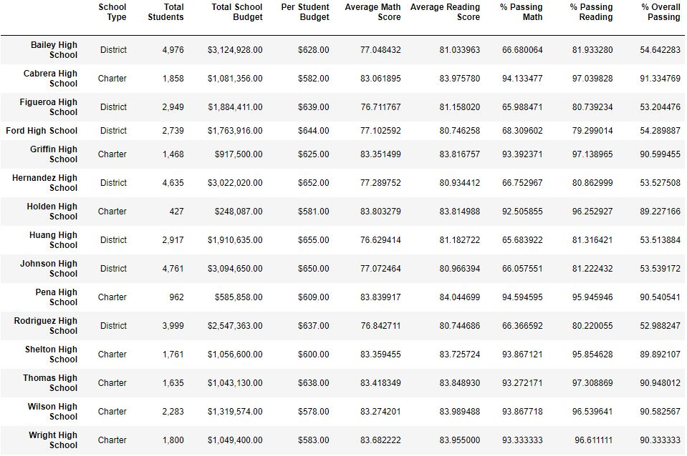

**Highest-Performing Schools by Percentage of Overall Passing**

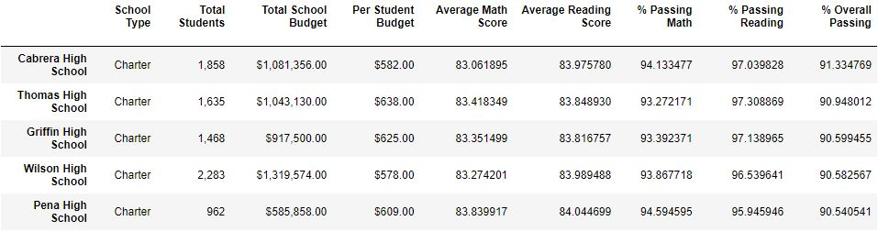

**Lowest-Performing Schools by Percentage of Overall Passing**

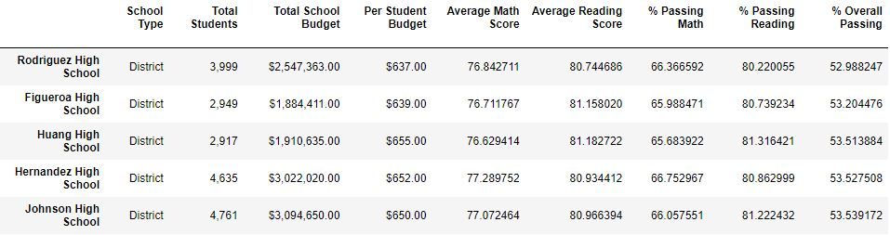

**Math Scores by Grade**

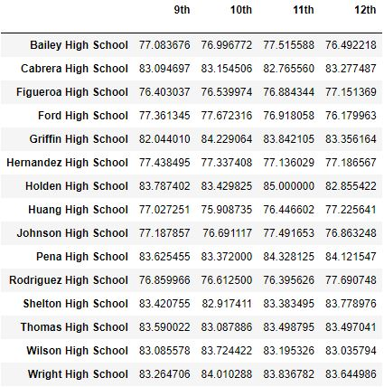

**Reading Scores by Grade**

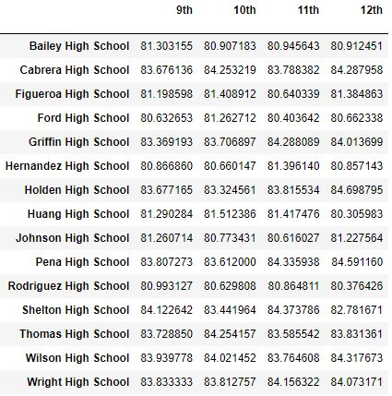

**Scores by School Spending**

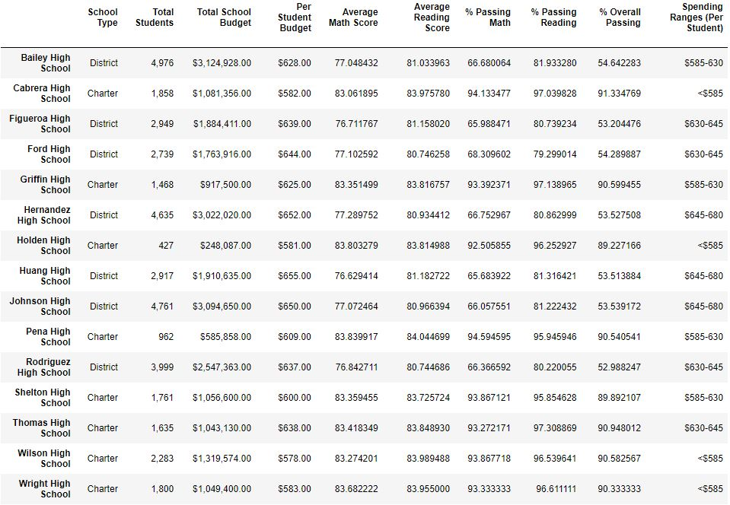

**Spending Summary**

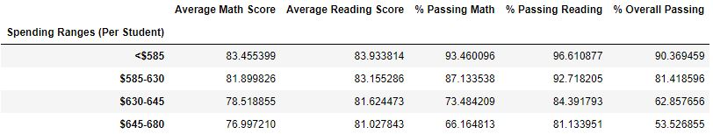

**Scores by Schools Size**

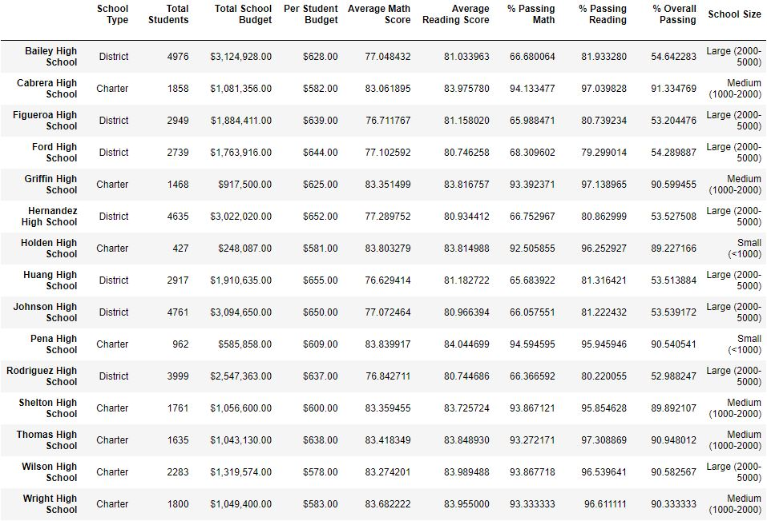

**Scores by School Size Summary**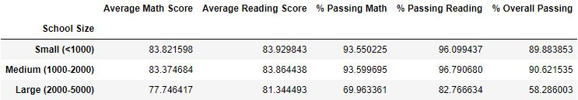

**Scores by School Type**

