Jenny Cockell: The Woman that Reincarnated to See her Children Again
NOVEMBER 6, 2017

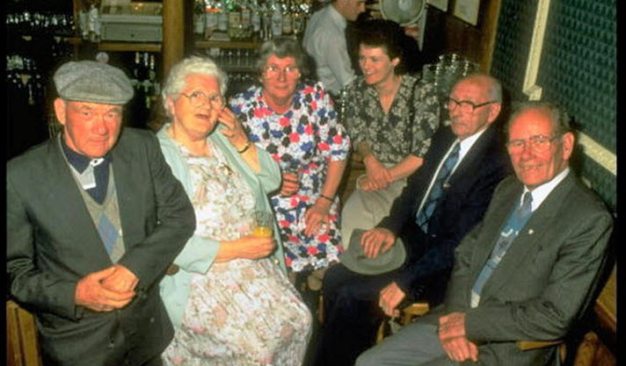

In the 1950s, 4 year old Jenny Cockell from Northamptonshire (England), began to have memories of incidents, faces; family members and places from a past life. After a short time fragmented memories started to make sense. She started to remember that she was a mother of 8 children living in Malahide, Ireland. She remembered that she died young worrying about who will take care of her children since her husband was abusive and an alcoholic. The memories allowed Jenny to draw maps of the village when she was still a child. After looking at maps she was able to confirm that her memories were real; the village did exist.
As a child Jenny assumed that everyone had memories from past lives. She soon discovered that this was not the case. In one ocassion during Sunday school the children were introduced to the concepts of life and death and the afterlife. Jenny could not understand why nobody discussed previous lives and only this life. With time she realised that she was the exception.
Once an adult (in the 70s) and after having children in her current life she decided she wanted to research further and get proof that her memories were real. After having a hipnosis Jenny Cocknell realised that she could no longer suppress her past life memories. Eventually she made the trip to Ireland and visited the village of Malahide and was able to confirm her memories of the village and locate her family house. She was also able to get information about the mother of 8 that had died at the house. Her name in her previous life was Mary Sutton.
With this information at hand, she moved on to post an announcement in the local newspaper requesting information about the whereabouts of the children. Some time later she received a letter giving her information about her children. All of her children had been sent to local orphanages except from one who had stayed with the father. Jenny started her research and visited the orphanages to seek information in the registers. She was able to locate some of the children who by then were in their 70s; old enough to be her parents. Eventually, the puzzle was complete; 6 out of the 8 children were located as 2 had already died.
Jenny was very cautious with explaining her experiences with the 6. She did not try to persuade them that she was the reincarnation of their mother, Mary Sutton. All of her children were convinced that Jenny was authentic as Jenny was able to share so many incidents and characteristics from their childhood that only their mother could know. Her children had different perceptions to the story but all accepted her. Some see her as a reincarnation of their mother while others the soul of their mother communicating through Mary.

