**VUEJS-BOOTCAMP**

[**https://github.com/galpratama/zullkit-frontend-live**](https://github.com/galpratama/zullkit-frontend-live)

[**https://github.com/galpratama/zullkit-html**](https://github.com/galpratama/zullkit-html)

[**https://galpratama.notion.site/Bootcamp-VueJS-3-Handbook-e7aa7200699f4647bf67d3d882ed1120**](https://galpratama.notion.site/Bootcamp-VueJS-3-Handbook-e7aa7200699f4647bf67d3d882ed1120)

**Update :**

**https://github.com/galpratama/zullkit-frontend-live/commit/af3362b8d55229eb47a5c99d36b4e25149cf7c2f**

**Untuk css Tailwind :** [**https://flowbite.com/**](https://flowbite.com/)

[**https://zullkit-backend.buildwithangga.id/**](https://zullkit-backend.buildwithangga.id/)

[**https://www.postman.com/galpratama**](https://www.postman.com/galpratama)

[**https://www.postman.com/galpratama/workspace/bwa/documentation/7325-e490a8a0-83b7-4648-8059-ab392beb7139**](https://www.postman.com/galpratama/workspace/bwa/documentation/7325-e490a8a0-83b7-4648-8059-ab392beb7139)

**API**

<https://zullkit-backend.buildwithangga.id/api/categories>

Dokumentasi :

[**https://www.indeveloper.id/**](https://www.indeveloper.id/)

Pengambilan data dengan axios, bisa menggunakan :

* Promise
* Asyn await

Key Modifier. @keyup.enter=”login”

<input placeholder="Type your password"

                @keyup.enter="login"

                v-model="form.password"

                id="password"

                type="password"

                name="password"

                class="block w-full py-3 mt-2 border border-gray-300 rounded-full shadow-sm px-7 focus:border-indigo-300 focus:outline-none focus:ring focus:ring-indigo-200 focus:ring-opacity-50 disabled:bg-gray-100" />

Menggunakan v-if. Gallery.vue

<div v-if = "!thumbnail">

      <img :src="defaultImage" alt="" class="w-full mt-6 rounded-2xl" />

</div>

<img :src="thumbnail" alt="" class="w-full mt-6 rounded-2xl" />

Vuex <-> Pinia

Cli <-> Vite

RouterLink

import { RouterLink } from 'vue-router'

Navbar :

<RouterLink to="/">Home</RouterLink>

Categories :

<RouterLink :to="{name: 'category-items', params: {id: id}}">

   {{title}}

</RouterLink>

ItemCard :

<RouterLink :to="'/product/' + id">

  {{name}}

</RouterLink>

Axios

Items :

import { useRoute } from 'vue-router';

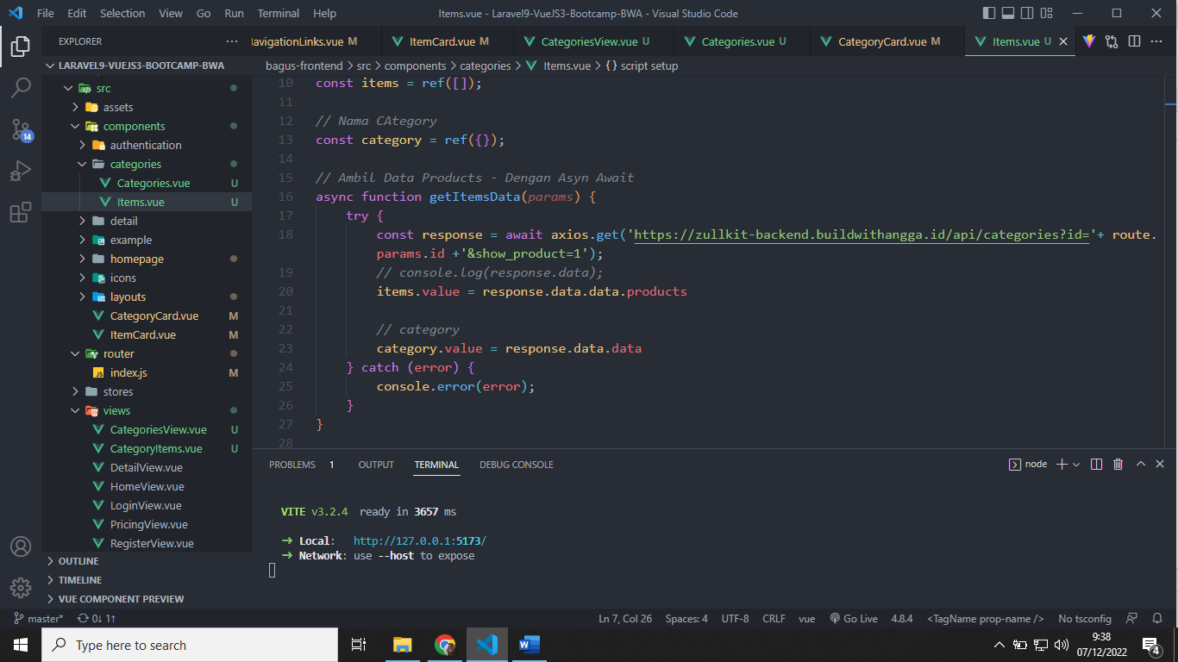

Categories / Item:

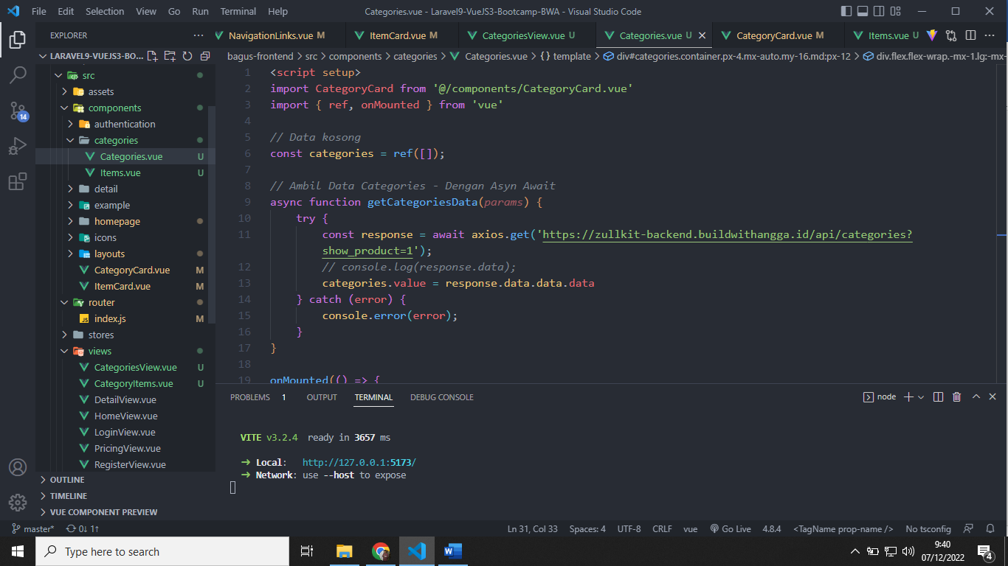

Categories :

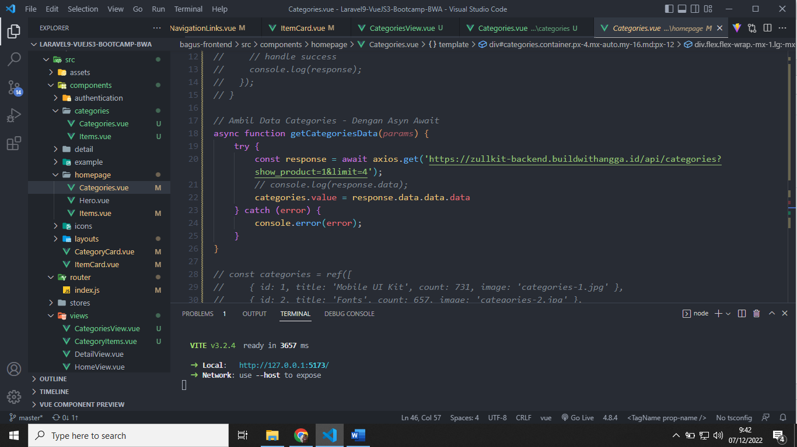

Product :

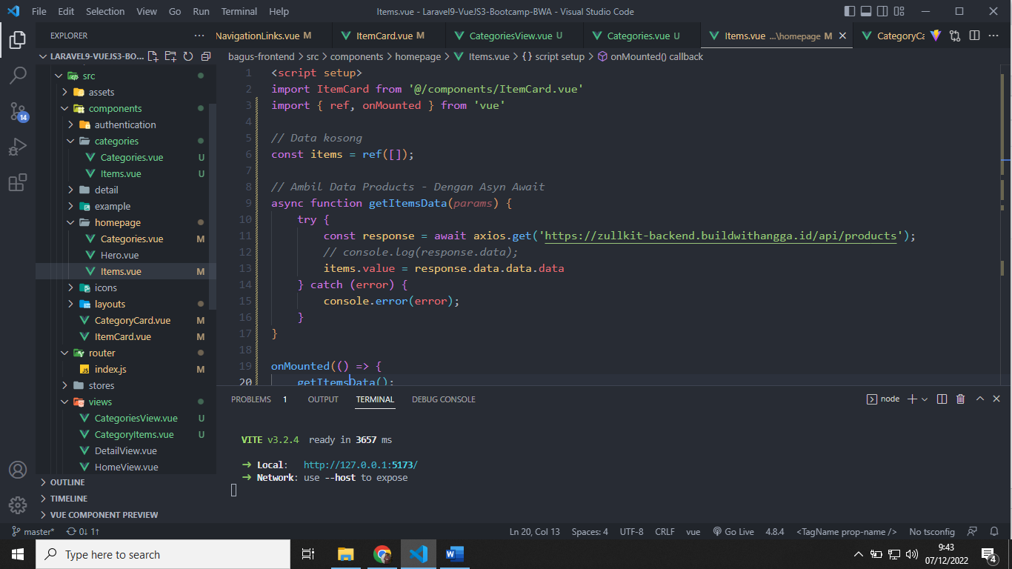

Component

Untuk pembuatan component, diperlukan RouterView

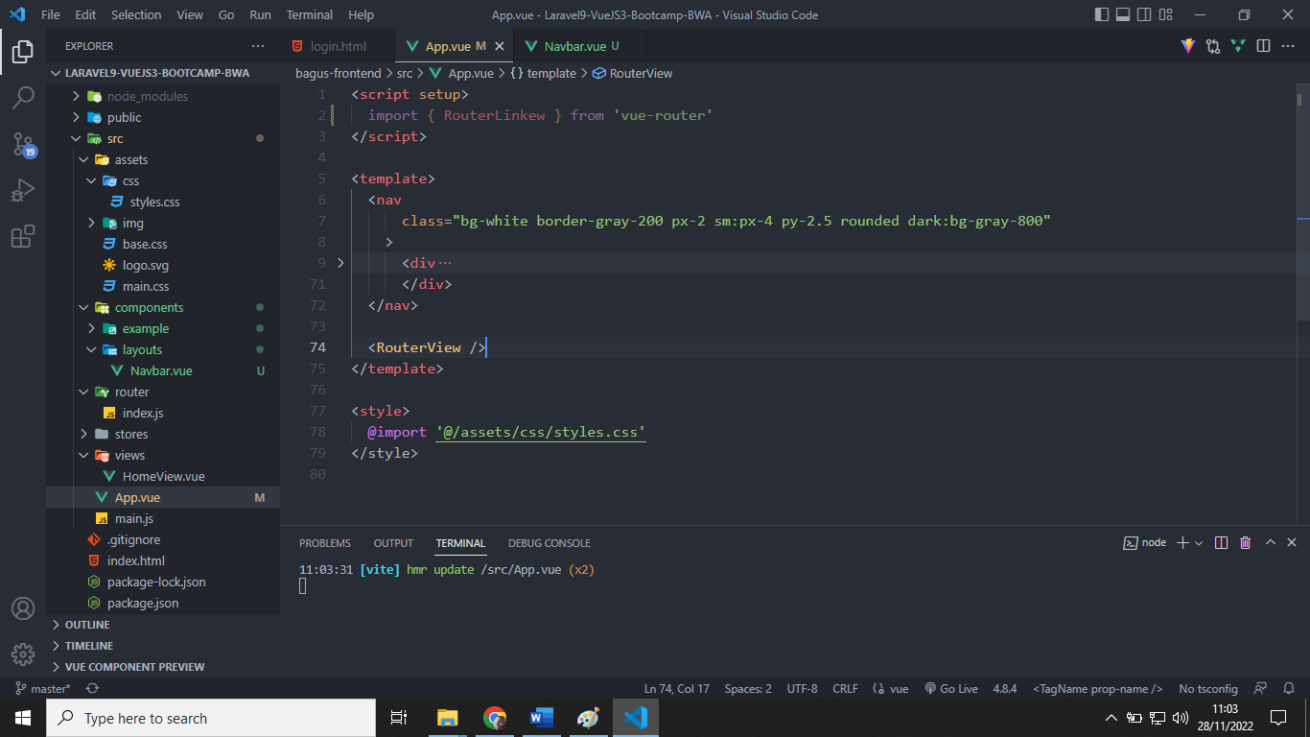

Binding class : Gallery.vue

<div class="overflow-hidden cursor-pointer rounded-2xl" :class="{'ring-2 ring-indigo-500' : defaultImage == gallery.image}">

**State Management :**

**Pinia**