A Recursive Decomposition Algorithm for Resolving Spatial Overlaps in Coordinate-Based Linked Lists as a Smart Windows abstraction.
By Bryan Wilcutt
3/13/2026
Abstract In computational geometry and spatial management, the resolution of overlapping rectangular entities is a fundamental challenge. This paper presents a deterministic algorithm designed to transform a linked list of potentially overlapping rectangular objects into a new linked list containing only non-overlapping constituent parts. The approach utilizes an iterative subtraction and piecewise decomposition method, ensuring that the original spatial coverage is preserved while eliminating redundancy.

Introduction
Managing spatial data using linear structures like linked lists presents unique challenges when objects share the same coordinate space. This paper outlines an algorithm that iterates through an input set to produce a secondary "clean" list where every spatial fragment is unique. This secondary set results in a linked list of coordinates associated with a raster display. Effectively, this algorithm allows “smart refresh” within a windowing environment. This would allow a window to be moved across a display while only updating the moving window in the foreground and newly revealed fragments of background objects.
This paper describes an algorithm reminiscent of the clipping algorithm used in Mac classic [2], Amiga [1], and other systems. This algorithm is missing in modern systems such as Microsoft Windows and Linux windows variants [5]. We developed the algorithm to use in a classic windowing environment for a custom operating system. It’s been nearly 35 years since the advent of AmigaOS, which used “smart refresh” for its windowing environment. This paper outlines a similar algorithm to perform the same action, giving the user a much smoother experience when using a windowing environment. The nexus of this algorithm began with the construction of a custom windowing environment that would run efficiently on any modern hardware platform.
We will first go over the data structures of the source and destination linked lists. From there, we will develop the iterative process to break down a rectangular area into a linked list of discrete objects.

Data Structure Definition
The algorithm assumes a linked list node structure N:
Struct rectNode {
struct clipObject *nextObject;
struct clipObject *previousObject;
uint X1, Y1;
uint X2, Y2;
vFrame *cFrame;
};

Where;
0 ≤ x1 ≤ raster width,
0 ≤ y1 ≤ raster height,
0 ≤ x2 ≤ raster width,
0 ≤ y2 ≤ raster height.

Methodology: Iterative Piecewise Decomposition
This algorithm heavily relies on comparing each incoming rectangle against a growing set of already processed, non-overlapping rectangles.
When an incoming rectangle (R^{n}) overlaps with an existing rectangle (R^{e}), R^{n} is subdivided into smaller sub-rectangles that lie strictly outside the boundaries of R^{e}. This is a specialized notation of the Sutherland-Hodgman algorithm [6].
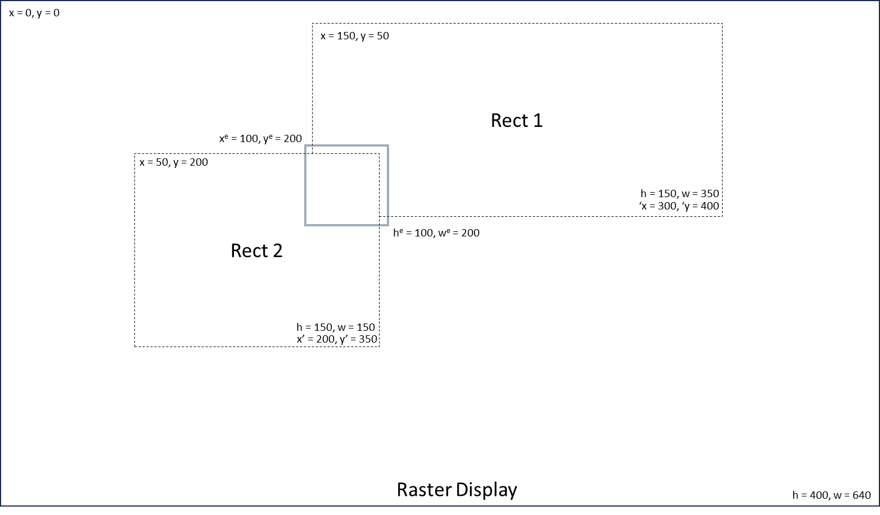
- Top Fragment: R^{n}.y < R^{e}.y.
- Bottom Fragment: (R^{n}.y + R^{n}.h) > (R^{e}.y + R^{e}.h).
- Left Fragment: R^{n}.x < R^{e}.x. Height is clipped to the vertical span of R^{e}.
- Right Fragment: (R^{n}.x + R^{n}.w) > (R^{e}.x + R^{e}.w). Height is clipped to the vertical span of R^{e}.
The resulting algorithm proceeds to isolate each rectangular area, producing two Rect objects for the final linked list.
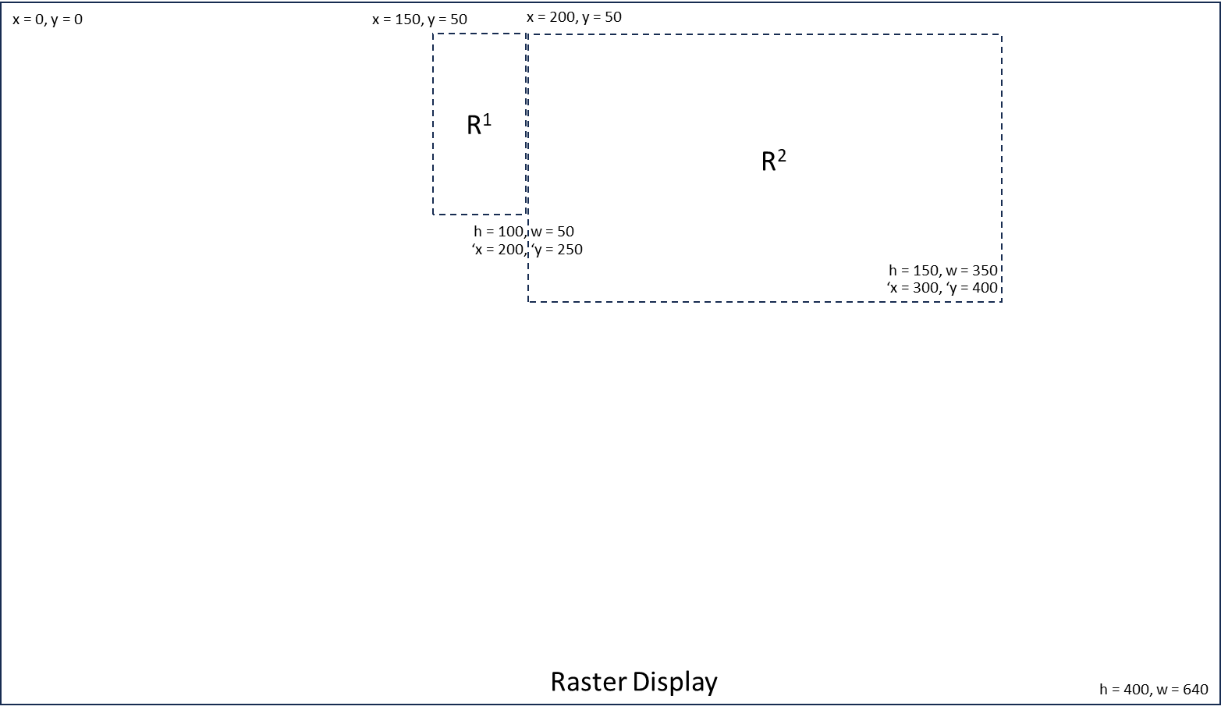

Mathematical Representation of Splitting
For a new rectangle R^{n} being subtracted by an existing rectangle R^{e}, the surviving area of R^{n} is defined by the set of fragments F:
- F^{top} : { x^{n}, y^{n}, w^{n}, y^{e} - y^{n} }
- F^{bottom} : { x^{n}, y^{e} + h^{e}, w^{n}, (y^{n} + h^{n}) - (y^{e} + h^{e}) }
- F^{left} : { x^{n}, max(y^{n}, y^{e}), x^{e} - x^{n}, min(y^{n} + h^{n}, y^{e} + h^{e}) - max(y^{n}, y^{e}) }
- F^{right} : { x^{e} + w^{e}, max(y^{n}, y^{e}), (x^{n} + w^{n}) - (x^{e} + w^{e}), min(y^{n} + h^{n}, y^{e} + h^{e}) - max(y^{n}, y^{e}) }

Implementation Routine
The process follows a nested traversal. Each candidate from the source list is checked against the entirety of the growing ResultSet. If an overlap is detected, the candidate is split, and the fragments are re-queued to be checked against the list again.
RectNode* ResolveList(RectNode* SourceList)
{
RectNode* ResultSet = NULL;
RectNode* Current = SourceList;

while (Current != NULL) {
RectNode* WorkQueue = CopyNode(Current);

while (WorkQueue != NULL) {
RectNode* Cand = Pop(&WorkQueue);
int wasSplit = 0;

for (RectNode* Fixed = ResultSet; Fixed != NULL; Fixed = Fixed->next) {
if (CheckOverlap(Cand, Fixed)) {
RectNode* Frags = SplitRectangle(Cand, Fixed);
WorkQueue = AppendLists(Frags, WorkQueue);
free(Cand);
wasSplit = 1;
break;
}
}

if (!wasSplit) {
Cand->next = ResultSet;
ResultSet = Cand;
}
}
Current = Current->next;
}
return ResultSet;
}

Discussion and Conclusion
The recursive decomposition algorithm presented provides a deterministic solution for resolving spatial overlaps within a coordinate-based linked list [4]. By transforming complex overlapping polygons into a set of discrete, mutually exclusive rectangular fragments [7], we ensure that every unit of spatial area is represented exactly once.

Performance Analysis and Complexity
In our earlier implementations of developing a raster clipping algorithm, performance became the factor in determining whether our algorithm(s) were capable of running on most available hardware systems. Here, we have noted complexity and fragmentation as possible areas of improvement—both being going issues. The algorithm’s primary trade-off is between geometric precision and computational overhead. The algorithm spends considerable time splitting rectangles [3] to build the final output linked list. This list is then used to identify areas to redraw on the display.

Optimization Strategies
Several improvements were considered:
Bounding Box Pre-filtering: An Axis-Aligned Bounding Box (AABB) check can bypass pairs that do not intersect.
Spatial Partitioning: Integrating a Quadtree or R-Tree structure would allow the algorithm to only compare new rectangles against existing fragments in their immediate vicinity, potentially reducing complexity toward O(N log N).
Fragment Merging: A post-processing pass could identify adjacent fragments with the same original ID and matching dimensions, merging them back into larger rectangles to reduce the final node count.

Optimized Clipping via Persistent Clip Regions
The Recursive Decomposition algorithm was implemented in C++ for WCPP, a small graphical system for embedded applications.
In standard graphical systems, clipping calculations are often performed during the rendering cycle which may lead to redundant traversals. Here, we outline the proposed Clip Region approach that optimizes performance by maintaining a persistent list of clip coordinates. By shifting the computational overhead from the render-time phase to the state-change phase, we achieve faster frame updates in complex windowing environments.

The system utilizes a dual-linked-list structure maintained by a "Master" window.

The FrameList and ClipList
The Master window manages a collection of graphical objects (frames) which are defined as:
clipObject: A standard linked list containing the graphical objects.
ClipList: A parallel list where each entry is a clipObject corresponding to a frame in the FrameList.
The clipObject is a data structure designed to store the immediate state of its parent frame. Each clipObject contains spatial data as well as pointers to other clipObjects.
To ensure the ClipList remains accurate, data members are updated immediately upon any state change in the UI.

Transformation (Moving and Resizing)
Transformations are computationally inexpensive. When a frame is moved or resized, the corresponding clipObject internal data members are updated in constant time which ensures that the clipping boundaries are always "render-ready."

Object Removal
Removing an object requires the clipObject to be unlinked from the middle of the ClipList. By utilizing a doubly linked list (maintaining both previous and next pointers), the system can bridge the gap left by the removed object without a full list traversal.

Z-Order Management (Redepthing)
"Redepthing" occurs when a frame's stack order changes relative to its peers. Because the ClipList represents the visual hierarchy, the clipObject must be repositioned within the list. This is handled by updating the pointer references of the object and its new neighbors, ensuring the clipping order reflects the new visual depth.
By maintaining a persistent, always-current clipList, the system eliminates the need to recalculate spatial boundaries during the high-pressure rendering loop. This approach is particularly effective in environments with frequent object movement but relatively stable depth-stacking.

The Frame Structure
The heart of the clipping algorithm is the definition of a frame. Frames make up windows, title bars, icons, even single characters in a font. Our frames are declared as:
vFrame::vFrame()
{
state = S_NONE;

Depth = 0;

nextFrame = NULL;
previousFrame = NULL;
frameList = NULL;
clipList = NULL;
frameView = NULL;

UserID = 0;
priority = 0;
Owner = NULL;
absolute_x = 0;
absolute_y = 0;

original_x = 0;
original_y = 0;
original_height = 0;
original_width = 0;

border = NULL;
fF = sys_get_frameFlags();

// Initialize clip for this frame.

rectNode.X1 = 0;
rectNode.Y1 = 0;
rectNode.X2 = 0;
rectNode.Y2 = 0;
rectNode.cFrame = this;
rectNode.nextObject = NULL;
rectNode.previousObject = NULL;
}

Among other data, vFrames contains the object’s spatial information, specifically in the frameClip sub-structure. This substruction becomes our “clip”. As each frame contains this spatial data, we can layer frames and perform our clipping algorithm as necessary.
As you can see, the rectNode structure becomes the heart of the clipping algorithm.
You can view more on the WCPP windowing system on GitHub under bwilcutt@yahoo.com.

Final Summary
The implementation of this recursive decomposition algorithm performs basic computational operations, leaving the final use of the resulting linked list an implementation detail for the specific OS. By treating windowing as a series of discrete spatial rects rather than a stack of opaque buffers, we significantly reduce the overhead required for real-time display updates. This algorithm proves that "smart" windowing is achievable without the heavy hardware requirements of modern excessive computational operations. As this project evolves, the integration of a "merging pass" will further refine this abstraction, ensuring that our custom environment remains lean enough for a next-generation hobbyist and for specialized hardware.

References
[1] Amiga Corporation, Amiga Intuition Reference Manual. Reading, MA, USA: Addison-Wesley, 1985.
[2] Apple Computer, Inc., Inside Macintosh: Volume I. Reading, MA, USA: Addison-Wesley, 1985.
[3] J. L. Bentley and D. Wood, "An optimal worst-case algorithm for reporting intersections of rectangles," IEEE Trans. Comput., vol. C-29, no. 7, pp. 571–577, Jul. 1980.
[4] W. Lipski, E. Lodi, F. Luccio, C. Mugnai, and L. Pagli, "On two-dimensional data organization II," Fundam. Inform., vol. 2, pp. 245–260, 1979.
[5] R. W. Scheifler and J. Gettys, "The X Window System," ACM Trans. Graph., vol. 5, no. 2, pp. 79–109, Apr. 1986.
[6] I. E. Sutherland and G. W. Hodgman, "Reentrant polygon clipping," Commun. ACM, vol. 17, no. 1, pp. 32–42, Jan. 1974.
[7] K. Weiler and P. Atherton, "Hidden surface removal using polygon area subdivision," ACM SIGGRAPH Comput. Graph., vol. 11, no. 2, pp. 214–222, Jul. 1977.

