CHANGE CONTROL pOLICY
[DCN ]

Table of Contents
1 History matrix 2
2 Acronyms & definitions 2
3 Introduction 2
4 Approach 2
5 Roles and Responsibilities 2
6 Change Control Process 3
6.1 Emergency Changes 5
6.2 Change Control Process Description 5
6.3 Software Project Change Request Tracking 6
6.3.1 Implementation 6
6.3.2 Deployment of Internally Developed Software: 6
6.3.3 Completion 6
6.4 Firewall Change Request Tracking 6
6.4.1 Implementation 6
6.4.2 Firewall Governance 7
6.5 Computer Change Request Tracking 7
7 Change Request Reporting 7

{ Written by Bryan Wilcutt, PMP, publicly available to all }

History matrix
Date/Version | Author | Change Description

Acronyms & definitions
SCR | System Change Request
CRC | Change Request Coordinator
TFM | TerraForm Manager
CCB | Change Control Board
CRF | Change Request Form

Introduction
This document outlines the necessary procedures and processes to record, approve and archive changes within the {Company Name} Infrastructure or System domains. Included are samples of the various System Change Request (SCR) forms, chain-of-authority and processing instructions.

Approach
Given the large-scale system and DevOps environment operated by {Company Name}, coupled with liability, a change control process has been put into place to control risk. This process helps eliminate individuals from making unnecessary or unapproved changes to the system, with some of these changes possibly being catastrophic in nature.
The change request process includes the common questions of W5H: Who, What, Where, When, Why and How. Also included in the change request is the Known Risks and Remedies. The change request forms will record this information and be processed through a chain of authority for approval.

Roles and Responsibilities
The following table outlines the individuals responsible for specific actions of the change process. Actions required by each authorizing position is outlined in Table 1: Roles and Responsibilities.

Table 1: Roles and Responsibilities
Name | Role | Responsibility
Principal | Project Sponsor | - Final approving authority for the Change Control Management Plan, by consensus if there are multiple Sponsors.  - Determines the need for and composition of a Steering Committee.  - Makes decisions on SCRs escalated by the Change Control Board (CCB).
Team Members | Change Control Board (CCB) | - Primary decision-making body for SCRs.  - Meets on a regular basis to address outstanding SCRs and escalates to Project Sponsor(s) and/or Executive Steering Committees, as necessary.  - Act on SCR decisions by Project Sponsor(s) and/or the Executive Steering Committee.
 | Project Manager | - Creates or delegates the creation of the Change Control Management Plan.  - An active sponsor of approved changes.  - Manages the CCP and any resistance to approved changes.  - Approves SCRs for analysis.  - Assigns the SCR analysis to a Change Owner.  - Reviews the scope, budget and schedule impacts.  - Assigns project resources for SCR analysis and, if approved, implementation.  - Reviews the SCR implementation after it is deployed.  - Communicate SCR status/decision back to Stakeholders.  - Votes as a member of the CCB. (May or may not be the CCB chairperson, depending on project size and complexity.)  - Initiates the escalation process to the Executive Steering Committee, as needed.
Employee | Change Request Owner | - Identifies the potential change.  - Identifies possible solutions and their impact to the project and its Stakeholders.  - Takes ownership and works with the project team to analyze, evaluate, and, if approved, implement SCRs.  - Completes the SCR Form (CRF).  - Prepare supporting documentation for the SCR.  - Obtains manager approval to submit the CRF to the SCR Coordinator (CRC).  - Submits CRF to the CRC.  - Verifies SCRs are implemented correctly.
 | Change Request Originator’s Manager | - Reviews and approves the CRF created by the SCR Originator.
 | Change Request Coordinator (CRC) | - Single point of contact for SCRs.  - Receives and records SCRs in the chosen tracking tool.  - Schedules and transcribes the CCB meetings.  - Maintains the SCR tracking tool, monitors SCR progress and reports status regularly.  - Produces metrics on SCRs.  - Measures the overall quality of the CCP to report trends and make recommendations for process improvement.  - Maintain project SCR documentation in project library.

Change Control Process
Identifying what kinds of changes require this process is important. Some changes may not require a CCP treatment, such as daily work activities, changes with the test system, etc. Other changes, however, must be pushed through this process to make everyone aware of the change and its impact. Notably, any change to systems that are customer facing or impact business operations must be processed appropriately.

The following actions may cause a change request:

- Changes to TFM installed software - System
- Changes to any TFM hardware configuration (remote or local) including adding, removing or reconfiguring existing hardware - System
- Changes to {COMPANY NAME} management software or hardware - Infrastructure

The requesting party must identify and complete the correct SCR form. In most cases, the process followings the diagram below.

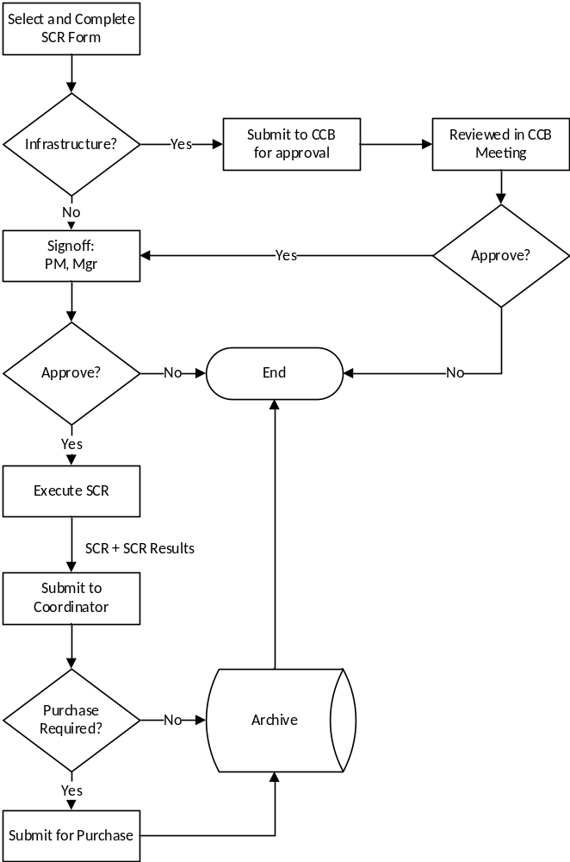
Figure 1: Change Request Process

Emergency Changes
Some change requests may need to follow an expedited control path to address emergencies. Following the standard change request process may not allow personnel to react to severe situations in a timely manner. These types of situations may include, but are not limited to:

- Where life and well-being is concerned,
- Where customer loss of information or usage is imminent,
- Where the standard control path for a change request may cause loss, misuse or non-use of resources.

When emergencies are addressed, a change control form should be completed to indicate what was changed. The “Expedited” box of the form should be selected, telling the reader that the change did not follow the standard change control process. The CCB should be informed of all expedited changes and their results.

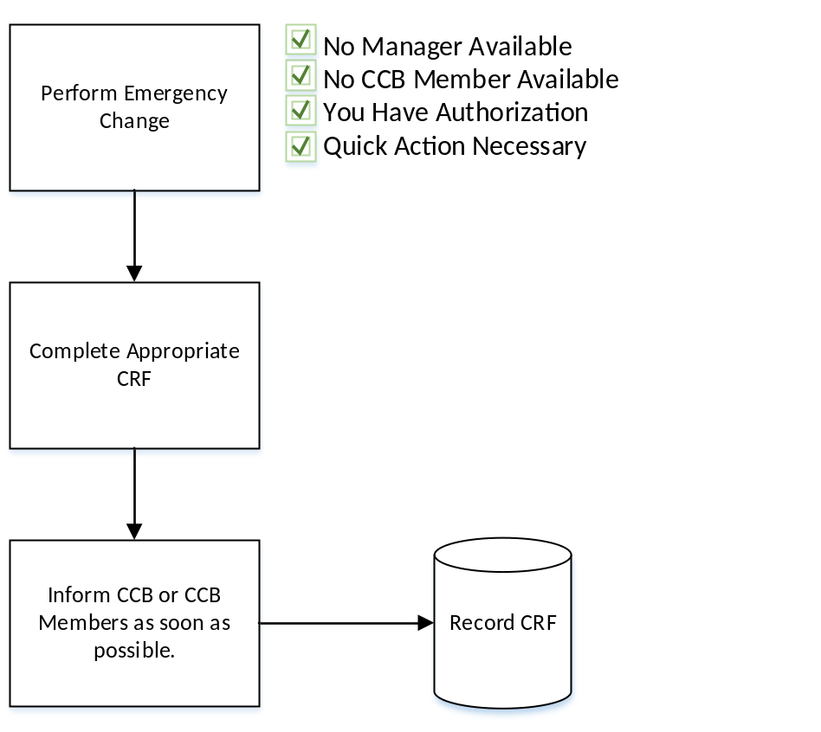
Figure 2: Quick Action Steps

Change Control Process Description
When a change needs to be made or hardware/software needs to be deployed, the person proposing the change should obtain a SCR form, obtain a SCR number from the CRC, and record the SCR number in the appropriate control log and on the form.

Each field in the Submit area of the form must be completed in detail including the proposed change date, a description of what needs to be changed, why it needs to be changed, the risks of making/not making the change, the systems affected, a description or documentation of any testing that was done, and a rollback plan should any unforeseen errors or obstacles be encountered. Additional documents should be attached if needed.
After completing the form and attaching all documentation, review and approval by all members of the appropriate team should be obtained. The approval responsibility should not be taken lightly. Each team member must review the proposal, test results and implementation plan. Once satisfied to the point of taking individual personal responsibility, each team member should sign the form indicating their agreement. If any team member feels that they cannot satisfy themselves that the proposed change can be implemented successfully, then the entire team should meet to resolve the concern, make appropriate changes to the testing or implementation plan, and continue to meet until all concerns are resolved and all team members are satisfied.

The person proposing the change should then sign the final SCR form and seek approval and signature from the impacting stakeholders as well as their manager.

Software Project Change Request Tracking

Implementation
After all approvals are complete, the implementation/deployment process can begin by following each step of the plan based on the prescribed schedule. The implementation process will vary depending on the type of change being implemented. If issues are encountered, the changes may need to be backed out, the issues encountered documented, and the whole process will need to be started over again beginning with the completion of a new SCR form.

Deployment of Internally Developed Software:
When internally developed software is being deployed, the person implementing the change should:

- Notify the entire team of the deployment schedule.
- Make a backup of the original application files being replaced.
- Perform the installation steps documenting any deviations from the original plan.
- Test the installed application to make sure there are no issues. (If issues are encountered, discuss backing out the changes with the team and management).
- Notify the entire team of the results.
- Log the SCR into the Confluence log at: {web page}
- Save an electronic copy of the SCR material (including changes made during the deployment) on the network at: P:\TerraFormManager\SystemChangeRequest\Installs

Completion
After the changes are complete and successfully tested, the hard copy of the SCR and all supporting documentation should be submitted to the CRC for retention.

Firewall Change Request Tracking

Implementation

Firewall changes are managed through this Change Control Policy. All changes require a review by IT as well as the Change Control Board. General change practices include the following:

Step | Process
1 | Change requests begin with a Firewall Change Request form.
2 | Change requests are identified by a unique Systems Change Request (SCR) number.
3 | Change requests are assessed by IT for:  - Risk assessment impact  - Time and Cost  - Need
4 | Upon approval of the IT department, the change request is then review by the CCB for:  - Business need  - Review of IT’s risk assessment
5 | If the requests survives the IT and CCB approval process, IT may proceed with making the necessary change.
6 | Upon implementation, the IT team shall:  - Create a technical definition of the issue and design for the firewall change.  - Analyze and create proposed solution for the Firewall Rules.  - Backup firewall rules before any actual changes are made.
7 | The IT shall test and validate the firewall rules within an isolated environment where possible.
8 | Document the change in the System Design document.
9 | Build the final Firewall changes required.
10 | Deploy the Firewall changes during a “quiet time” on the network (nights, weekends, etc.)
11 | Review and monitor firewall changes, backing them out immediately if issues occur.
12 | Review results with the CCB.

Firewall Governance
In general, changes to any Firewall within the control of {COMPANY NAME} should be proposed, reviewed and tracked. All firewall rules should be readily available for review by either management, the IT team or authorized outside personnel. Specific rules for governance include:

- Restrict modification to the firewall rules, objects and services to one SA at a time.
- Strict adherence to procedure will prevent multiple simultaneous modifications to a Firewall rule base if not available as part of the FW software.
- Archiving of previous rule sets when rules do change.
- List the changes made with each revision, refer to the associated SCR numbers.
- Store multiple versions of Firewall configuration data for safe keeping.
- Report all revisions to the CCB.
- Roll back changes to a prior state when issues occur related to Firewall changes.

Computer Change Request Tracking
Add, removing software to a local PC requires a change control action. The organization does not leave licensing decisions to individual employees and, as such, requires a change request and involvement of IT. Having unauthorized software on a machine is strictly prohibited. Similarly, repurposing and reimaging a machine also requires as change request action.

Change Request Reporting
{Company Name} SCR process shall also include a monthly metric to following the progress of approved SCRs, rejected SCRs and any specific issues preventing an SCR from completing. This shall be the responsibility of the SCR Coordinator. The following table outlines the reporting process.

Table 2: Report Frequency
Title | Frequency | Content | Usage
Opened, Pending, and Approved SCRs | Regularly Scheduled CCB Team Meeting (Weekly) | Summary of the SCRs that have been opened, still pending and approved since the last reporting. | Keeps the project team and Stakeholders informed about the changes being made.
SCR Implementation Status | As Completed | Lists all SCRs approved for implementation, activities to implement, estimated completion date, and current status. | Used by management, the CRC, and SCR Owners to track SCR implementation.
Metrics Report | Monthly | Identifies the total number of SCRs opened, approved and pending. Include aging statistics that show how long it takes to approve a SCR, the duration at each phase of the process, the number of SCRs referred to CCB and the number of rejected SCRs. | Include as part of quality reporting.

Internal System Change Request
Submit | SCR No. | Rev/Milestone# | Title |  | Deploy Date |  | Scheduled  Non-scheduled  Expedited
Submit | Submitted By | Submit Date | Submit Email |  | Jira # |  | Risk/Impact Scale  Minimal - 1  Minor - 2  Major - 3  High - 4
Submit | Description of requested change ( details attached) |  |  |  | Items Affected  Code  Server  Database  Stored procedures  Functions  Triggers  Tables  Other (Explain)
Submit | Reason or basis for request ( details attached) |  |  |  | Testing (Post Install)  GUI Services Database  Other ______________________  Approved:_______________________  Rejected (Attach comments)  Defects Discovered  Rollback  Deploy Fix Date:  Approved By: _______  Non-critical/Fix in future sprint
Submit | Signatures of Team:
Submit | Impact/Rating ( details attached)
Submit | Risks/Rating ( details attached)
Submit | Estimated Cost ( details attached)–hours per person or $ |  |  | Estimated Duration ( details attached)
Submit | Rollback Plan (describe or attach) |  |  | Test Plan (describe or attach)
Approval | Approved by  Lead Developer: ____________________________________________________  Network Administrator: ______________________________________________  Database Administrator: _____________________________________________  Systems Engineer Supervisor: _________________________________________  President: ____________________________________________________ |  |  |  |  | Approved Date  As per E-mail  As per E-mail  As per E-mail  As per E-mail  As per E-mail
Approval | Comments ( details attached)
Figure 3: Internal SCR Form

Internal Infrastructure System Change Request
Submit | SCR No. | Owner | Title |  | Deploy Date |  | Scheduled  Non-scheduled  Expedited
Submit | Submitted By | Submit Date | Submit Email |  | Ticket # |  | Risk/Impact Scale  Minimal - 1  Minor - 2  Major - 3  High - 4
Submit | Description of requested change ( details attached) |  |  |  | Items Affected  Documentation  Network Device  Server  VM  OS/SW  ______________________________  ______________________________  ______________________________  ______________________________  ______________________________  Other (Explain)
Submit | Reason or basis for request ( details attached) |  |  |  | Testing (Post Install)  Approved:_______________________  Rejected (Attach comments)  Defects Discovered  Rollback  Deploy Fix Date:  Approved By:  Non-critical/Fix in future sprint
Submit | Signatures of Team:
Submit | Impact/Rating ( details attached)
Submit | Risks/Rating ( details attached)
Submit | Estimated Cost ( details attached)–hours per person or $  Install: |  |  | Estimated Duration ( details attached)
Submit | Rollback Plan (describe or attach) |  |  | Test Plan (describe or attach)
Approval | Approved by  Submitted By:  Network Administrator:  Database Administrator:  Systems Engineer Supervisor:  President: |  |  |  |  | Approved Date  As per E-mail  As per E-mail  As per E-mail  As per E-mail  As per E-mail
Approval | Comments ( details attached)
Figure 4: Infrastructure CRF

Computer Setup Request
Submit | SCR No. | Assignee’s Name |  |  | Complete By Date | Scheduled  Non-scheduled  Expedited
Submit | Submitted By | Submit Date | Submit Email |  | Installed By  (IT Resource Name) | Risk/Impact Scale  Minimal - 1  Minor - 2  Major - 3  High - 4
Submit | WARNING!  All licensed software installations must be under the control of {COMPANY NAME} and {COMPANY NAME} Employees. Lent computers require a return date. |  |  | Domicile:  On-Campus Only Off-Campus Customer Use
Submit | Computer Profile  {COMPANY NAME} Tag #: _____________________  Manufacturer: ___________________________________  Laptop Yes No |  |  | Image  Developer Office QA IT Do Not Reimage
Submit | Ram Addition  RAM +1G +2 +4 Other(_____) |  |  | Reason
Submit | Storage Addition  Storage SDD Spinner  256G 512G 1Tb Other(_____) |  |  | Reason
Submit | Requested Software Installation  App ___________________, License #: ________________________________  (IT Only)  App ___________________, License #: ________________________________  (IT Only)  App ___________________, License #: ________________________________  (IT Only)  App ___________________, License #: ________________________________  (IT Only)  App ___________________, License #: ________________________________  (IT Only) |  |  |  | WARNING!  Installation of software packages are subject to license availability. Unauthorized installation of software, licensed or public domain, is subject to disciplinary action including termination.
Submit | Reason or basis for request ( details attached) |  |  |  | Surrender:  Date (______________)  After (______________)  Indefinite
Submit | Signatures of Team:
Approval | Approved by:  Lead Developer: _________________  Network Administrator: _________________  Database Administrator: _________________  Systems Engineer Supervisor: _________________  President: _________________ |  |  | Approved Date:  As per E-mail  As per E-mail  As per E-mail  As per E-mail  As per E-mail
Figure 5: Computer Setup Request Form

VM Request Form
Submit | SCR No. | Title |  |  |  | Deploy By Date | Scheduled  Non-scheduled  Expedited
Submit | Submitted By | Submit Date | Submit Email |  |  | Installed By  (IT Resource Name) | Risk/Impact Scale  Minimal - 1  Minor - 2  Major - 3  High - 4
Submit | Standard Machine Types:  Development (2 CPUs, 2G Ram, 50G Storage)  Database (2 CPUs, 4G Ram, 100G Storage)  Test (1 CPU, 2G Ram, 20G Storage)  Test w/Database (4 CPUs, 4G Ram, 100G Storage) |  |  |  | Other:  Backup Yes No  IP Static (_______________________) Dynamic
Submit | CPU Exception  CPU 2 4 6 Other (_____) |  |  |  | Reason
Submit | RAM Exception  RAM 4G 5G 6G Other(_____) |  |  |  | Reason
Submit | Storage Exception  Storage 30G 40G 50G Other(_____) |  |  |  | Reason
Submit | Requested Software Installation  Windows  SQL/MySQL  Ubuntu  Windows Dev Tools Package  Ubuntu Dev Tools Package |  |  | App (___________________)  App (___________________)  App (___________________)  App (___________________)  App (___________________) |  | WARNING!  Installation of software packages are subject to license availability. Unauthorized installation of software, licensed or public domain, is subject to disciplinary action including termination.
Submit | Reason or basis for request ( details attached) |  |  |  |  | VM Tear-Down:  Date (______________)  After (______________)  Indefinite
Submit | Signatures of Team:
Submit | Risks/Rating ( details attached)
Approval | Approved by:  Lead Developer: _________________  Network Administrator: _________________  Database Administrator: _________________  Systems Engineer Supervisor: _________________  President: _________________ |  |  |  | Approved Date:  As per E-mail  As per E-mail  As per E-mail  As per E-mail  As per E-mail
Approval | Comments ( details attached)
Figure 6: VM Request Form

Firewall Change Request Form
Submit | SCR No. | Description |  |  | Deploy By Date | Scheduled  Non-scheduled  Expedited
Submit | Requesters Name | Submit Date | Requesters Email |  | Changed By  (IT Resource Name) | Risk/Impact Scale  Minimal - 1  Minor - 2  Major - 3  High - 4
Submit | Request Type:  New Request Modify Existing Request Replace Existing Request Remove Existing Request  Other (explain):
Submit | Reason:
Submit | Host / Network: |  |  | Firewall(s):  Perimeter Data Center Other (explain):
Submit | Proposed Firewall Changes:  All network traffic for the host/network listed above is blocked by default.
  Source Address(es) | Destination Address(es) | Port(s) | Action (Block, Permit, etc.)
Submit | Comments: |  |  |  | VM Tear-Down:  Date (______________)  After (______________)  Indefinite
Submit | Signatures of Team:
Submit | Risks/Rating ( details attached)
Approval | Approved by:  Lead Developer: _________________  Network Administrator: _________________  Database Administrator: _________________  Systems Engineer Supervisor: _________________  President: _________________ |  |  | Approved Date:  As per E-mail  As per E-mail  As per E-mail  As per E-mail  As per E-mail
Approval | Comments ( details attached)
Figure 7: Firewall Change Request Form

