Human-Centred Systems Design Group Project

Team 42

Daniel Bacon, Owen Lyons, Joe Slade, Ben Wimsett

# Introduction

The team had several meetings to allocate work, discuss progress and assist each other in areas they found difficult. During the first meeting a GitHub repository was created to store and track out progress, and a Slack workspace with channels for each of the work areas was setup for any relevant communications. After that the team attempted to meet regularly, with frequency increasing as the deadline grew nearer and between meetings communication was maintained using Slack.

# Use Case Diagram

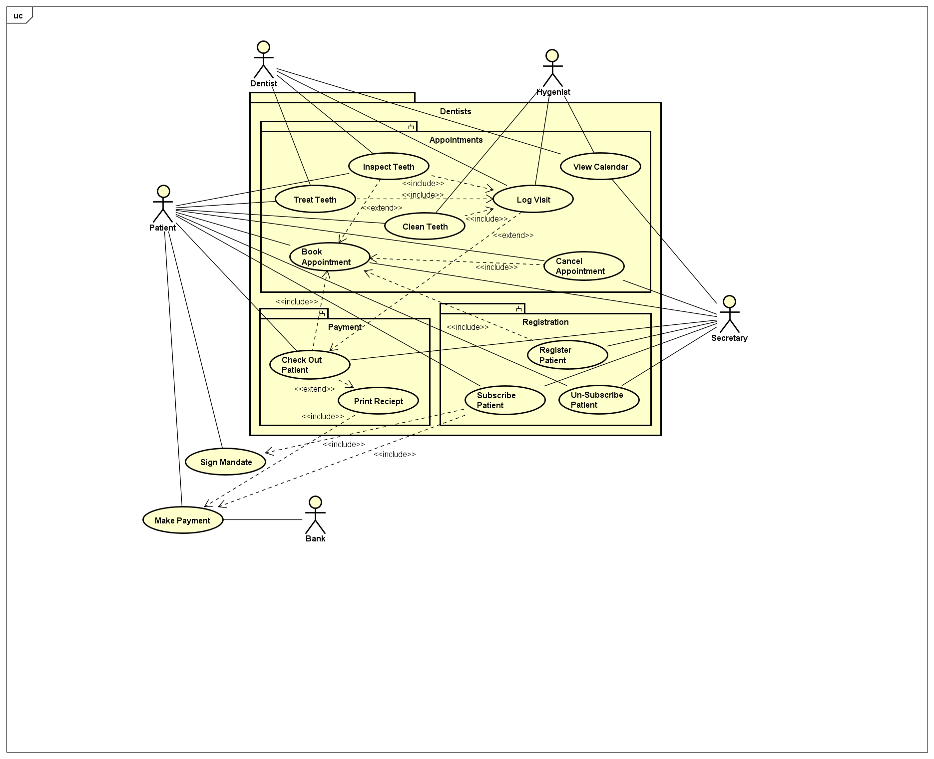

# Information Model

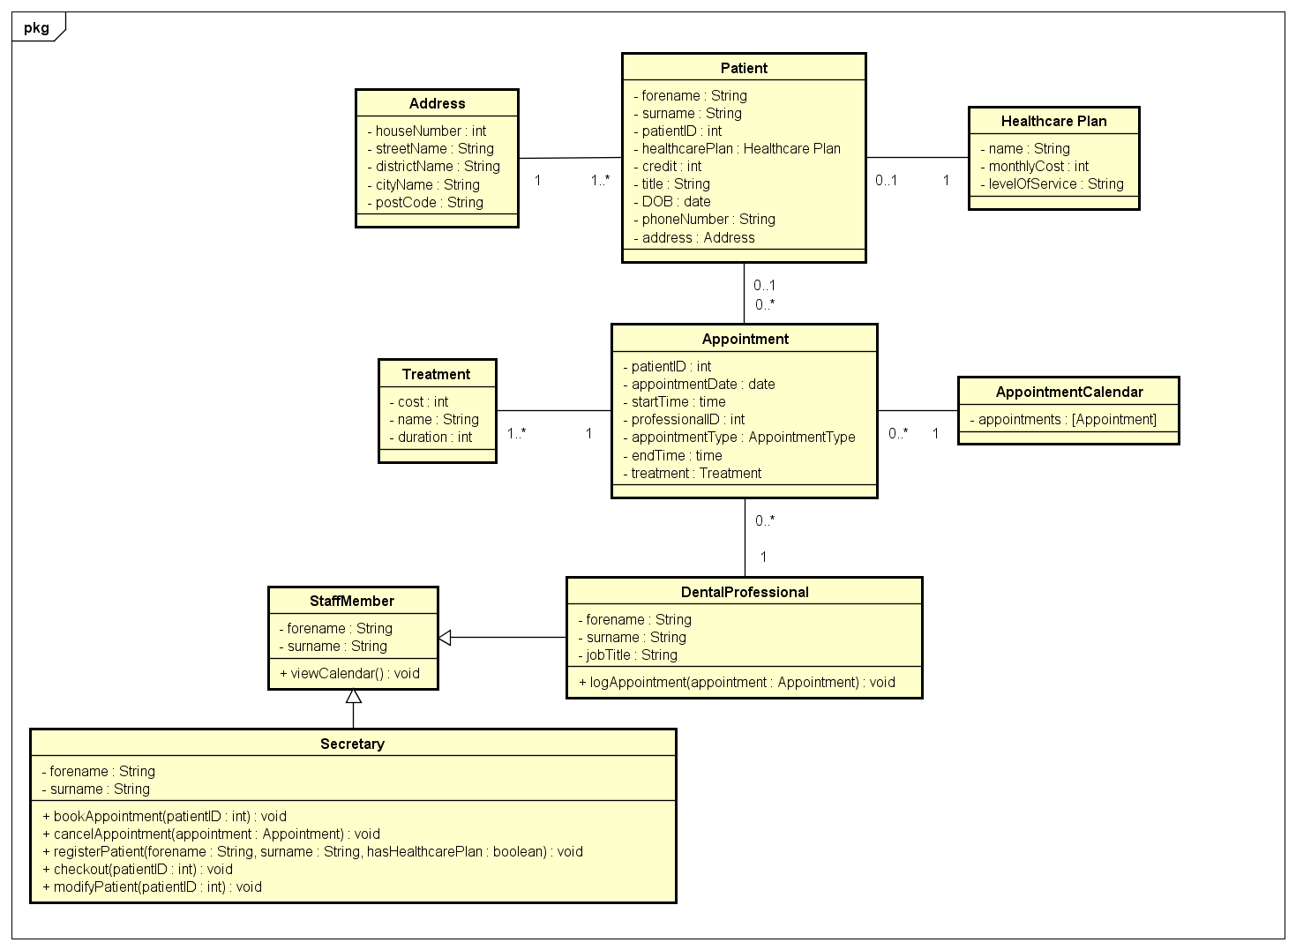

# Data Model

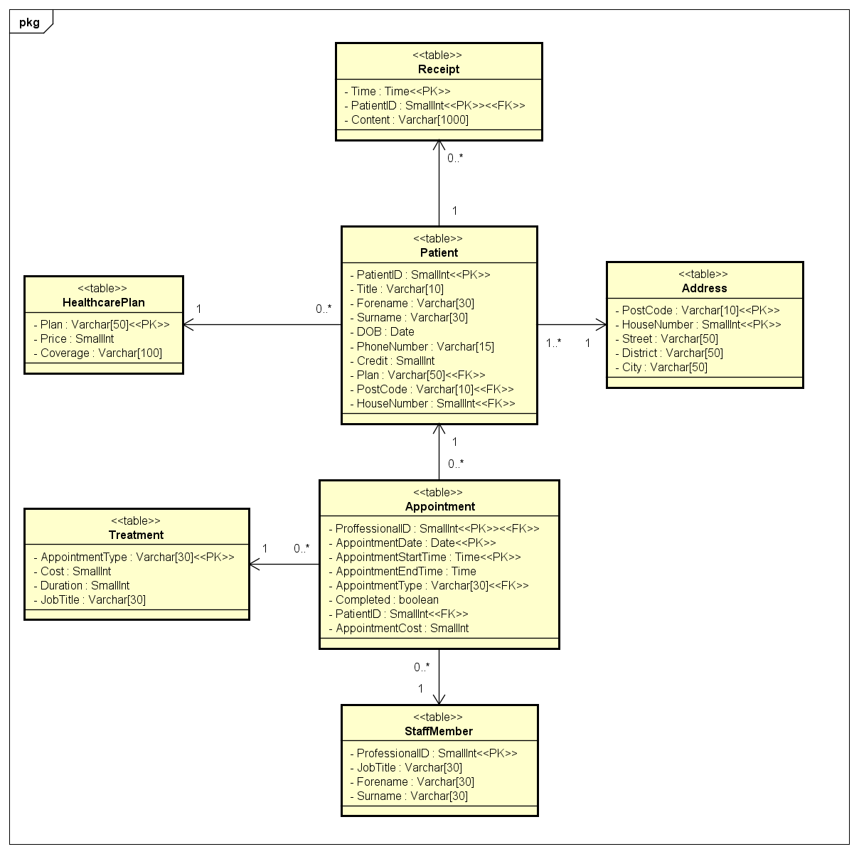

# Secretary UI Screenshots

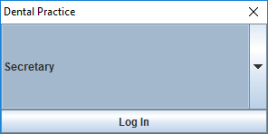 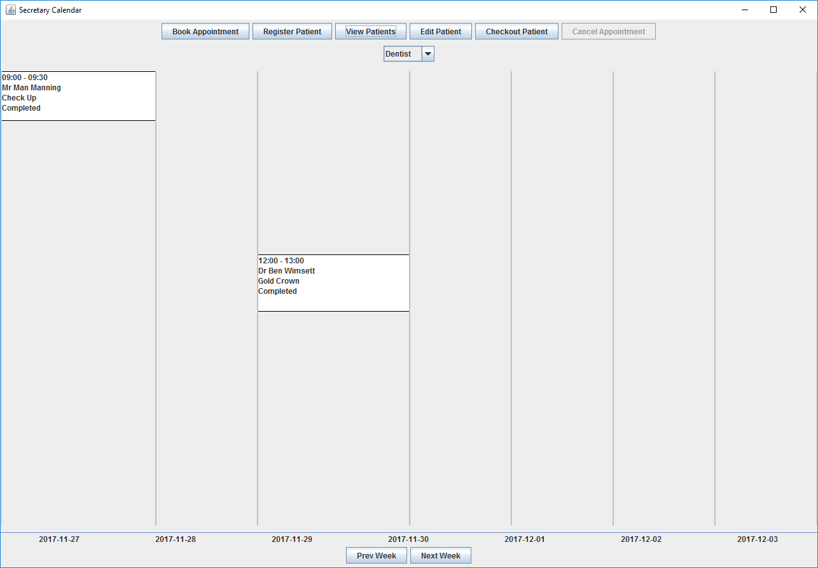 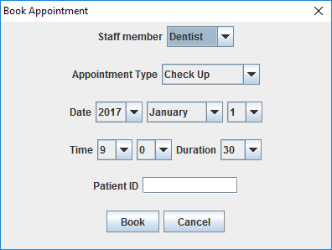 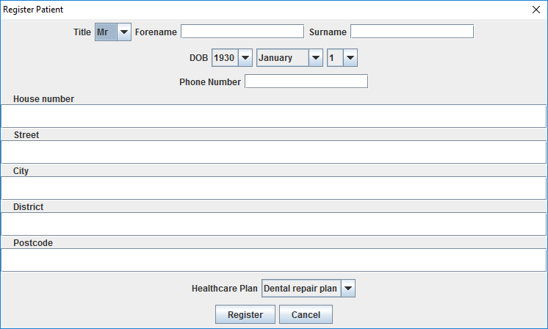

# Partner UI Screenshots

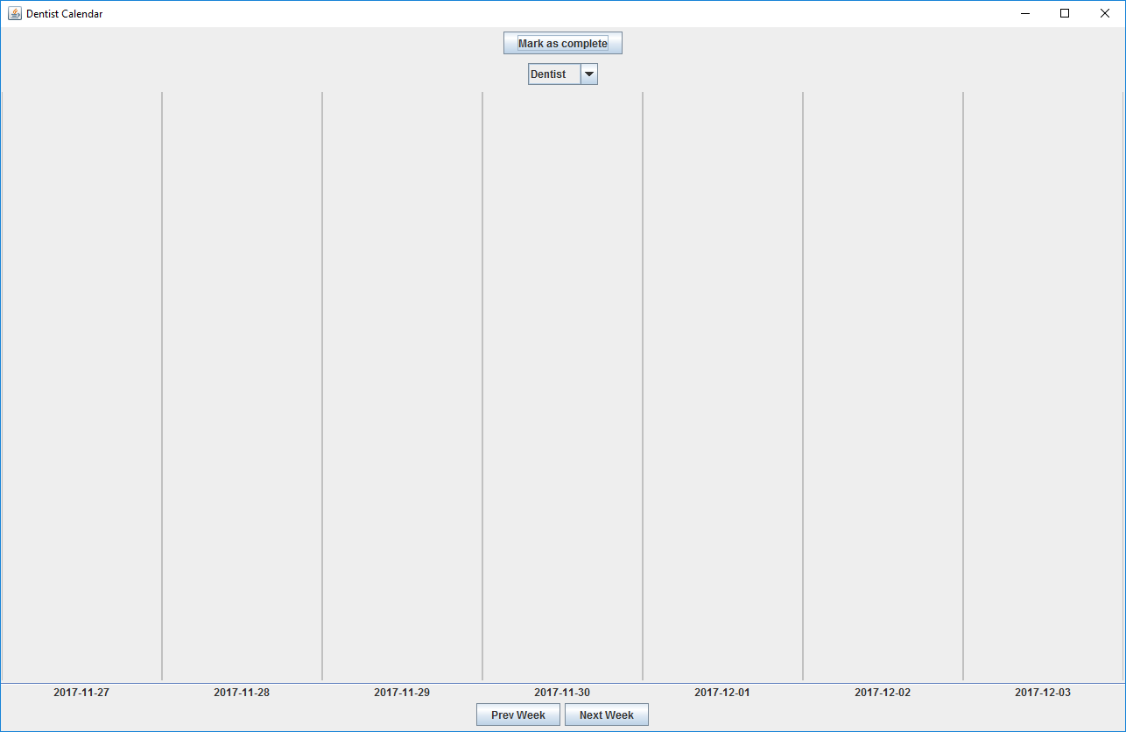

# Query Testing Screenshots

## Registering a Patient

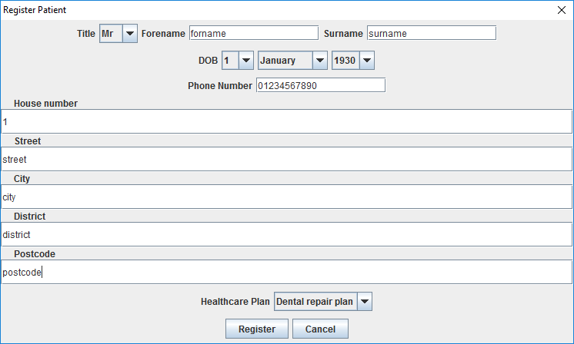 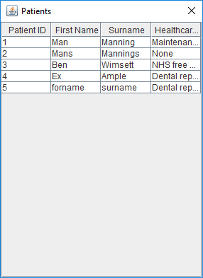Subscribing patients

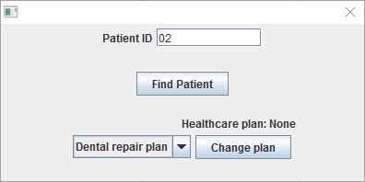 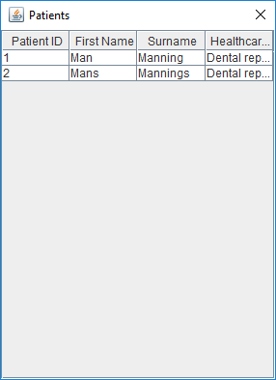

## Booking holiday

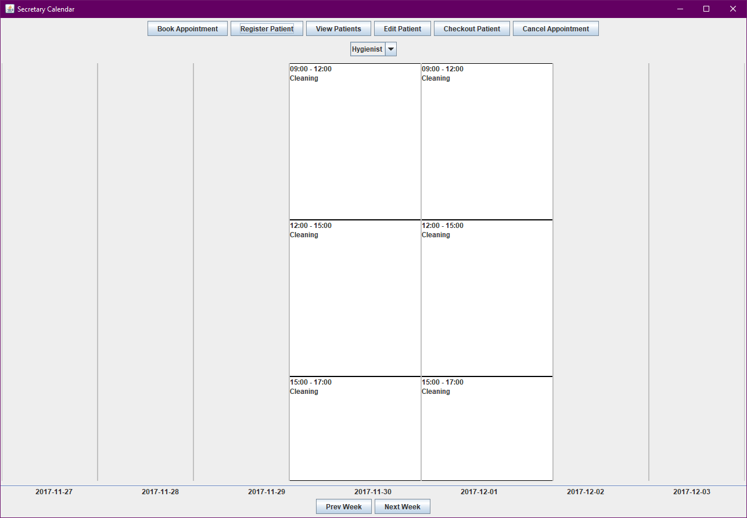

## Booking Appointment

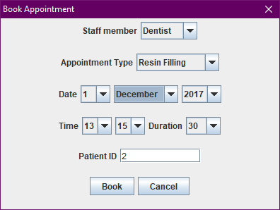 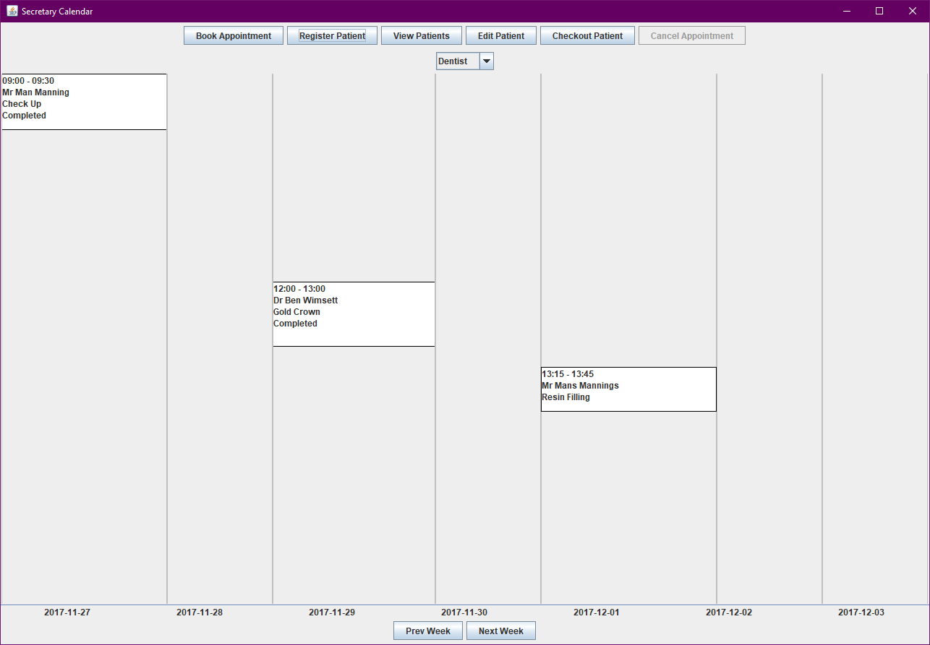 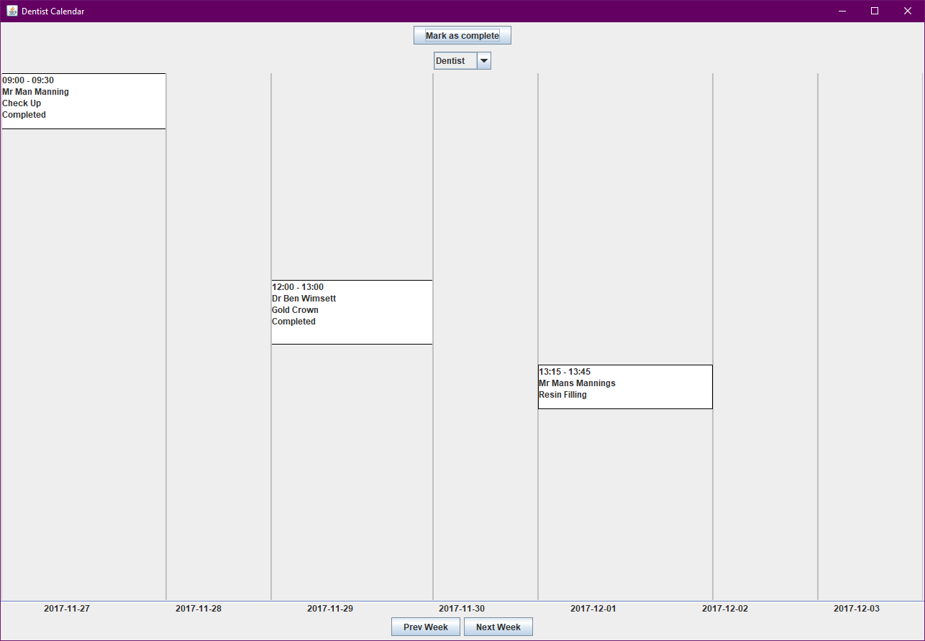

## Recording Treatment Price

## 

# Effort Declaration

The team worked effectively both as individuals and while directly interacting with each other. Each member was assigned their own task at each point of the project, with some tasks requiring collaboration between members. Aside from this, there were no instances where tasks had to be re allocated. A high level of communication was maintained throughout the project and each member was happy to support another if necessary.

## Task Distribution

|  |  |  |  |  |
| --- | --- | --- | --- | --- |
| Task | Daniel | Owen | Joe | Ben |
| UML | X | X | X | x |
| SQL | X |  | x |  |
| Java |  | X |  | X |
| Report |  |  | x |  |

## Effort Contribution

|  |  |  |  |  |
| --- | --- | --- | --- | --- |
|  | Daniel | Owen | Joe | Ben |
| Effort | 100 | 100 | 90 | 110 |

Signed;

|  |  |  |  |
| --- | --- | --- | --- |
| __________________ | __________________ | __________________ | __________________ |
| Daniel Bacon | Owen Lyons | Joe Slade | Ben Wimsett |