Client-Side Debugging with Chrome Developer Tools

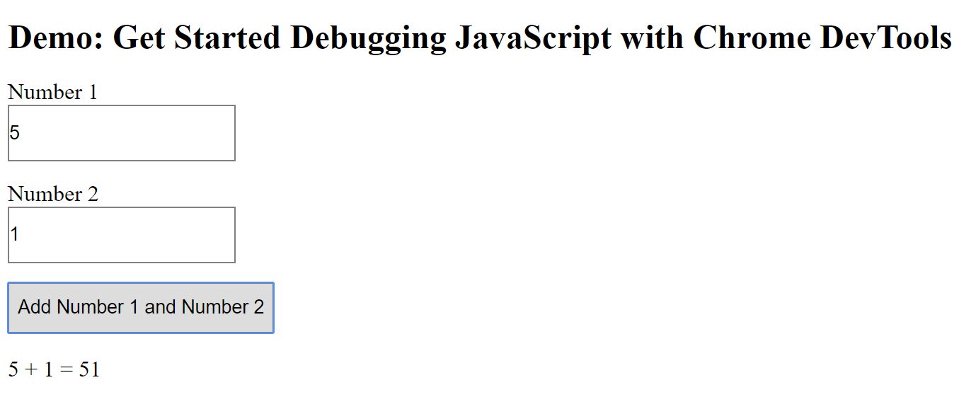

As an easy example, I am going to be using the Chrome Developer Tools to explain how to use client-side debugging on the example provided by Chrome.

**Breakpoints**

Step 1: Open Developer Tools by pressing F12 or using the shortcut ctrl+shift+I to open the console on the webpage.

Step 2: To set a breakpoint, open the sources tab and locate the “Event Listener Breakpoint” tab.

Step 3: This will list various mouse events, like click or mousedown events.

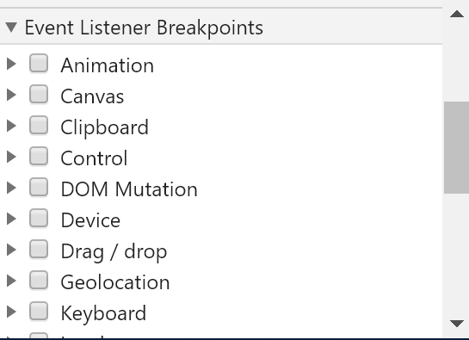

Step 4: Locate the click event listener and select the checkbox. This will create a pause anytime the click event listener is performed.

**Log and Read Messages**

Step 1: With Developer Tools open, you can navigate to the sources tab to view the existing JavaScript on the page.

Step 2: Messages are programmed using console.log() to output a message. In this example, they used:

console.log(‘Hello, Console!’);

To output a message saying: Hello, Console!

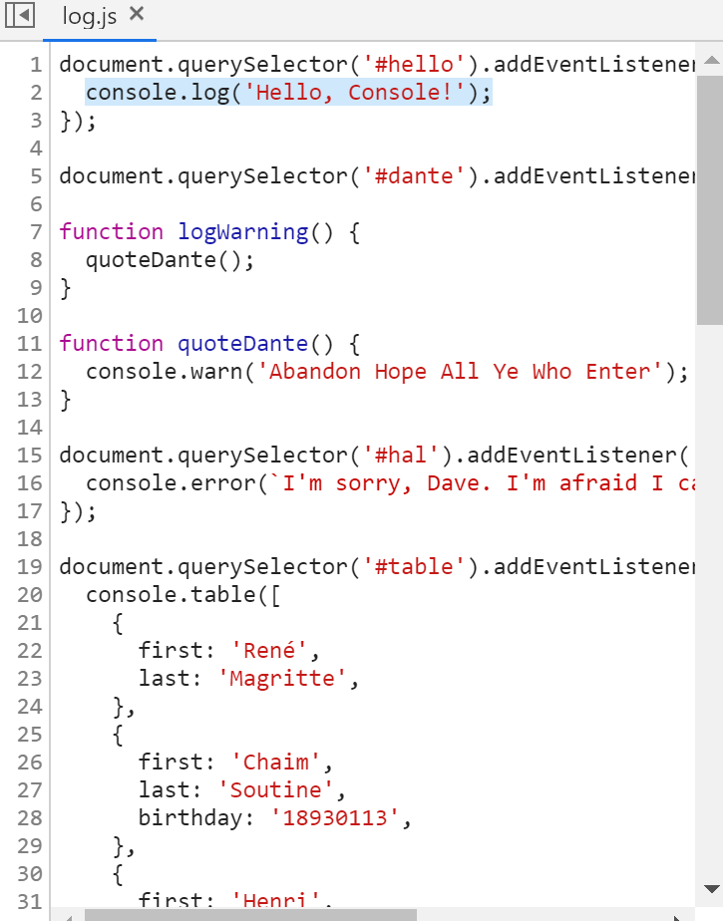

Step 4: You can easily create a message by using code comments to document your message, and applying the message to a console.log() for the message output.

**HTML in JavaScript Console Window**

Step 1: Open to the JavaScript Console Window in DevTools

Step 2: To access HTML elements within the JavaScript window, you must use the beginning code:

Console.dir

Using this code allows HTML elements to be accessed within the Console Window.

**Simulate CSS States on Live HTML Elements**

Step 1: Open Developer Tools with F12 and locate the element you want to edit.

Step 2: Toggle to the style sheet that applies to that element.

Step 3: Find the specific style tag you want to modify

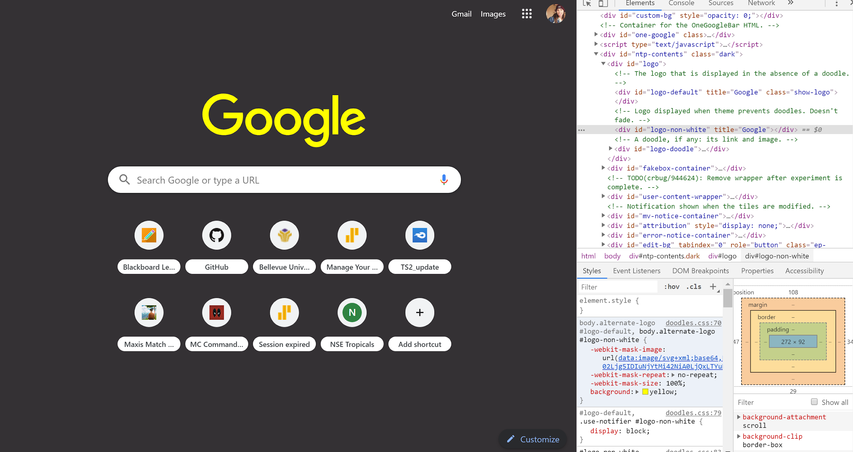

Step 4: In this example, I edited the Google logo on the Google Homepage. This is done by selecting the style tag and modifying, adding, or changing the style.

Step 5: I modified the “background-color:” tag from white to yellow. This changes in real time so you can see the effect.

References:

Basques, K. (2019, May 29). Get Started with Debugging JavaScript in Chrome DevTools | Tools for Web Developers | Google Developers. Retrieved July 27, 2019, from https://developers.google.com/web/tools/chrome-devtools/javascript/

Basques, K. (2019, June 7). Get Started With Logging Messages In The Console | Tools for Web Developers | Google Developers. Retrieved July 27, 2019, from https://developers.google.com/web/tools/chrome-devtools/console/log

Plalx. (2013, May 12). Selecting DOM elements in Chrome. Retrieved July 27, 2019, from https://stackoverflow.com/questions/16510234/selecting-dom-elements-in-chrome-console