## TITANS WEB QA REPORT

1. Not working. (Done)

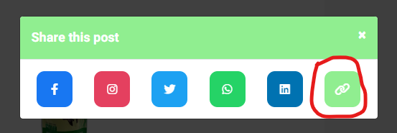

1. Linked with login page. (Done)

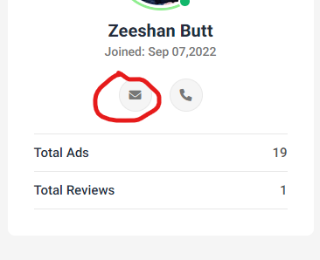

1. Static button. (Done)

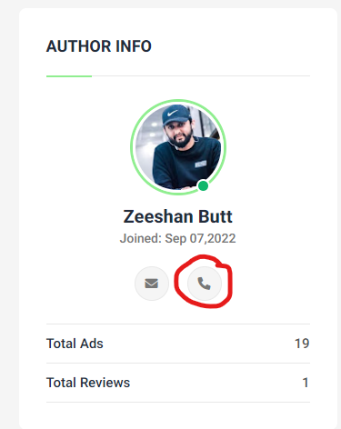

1. Forgot password not working..

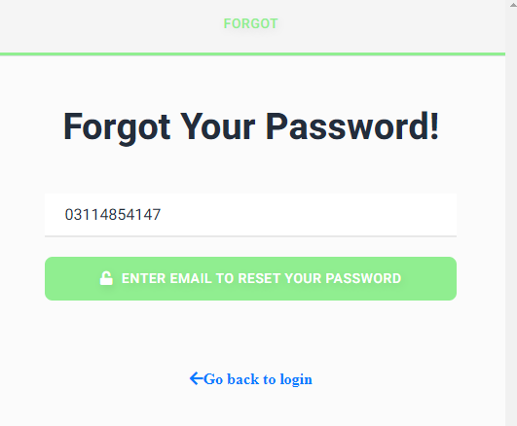

1. Not working. (Done)

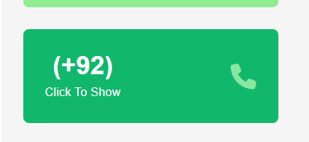

1. Email address text-transform: capitalize. (Done)

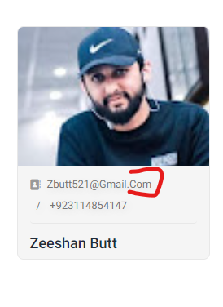

1. Unable to sign up.
2. Bookmarks not working.(Done)
3. Chat not working. (Already working)
4. Forget password not working.
5. Notifications not working.
6. Unable to delete any form in dashboard duo to description.

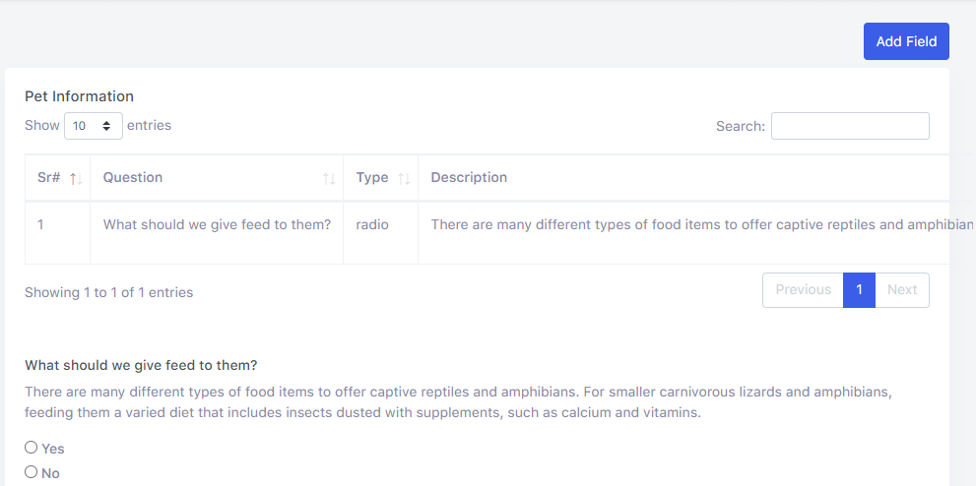

1. Scroll is not working correctly.

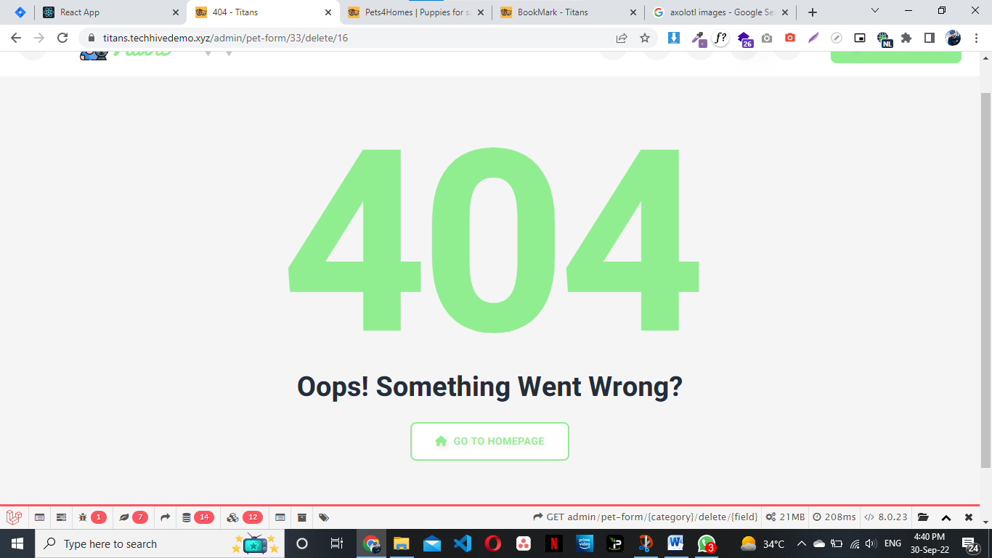

1. Pet price in dollars.

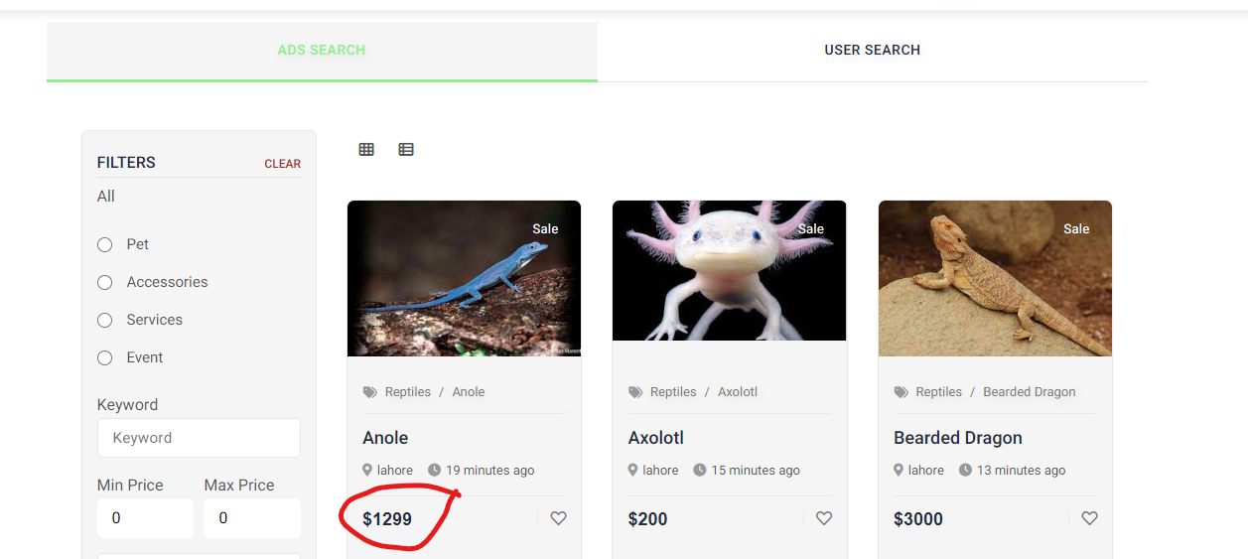

1. Wish list is not clickable in ad search.

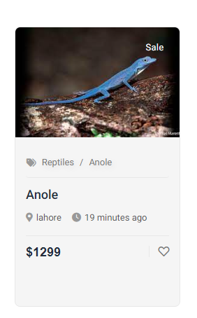

1. Not linked with categories.

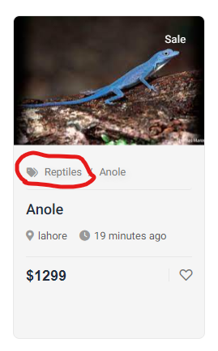

1. Low image quality in user search.

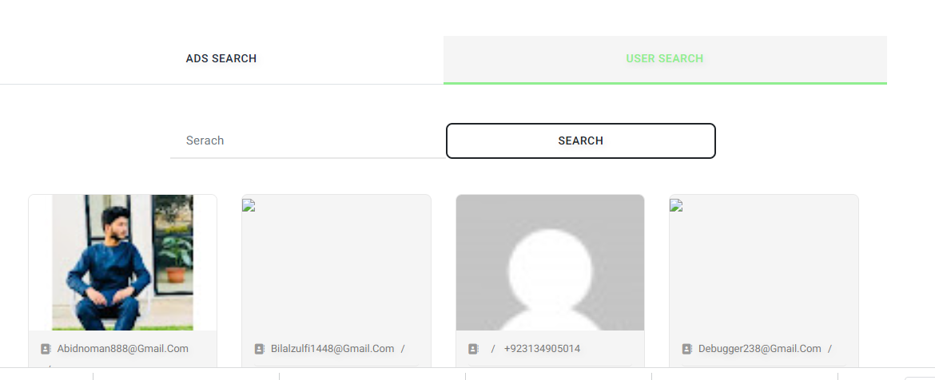

1. Not working. (Done)



1. Unable to add master category from dashboard. (Not a master category)

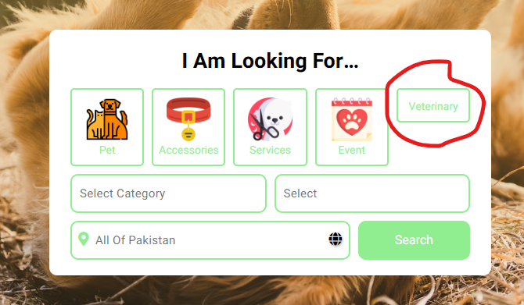

1. Pagination not working in search.

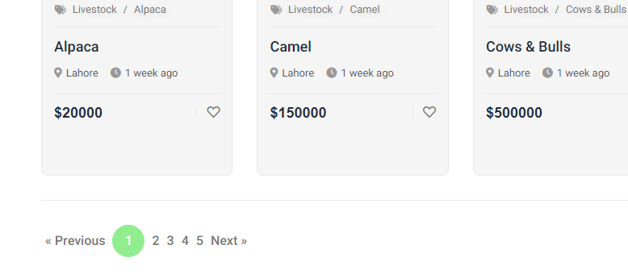

1. Billing details vanished after submit my details. (Done)

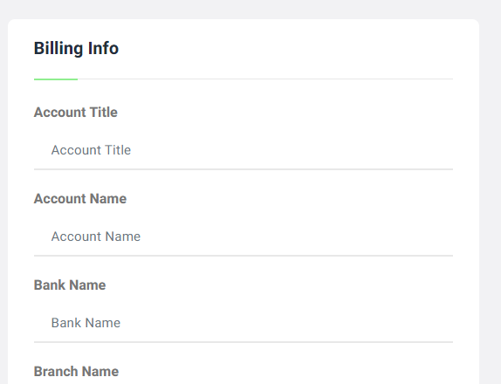

1. Category linked with current ad.

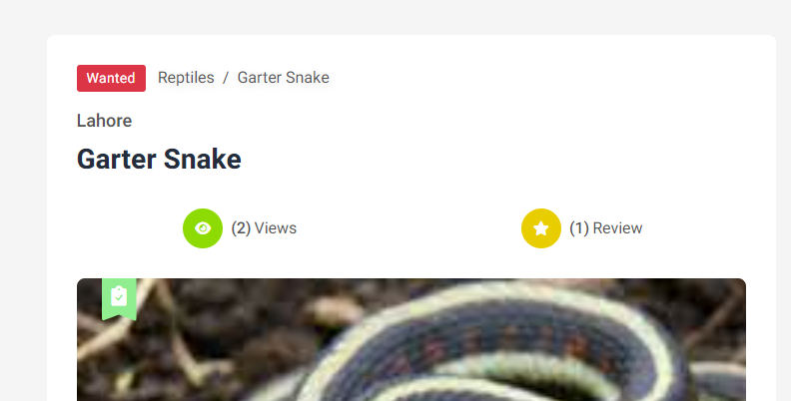

1. How can I read my reviews? 2unread review. (Done)

