Purdue SMIF Website: Design Audit
Prepared for Ian Teh · 19 October 2026 · Site: www.purduesmif.org

Bottom line
On the technical basics the site already beats the peer set. Median page weight (339KB) is about an eighth of the buy-side median and a quarter of the student median, load speed is in the same range as peers, and axe found zero serious or critical accessibility violations on our pages, versus failures on 7 of 11 peer sites. Where it loses is simplicity: ten top-level nav links set in tiny uppercase type, research buried one click deep, and a team page that runs to roughly 45,000px on a phone. This release fixes the cheap items (research on the home page, pitch decks, tap targets, label/name mismatches, a contradictory Apply page). The structural items below are proposed, not shipped, because they change navigation and page architecture.

Method and sites
Headless Chromium (Playwright 1.56) captured each site on 19 October 2026 at desktop (1440×900) and mobile (390×844). For every page: nav link count, styled CTAs above the fold, words above the fold, text under 12px, interactive elements under 24px on mobile, page weight and request count, Largest Contentful Paint, and axe-core accessibility violations. 38 pages across 12 sites.
Group | Site | URL | Pages captured
Ours | Purdue SMIF | https://www.purduesmif.org/ | 11 routes
Buy-side | Bridgewater | https://www.bridgewater.com/ | home, research, team
Buy-side | Oaktree | https://www.oaktreecapital.com/ | home, research, team
Buy-side | AQR | https://www.aqr.com/ | home
Buy-side | Two Sigma | https://www.twosigma.com/ | home, research, team
Buy-side | D. E. Shaw | https://www.deshaw.com/ | home, team
Buy-side | KKR | https://www.kkr.com/ | home, research, team
Student fund | Nittany Lion Fund (Penn State) | https://nittanylionfund.com/ | home, team
Student fund | McIntire Investment Institute (UVA) | https://mcintireinvestmentinstitute.org/ | home, team
Student fund | Fordham SMIF | https://www.fordhamsmif.com/ | home, research, team
Student fund | South Hill Fund (Ithaca) | https://www.southhillfund.com/ | home, research
Student fund | Trinity SMF | https://trinitysmf.com/ | home, research, team

Caveats. Bridgewater blocked its people page (HTTP 403), so it is excluded. AQR navigation could not be auto-discovered, so only its home page was captured. Sites without a <header> or <nav> element report 0 nav links and are excluded from the nav median. Wisconsin AIM returned 404 and other candidate student funds did not resolve, so the student set is 5. The tap-target metric counts any link or button under 24px in either dimension, so it overstates failures that WCAG 2.5.8 exempts (inline text links). Treat it as directional.

Scorecard
Medians across captured pages. "Ours (after)" is re-measured on this release locally; everything else is the live capture.
Metric | Ours | Buy-side median | Student median | Read
Page weight (KB) | 339 | 2,730 | 1,455 | Lower is better. Only South Hill ships lighter pages.
Requests | 17 | 68 | 54 | Lower is better.
Largest Contentful Paint (ms) | 332 | 452 | 234 | All fast on a cold headless load. Student median is quicker; ours beats buy-side.
Serious/critical axe nodes | 0 | 3.5 | 3.5 | Ours 0. Peers fail mostly on color contrast.
Desktop nav links | 10 | 6 | 5 | Ours is the densest except South Hill (12).
Text elements under 12px (desktop) | 4 | 0 | 0 | Buy-side mostly zero. Ours peaks at 19 on /recruiting.
Mobile targets under 24px | 17 | 32 | 10 | Ours pre-fix; after this release the median is 1.
Mobile page height (px) | 6,771 | 5,758 | 6,310 | Ours skewed by /team at 44,830px.

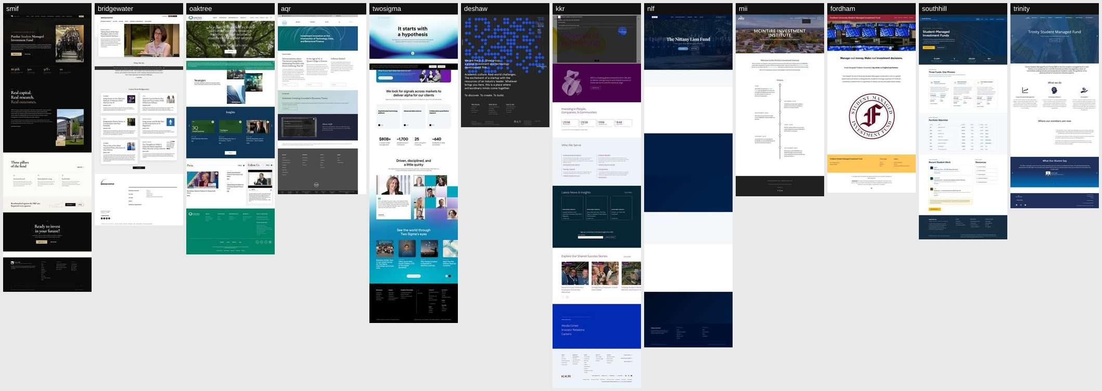
Home pages, full length, left to right: ours, six buy-side firms, five student funds.

Page-by-page critique
- Home. Strong hero, real photography, clear Apply and View Portfolio CTAs. The stats band sits partly below the fold on a laptop. Research did not appear at all, while Bridgewater, Oaktree, and AQR all put their latest writing on the home page. Fixed: a "Latest from the fund" strip now shows the three newest publications.
- Navigation. Ten links plus Apply in 11px tracked uppercase. Oaktree runs 4 primary items with a utility row, D. E. Shaw 3 primary plus utility, MII 4 plus an Apply pill, NLF 4. Ours asks visitors to parse more choices in smaller type than any peer except South Hill.
- Research. Rebuilt last round; now also hosts Pitch Decks as a fifth series with ticker, sector, and Long/Short in each row and the featured slot. Matches South Hill's "Pitch Decks & Investment Research" library (ticker tiles, filter chips, not-advice banner) and Oaktree's category tabs. The library is empty for pitches until the first deck is posted.
- Team. Clean cards and search, but 52 members render as one scroll of about 45,000px on mobile. NLF solves the same problem with jump buttons (Executive Board, Leadership, Fund Managers). Larissa Adamic is added as the third faculty advisor with an initials placeholder.
- About. Dense but credible governance copy. Advisor grid now runs three across. Ten sub-12px labels.
- Holdings / Performance / Sectors. The data pages are the site's strongest asset; no peer student fund publishes this much live portfolio data. Accessible-name mismatches on the holdings movers are fixed; /sectors "View team" links now meet 24px.
- Recruiting / Apply. Apply said "Applications are open" while Recruiting, which reads the event calendar, said the cycle had closed. Apply is now status-neutral and points to the calendar. Recruiting carries the most sub-12px text on the site (19 desktop, 29 mobile).
- Theming. Heroes alternate between ink and cream without a rule. Buy-side sites pick one hero treatment and hold it.

Best elements to borrow
Element | Source | Status
Latest research on the home page | Bridgewater, Oaktree, AQR | Shipped
Pitch deck library with ticker-first rows and a not-advice notice | South Hill Fund | Shipped
Category tabs over one research index | Oaktree (All, Memos, Market Commentary, Education, Press) | Already in place
Primary/utility nav split | Oaktree, Bridgewater, D. E. Shaw | Proposed
Short primary nav plus Apply pill | McIntire Investment Institute, Nittany Lion Fund | Proposed
Section jump buttons on the team page | Nittany Lion Fund | Proposed
Stats band inside the hero fold | South Hill Fund | Proposed
Search in the header | Two Sigma | Proposed
Filter sidebar plus sort on insights | KKR | Not needed at our volume

What not to copy: cookie walls and consent banners that cover a third of the fold on several buy-side homes, multi-megabyte hero video, and low-contrast gray-on-white text (Oaktree alone logged 32 contrast failures on its home page).

Ranked recommendations
Status | Recommendation
Shipped | Home "Latest from the fund" strip pulling the three newest publications.
Shipped | Pitch Decks series on /research, plus npm run publish:research for one-command uploads.
Shipped | 24px minimum targets on footer, member-card, home, and sector links; mobile undersized targets fell from a median of 17 to 1 per page (remaining hits are the skip link and inline text links).
Shipped | Accessible names now start with the visible label (holdings movers, recruiting calendar); fixes the axe label-content-name-mismatch failures.
Shipped | Apply hero no longer contradicts the recruiting calendar; line length capped for readability.
Shipped | Faculty advisor Larissa Adamic added to /team, /about, her profile page, and llms.txt.
Proposed 1 | Cut primary nav from 10 to about 6: Portfolio dropdown (Holdings, Performance, Sectors), Join (Recruiting, Apply), with About, Team, Research, Learn. Highest simplicity gain; touches every page, so it needs your sign-off.
Proposed 2 | Raise 10px eyebrow labels to 11 to 12px site-wide. Low risk, broad visual change.
Proposed 3 | Team page jump links or collapsed sector groups to cut mobile length.
Proposed 4 | Pick one hero treatment (ink or cream) and apply it consistently.
Proposed 5 | Pull the home stats band into the first viewport.
Proposed 6 | Newsletter capture for The Macro Brief on the home page.
Proposed 7 | Header search across research and team.

Appendix: student fund contact sheets
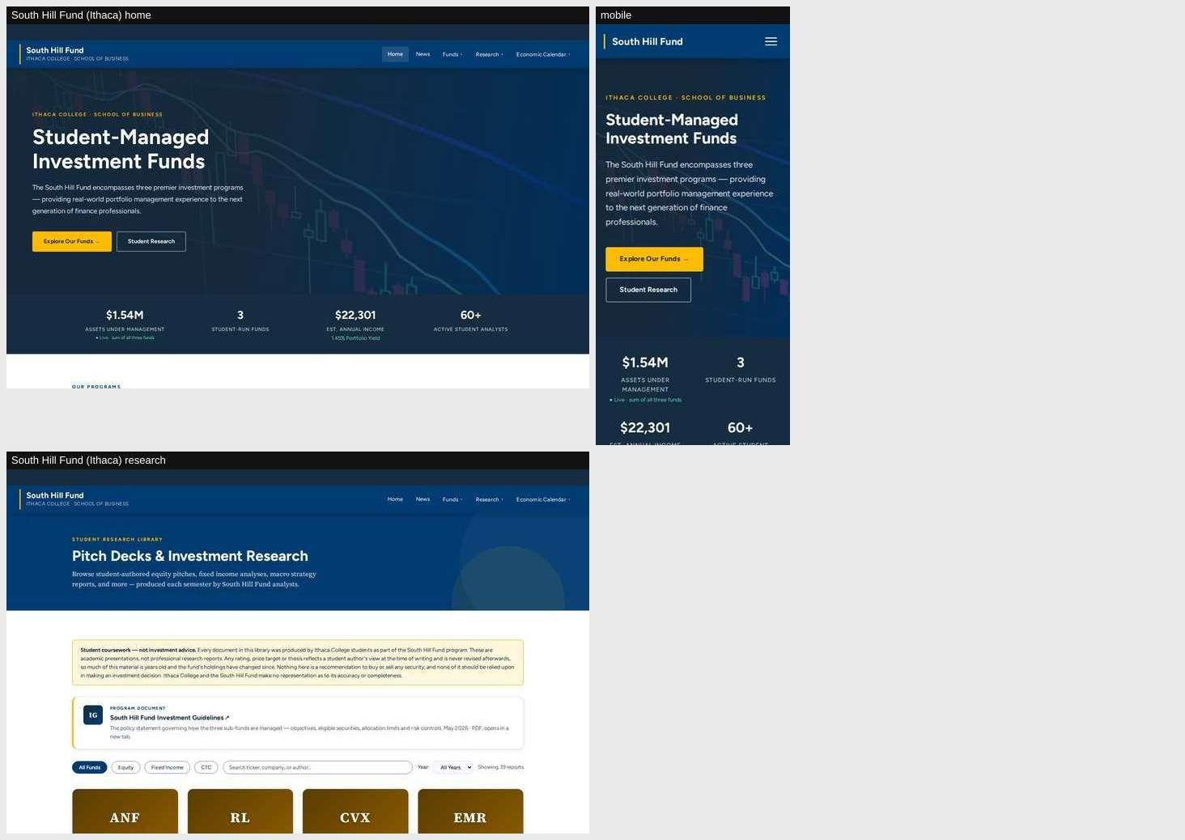
South Hill Fund (Ithaca)
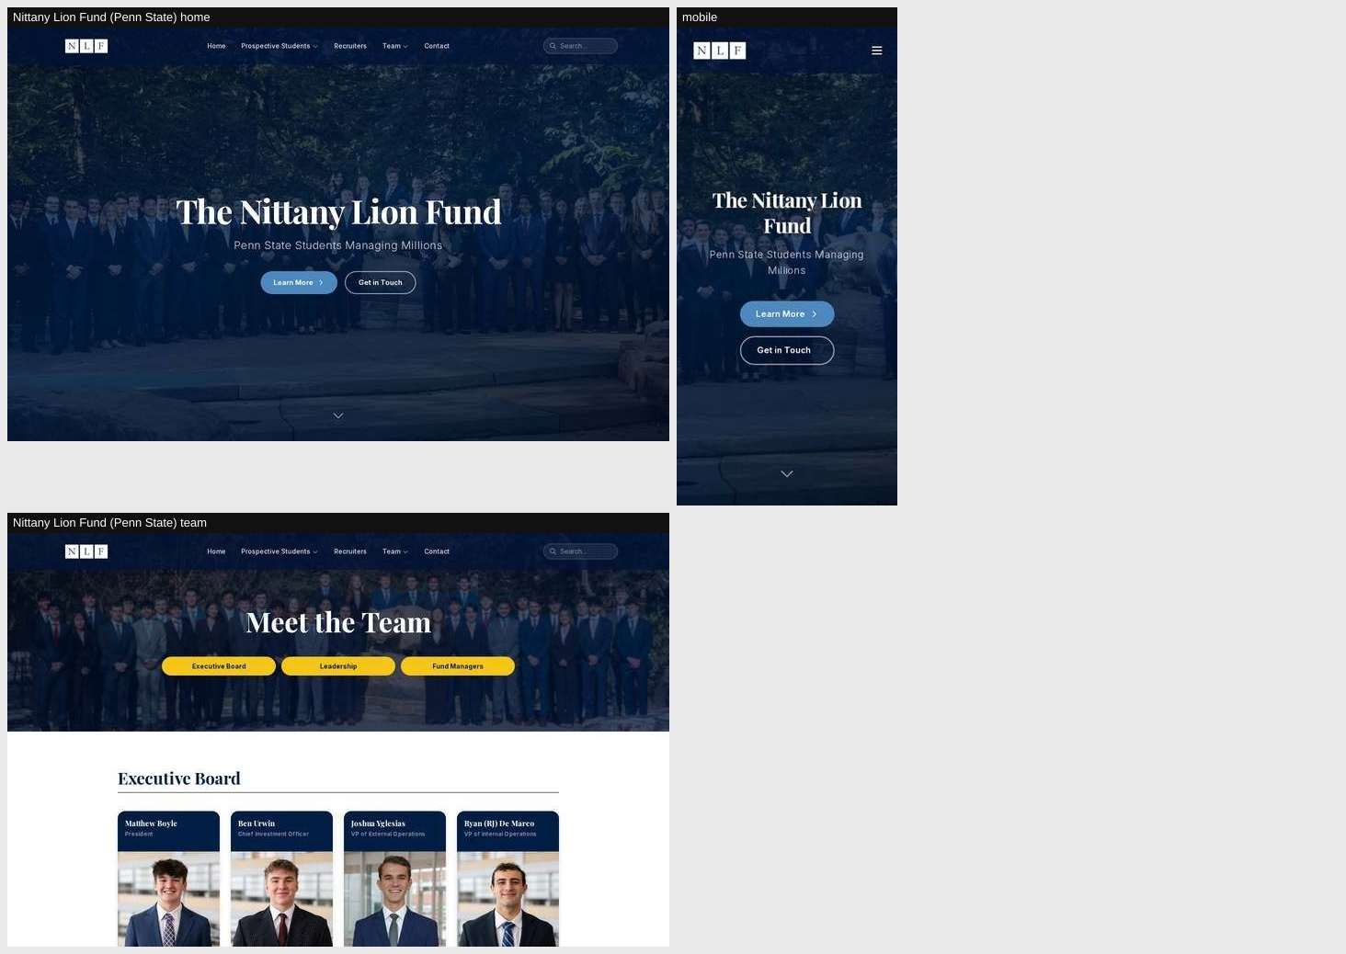
Nittany Lion Fund (Penn State)

