1 . Perfect-Information Games
Deadline: 04.11.2025
(a) Preliminaries
A game has perfect information if:
Every player knows all previous actions taken by all players.
There is no hidden information (no face-down cards, no secret moves).
The outcome of actions is deterministic — no random chance involved.

Perfect information refers to the property that, whenever it is a player’s turn to move, they know all the moves that have been made previously. Games with perfect information are represented by rooted directed trees.

Definition 3.1.1 A rooted directed tree consists of a set of nodes and directed edges joining them.
- The root of the tree has no directed edges leading to it (has indegree 0), while every other node has exactly one directed edge leading to it (has indegree 1).
- There is a unique path (that is, a unique sequence of directed edges) leading from the root to any other node. A node that has no directed edges out of it (has outdegree 0) is called a terminal node, while every other node is called a decision node.
- We shall denote the set of nodes by X, the set of decision nodes by D and the set of terminal nodes by Z. Thus X = D∪Z.

Definition 3.2.1 The backward-induction algorithm is the following procedure leading to a marking of all the nodes.
- Select a decision node x whose immediate successors are all marked. Let i be the player who moves at x. Select a choice that leads to an immediate successor of x with the highest payoff (or utility) for Player i (highest among the utilities associated with the immediate successors of x). Mark x with the payoff vector associated with the node that follows the selected choice.
- Repeat the above step until all the nodes have been marked

(b) Model Setup
Players:
- Player 1 (P1)
- Player 2 (P2)
- Dealer (D)

Game Objective: Each player (P1 and P2) aims to get a card sum as close as possible to 15 without exceeding it. The dealer plays by the same rules but their strategy determines the outcome for both players.
Deck and Values
- Cards: 1-10 (one card of each value)
- Target: Obtain sum ≤ 15, as close to 15 as possible

Game Sequence
- P1 receives one face-up card (visible to all)
- P2 receives one face-up card
- Dealer receives one face-up card
- Players take turns (P1 → P2 → D) choosing: Hit (take card) or Stand (stop)
- All cards are dealt face-up, deck order is known in advance
- Game ends when all participants Stand or someone busts (>15)

Actions
- Hit - take the next face-up card
- Stand - stop taking cards

Payoffs
At game end, each player compares with the dealer:
- If player busts (>15): payoff = -1
- If dealer busts: all non-busted players get +1
- If no busts: player closer to 15 wins
Payoffs are summed for P1 and P2 relative to the dealer.
Example:
- P1 closer to 15 than D → P1: +1, D: -1
- P2 closer to 15 than D → P2: +1, D: -1
- Tie → 0

Simplified Scenario
- Deck = [3, 4, 5]
- Initial cards: P1 = 5, P2 = 4, Dealer = 3
- Target = 15

(c) Program code/Table Analysis
flowchart TD
Start[Game Start: P1=5, P2=4, D=3] --> N000
N000[P1's Turn: Sum=5] --> N100_Stand
N000 --> N100_Hit
N100_Stand[P1: Stand] --> N210
N100_Hit[P1: Hit +3 = 8] --> N220
N210[P2's Turn: Sum=4] --> N211_Stand
N210 --> N211_Hit
N211_Stand[P2: Stand] --> N311
N211_Hit[P2: Hit +4 = 8] --> N321

N220[P2's Turn: Sum=4<br>P1=8, D=3] --> N221_Stand
N220 --> N221_Hit
N221_Stand[P2: Stand] --> N331
N221_Hit[P2: Hit +4 = 8] --> N341
N311[Dealer's Turn: Sum=3<br>P1=5, P2=4] --> N311_Stand
N311 --> N311_Hit
N321[Dealer's Turn: Sum=3<br>P1=5, P2=8] --> N321_Stand
N321 --> N321_Hit
N331[Dealer's Turn: Sum=3<br>P1=8, P2=4] --> N331_Stand
N331 --> N331_Hit
N341[Dealer's Turn: Sum=3<br>P1=8, P2=8] --> N341_Stand
N341 --> N341_Hit
N311_Stand[D: Stand → P1=5, P2=4, D=3<br>Payoff = +2]
N311_Hit[D: Hit +5 = 8 → P1=5, P2=4, D=8<br>Payoff = -2]
N321_Stand[D: Stand → P1=5, P2=8, D=3<br>Payoff = +2]
N321_Hit[D: Hit +5 = 8 → P1=5, P2=8, D=8<br>Payoff = -1]
N331_Stand[D: Stand → P1=8, P2=4, D=3<br>Payoff = +2]
N331_Hit[D: Hit +5 = 8 → P1=8, P2=4, D=8<br>Payoff = -1]
N341_Stand[D: Stand → P1=8, P2=8, D=3<br>Payoff = +2]
N341_Hit[D: Hit +5 = 8 → P1=8, P2=8, D=8<br>Payoff = 0]
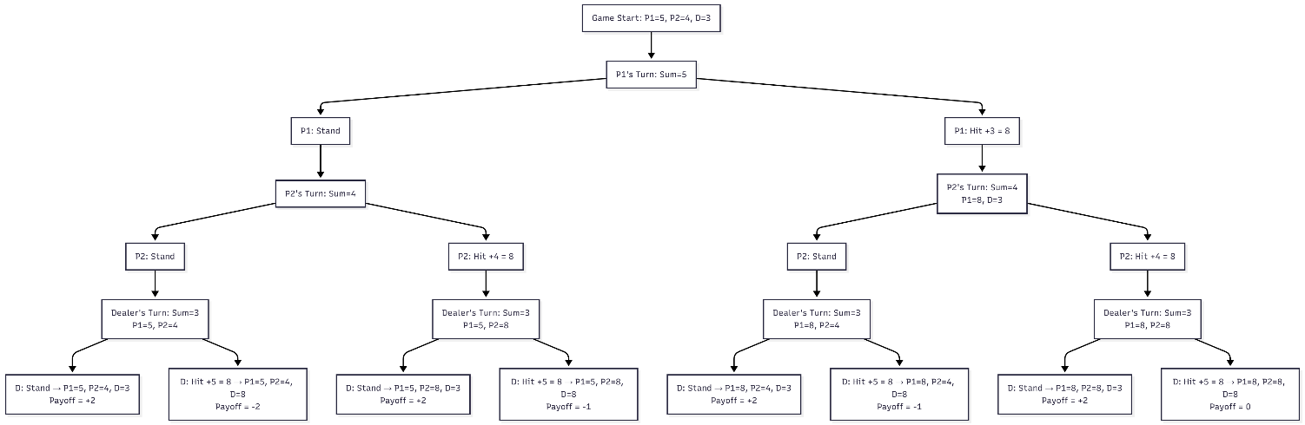

(d) Description of the program
This flowchart represents the game tree of a simplified Blackjack game with perfect information (i.e., all players know previous moves).
Here’s what it shows step by step:
Overview
- Players:
  - P1 (Player 1) starts with a total of 5.
  - P2 (Player 2) starts with a total of 4.
  - D (Dealer) starts with a total of 3.
- Each player, on their turn, can Hit (draw a card) or Stand (stop drawing).
- When hitting, the card values are shown directly in the chart (e.g., Hit +3 = 8).
- At the end, payoffs are calculated from the outcomes (positive = player advantage, negative = dealer advantage).
Flow Explanation
- Start
  - Game begins with: P1=5, P2=4, D=3.
- P1’s Turn (Node N000)
  - P1 can either:
    - Stand → go to node N210, or
    - Hit (+3) → total becomes 8, go to N220.
- P2’s Turn
  - If P1 stood: P2’s turn at N210, with sum=4.
    - P2 can Stand (N211_Stand) → go to N311, or
    - Hit (+4) → total = 8 → N321.
  - If P1 hit: P2’s turn at N220, same options:
    - Stand (N221_Stand) → go to N331,
    - Hit (+4) → total = 8 → N341.
- Dealer’s Turn
  - The dealer acts last in all four cases:
    - N311 → D=3 vs P1=5, P2=4
    - N321 → D=3 vs P1=5, P2=8
    - N331 → D=3 vs P1=8, P2=4
    - N341 → D=3 vs P1=8, P2=8
Each time, the dealer can:
  - Stand, or
  - Hit (+5) → total becomes 8.
Payoffs Summary
Scenario | Final State (P1, P2, D) | Dealer Action | Payoff
N311_Stand | (5, 4, 3) | Stand | +2
N311_Hit | (5, 4, 8) | Hit | -2
N321_Stand | (5, 8, 3) | Stand | +2
N321_Hit | (5, 8, 8) | Hit | -1
N331_Stand | (8, 4, 3) | Stand | +2
N331_Hit | (8, 4, 8) | Hit | -1
N341_Stand | (8, 8, 3) | Stand | +2
N341_Hit | (8, 8, 8) | Hit | 0

- Positive payoff (+) → Players perform better (dealer loses).
- Negative payoff (-) → Dealer performs better.
- The game tree is meant for backward induction (to find the optimal strategy and final equilibrium payoff).
- By tracing backward from payoffs, one can determine the best move (Hit or Stand) for each player at every decision point.
(e) Analysis
Step 1: Dealer Level (Minimizes Payoff)
- Chooses Hit (payoff = -1) over Stand (payoff = +2)
- Chooses Hit (payoff = 0) over Stand (payoff = +2)
- Chooses Hit (payoff = -2) over Stand (payoff = +2)
- Chooses Hit (payoff = -1) over Stand (payoff = +2)

Step 2: P2 Level (Maximizes Payoff)
- 1:
  - Stand → -1 (after dealer's optimal play)
  - Hit → 0 (after dealer's optimal play)
  - Chooses Hit (0 > -1)
- 2:
  - Stand → -2
  - Hit → -1
  - Chooses Hit (-1 > -2)

Step 3: P1 Level (Maximizes Payoff)
0:
  - Stand → -1 (after P2's optimal play)
  - Hit → 0 (after P2's optimal play)
  - Chooses Hit (0 > -1)

(f) Results & Discussion
The backward induction analysis reveals:
Optimal Strategy:
- P1: Hit (takes card 3 → sum 8)
- P2: Hit (takes card 4 → sum 8)
- Dealer: Hit (takes card 5 → sum 8)
- Final: P1=8, P2=8, D=8 → Payoff = 0
Key Insights:
- Even with perfect information, players cannot achieve positive payoff against optimal dealer play
- The dealer's minimizing strategy effectively neutralizes player advantages
- Players must anticipate the dealer's counter-strategies when making decisions
- The existence of high-payoff outcomes (+2) doesn't guarantee they are achievable under optimal play
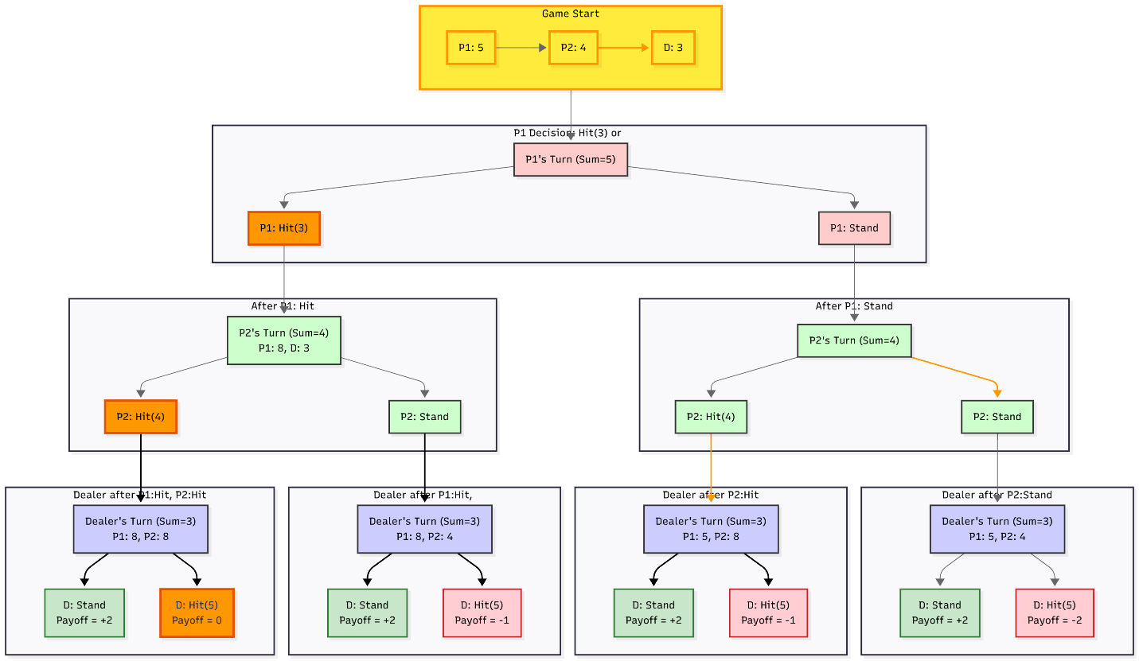

# Modified Game: Cooperative Bonus Analysis

Change Introduced
-Cooperative Bonus: If both players beat dealer, each gets +0.5 extra payoff
- Total payoff = Base payoff + 1.0 (if P1 > D AND P2 > D)

Equilibrium Comparison

Aspect | Original Game | Modified Game
Optimal Path | P1: Hit → P2: Hit → D: Hit | P1: Hit → P2: Hit → D: Hit
Final Payoff | 0 | 0
Strategy | Unchanged | Unchanged

Key Finding: No Equilibrium Change

Why?
- Dealer's minimizing strategy blocks bonus activation
- Bonus requires P1 > D AND P2 > D
- Dealer always chooses actions to prevent this condition
- Cooperative bonus becomes theoretically visible but practically unattainable

Not all rule modifications affect equilibrium. Only changes that alter actual strategic incentives at decision margins impact optimal play.

The cooperative bonus is an "empty promise" - players see it but can't achieve it against rational opponents.

(g) Conclusion
This extended Blackjack version with two players demonstrates:
- How backward induction solves complex multi-player sequential games
- The importance of anticipating opponent responses in strategic decision-making
- That perfect information doesn't guarantee positive outcomes against optimal opponents
The methodology can be extended to more players and complex card distributions, providing a framework for analyzing strategic interactions in perfect information environments.

(h) Contributions
(i) References
https://drive.google.com/file/d/16CTO2i3-kmlMvPnvUH_VJvalz_u9hyR6/view?usp=drive_link
AI

