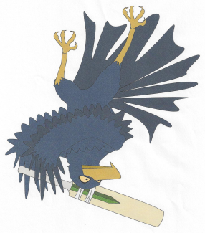

**Jandakot Lakes Junior Cricket Club**

PO Box 3618

Success WA 6964

Email: admin@jandakotlakesjcc.org.au

Website: www.jandakotlakesjcc.org.au

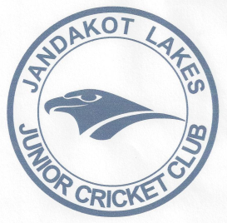

Minutes of Committee Meeting –Monday 9thth July 2018

At Jandakot Lakes Cricket Club

1. Meeting Open:630pm
2. Attendees:

Jason Sweetman (President

Richard Harvey (Vice President)

Melanie Walker (Secretary)

Karen Walker (Treasurer)

Brad Day

Nyree Collins(Registrar)

Jamie Bradford

Todd Stevens

Kerry Mayers

1. Apologies:

Peter Copeland

Andrew Fontaine

Scott Clissold

Darryl Martin

1. Guests: Elle Sherwin

1. Minutes of Previous Meeting: Monday 11th June 2018;

Approved by: Richard Harvey; Seconded: Karen Walker

1. Correspondence Inward and Outward:

Inward and Outward:

* Registration enquiries.
* Dropbox information
* Constitution draft
* Bunnings sausage sizzle correspondence
* SWMJCC invoices
* Jandakot Jets Football Club invoices
* Westnet notice
* Copy of public liability

7. President’s Report:

* 30/6 equipment was all sorted ready for new season. Would like to thank everyone who gave up sometime on there weekend to come down and help out.
* Seems as though we only need new helmets and game balls for this season.
* New committee shirts have been ordered for this season

1. Vice President's Report:

* Focus this season for SWMJCC is on the girls competition. U11s/U13s girls competition both have similar pathways to the boys comp.
* Fixtures for U14s boys comp will be all one-day games to hopefully increase participation numbers

1. Treasurer’s Report:

* A. Balance as at 11.6.18-$13,739.70
* B. Received -CBA Merchant fees- $49.50

-Petty cash- $200

* C. Accounts Paid- None

1. Registrar’s Report:

* Will be having handover with Karen Walker to get up to speed with registrars’ role.
* Registrations will open end of July.
* Need website to be updated to have registration link.

1. Team Manager Coordinator

* Team managers coordinator will now be Mark Williams.

1. Junior/Master Blasters:

* Elle Sherwin attended the committee meeting to explain the changes to the new competition.
* Woolworths has become the new sponsor for the Master and Junior Blasters.
* The programs are similar to the old T20 and Milo In2cricket. Junior blasters take over the old In2cricket and Master Blasters takes over T20.
* There will be no age limit on the blasters competition allowing kids to move up to master blasters if they are too good for junior blasters.
* Master blasters will be played in a small game format with small teams being formed with a coach and team manager. It will still be played all in one night however Cricket Australia think this will be a better transformation to U10s having this format in Master Blasters.
* Shirts for Junior Blasters will come with the pack they get from Cricket Australia however Master Blasters shirts are to come from the clubs. Junior Blasters have the option to personalise their shirts.
* There will also be the option of having gala days with other clubs where the small teams will be able to compete against other clubs.
* Woolworths will be having a large promotion running to promote new competition and hopefully attract more kids to play.
* Registrations will all be online. There will also be the option to have half of the season run in last term this year 2018 and finish in term 1 of 2019. Clubs need to discuss and come up with what works best for them.
* All packs will be sent directly to the kids however if they get a club shirt they will have to collect from clubs.
* All equipment used by clubs for the Master and Junior blasters will be given to them from the WACA. The clubs however need to order the equipment.
* Clubs will need a coordinator for thr running of the Master/Junior balsters.
* Clubs need to look at a welcome night to introduce members to the club and to the new format.
* Jandakot have the option of also running the competition in Aubin Grove. Club needs to discuss.
* Junior Blasters will be $99 and Master Blasters will be $110.
* 14th October 2018 will be the coaches course from 9-1 for anyone who needs accreditation.

1. General Business:

* CONSTITUTION- Kerry Mayers Proposed to alter the constitution. A general meeting will be held at the next committee meeting on August 13th. The proposed rewrite has been submitted to the committee members. All members of the club will be emailed or contacted and invited to the next meeting for a special resolution to be voted on.
* BUNNINGS SAUSAGE SIZZXLE- Bunnings sausage sizzle will be on 15th July currently we have all positions filled so hopefully will be a good day. Karen and Nyree have arranged food and drinks. Thanks to The Spud Shed for arranging the food and drink we need and for the kind donations of sauces, onions, napkins.
* More marquees need to be purchased this season. Need to look into cost.

1. Next meeting:
   * 13th August 2018
2. Meeting close: 8.12pm