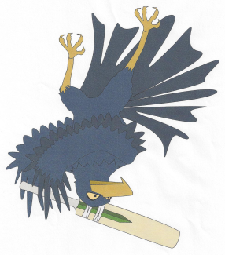

**Jandakot Lakes Junior Cricket Club**

PO Box 3618

Success WA 6964

Email: admin@jandakotlakesjcc.com.au

Website: www.jandakotlakesjcc.com.au

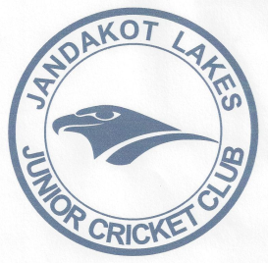

Minutes of Committee Meeting -Wednesday 22nd August 2018

At Jandakot Lakes Cricket Club

1. Meeting Open:630pm
2. Attendees:

Jason Sweetman (President

Richard Harvey (Vice President)

Melanie Walker (Secretary)

Karen Walker (Treasurer)

Brad Day

Nyree Collins(Registrar)

1. Apologies:

Peter Copeland Jamie Bradford

Andrew Fontaine Todd Stevens

Scott Clissold Kerry Mayers

Darryl Martin

1. Guests: Emily Johnston

Emily came to introduce herself to our committee as she has now taken the role that Elle Sherwin used to hold with the WACA. She is the cricket manager for the SWMJCC area and will help us with club development.

There will be a cricket blast training that Jandakot will host on the 8th Oct 2018. There is also a live my cricket training session on the 17th sept at the WACA at 6pm.

1. Minutes of Previous Meeting: Monday 9th July 2018;

Approved by: Richard Harvey; Seconded: Karen Walker

1. Correspondence Inward and Outward:

Inward and Outward:

* Registration enquiries.
* Cricket registrations
* Elle Sherwin asking when we will hold registration day.
* Grants that are available to all clubs.
* Female skills workshop
* Summer meet and greet with Cockburn council
* 2 invoices from Cricket and Footy shop
* General junk mail
* Handover date and information from Cockburn council
* Associations and clubs asking if our constitution is up to date
* Girls cricket night from Shane Styles
* SEDA opportunities for 2019
* Little legends funding application acceptance
* Growing girls cricket fund grant

7. President’s Report:

* Attended SWMJCC meeting- season start is the 20th Oct 2018.
* WACA is hosting U10/U11/U12 and girls coaches’ course on the 10th October. All those coaches in those age groups need to attend and need to pick up score cards from course.
* Have sent an email to coaches who have already put their hands up to coach letting them know of upcoming events and dates to keep free.
* On the 14th October Jandakot will be hosting the coaching accreditation course for any coaches that have not yet got their accreditation.
* Looking for more coaches to coach U10s teams.
* Need to look for someone to run the Master/Junior blasters this season. Woolworths are happy to work with clubs as the new sponsor of the competition. WACA will contact Woolworths and clubs about deals with the company.
* Karen/Mel to update name board.
* Team manager bags need to be organised and sorted ready for the new season. Need to supply team managers with a hard copy of the rules. Team manager need to be aware of $5 umpire fee each game for each child.
* Need to order more shirts and caps.
* Balls and new committee/coaches’ shorts have been ordered ready for the season.
* Bought new game bags to replace the broken ones.
* Getting a fixed gazebo erected in between the ovals before season start.

1. Vice President's Report:

* Looking into the purchase of new sun shelters. Have been in contact with Bronwyn Miller from the council about applying for a sports grant to fund some of the purchase. Looking to buy 6 x 3m gazebos.

1. Treasurer’s Report:

* A. Balance as at 31.7.18-$13,490.20
* B. Received -Bunnings sausage sizzle-$1725.00

-Bunnings sausage sizzle-$240.60

-WACA girls funding-$1000

-Petty cash- $200

* C. Accounts Paid- Bunnings sausage sizzle-$800.35

-Gear bags day- $46.49

-Pizza-$42.90

-Jandakot Jets TV& canteen upgrade-$565.14

Bank balance bought forward $15000.92

Also voted on and unanimously voted on to change over to MYOB. Karen to look into change over.

1. Registrar’s Report:

* We have had 69 registrations.

1. Team Manager Coordinator

* No report

1. Junior/Master Blasters:

* No report

1. Upcoming events-

* 22nd sept registration day
* 17th sept live scoring app course at WACA
* 8th October Jandakot hosting master/junior blasters training night.
* 10th October U10/U11/U112 coaches’ night at the WACA
* 14th October coaches accreditation course
* 20th October season start

1. General Business:

* CONSTITUTION- Kerry Mayers Proposed to alter the constitution. A general meeting will now be held on the 10th Sept to discuss the constitution ready for submission.
* Registration/ uniform day will be held on the 22nd Sept from 9-1130am.
* Canteen- Nyree looking into having food trucks come down to the club on a Friday night instead of running the canteen as we don’t have enough helpers to open every Friday.
* There will be no senior delegate this season.
* Jason Sweetman will be our coaches coordinator this season.
* Looking into having a coaches and team managers welcome night needs further discussion.

1. Next meeting:
   * 10th Sept 2018
2. Meeting close: 8.01pm