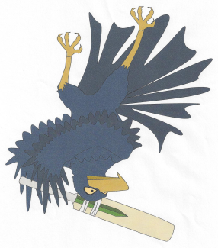

**Jandakot Lakes Junior Cricket Club**

PO Box 3618

Success WA 6964

Email: admin@jandakotlakesjcc.com.au

Website: www.jandakotlakesjcc.com.au

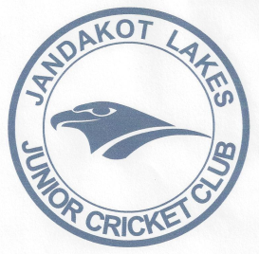

Minutes of Committee Meeting -Monday 8th October

At Jandakot Lakes Cricket Club

1. Meeting Open:630pm
2. Attendees:

Nyree Collins (Registrar)

Richard Harvey (Vice President)

Melanie Walker (Secretary)

Karen Walker (Treasurer)

Brad Day

Todd Stevens

Peter Copeland

Tony Timothy

1. Apologies:

Jamie Bradford

Andrew Fontaine

Scott Clissold Kerry Mayers

Darryl Martin

1. Guests: No
2. Minutes of Previous Meeting: Monday 18th August;

Approved by: Richard Harvey; Seconded: Karen Walker

1. Correspondence Inward and Outward:

Inward and Outward:

* Registration enquiries.
* Cricket registrations
* Draft of constitution
* Fixtures for 2018
* Coaches night
* Club handover
* Richard Harveys resignation
* Kit bag collection

7. President’s Report:

- Uniform day will be held on 14th October from 9-11am. Need as many hands as possible to help out. Currently

Have Jason, Nyree, Karen, Peter, Todd Rich and Mel.

- Team photos are 3rd December from 4pm-6pm. Karen and Mel to organise.

- Georgia Platten will be or Master/Junior blasters coordinator. A roster will be set up for committee to help out

On Friday nights. The gala day will be held on 7th December and we will need all hands-on deck.

* Mario has put a complaint in abut the state of the pitch and how sprinklers are not doing what they are supposed to do causing problems with the pitches. Council to respond.
* Windups and trophies need to be discussed at next meeting.

1. Vice President's Report:

* Have quotes for gazebos and will fill in form for funding and send to council. Await a response.

1. Treasurer’s Report:

* A. Balance as at 1.8.18-$15000.92
* B. Received -City of Cockburn $150

-Uniforms $600

-Cricket Australia registrations $371.96

-Cricket Australia registrations $1658.53

-Cricket Australia registrations $1596.98

-Cricket Australia registrations $3083.53

-Cricket Australia registrations $2686.54

-Cricket Australia registrations $3101.99

-Cricket Australia registrations $1576.23

-Cricket Australia registrations $943.52

-Cricket Australia registrations $1561.42

-Cricket Australia registrations $2786.46

-Petty cash- $200

* C. Accounts Paid- Merchant fees $49.50

-SWMJCC $3250.00

-Merchant fees $49.50

-Cricket & football shop (Shirts) $1047.00

-Cricket & football shop (balls) $6915.00

Bank balance bought forward $23807.08

1. Registrar’s Report:

* This season we have 16 teams.

3 u10s

3 u11s

3 u12s

2 u13s

1 u14s

1 u15s

1 u17s

Fixtures have already been put on SWMJCC website.

We have had 30 Junior Blasters and 35 Master Blasters registered. Blasters season starts on 2nd November.

1. Team Manager Coordinator

* No report

1. Junior/Master Blasters:

* No report

1. Upcoming events-

* 14th Oct Coaches Accreditation course
* 14th October uniform day
* 20th Oct season start
* 2nd Nov Junior/Master blasters season start
* 3rd Dec Team photos

1. General Business:

* CONSTITUTION- Mel Walker put forward the motion for a change to the Jandakot Lakes Junior Cricket club constitution and those present committee of 4 executive committee and 4 general committee members voted unanimously to accept the motion. We also had a proxy vote of yes by 2 other committee members.
* Brad Day attended my cricket live scoring app course. He thinks it is a great idea for the club in going forward to try to get more teams using the app. He said it was quite easy to use and made less work for coaches and scorers. Maybe club needs to look into purchasing Ipads for teams to use. This year we might trial u13, u14 and u15 using the app plus keeping a paper copy to see how well we use the app.

1. Next meeting:
   * 11th Nov 2018
2. Meeting close: 7.33pm