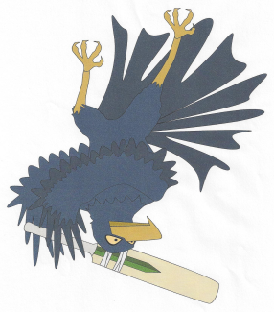

**Jandakot Lakes Junior Cricket Club**

PO Box 3618

Success WA 6964

Email: admin@jandakotlakesjcc.com.au

Website: www.jandakotlakesjcc.com.au



Minutes of Committee Meeting -Monday 8th July 2019

At Jandakot Lakes Cricket Club

1. Meeting Open:630pm
2. Attendees:

Jason Sweetman (President)

Melanie Walker (Secretary)

Mark Williams (V President)

Danielle Gray (Registrar)

Mick Gray

Lenore Jepsen

Jamie Bradford

Brian Mathews

1. Apologies:

Andrew Fontaine

Karen Walker

Scott Clissold

Tracey Bettridge

Brad Day

1. Guests: Nil
2. Minutes of Previous Meeting: Monday 10th June;

Approved by: Jason Sweetman; Seconded: Mark Williams

1. Correspondence Inward and Outward:

Inward and Outward:

* Sporting company advertising
* Website Advertising

1. Presidents Report:

* We have reassessed the fees and have decided for this season that u10s-U14s will be $175 and U15-U17s will be $195. Was voted in by Jamie Bradford and seconded by Brian Mathews.
* The bins that the JJJFC asked us to put in for have been paid in full by the footy club.
* I will contact Nathan from Cockburn council about the use of Harmony Primary on Saturday mornings. See if we will need to pay a levy for the use of the oval.
* The Jandakot Park CC is having a quiz night and has asked us if we would like to help organise this. We will go halves in any door takings and any raffles held on the night. The senior club will keep all bar takings as they hold the licence. Danielle will consult with Mario about organising this event.
* We had a busy bee for our storeroom on the 7th July. We had a huge turn out which made it run a lot more smoothly and quickly.
* We are still looking into cost of balls.
* This will also be my last season as President so we will be seeking a new president for the 2020/21 season.

1. Vice President's Report:

* I attended the SWMJCC meeting for Jason this month. It was a general discussion about the upcoming season and what to expect for this season.
* This season our summer break will be shorter with matches going up until Christmas. U13/14s finals will be held at Tompkins Park this season and U15/17 will be home advantage to the team that finished higher on the ladder.
* This will also be my last season with Jandakot so we will be seeking a new Vice President for the 2020/21 season.

1. Treasurer’s Report:

* A. Balance as at 11.3.19- $16850.22
* B. Received -no report

* C. Accounts Paid-

Bank balance bought forward 08.4.19 $5618.39

1. Registrar’s Report:

* Registrations will hopefully be open this week.

1. Team Manager Coordinator

* No report

1. Junior/Master Blasters: No report
2. Trophies/Photos: No report
3. Windups: No report
4. Uniforms: No report

1. Equipment Report:

* We need to purchase 5 bags and new helmets for this season.
* Also need to look into cost of balls.

Upcoming events-

* Next meeting 12th August

1. General Business:

-No report

1. Next meeting:
   * 12th August 2019
2. Meeting close: 7.30pm