**Problem Statement**: When I set my alarm it doesn't take into account which mode of transportation I will be using based on the weather conditions. I need to wake up early to check if the weather will allow for me to ride my bike or if I need to take the bus. My app will look at the weather and then adjust my alarm based on which mode of transportation will be available on a given day. I want an alarm app that will adjust my alarm settings when the weather changes.

Main Phone Screen:

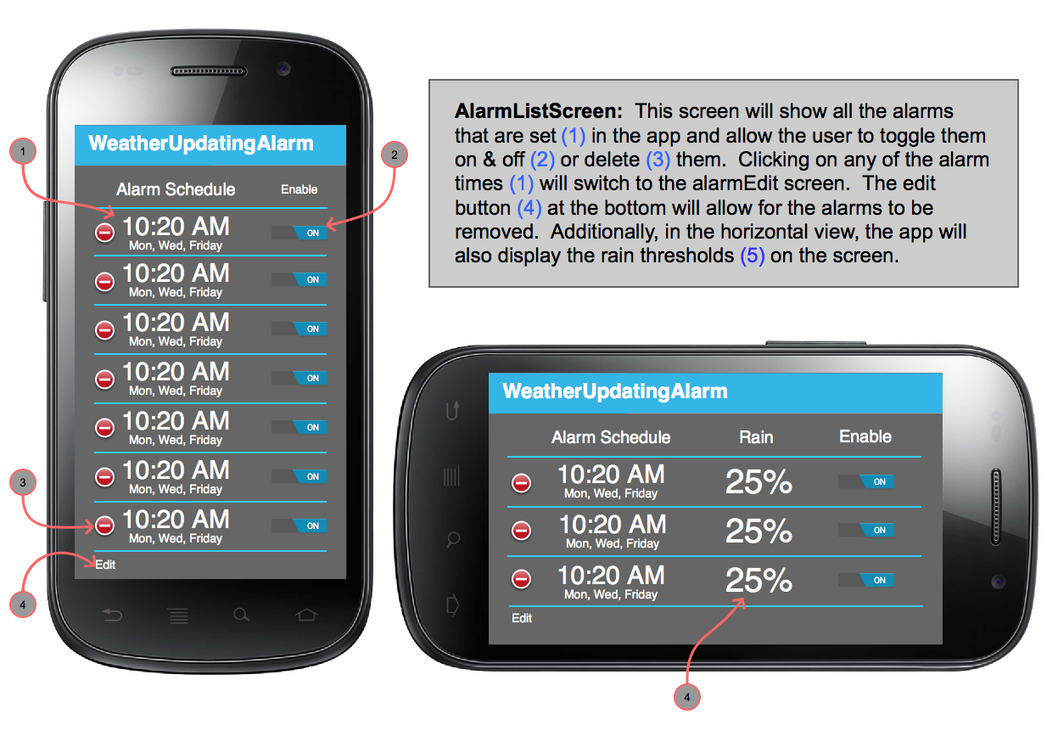

Tablet Vertical Alarm List:

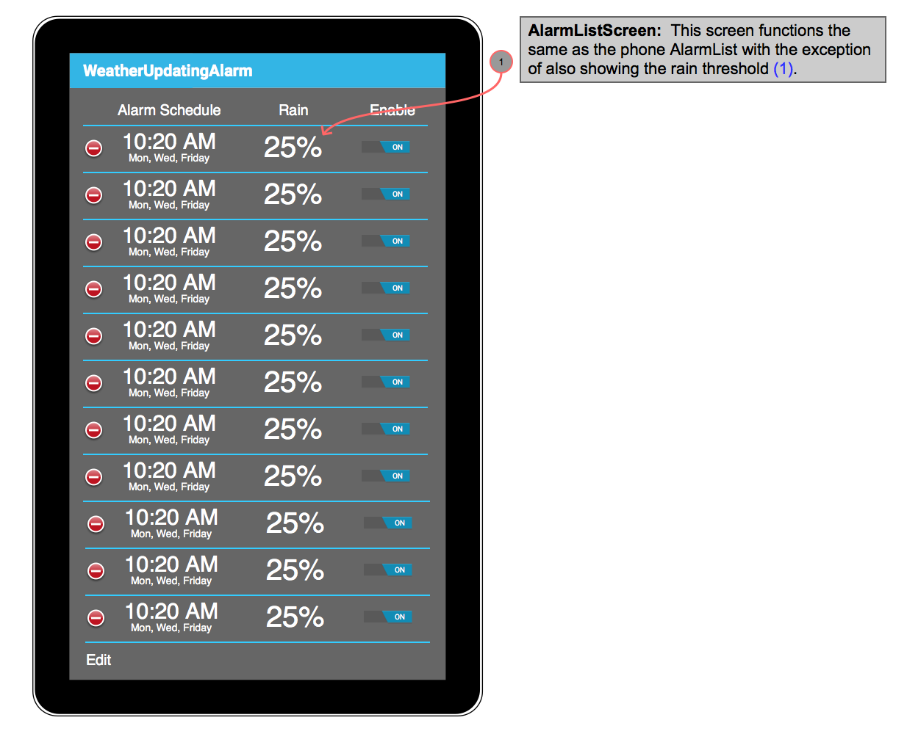

Phone Alarm Edit Screen:

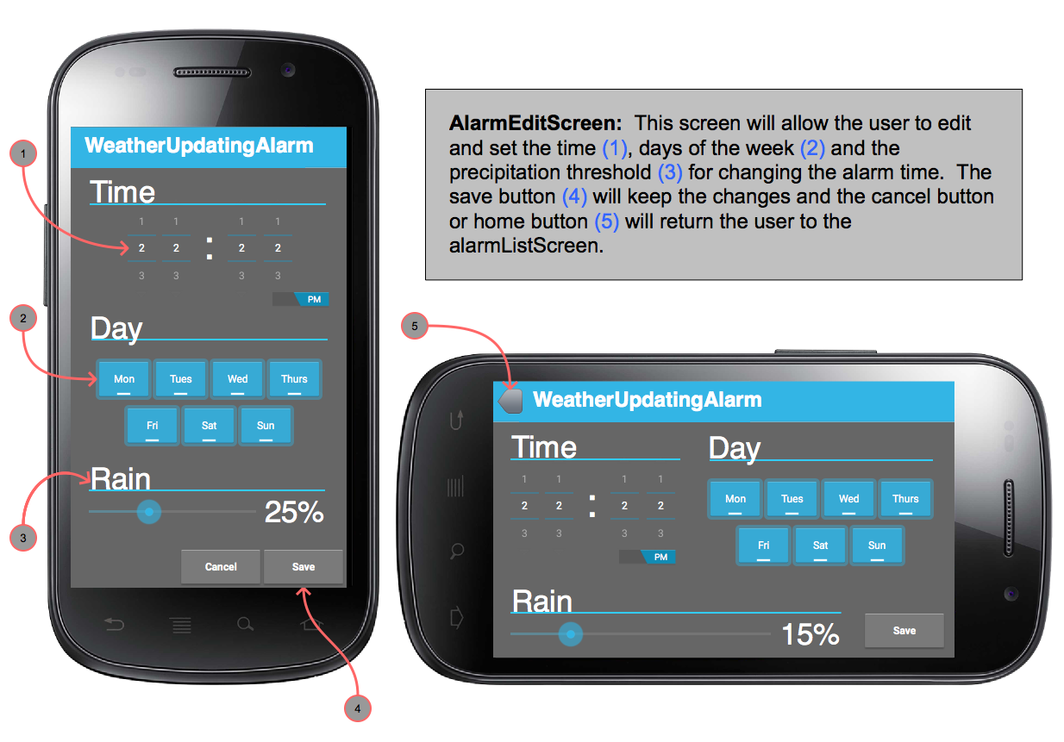

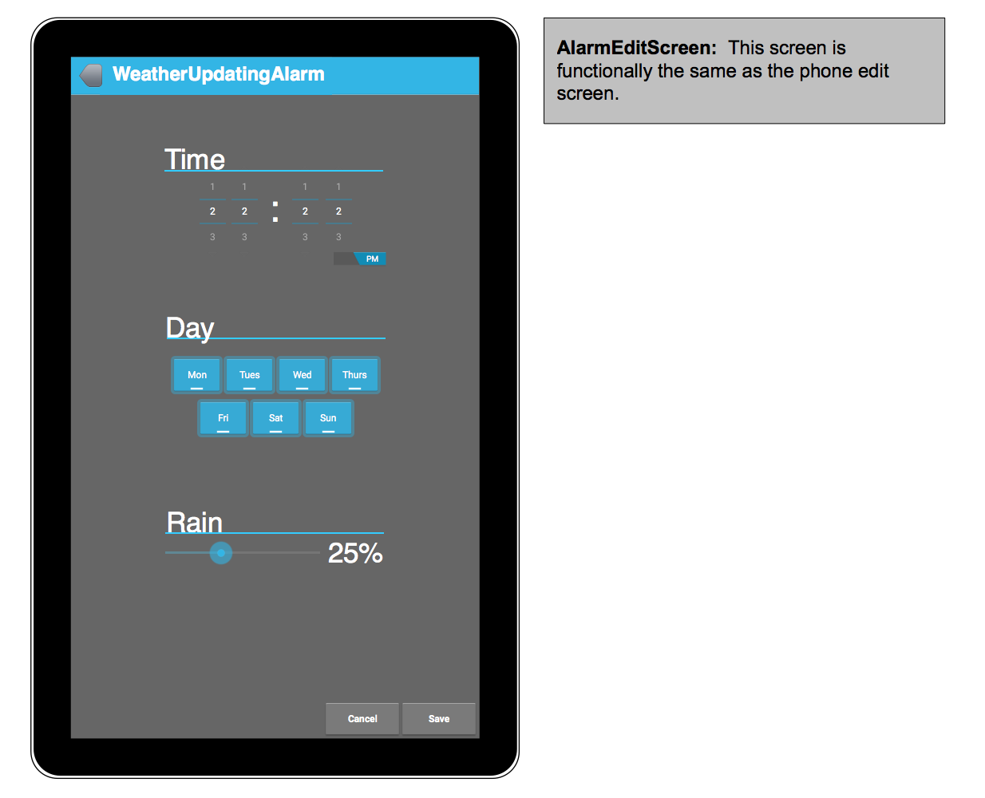Tablet Alarm Edit Screen:

Tablet Horizontal View:

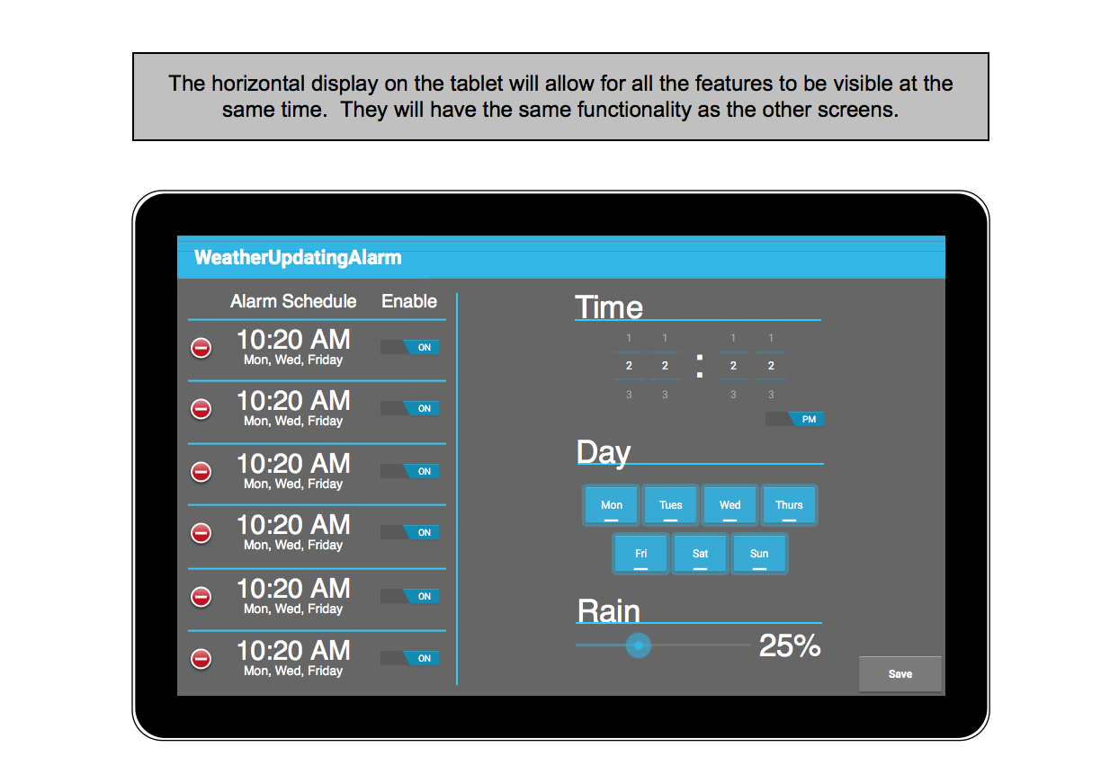

Toast Messages:

