# Udacity Data Analyst Nanodegree Program - P1: Test a Perceptual Phenomenon - Ben Wong

Question 1)

The independent variable in the Stroop task is the list of color words – both

congruent words and incongruent words. The dependent variable is the time it

takes to name the ink colored words.

Question 2a)

*Ho*: μC = μI

The time it takes to read a list of congruent words equals the time to read a list of

incongruent words.

*HA*: μC !– μI

The time it takes to read a list of congruent words does not equal the time to read a

list of incongruent words.

Question 2b)

I am proposing that a t-test is used for testing the hypothesis for the following reasons:

1. We don’t know the population standard deviation
2. We assume that the distribution is normal

Question 3)

Congruent set: mean = 14.1; median = 14.4; standard deviation = 3.6

Incongruent set: mean = 22; median = 21; standard deviation = 4.8

Question 4)

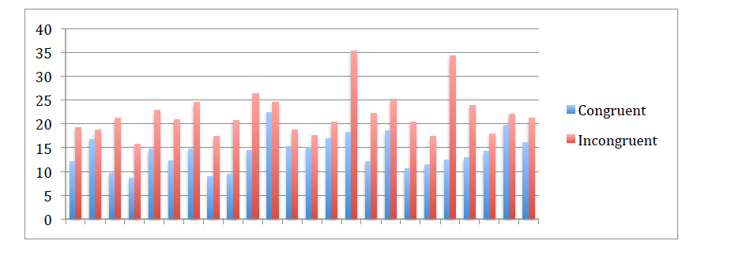

Question 5)

1. The difference between each pair is as follows:

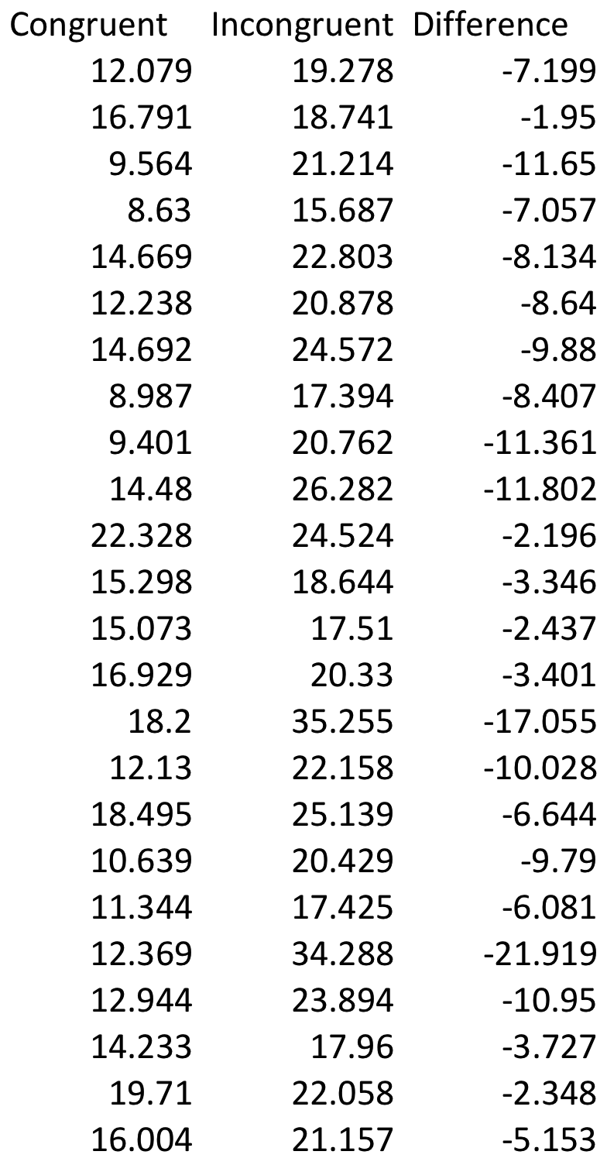

1. Difference between XC and X I : d = XC - X I ; 14.05 – 22.02 = -7.95
2. Standard Error of the Mean Differences: 1.22
3. T-statistic = -7.95/1.22 = -6.52
4. The two-tailed P value is less than 0.0001
5. By conventional criteria, this difference is considered to be extremely statistically significant and we reject the null hypothesis.
6. Therefore, we can conclude that the time it takes to read a list of congruent words does not equal the time to read a list of incongruent words

Resources used:

http://www.quantitativeskills.com/sisa/statistics/t-test.php?mean1=14.05&mean2=22.02&N1=24&N2=24&SD1=3.56&SD2=4.8&CI=95&Submit1=Calculate

https://www.graphpad.com/quickcalcs/ttest2/ http://www.calculatorsoup.com/calculators/statistics/descriptivestatistics.php