**Personal Particulars**

Name: Brian Wong Liang Rui

Gender: Male

Date of Birth: 25/07/1998

Marital Status: Single

Nationality: Singaporean

**Contact Information**

HP: +65 8123 3801, H: Home: 6870 8495

Email: [bwonglr@gmail.com](mailto:bwonglr@gmail.com)

Mailing Address: 32 Dover Rise #10-11 Singapore 138686

**Educational Background**

2011 to 2014 - Fairfield Methodist Secondary School

GCE’ ‘O’ Levels

2015 to present(Expected to graduate in April 2018) - Singapore Polytechnic

Diploma in Information Technology

**Extra Curriculums Activities**

2012 to 2014 Singapore Red Cross Uniform Group

Last Position held: Corporal, squad leader

2013 Red Cross District Competition – Awarded Gold, Part of winning team

2011 to 2013 – Participated in Fairfield Sec Cross Country and provided Red Cross safety station manning

2013 – FMSS Founder Day Parade participation

2013 – Participation in Science Expedition for research to Taiwan for 5 days

2013 – Participated in Outward Bound 3-day leadership camp

**Others**

Hobbies Gym work-outs, listening to all sorts of music, Video games

**Computer Literacy:**

Microsoft Office Suite (Word/Excel/Powerpoint)

Programming languages: Java, CSharp, Java script

Programming Platforms: Visual Studio 2017, Netbeans 8.1

Cloud Computing

Databases: MYSQL, Microsoft SQL Server Express

SCRUM/Agile Design Methodology

**Referees**

To be provided on request

LinkedIn/BrianWong

Facebook.com/BrianWong

Job Search

<https://www.jobstreet.com.sg/en/job/web-designer-5836800?fr=21>

Position: Web Designer

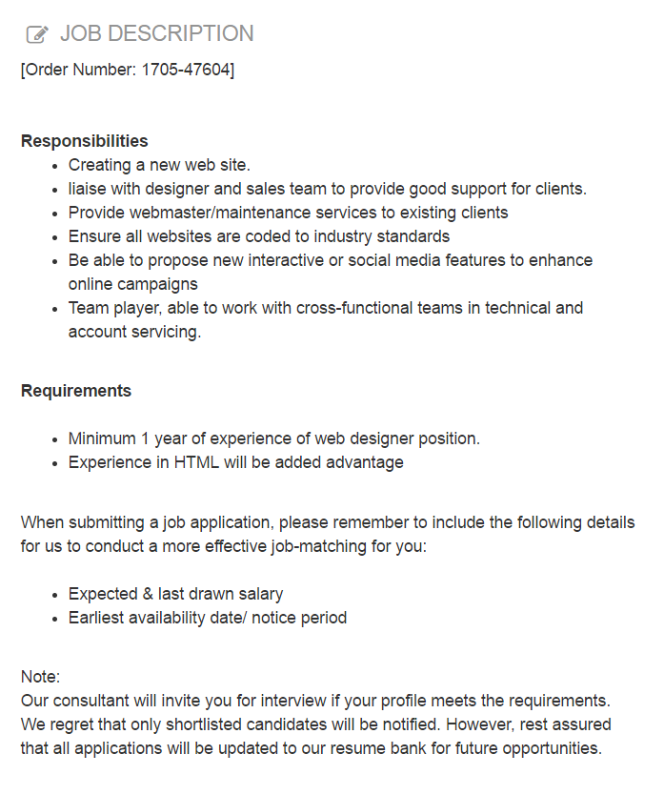

Cover Letter for resume

Dear Advertiser/Human Resource Manager

I read with great interest in your advertised positon of Web Designer posted in the Jobstreet portal on 22 May 2017. I would like to apply for this role as I have the right technical .skill sets and the willingness to learn and adapt to any new environment

I graduated from the Singapore Polytechnic with a Diploma in Information Technology. Among the various IT subjects that I learnt during my Diploma education, Digital Web Design and UX(User Experience)were my favourites and my academic grade was A and B+ respectively. I was fascinated how the world of digital design can transform a passive website into an interactive one. My two web projects, body building portal were testimony of my deep interest in the world of web design.

For the first project, I designed a bodybuilding portal that showcase many different types of exercises that can be found in most popular gyms like Fitness First. My ability to do research was put into good use as I was able to summarised the correct exercise techniques to be used for each of these machines.

For the second project, I revamped a café website Coffee n Toast to improve the user experience besides it lack of interactive features. Besides this, I was able to also develop a mobile version to make the web pages responsive. I acquired [… add details of web programming and UX techniques]

I am confident that with these two portfolio projects which had further enriched my keen interest in web design, I would be an asset to your company and the web design team. I believe a designer must also meet with clients face to face to understand the requirements of the projects from time to time.

I would be most happy to discuss more when we have the chance to meet.

Yours sincerely

Brian Wong