Team: Lunar
Assignment 2
Swathi Kotturu, Akshaya Manhas, Raman Kaur, Brett Wormley
CS 151 Section 2
CRC Cards

ScoreCard
Class Responsibilities
· keeps track of wins
· keeps track of ties
is able to update the number of wins/tie
Collaborators
· Referee

Referee
Class Responsibilities
· determines who won the throw
· tells the ScoreCard to update
determines who won the match
Collaborators
· ScoreCard

Player (abstract)
Class Responsibilities
make a move
Collaborators

Computer Player (extends Player)
Class Responsibilities
makes move
Collaborators

UserPlayer (extends Player)
Class Responsibilities
(make a move) get user input for which object the user wishes to throw
Collaborators
Help

GameController (main class)
Class Responsibilities
displays messages (score, help)
get user input (except UserPlayer prompt for throw)
interprets user input
Collaborators
Referee
Player (UserPlayer and ComputerPlayer -- common interface)
Help

Help
Class Responsibilities
displays help
Collaborators

GameObject
Class Responsibilities
enumerates rock/paper/scissors
returns a descriptive string
Collaborators

Class Diagrams

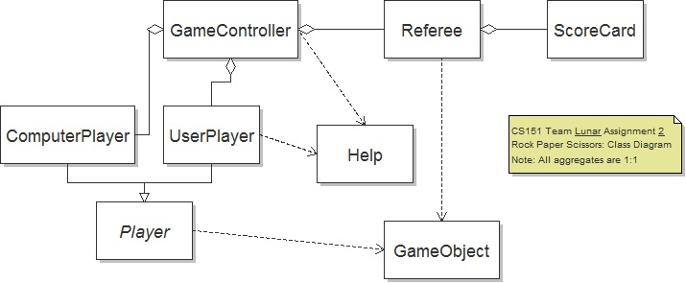
Sequence Diagrams

