In class assignment day 12
Ref. Toro Riemann Solver Ed. 3
Implement the Lax-Friedrich scheme in conservative form, see Toro p185
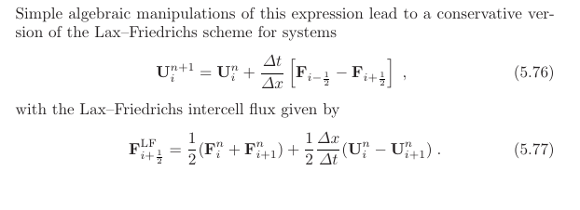
Start with your existing code and make sure to write generic code, i.e., implement a function for F^LF_i+/-1/2 and one function for the F^n_i.
Before starting to code, discuss with your group how array indices/slices are linked to the equations.
Now solve the inviscid Burgers equation, see below, plot and describe your results. Please submit your solution in an jupyter notebook.


