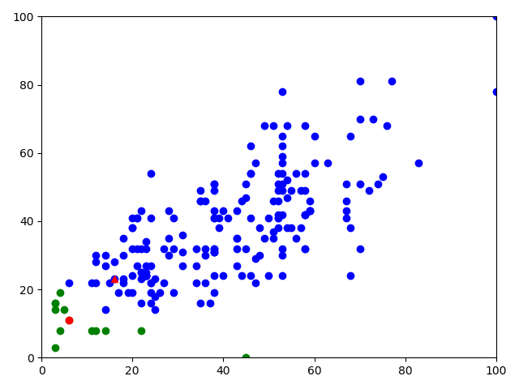Starting Loop

|  |  |
| --- | --- |
| Centroid 1 | |
| (6, 11) |  |
| Centroid 2 | |
| (16, 23) |  |

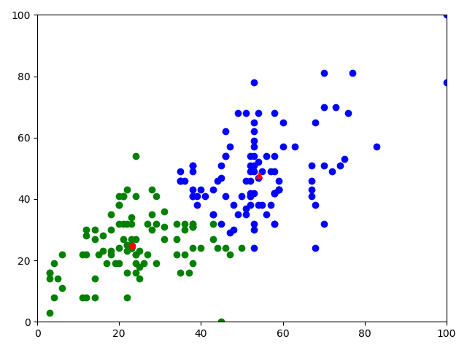

Middle Loop

|  |  |  |  |
| --- | --- | --- | --- |
| Centroid 1 |  |  |  |
| (23.242105263157896, 24.842105263157894) | | | |
| Centroid 2 |  |  |  |
| (54.27619047619048, 47.885714285714286) | | | |

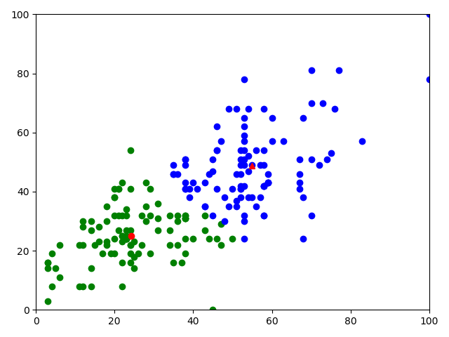Final Loop

|  |
| --- |
| Centroid 1 |
| (24.23, 25.1) |
| Centroid 2 |
| (54.84, 48.78) |

The data was normalized in Excel using min/max normalization. The actual formula used was =ROUND(((E2-MIN(E$2:E$801))/(MAX(E$2:E$801)-MIN(E$2:E$801))*100),0). The code takes the normalized data, puts it into arrays, and iterates through them, assigning points to clusters based on their proximity to centroids, which update after each loop. It ceases to loop once the centroids stop changing.