**PyXRFPower Instruction Manual**

B. Roter ([benjaminroter2026@u.northwestern.edu](mailto:benjaminroter2026@u.northwestern.edu))

Northwestern University

This is the manual for using the PyXRFPower graphical user interface to quickly fit and estimate signal-dependent spatial resolutions of scanning fluorescence X-ray microscope images acquired at synchrotron light sources.

*Directory and File Information*

1. Choose a file (or set of files) to open using the “…” button next to *Current Directory*.
   1. NOTES: As mentioned in the Github *ReadMe*,
      1. For HDF5 files, because synchrotron light sources can store data differently (i.e. have different file structures), if the synchrotron of interest is not available, please email me and provide a sample file so the structure can be included.
      2. MBLANK Matlab files are currently supported, but if using a separate Matlab file structure, please send an email request along with a sample file to have that structure included.
2. Select the desired file from the first drop-down menu to analyze.
   1. NOTE: Make sure the desired units of *all* elemental maps are the same if calibrating beforehand
      1. Spatial resolutions will not be affected, but power spectral density (PSD) profiles will be vertically shifted
3. Select the desired synchrotron (if applicable) from drop-down menu next to *Synchrotron*.

*Image Information*

1. *Image dimensions* for the image are displayed in terms of pixels.
2. *Pixel dimensions* for a single image pixel are displayed in terms of microns (µm).
   1. To use dimensions different from what was recorded in scan data, check the *Use different dimensions* box, and follow the instructions.
      1. NOTE: In general, pixel dimensions should **NOT** be significantly different from each other.
3. Indicate if padding should be used by checking the *Enabled* checkbox next to *Padding*.
   1. Padding will add an extra row and/or column of pixels to each image, and for each image, those extra pixels will have the average value of that image stored in them. This will ensure that the center of each image will be an integer value in terms of pixel indices.
   2. Default: Enabled

*Experimental Setup Information*

1. Indicate if a circular X-ray beam was used (or assumed) by checking the *Enabled* checkbox next to *Circular X-ray Beam*.
   1. Note: If not enabled, separate *x* and *y* power spectral densities (thus, separate *x* and *y* – see resolutions will be calculated instead of a single resolution
   2. Default: Enabled

*Gaussian Edge Smoothing*1

1. Check the *Enabled* box just under *Gaussian Edge Smoothing (Optional)* to enable Gaussian edge filtering to the original image (to smooth out discontinuities at the image edges, thus remove vertical streaks in Fourier space).
   1. Note: This is *optional* if the original image is already filtered (whether via Gaussian edge filtering or another type of edge filtering algorithm).

1. Choose the desired filter parameters (if filtering enabled):
   1. Standard deviation – the width of the Gaussian function (in *pixels*)
      1. Default: 5
   2. Roll-off tuning parameter – how many standard deviations the intensities should roll off to at the image edges
      1. Default: 10

*Radial Frequency Bin Selection*

1. Choose the desired number of radial spatial frequency bins for calculating – the azimuthally averaged power spectral density.1
   1. Default:
      1. number of *x*-direction pixels
      2. number of *y*-direction pixels
      3. Notes:
         1. This is just a *guess* of the optimal number of bins should be. The lower the bin number, the less representative the spectral density will be. The higher the bin number, the “grainer” will be, and the more likely there will be radial spatial frequency bins containing no contributing pixels (see Fig. 1 for profiles using three values of for a calcium map for a biological sample scanned at beamline 8-BM-B at the Advanced Photon Source, for example [unpublished]).
         2. For an anisotropic (non-circular) beam, especially with rectangular fields of view and differing image pixel sizes, the number of radial spatial frequency bins containing pixels that contribute to the overall power spectral densities in *x* and *y* may be different and less than the specified value of . Nevertheless, choosing a A graph with a line and a red line

            Description automatically generated with medium confidencesuitable is still of great importance.

Fig. 1. profiles for a calcium map acquired from a biological sample scanned at beamline 8-BM-B at the APS when tuning radial frequency bin numbers [unpublished]. Much lower values of can lead to less representative power spectral densities, while much higher values of can lead to more “granular” profiles. The value of associated with the red profile was when using the default interface choice of .

*Elemental Image Preview*

1. To preview and visualize elemental images before PSD calculations, click *Preview Elemental Image*.
2. To switch between elemental maps, click on the *Element* drop-down menu to select a different element or use the left and right arrows next to it.
3. To change elemental map contrast, adjust the contrast factor and/or the lower and upper quantiles *LQ* and *UQ* of the map data, respectively.
   1. If intensities are below *LQ*, those values will be mapped to the color corresponding to *LQ* (a similar thing happens for intensities above *UQ*)
   2. Note: Adjusting these parameters are for visualization only and will *not* affect PSD calculations.

1. To change the elemental map orientation by rotating 90° (counter)clockwise and/or flipping vertically and/or horizontally, click on the corresponding buttons and/or checkboxes.

*PSD Calculation*2

1. To calculate both the 2D and azimuthally averaged PSDs and , respectively, and both types of PSDs, click on the *Calculate PSD* button.
   1. spatial frequency in *x*
   2. spatial frequency in *y*
   3. radial spatial frequency
   4. Note: For an anisotropic (non-circular) beam, separate *x* and *y* PSDs and are calculated, respectively.

At this point, two new windows should pop up:

* Elemental image and 2D PSD window
* Element selection window

*Elemental Image and 2D PSD Window*

1. An image/map for the first chemical element signal magnitude will be displayed upon launching, as well as its corresponding plot.
   1. Note: The plots really show , as they are a lot more informative than plotting them on absolute scales.

1. To view a different elemental map and , either select a different element from the drop-down menu at the top of the window or click either arrow button next to the drop-down menu.
2. To reopen this window if it gets closed, in the menu bar, click *View* 🡪 *View 2D Plots*.
   1. Note: This *excludes* if the *Calculate PSD* button is clicked after the first time.

*Element Selection Window*

1. A window containing list of different elements one can select for viewing and fitting purposes (see *Azimuthal PSD Fitting* for more on the latter) will be displayed immediately after PSD calculations.
   1. Up to *ten* different elements can be selected at a time.

*Azimuthal PSD Plot Window*

NOTE: With respect to azimuthally averaged PSDs, while only the isotropic beam case is discussed, i.e. , the instructions also apply to the anisotropic beam case, i.e. *x* and *y* azimuthal PSDs and and *x* and *y* resolutions and , respectively.

1. Once either the *OK* or *Cancel* buttons are clicked, a new window containing an azimuthal PSD plot will be created.
   1. If the *OK* button is clicked, all selected element azimuthal PSD curves will be displayed simultaneously.
      1. The PSD profiles are color-coded, and their corresponding elements are displayed as plot text using the same colors.
      2. NOTE: For the anisotropic beam case, the spatial frequency extents for *x* and *y* may be different depending on real space pixel sizes
   2. If the *Cancel* button is clicked, the plot will be empty.

1. To select a different set of elements, click the *Select Element(s)* button toward the bottom-left corner of the window.

1. To reopen this window if it gets closed, in the menu bar, click *View* 🡪 *View Azimuthal PSD Plot*.
   1. Note: This *excludes* if the *Calculate PSD* button is clicked after the first time.

*Azimuthal PSD Fitting*

1. To create linear and horizontal fits to the azimuthal PSD plot for purposes of estimating image spatial resolutions, click on the *Create Linear and Horizontal Fits* button next to the *Select Element(s)* button to start the process.

1. Follow the instructions given toward the top of the window to know which type of fit to create, as well as for what selected element.
2. To create a fit, click and drag to select points in a region of interest.
   1. For resolution calculation purposes, select points that are in regions whose maximum selected frequency (for *data trend fitting*) and minimum selected frequency (for *noise floor fitting*) are *just below and above* the knee frequency, respectively.
      1. See Step 26 for further justification.

1. Some notes about and linear fitting on a log-log scale (see Fig. 2 for an illustration):
   1. Image signals tend to decline as approximate power laws (i.e., , where *m* < 0 is the power law constant) in Fourier space on a linear scale, meaning they tend to decline linearly on a log-log scale (thus, *m* is the slope of in log-log space) [1].
   2. At a certain frequency – the *knee frequency* , there will only be a noise signal, and will flatten out a constant, non-zero value – the *noise floor*
      1. In other words,
      2. Note: This assumes either that only Poisson noise exists in the image or Poisson noise dominates other types of noise present
2. Once a region is selected, if necessary, click and drag the box that is created and/or click and drag the left or right edges to either expand or compress the chosen region.
   1. The left and right edges of the box should turn *red* when hovering over them.

1. After region selection satisfaction, click the *Apply Fit* button to calculate:
   1. For data trend fitting:
      1. *m*
      2. Vertical intercept
   2. For noise floor fitting: Vertical intercept

1. To further tune the above parameter(s), repeat Steps 25, 27, and 28.
2. When satisfied with the parameters for a given fit and element, click the *Select Noise Floor Points* (or *Select Data Trend Points* if using a non-circular X-ray beam)button to proceed to the next type of fit (and element, if applicable).
3. Repeat Steps 24, 25, and 27-30 until the *Finish* button lights up, and click *Finish* to conclude fitting.
4. At the bottom of the fitting window next to *Resolution-Determining SNR Cutoff*, type in an acceptable SNR cutoff, and click *Calculate Image Resolution*
   1. Estimating spatial resolutions at (i.e. image SNR cutoff = 1) is not very representative since there are about equal contributions between signal and noise.
   2. Default: 5 (per the *Rose criterion*)
      1. Rose criterion – the result of an “early-TV-and-film-days” survey that said that an image SNR of 5 (i.e. ) was acceptable enough for humans at the time (i.e. an arbitrary, subjective decision) [2]
   3. Note: SNR, in this case, is assumed to be defined as the ratio of signal to noise *powers* (*not amplitudes*)

At this point:

* The plot should show curves for all selected elements, as well as their corresponding linear and horizontal fits (see Fig. 2 for the sample used for Fig. 1 for an example).
* An *Azimuthal PSD Slope and Resolution Output* window should pop up.

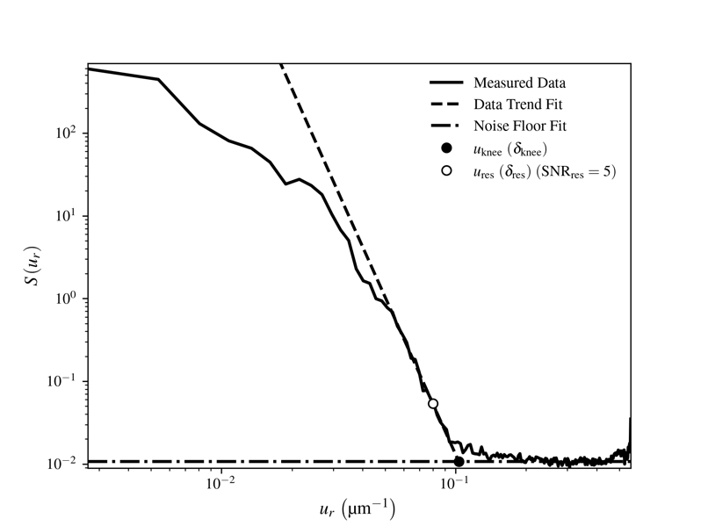

0.080 µm–1 (6.3 µm)

0.10 µm–1 (4.9 µm)

Fig. 2. Fitted profile for calcium (). The “data trend” fit approximates the power law decay in fluorescence signal *just before* the signal turns completely into noise (i.e. reaches the “knee”), and the “noise floor fit” approximates the constant power spectral density of the Poisson noise at spatial frequencies above the knee. The spatial resolution at the knee (where the signal-to-noise ratio/SNR cutoff is 1) is shown, but resolutions corresponding to a higher SNR cutoff (in this case, the SNR cutoff was chosen to be 5, as per the Rose criterion) are more representative since there are smaller contributions from noise [2].

*Azimuthal PSD Slope and Resolution Output Window*

1. A window containing a table listing each selected element and their corresponding values of , cutoff spatial frequency ( is a constant), and half-period, real space image resolution will be displayed immediately after clicking the *Finish* button in the *Azimuthal PSD* window.
2. To reopen this window if it gets closed, in the menu bar, click *View* 🡪 *View Azimuthal PSD Slope and Resolution Outputs*.
   1. Note: This *excludes* if the *Calculate PSD* button is clicked after the first time.

*Batch Exporting 2D Plots and Data*

1. To batch export elemental images, their corresponding images, and their corresponding data arrays to SVG and CSV files, respectively, click the *Batch Export* button in the bottom left corner of the *Elemental Image and 2D PSD* window and follow the instructions.
   1. There will be two folders created that will store the 2D and radial PSD plots and data:
      1. *elemental_images*
         1. The default file names are:
            1. *el_img_*\**name of input file*\**_*\**element name*\**.svg*
            2. *el_img_data_*name of input file*_*element name*.csv*
      2. *2d_psd_plots*
         1. The default file names are:
            1. *psd_2d_*\**name of input file*\**_*\**element name*\**.svg*
            2. *psd_2d_data_*name of input file*_*element name*.csv*
   2. The images will be of , while the data will be of the *absolute* data.
2. To export the plot containing the curves for each selected element, their corresponding linear and horizontal fits, and their fit and resolution outputs, click the *Export* button at the bottom right corner of the *Azimuthal PSD Plot* window, and follow the instructions.
   1. There will be a folder created called *psd_a* that will store:
      1. All selected element PSD plots and their fits.
         1. *psd_a_*name of input file*_*element name*.svg*
      2. All selected element PSD plot and fit data, as well as all parameters discussed previously.
         1. *psd_a_data_*name of input file*_*element name*.csv*
      3. A summary of all selected element values for , , and .
         1. *psd_a_slope_res_outputs_*name of input file*_*element name*.csv*
3. To export plots containing and profiles, as well as their corresponding data files, the same types of files will be generated when following Step 36; however, *xy* will appear in the file names.
4. An important note: There is ***NO*** warning about a certain file name already existing – they *will be overwritten* if the same file name is used!

*Final Comment*

If the *Preview Elemental Image* button is clicked at all after initial PSD computations, *all succeeding data, i.e. fits and resolution calculations, will disappear!*

*References*

[1] C. Jacobsen, *X-ray Microscopy* (Cambridge University Press, 2020).

[2] A. Rose, J. Soc. Motion Pic. Eng. **47**, 273 (1946).

*Footnotes*

1The edge filter code was adapted from IDL code written by C. Jacobsen and B. Hoernberger (1998).

2The PSD calculation code was adapted from IDL code written by C. Jacobsen and B. Hoernberger (1998).