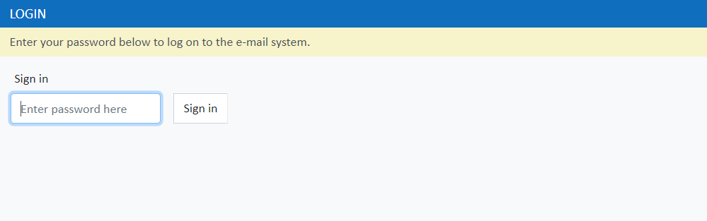

Figure : Email system Login page

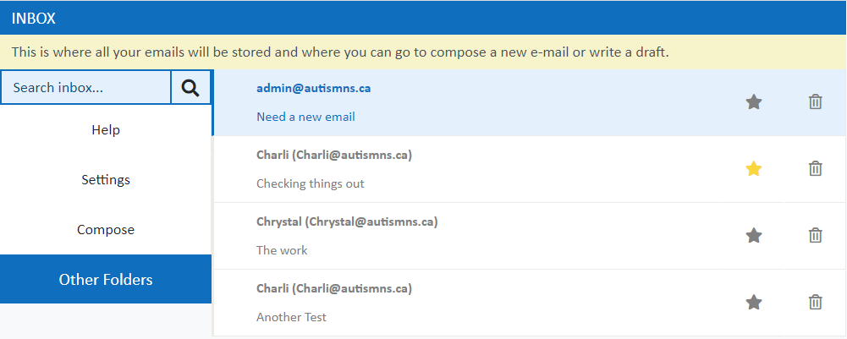

Figure : Email system Inbox page. The user’s emails are displayed here and they are able to view, favourite, delete or compose emails. The interface is the same for admin and student

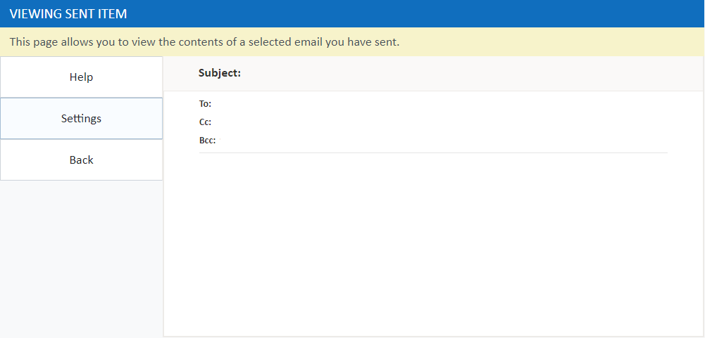

Figure : Email system View Email page. This page has the same interface for admin and student, and also for sent and received emails. This page displays the contents of a selected email

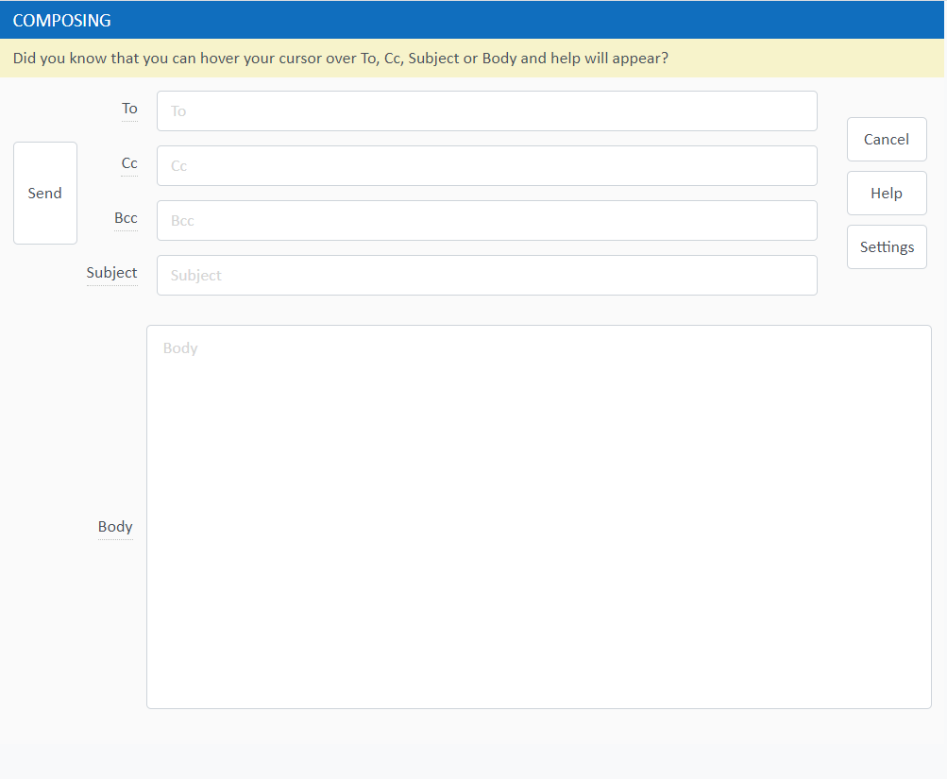

Figure : Email system Compose page. This is the area for writing new e-mails. The interface is the same for admin and students, but the student page has certain features that can be toggled on and off.

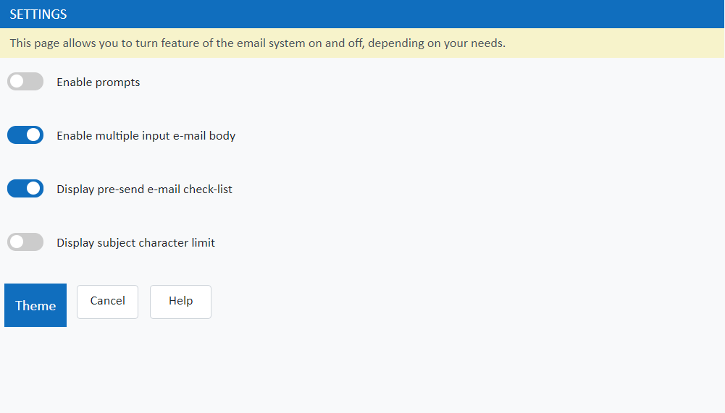

Figure 5: Email system Student Settings page. From this page the student is able to adjust the system for different levels of familiarity with email systems. The student can also change the system’s theme from this page.

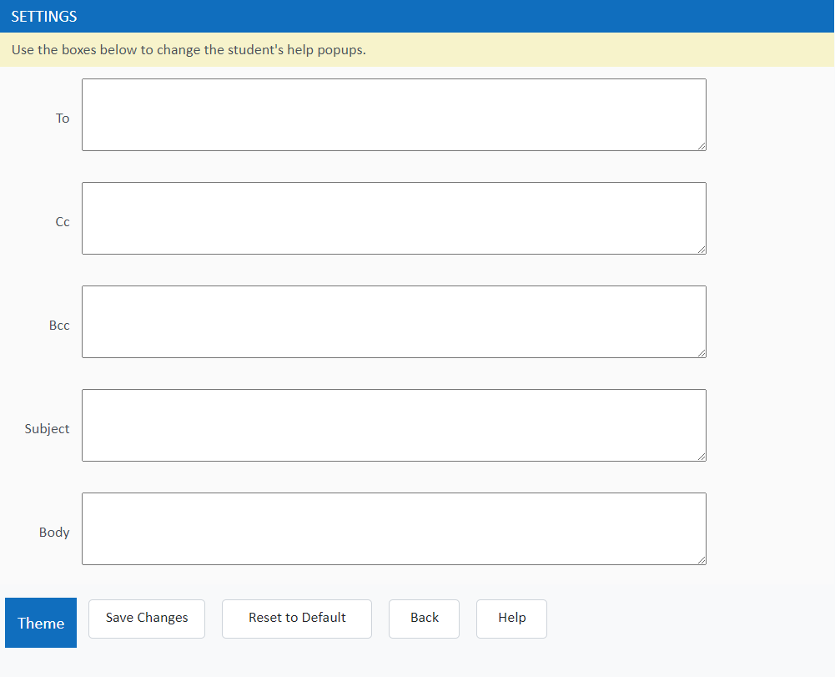

Figure 6: Email system Admin Settings page. From this page the admin is able to change the popup messages that will be displayed to the student when composing an email, as well as change the system's theme.