chapter3_figures

BWSchroeter

2023-06-23

library(knitr)  
library(kableExtra)

##   
## Attaching package: 'dplyr'

## The following object is masked from 'package:kableExtra':  
##   
## group_rows

## The following objects are masked from 'package:stats':  
##   
## filter, lag

## The following objects are masked from 'package:base':  
##   
## intersect, setdiff, setequal, union

##   
## Attaching package: 'tidyr'

## The following object is masked from 'package:reshape2':  
##   
## smiths

## 'data.frame': 24 obs. of 3 variables:  
## $ V1 : chr "BS01" "BS02" "BS03" "BS04" ...  
## $ Sample : chr "LaH0_1" "LaH0_2" "LaH0_3" "LaH18_1" ...  
## $ SamplingTime: chr "0 hpi" "0 hpi" "0 hpi" "18 hpi" ...  
## <table class="table" style="margin-left: auto; margin-right: auto;">  
## <thead>  
## <tr>  
## <th style="empty-cells: hide;border-bottom:hidden;" colspan="5"></th>  
## <th style="border-bottom:hidden;padding-bottom:0; padding-left:3px;padding-right:3px;text-align: center; font-weight: bold; font-style: italic; " colspan="2"><div style="border-bottom: 1px solid #ddd; padding-bottom: 5px; ">Phytophthora cinnamomi</div></th>  
## <th style="border-bottom:hidden;padding-bottom:0; padding-left:3px;padding-right:3px;text-align: center; font-weight: bold; font-style: italic; " colspan="2"><div style="border-bottom: 1px solid #ddd; padding-bottom: 5px; ">Lupinus angustifolius</div></th>  
## </tr>  
## <tr>  
## <th style="text-align:center;"> Accession </th>  
## <th style="text-align:center;"> Sample name </th>  
## <th style="text-align:center;"> Sampling time </th>  
## <th style="text-align:center;"> Total reads </th>  
## <th style="text-align:center;"> Total mapped reads </th>  
## <th style="text-align:center;"> Mapped reads </th>  
## <th style="text-align:center;"> Mapped reads (%) </th>  
## <th style="text-align:center;"> Mapped reads </th>  
## <th style="text-align:center;"> Mapped reads (%) </th>  
## </tr>  
## </thead>  
## <tbody>  
## <tr grouplength="12"><td colspan="9" style="border-bottom: 1px solid;"><strong>Water controls</strong></td></tr>  
## <tr>  
## <td style="text-align:center;padding-left: 2em;" indentlevel="1"> BS01_S2 </td>  
## <td style="text-align:center;"> LaH0_1 </td>  
## <td style="text-align:center;"> 0 hpi </td>  
## <td style="text-align:center;"> 35,723,772 </td>  
## <td style="text-align:center;"> 30,381,762 </td>  
## <td style="text-align:center;"> 7 </td>  
## <td style="text-align:center;"> 0.00 </td>  
## <td style="text-align:center;"> 30,381,755 </td>  
## <td style="text-align:center;"> 100.00 </td>  
## </tr>  
## <tr>  
## <td style="text-align:center;padding-left: 2em;" indentlevel="1"> BS02_S3 </td>  
## <td style="text-align:center;"> LaH0_2 </td>  
## <td style="text-align:center;"> 0 hpi </td>  
## <td style="text-align:center;"> 40,589,157 </td>  
## <td style="text-align:center;"> 33,832,923 </td>  
## <td style="text-align:center;"> 15 </td>  
## <td style="text-align:center;"> 0.00 </td>  
## <td style="text-align:center;"> 33,832,908 </td>  
## <td style="text-align:center;"> 100.00 </td>  
## </tr>  
## <tr>  
## <td style="text-align:center;padding-left: 2em;" indentlevel="1"> BS03_S4 </td>  
## <td style="text-align:center;"> LaH0_3 </td>  
## <td style="text-align:center;"> 0 hpi </td>  
## <td style="text-align:center;"> 41,987,225 </td>  
## <td style="text-align:center;"> 35,747,378 </td>  
## <td style="text-align:center;"> 12 </td>  
## <td style="text-align:center;"> 0.00 </td>  
## <td style="text-align:center;"> 35,747,366 </td>  
## <td style="text-align:center;"> 100.00 </td>  
## </tr>  
## <tr>  
## <td style="text-align:center;padding-left: 2em;" indentlevel="1"> BS04_S5 </td>  
## <td style="text-align:center;"> LaH18_1 </td>  
## <td style="text-align:center;"> 18 hpi </td>  
## <td style="text-align:center;"> 40,946,170 </td>  
## <td style="text-align:center;"> 34,126,704 </td>  
## <td style="text-align:center;"> 48 </td>  
## <td style="text-align:center;"> 0.00 </td>  
## <td style="text-align:center;"> 34,126,656 </td>  
## <td style="text-align:center;"> 100.00 </td>  
## </tr>  
## <tr>  
## <td style="text-align:center;padding-left: 2em;" indentlevel="1"> BS05_S6 </td>  
## <td style="text-align:center;"> LaH18_2 </td>  
## <td style="text-align:center;"> 18 hpi </td>  
## <td style="text-align:center;"> 52,569,117 </td>  
## <td style="text-align:center;"> 43,993,443 </td>  
## <td style="text-align:center;"> 18 </td>  
## <td style="text-align:center;"> 0.00 </td>  
## <td style="text-align:center;"> 43,993,425 </td>  
## <td style="text-align:center;"> 100.00 </td>  
## </tr>  
## <tr>  
## <td style="text-align:center;padding-left: 2em;" indentlevel="1"> BS06_S7 </td>  
## <td style="text-align:center;"> LaH18_3 </td>  
## <td style="text-align:center;"> 18 hpi </td>  
## <td style="text-align:center;"> 46,878,736 </td>  
## <td style="text-align:center;"> 39,131,548 </td>  
## <td style="text-align:center;"> 9 </td>  
## <td style="text-align:center;"> 0.00 </td>  
## <td style="text-align:center;"> 39,131,539 </td>  
## <td style="text-align:center;"> 100.00 </td>  
## </tr>  
## <tr>  
## <td style="text-align:center;padding-left: 2em;" indentlevel="1"> BS07_S8 </td>  
## <td style="text-align:center;"> LaH30_1 </td>  
## <td style="text-align:center;"> 30 hpi </td>  
## <td style="text-align:center;"> 35,807,174 </td>  
## <td style="text-align:center;"> 29,964,327 </td>  
## <td style="text-align:center;"> 159 </td>  
## <td style="text-align:center;"> 0.00 </td>  
## <td style="text-align:center;"> 29,964,168 </td>  
## <td style="text-align:center;"> 100.00 </td>  
## </tr>  
## <tr>  
## <td style="text-align:center;padding-left: 2em;" indentlevel="1"> BS08_S9 </td>  
## <td style="text-align:center;"> LaH30_2 </td>  
## <td style="text-align:center;"> 30 hpi </td>  
## <td style="text-align:center;"> 42,997,642 </td>  
## <td style="text-align:center;"> 35,706,355 </td>  
## <td style="text-align:center;"> 32 </td>  
## <td style="text-align:center;"> 0.00 </td>  
## <td style="text-align:center;"> 35,706,323 </td>  
## <td style="text-align:center;"> 100.00 </td>  
## </tr>  
## <tr>  
## <td style="text-align:center;padding-left: 2em;" indentlevel="1"> BS09_S10 </td>  
## <td style="text-align:center;"> LaH30_3 </td>  
## <td style="text-align:center;"> 30 hpi </td>  
## <td style="text-align:center;"> 32,647,597 </td>  
## <td style="text-align:center;"> 27,275,505 </td>  
## <td style="text-align:center;"> 24 </td>  
## <td style="text-align:center;"> 0.00 </td>  
## <td style="text-align:center;"> 27,275,481 </td>  
## <td style="text-align:center;"> 100.00 </td>  
## </tr>  
## <tr>  
## <td style="text-align:center;padding-left: 2em;" indentlevel="1"> BS10_S11 </td>  
## <td style="text-align:center;"> LaH48_1 </td>  
## <td style="text-align:center;"> 48 hpi </td>  
## <td style="text-align:center;"> 44,416,982 </td>  
## <td style="text-align:center;"> 36,614,529 </td>  
## <td style="text-align:center;"> 8 </td>  
## <td style="text-align:center;"> 0.00 </td>  
## <td style="text-align:center;"> 36,614,521 </td>  
## <td style="text-align:center;"> 100.00 </td>  
## </tr>  
## <tr>  
## <td style="text-align:center;padding-left: 2em;" indentlevel="1"> BS11_S12 </td>  
## <td style="text-align:center;"> LaH48_2 </td>  
## <td style="text-align:center;"> 48 hpi </td>  
## <td style="text-align:center;"> 34,172,572 </td>  
## <td style="text-align:center;"> 19,074,043 </td>  
## <td style="text-align:center;"> 126 </td>  
## <td style="text-align:center;"> 0.00 </td>  
## <td style="text-align:center;"> 19,073,917 </td>  
## <td style="text-align:center;"> 100.00 </td>  
## </tr>  
## <tr>  
## <td style="text-align:center;padding-left: 2em;" indentlevel="1"> BS12_S13 </td>  
## <td style="text-align:center;"> LaH48_3 </td>  
## <td style="text-align:center;"> 48 hpi </td>  
## <td style="text-align:center;"> 36,024,194 </td>  
## <td style="text-align:center;"> 28,807,216 </td>  
## <td style="text-align:center;"> 9 </td>  
## <td style="text-align:center;"> 0.00 </td>  
## <td style="text-align:center;"> 28,807,207 </td>  
## <td style="text-align:center;"> 100.00 </td>  
## </tr>  
## <tr grouplength="3"><td colspan="9" style="border-bottom: 1px solid;"><strong>Hyphae controls</strong></td></tr>  
## <tr>  
## <td style="text-align:center;padding-left: 2em;" indentlevel="1"> BS13_S14 </td>  
## <td style="text-align:center;"> PcHyp_1 </td>  
## <td style="text-align:center;"> 0 hpi </td>  
## <td style="text-align:center;"> 46,476,987 </td>  
## <td style="text-align:center;"> 35,095,780 </td>  
## <td style="text-align:center;"> 35,095,057 </td>  
## <td style="text-align:center;"> 100.00 </td>  
## <td style="text-align:center;"> 723 </td>  
## <td style="text-align:center;"> 0.00 </td>  
## </tr>  
## <tr>  
## <td style="text-align:center;padding-left: 2em;" indentlevel="1"> BS14_S15 </td>  
## <td style="text-align:center;"> PcHyp_2 </td>  
## <td style="text-align:center;"> 0 hpi </td>  
## <td style="text-align:center;"> 42,719,153 </td>  
## <td style="text-align:center;"> 31,942,184 </td>  
## <td style="text-align:center;"> 31,940,908 </td>  
## <td style="text-align:center;"> 100.00 </td>  
## <td style="text-align:center;"> 1,276 </td>  
## <td style="text-align:center;"> 0.00 </td>  
## </tr>  
## <tr>  
## <td style="text-align:center;padding-left: 2em;" indentlevel="1"> BS15_S16 </td>  
## <td style="text-align:center;"> PcHyp_3 </td>  
## <td style="text-align:center;"> 0 hpi </td>  
## <td style="text-align:center;"> 42,953,852 </td>  
## <td style="text-align:center;"> 33,309,346 </td>  
## <td style="text-align:center;"> 33,308,551 </td>  
## <td style="text-align:center;"> 100.00 </td>  
## <td style="text-align:center;"> 795 </td>  
## <td style="text-align:center;"> 0.00 </td>  
## </tr>  
## <tr grouplength="9"><td colspan="9" style="border-bottom: 1px solid;"><em><strong>in planta</strong></em></td></tr>  
## <tr>  
## <td style="text-align:center;padding-left: 2em;" indentlevel="1"> BS16_S17 </td>  
## <td style="text-align:center;"> LaPc18_1 </td>  
## <td style="text-align:center;"> 18 hpi </td>  
## <td style="text-align:center;"> 42,095,147 </td>  
## <td style="text-align:center;"> 35,019,695 </td>  
## <td style="text-align:center;"> 592,912 </td>  
## <td style="text-align:center;"> 1.69 </td>  
## <td style="text-align:center;"> 34,426,783 </td>  
## <td style="text-align:center;"> 98.31 </td>  
## </tr>  
## <tr>  
## <td style="text-align:center;padding-left: 2em;" indentlevel="1"> BS17_S18 </td>  
## <td style="text-align:center;"> LaPc18_2 </td>  
## <td style="text-align:center;"> 18 hpi </td>  
## <td style="text-align:center;"> 39,508,572 </td>  
## <td style="text-align:center;"> 32,954,524 </td>  
## <td style="text-align:center;"> 910,867 </td>  
## <td style="text-align:center;"> 2.76 </td>  
## <td style="text-align:center;"> 32,043,657 </td>  
## <td style="text-align:center;"> 97.24 </td>  
## </tr>  
## <tr>  
## <td style="text-align:center;padding-left: 2em;" indentlevel="1"> BS18_S19 </td>  
## <td style="text-align:center;"> LaPc18_3 </td>  
## <td style="text-align:center;"> 18 hpi </td>  
## <td style="text-align:center;"> 51,975,816 </td>  
## <td style="text-align:center;"> 42,950,048 </td>  
## <td style="text-align:center;"> 283,922 </td>  
## <td style="text-align:center;"> 0.66 </td>  
## <td style="text-align:center;"> 42,666,126 </td>  
## <td style="text-align:center;"> 99.34 </td>  
## </tr>  
## <tr>  
## <td style="text-align:center;padding-left: 2em;" indentlevel="1"> BS19_S20 </td>  
## <td style="text-align:center;"> LaPc30_1 </td>  
## <td style="text-align:center;"> 30 hpi </td>  
## <td style="text-align:center;"> 46,398,841 </td>  
## <td style="text-align:center;"> 38,122,434 </td>  
## <td style="text-align:center;"> 5,175,589 </td>  
## <td style="text-align:center;"> 13.58 </td>  
## <td style="text-align:center;"> 32,946,845 </td>  
## <td style="text-align:center;"> 86.42 </td>  
## </tr>  
## <tr>  
## <td style="text-align:center;padding-left: 2em;" indentlevel="1"> BS20_S21 </td>  
## <td style="text-align:center;"> LaPc30_2 </td>  
## <td style="text-align:center;"> 30 hpi </td>  
## <td style="text-align:center;"> 40,758,992 </td>  
## <td style="text-align:center;"> 33,559,178 </td>  
## <td style="text-align:center;"> 4,558,646 </td>  
## <td style="text-align:center;"> 13.58 </td>  
## <td style="text-align:center;"> 29,000,532 </td>  
## <td style="text-align:center;"> 86.42 </td>  
## </tr>  
## <tr>  
## <td style="text-align:center;padding-left: 2em;" indentlevel="1"> BS21_S22 </td>  
## <td style="text-align:center;"> LaPc30_3 </td>  
## <td style="text-align:center;"> 30 hpi </td>  
## <td style="text-align:center;"> 40,230,471 </td>  
## <td style="text-align:center;"> 33,263,922 </td>  
## <td style="text-align:center;"> 2,015,833 </td>  
## <td style="text-align:center;"> 6.06 </td>  
## <td style="text-align:center;"> 31,248,089 </td>  
## <td style="text-align:center;"> 93.94 </td>  
## </tr>  
## <tr>  
## <td style="text-align:center;padding-left: 2em;" indentlevel="1"> BS22_S23 </td>  
## <td style="text-align:center;"> LaPc48_1 </td>  
## <td style="text-align:center;"> 48 hpi </td>  
## <td style="text-align:center;"> 43,617,213 </td>  
## <td style="text-align:center;"> 34,877,458 </td>  
## <td style="text-align:center;"> 7,588,897 </td>  
## <td style="text-align:center;"> 21.76 </td>  
## <td style="text-align:center;"> 27,288,561 </td>  
## <td style="text-align:center;"> 78.24 </td>  
## </tr>  
## <tr>  
## <td style="text-align:center;padding-left: 2em;" indentlevel="1"> BS23_S24 </td>  
## <td style="text-align:center;"> LaPc48_2 </td>  
## <td style="text-align:center;"> 48 hpi </td>  
## <td style="text-align:center;"> 43,018,344 </td>  
## <td style="text-align:center;"> 34,583,412 </td>  
## <td style="text-align:center;"> 11,549,374 </td>  
## <td style="text-align:center;"> 33.40 </td>  
## <td style="text-align:center;"> 23,034,038 </td>  
## <td style="text-align:center;"> 66.60 </td>  
## </tr>  
## <tr>  
## <td style="text-align:center;padding-left: 2em;" indentlevel="1"> BS24_S25 </td>  
## <td style="text-align:center;"> LaPc48_3 </td>  
## <td style="text-align:center;"> 48 hpi </td>  
## <td style="text-align:center;"> 43,357,443 </td>  
## <td style="text-align:center;"> 34,541,507 </td>  
## <td style="text-align:center;"> 8,934,234 </td>  
## <td style="text-align:center;"> 25.87 </td>  
## <td style="text-align:center;"> 25,607,273 </td>  
## <td style="text-align:center;"> 74.13 </td>  
## </tr>  
## </tbody>  
## </table><table class="table" style="margin-left: auto; margin-right: auto;">  
## <thead>  
## <tr>  
## <th style="empty-cells: hide;border-bottom:hidden;" colspan="5"></th>  
## <th style="border-bottom:hidden;padding-bottom:0; padding-left:3px;padding-right:3px;text-align: center; font-weight: bold; font-style: italic; " colspan="2"><div style="border-bottom: 1px solid #ddd; padding-bottom: 5px; ">Phytophthora cinnamomi</div></th>  
## <th style="border-bottom:hidden;padding-bottom:0; padding-left:3px;padding-right:3px;text-align: center; font-weight: bold; font-style: italic; " colspan="2"><div style="border-bottom: 1px solid #ddd; padding-bottom: 5px; ">Lupinus angustifolius</div></th>  
## </tr>  
## <tr>  
## <th style="text-align:center;"> Accession </th>  
## <th style="text-align:center;"> Sample name </th>  
## <th style="text-align:center;"> Sampling time </th>  
## <th style="text-align:center;"> Total reads </th>  
## <th style="text-align:center;"> Total mapped reads </th>  
## <th style="text-align:center;"> Mapped reads </th>  
## <th style="text-align:center;"> Mapped reads (%) </th>  
## <th style="text-align:center;"> Mapped reads </th>  
## <th style="text-align:center;"> Mapped reads (%) </th>  
## </tr>  
## </thead>  
## <tbody>  
## <tr grouplength="3"><td colspan="9" style="border-bottom: 1px solid;"><strong>Hyphae controls</strong></td></tr>  
## <tr>  
## <td style="text-align:center;padding-left: 2em;" indentlevel="1"> BS13_S14 </td>  
## <td style="text-align:center;"> PcHyp_1 </td>  
## <td style="text-align:center;"> 0 hpi </td>  
## <td style="text-align:center;"> 46476987 </td>  
## <td style="text-align:center;"> 35095780 </td>  
## <td style="text-align:center;"> 35095057 </td>  
## <td style="text-align:center;"> 100.00 </td>  
## <td style="text-align:center;"> 723 </td>  
## <td style="text-align:center;"> 0.00 </td>  
## </tr>  
## <tr>  
## <td style="text-align:center;padding-left: 2em;" indentlevel="1"> BS14_S15 </td>  
## <td style="text-align:center;"> PcHyp_2 </td>  
## <td style="text-align:center;"> 0 hpi </td>  
## <td style="text-align:center;"> 42719153 </td>  
## <td style="text-align:center;"> 31942184 </td>  
## <td style="text-align:center;"> 31940908 </td>  
## <td style="text-align:center;"> 100.00 </td>  
## <td style="text-align:center;"> 1276 </td>  
## <td style="text-align:center;"> 0.00 </td>  
## </tr>  
## <tr>  
## <td style="text-align:center;padding-left: 2em;" indentlevel="1"> BS15_S16 </td>  
## <td style="text-align:center;"> PcHyp_3 </td>  
## <td style="text-align:center;"> 0 hpi </td>  
## <td style="text-align:center;"> 42953852 </td>  
## <td style="text-align:center;"> 33309346 </td>  
## <td style="text-align:center;"> 33308551 </td>  
## <td style="text-align:center;"> 100.00 </td>  
## <td style="text-align:center;"> 795 </td>  
## <td style="text-align:center;"> 0.00 </td>  
## </tr>  
## <tr grouplength="9"><td colspan="9" style="border-bottom: 1px solid;"><em><strong>in planta</strong></em></td></tr>  
## <tr>  
## <td style="text-align:center;padding-left: 2em;" indentlevel="1"> BS16_S17 </td>  
## <td style="text-align:center;"> LaPc18_1 </td>  
## <td style="text-align:center;"> 18 hpi </td>  
## <td style="text-align:center;"> 42095147 </td>  
## <td style="text-align:center;"> 35019695 </td>  
## <td style="text-align:center;"> 592912 </td>  
## <td style="text-align:center;"> 1.69 </td>  
## <td style="text-align:center;"> 34426783 </td>  
## <td style="text-align:center;"> 98.31 </td>  
## </tr>  
## <tr>  
## <td style="text-align:center;padding-left: 2em;" indentlevel="1"> BS17_S18 </td>  
## <td style="text-align:center;"> LaPc18_2 </td>  
## <td style="text-align:center;"> 18 hpi </td>  
## <td style="text-align:center;"> 39508572 </td>  
## <td style="text-align:center;"> 32954524 </td>  
## <td style="text-align:center;"> 910867 </td>  
## <td style="text-align:center;"> 2.76 </td>  
## <td style="text-align:center;"> 32043657 </td>  
## <td style="text-align:center;"> 97.24 </td>  
## </tr>  
## <tr>  
## <td style="text-align:center;padding-left: 2em;" indentlevel="1"> BS18_S19 </td>  
## <td style="text-align:center;"> LaPc18_3 </td>  
## <td style="text-align:center;"> 18 hpi </td>  
## <td style="text-align:center;"> 51975816 </td>  
## <td style="text-align:center;"> 42950048 </td>  
## <td style="text-align:center;"> 283922 </td>  
## <td style="text-align:center;"> 0.66 </td>  
## <td style="text-align:center;"> 42666126 </td>  
## <td style="text-align:center;"> 99.34 </td>  
## </tr>  
## <tr>  
## <td style="text-align:center;padding-left: 2em;" indentlevel="1"> BS19_S20 </td>  
## <td style="text-align:center;"> LaPc30_1 </td>  
## <td style="text-align:center;"> 30 hpi </td>  
## <td style="text-align:center;"> 46398841 </td>  
## <td style="text-align:center;"> 38122434 </td>  
## <td style="text-align:center;"> 5175589 </td>  
## <td style="text-align:center;"> 13.58 </td>  
## <td style="text-align:center;"> 32946845 </td>  
## <td style="text-align:center;"> 86.42 </td>  
## </tr>  
## <tr>  
## <td style="text-align:center;padding-left: 2em;" indentlevel="1"> BS20_S21 </td>  
## <td style="text-align:center;"> LaPc30_2 </td>  
## <td style="text-align:center;"> 30 hpi </td>  
## <td style="text-align:center;"> 40758992 </td>  
## <td style="text-align:center;"> 33559178 </td>  
## <td style="text-align:center;"> 4558646 </td>  
## <td style="text-align:center;"> 13.58 </td>  
## <td style="text-align:center;"> 29000532 </td>  
## <td style="text-align:center;"> 86.42 </td>  
## </tr>  
## <tr>  
## <td style="text-align:center;padding-left: 2em;" indentlevel="1"> BS21_S22 </td>  
## <td style="text-align:center;"> LaPc30_3 </td>  
## <td style="text-align:center;"> 30 hpi </td>  
## <td style="text-align:center;"> 40230471 </td>  
## <td style="text-align:center;"> 33263922 </td>  
## <td style="text-align:center;"> 2015833 </td>  
## <td style="text-align:center;"> 6.06 </td>  
## <td style="text-align:center;"> 31248089 </td>  
## <td style="text-align:center;"> 93.94 </td>  
## </tr>  
## <tr>  
## <td style="text-align:center;padding-left: 2em;" indentlevel="1"> BS22_S23 </td>  
## <td style="text-align:center;"> LaPc48_1 </td>  
## <td style="text-align:center;"> 48 hpi </td>  
## <td style="text-align:center;"> 43617213 </td>  
## <td style="text-align:center;"> 34877458 </td>  
## <td style="text-align:center;"> 7588897 </td>  
## <td style="text-align:center;"> 21.76 </td>  
## <td style="text-align:center;"> 27288561 </td>  
## <td style="text-align:center;"> 78.24 </td>  
## </tr>  
## <tr>  
## <td style="text-align:center;padding-left: 2em;" indentlevel="1"> BS23_S24 </td>  
## <td style="text-align:center;"> LaPc48_2 </td>  
## <td style="text-align:center;"> 48 hpi </td>  
## <td style="text-align:center;"> 43018344 </td>  
## <td style="text-align:center;"> 34583412 </td>  
## <td style="text-align:center;"> 11549374 </td>  
## <td style="text-align:center;"> 33.40 </td>  
## <td style="text-align:center;"> 23034038 </td>  
## <td style="text-align:center;"> 66.60 </td>  
## </tr>  
## <tr>  
## <td style="text-align:center;padding-left: 2em;" indentlevel="1"> BS24_S25 </td>  
## <td style="text-align:center;"> LaPc48_3 </td>  
## <td style="text-align:center;"> 48 hpi </td>  
## <td style="text-align:center;"> 43357443 </td>  
## <td style="text-align:center;"> 34541507 </td>  
## <td style="text-align:center;"> 8934234 </td>  
## <td style="text-align:center;"> 25.87 </td>  
## <td style="text-align:center;"> 25607273 </td>  
## <td style="text-align:center;"> 74.13 </td>  
## </tr>  
## </tbody>  
## </table>

x

<table class="table" style="margin-left: auto; margin-right: auto;"> <thead> <tr> <th style="empty-cells: hide;border-bottom:hidden;" colspan="5"></th> <th style="border-bottom:hidden;padding-bottom:0; padding-left:3px;padding-right:3px;text-align: center; font-weight: bold; font-style: italic; " colspan="2"><div style="border-bottom: 1px solid #ddd; padding-bottom: 5px; ">Phytophthora cinnamomi</div></th> <th style="border-bottom:hidden;padding-bottom:0; padding-left:3px;padding-right:3px;text-align: center; font-weight: bold; font-style: italic; " colspan="2"><div style="border-bottom: 1px solid #ddd; padding-bottom: 5px; ">Lupinus angustifolius</div></th> </tr> <tr> <th style="text-align:center;"> Accession </th> <th style="text-align:center;"> Sample name </th> <th style="text-align:center;"> Sampling time </th> <th style="text-align:center;"> Total reads </th> <th style="text-align:center;"> Total mapped reads </th> <th style="text-align:center;"> Mapped reads </th> <th style="text-align:center;"> Mapped reads (%) </th> <th style="text-align:center;"> Mapped reads </th> <th style="text-align:center;"> Mapped reads (%) </th> </tr> </thead> <tbody> <tr grouplength="3"><td colspan="9" style="border-bottom: 1px solid;"><strong>Hyphae controls</strong></td></tr> <tr> <td style="text-align:center;padding-left: 2em;" indentlevel="1"> BS13_S14 </td> <td style="text-align:center;"> PcHyp_1 </td> <td style="text-align:center;"> 0 hpi </td> <td style="text-align:center;"> 46476987 </td> <td style="text-align:center;"> 35095780 </td> <td style="text-align:center;"> 35095057 </td> <td style="text-align:center;"> 100.00 </td> <td style="text-align:center;"> 723 </td> <td style="text-align:center;"> 0.00 </td> </tr> <tr> <td style="text-align:center;padding-left: 2em;" indentlevel="1"> BS14_S15 </td> <td style="text-align:center;"> PcHyp_2 </td> <td style="text-align:center;"> 0 hpi </td> <td style="text-align:center;"> 42719153 </td> <td style="text-align:center;"> 31942184 </td> <td style="text-align:center;"> 31940908 </td> <td style="text-align:center;"> 100.00 </td> <td style="text-align:center;"> 1276 </td> <td style="text-align:center;"> 0.00 </td> </tr> <tr> <td style="text-align:center;padding-left: 2em;" indentlevel="1"> BS15_S16 </td> <td style="text-align:center;"> PcHyp_3 </td> <td style="text-align:center;"> 0 hpi </td> <td style="text-align:center;"> 42953852 </td> <td style="text-align:center;"> 33309346 </td> <td style="text-align:center;"> 33308551 </td> <td style="text-align:center;"> 100.00 </td> <td style="text-align:center;"> 795 </td> <td style="text-align:center;"> 0.00 </td> </tr> <tr grouplength="9"><td colspan="9" style="border-bottom: 1px solid;"><em><strong>in planta</strong></em></td></tr> <tr> <td style="text-align:center;padding-left: 2em;" indentlevel="1"> BS16_S17 </td> <td style="text-align:center;"> LaPc18_1 </td> <td style="text-align:center;"> 18 hpi </td> <td style="text-align:center;"> 42095147 </td> <td style="text-align:center;"> 35019695 </td> <td style="text-align:center;"> 592912 </td> <td style="text-align:center;"> 1.69 </td> <td style="text-align:center;"> 34426783 </td> <td style="text-align:center;"> 98.31 </td> </tr> <tr> <td style="text-align:center;padding-left: 2em;" indentlevel="1"> BS17_S18 </td> <td style="text-align:center;"> LaPc18_2 </td> <td style="text-align:center;"> 18 hpi </td> <td style="text-align:center;"> 39508572 </td> <td style="text-align:center;"> 32954524 </td> <td style="text-align:center;"> 910867 </td> <td style="text-align:center;"> 2.76 </td> <td style="text-align:center;"> 32043657 </td> <td style="text-align:center;"> 97.24 </td> </tr> <tr> <td style="text-align:center;padding-left: 2em;" indentlevel="1"> BS18_S19 </td> <td style="text-align:center;"> LaPc18_3 </td> <td style="text-align:center;"> 18 hpi </td> <td style="text-align:center;"> 51975816 </td> <td style="text-align:center;"> 42950048 </td> <td style="text-align:center;"> 283922 </td> <td style="text-align:center;"> 0.66 </td> <td style="text-align:center;"> 42666126 </td> <td style="text-align:center;"> 99.34 </td> </tr> <tr> <td style="text-align:center;padding-left: 2em;" indentlevel="1"> BS19_S20 </td> <td style="text-align:center;"> LaPc30_1 </td> <td style="text-align:center;"> 30 hpi </td> <td style="text-align:center;"> 46398841 </td> <td style="text-align:center;"> 38122434 </td> <td style="text-align:center;"> 5175589 </td> <td style="text-align:center;"> 13.58 </td> <td style="text-align:center;"> 32946845 </td> <td style="text-align:center;"> 86.42 </td> </tr> <tr> <td style="text-align:center;padding-left: 2em;" indentlevel="1"> BS20_S21 </td> <td style="text-align:center;"> LaPc30_2 </td> <td style="text-align:center;"> 30 hpi </td> <td style="text-align:center;"> 40758992 </td> <td style="text-align:center;"> 33559178 </td> <td style="text-align:center;"> 4558646 </td> <td style="text-align:center;"> 13.58 </td> <td style="text-align:center;"> 29000532 </td> <td style="text-align:center;"> 86.42 </td> </tr> <tr> <td style="text-align:center;padding-left: 2em;" indentlevel="1"> BS21_S22 </td> <td style="text-align:center;"> LaPc30_3 </td> <td style="text-align:center;"> 30 hpi </td> <td style="text-align:center;"> 40230471 </td> <td style="text-align:center;"> 33263922 </td> <td style="text-align:center;"> 2015833 </td> <td style="text-align:center;"> 6.06 </td> <td style="text-align:center;"> 31248089 </td> <td style="text-align:center;"> 93.94 </td> </tr> <tr> <td style="text-align:center;padding-left: 2em;" indentlevel="1"> BS22_S23 </td> <td style="text-align:center;"> LaPc48_1 </td> <td style="text-align:center;"> 48 hpi </td> <td style="text-align:center;"> 43617213 </td> <td style="text-align:center;"> 34877458 </td> <td style="text-align:center;"> 7588897 </td> <td style="text-align:center;"> 21.76 </td> <td style="text-align:center;"> 27288561 </td> <td style="text-align:center;"> 78.24 </td> </tr> <tr> <td style="text-align:center;padding-left: 2em;" indentlevel="1"> BS23_S24 </td> <td style="text-align:center;"> LaPc48_2 </td> <td style="text-align:center;"> 48 hpi </td> <td style="text-align:center;"> 43018344 </td> <td style="text-align:center;"> 34583412 </td> <td style="text-align:center;"> 11549374 </td> <td style="text-align:center;"> 33.40 </td> <td style="text-align:center;"> 23034038 </td> <td style="text-align:center;"> 66.60 </td> </tr> <tr> <td style="text-align:center;padding-left: 2em;" indentlevel="1"> BS24_S25 </td> <td style="text-align:center;"> LaPc48_3 </td> <td style="text-align:center;"> 48 hpi </td> <td style="text-align:center;"> 43357443 </td> <td style="text-align:center;"> 34541507 </td> <td style="text-align:center;"> 8934234 </td> <td style="text-align:center;"> 25.87 </td> <td style="text-align:center;"> 25607273 </td> <td style="text-align:center;"> 74.13 </td> </tr> </tbody> </table>

# Effector analysis

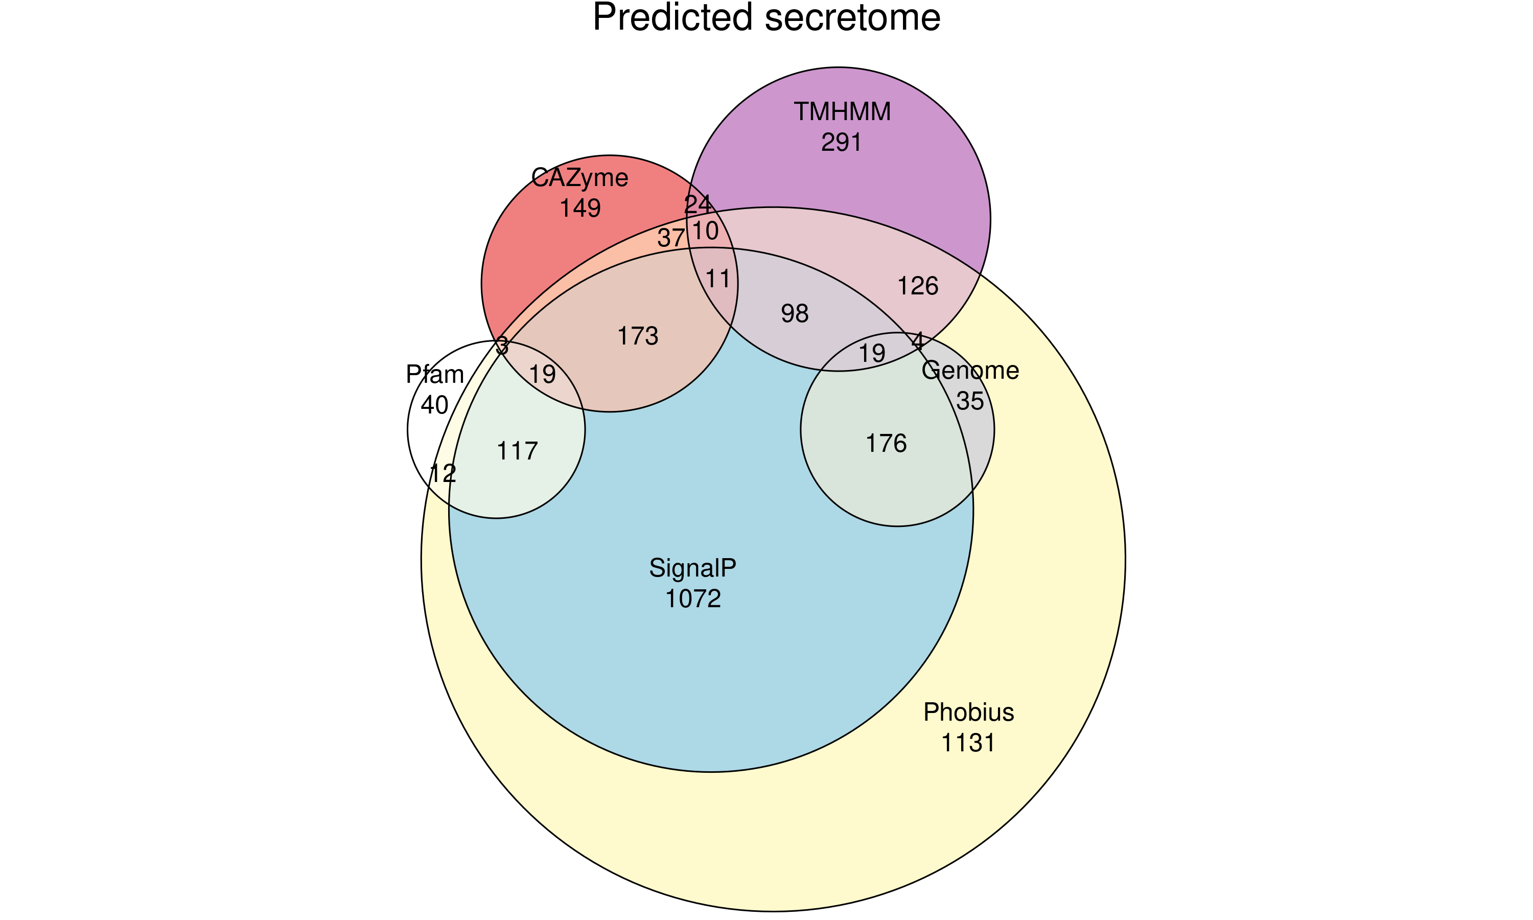 Figure_: Predicted secreted Phytophthora cinnamomi proteins. Total proteins obtained from .faa file were ran through multiple predictive models: SignalP, predicted signal peptides containing a Sec/SPI SPs using signalP6.0. Phobius, TMHMM and Pfam contain a predicted; signal peptides (Phobius-1.01); fewer than one transmembrane helix and a signal peptide within the first 60 amino acids (TMHMM-2.0C); or a Pfam domain associated with plant pathogenesis (Pfam-35.0), respectively using InterProScan 5.62-94. CAZyme are predicted carbohydrate-active enzymes using dbCAN3. Genome contains previously predicted known effectors (RxLR, CRN and NLPs) from Engelbrecht, Juanita, et al. 2021.

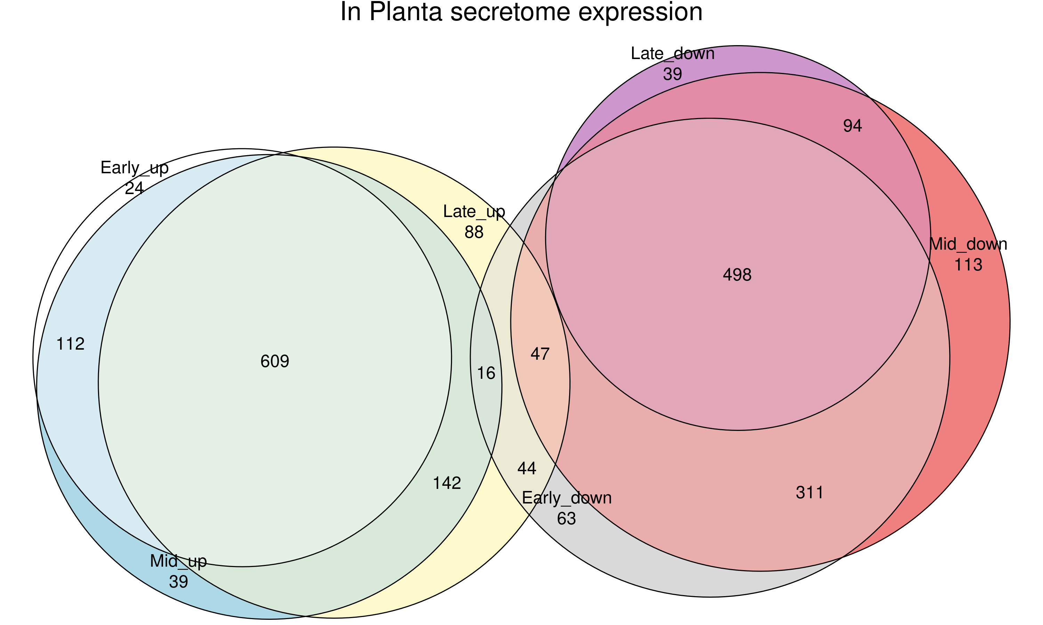

Figure_: Detected predicted secreted Phytophthora cinnamomi genes expression at 18-, 30-, and 48 hours post inoculation (hpi) in lupin. Genes were considered up regulated if log2fold change was greater than 0 and padj < 0.05, while down regulated if log2fold change was less than 0 and padj < 0.05.

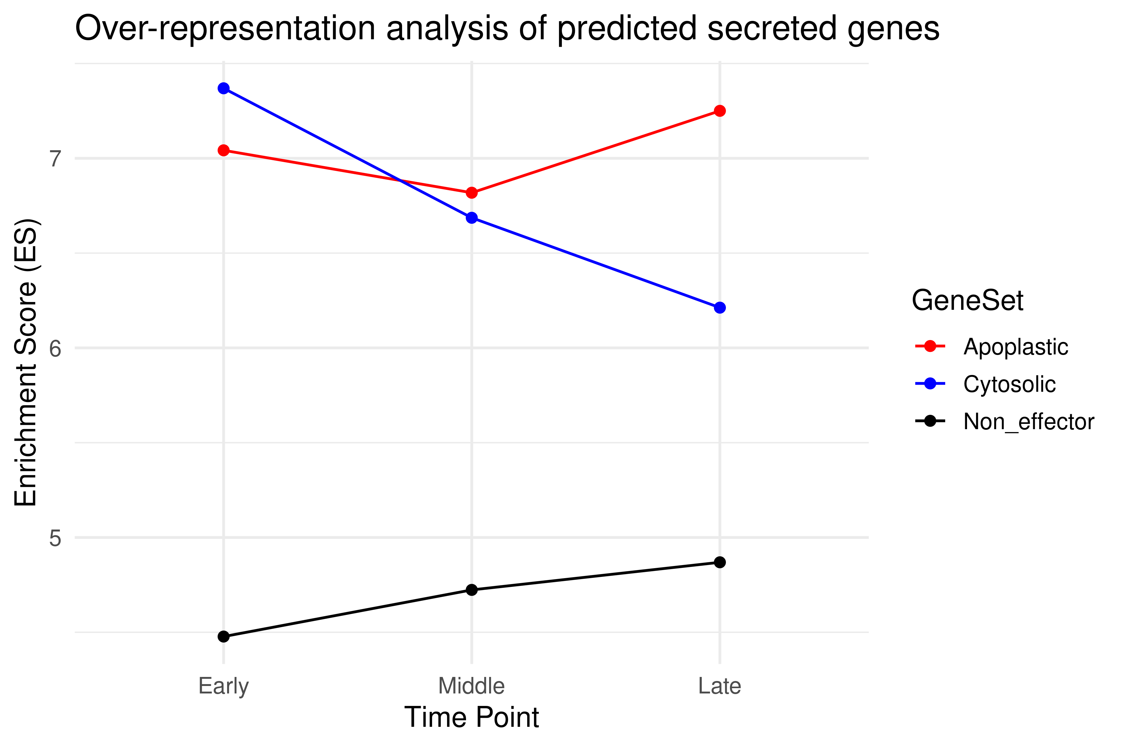

Figure_: Over representative analysis (ORA) of predicted apoplastic effectors (red), cytosolic effectors (blue) predicted using EffectorP-3.0, together with secreted genes (black) up regulated at 18-, 30-, and 48 hours post inoculation (hpi) in lupin. Background genes are all genes detected throughout the time course.

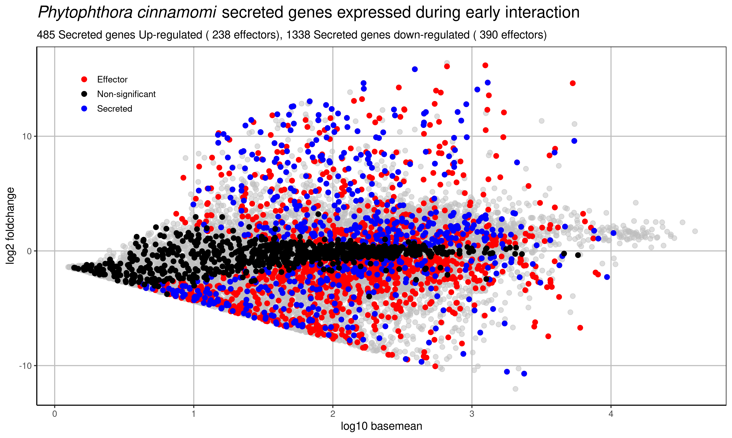 Figure_: Secreted Phytophthora cinnamomi genes expressed in Lupin at 18 hours post inoculation (hpi). Predicted effectors (red), predicted secreted genes (blue) and non significant secreted genes (black). Significance is denoted by +/- 2 log2foldchange in expression compared to vegetative hyphae grown on agar and padj > 0.5.

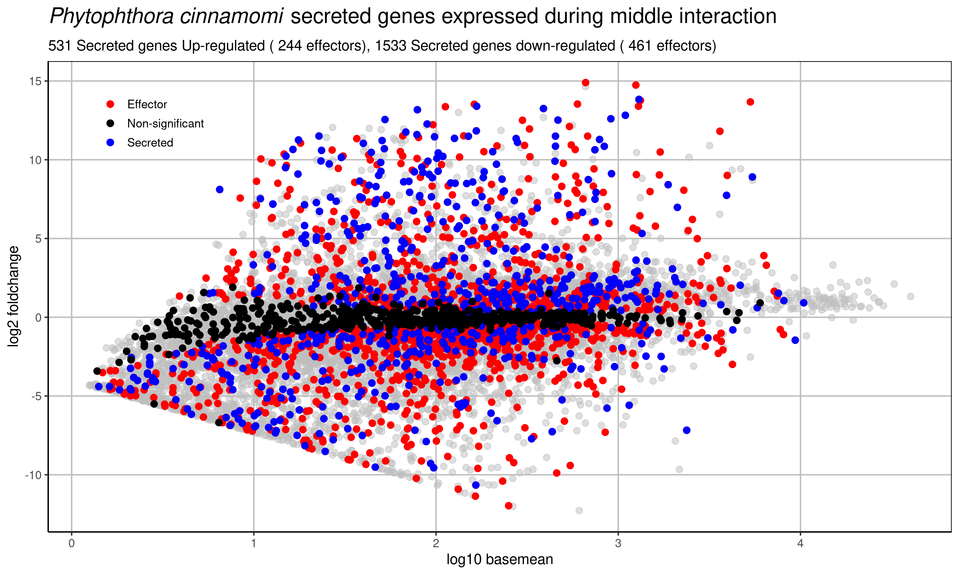 Figure_: Secreted Phytophthora cinnamomi genes expressed in Lupin at 30 hours post inoculation (hpi). Predicted effectors (red), predicted secreted genes (blue) and non significant secreted genes (black). Significance is denoted by +/- log2foldchange in expression compared to vegetative hyphae grown on agar and padj > 0.5.

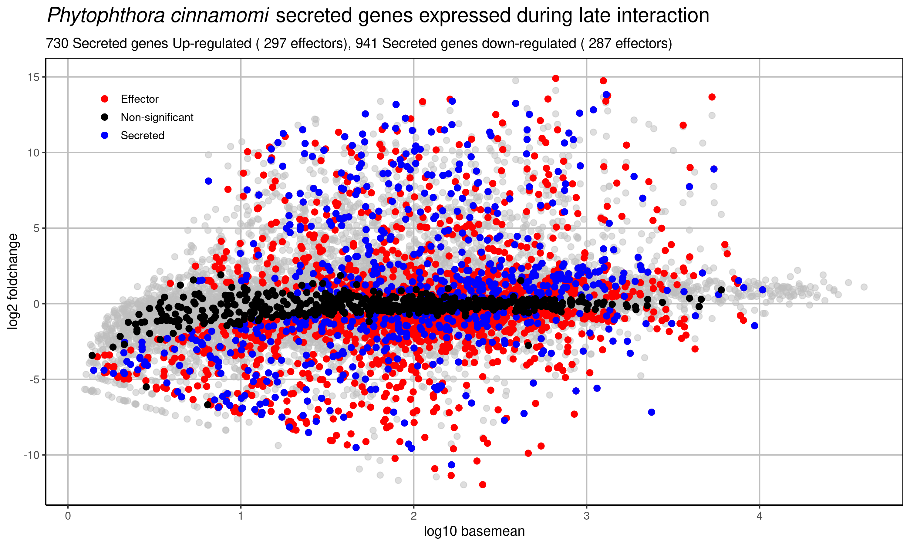 Figure_: Secreted Phytophthora cinnamomi genes expressed in Lupin at 48 hours post inoculation (hpi). Predicted effectors (red), predicted secreted genes (blue) and non significant secreted genes (black). Significance is denoted by +/- log2foldchange in expression compared to vegetative hyphae grown on agar and padj > 0.5.