CMP-4010B/CMP-7025B Assessment Sequence {001}

Reg No:
100473202

Marker:

Before you begin running your SQL commands, delete all your own test data and insert my own test data (AssessData2025.txt); use tests at the end of the document to ensure all data has being inserted correctly. Then proceed to run each tasks (A to I) as instructed below. Where your output is expected (in red), insert the SQL statement you run and then the output of running the statement on this document. It may be that a task requires you to run more than one SQL statement; in such cases insert in order the statements you run to achieve the task. You can insert any screenshots of running the tasks in PGAdmin as they will contain both the SQL and the output, but please make sure any text is of a size that can be read easily for marking and if you are showing a table output ALL rows are visible in the screenshot. If the running of the SQL command results on an error reported by the SQL environment, then record that error (i.e. copy it and paste the screenshot with the error shown). For each transaction of interest, show the contents of all relevant (if modified by the transaction of interest) tables. If you have not implemented a particular task write ‘NOT DONE’ as the output. Please do not delete the marks allocated to each section (in blue) as those will be used by markers. An example of how to fill the form is in the appendix.

Evaluation of transactions of interest

----------------------------------------------------------------------------------------------------------------------------------------------

Testing task A

--------------------------------------------------------------------------------------------------------------------------------------------------

A. Insert a new student member of the society.
- Insert a student with student number 600; Student name: “Liza, F.”; Student email ffl@myhome.com
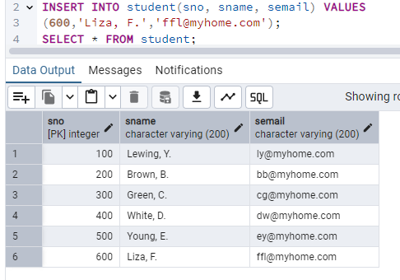

INSERT YOUR SQL QUERY AND OUTPUT HERE

Marks: /3

- Insert a student with student number 100; Student name: “Perez, B.”; Student email pb@myhome.com
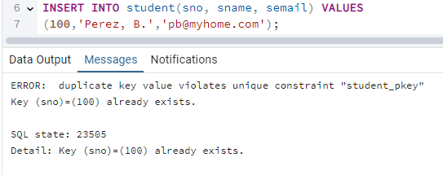

INSERT YOUR SQL QUERY AND OUTPUT HERE

Marks: /3

--------------------------------------------------------------------------------------------------------------------------------------------------

Testing task B

--------------------------------------------------------------------------------------------------------------------------------------------------

B. Insert a new examination for the coming year.

- Insert the values ‘VB01’ as exam code, ‘Visual Basic 1’ as exam title, ‘Norwich’ as location and date ‘02-11-2025’ with time ’09:00’.

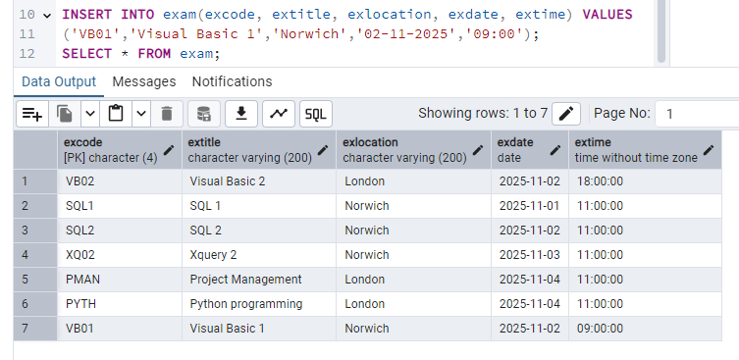

INSERT YOUR SQL QUERY AND OUTPUT HERE

Marks: /3

- Insert the values ‘VB03 as exam code, ‘Visual Basic 3’ as exam title, ‘London’ as location and date ‘03-11-2024’ with time ’19:00’.

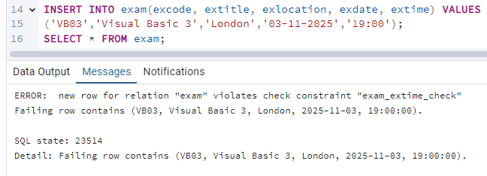

INSERT YOUR SQL QUERY AND OUTPUT HERE

Marks: /3

--------------------------------------------------------------------------------------------------------------------------------------------------

Testing task C

--------------------------------------------------------------------------------------------------------------------------------------------------

C. Delete a student. This happens if a student withdraws from the society. All the examination entries for the student must be cancelled. The cancelled entries must retain their student reference number even though there is no longer a matching row in the student table.

- Delete student with student number 200;

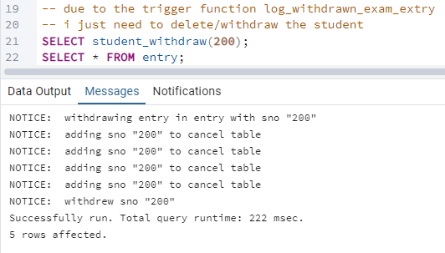

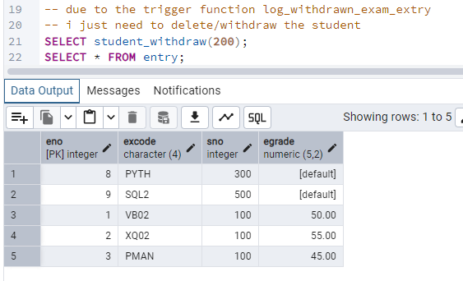

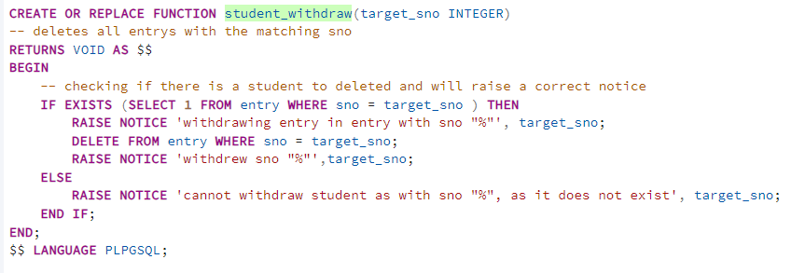

INSERT YOUR SQL QUERY AND OUTPUT HERE

Marks: /3

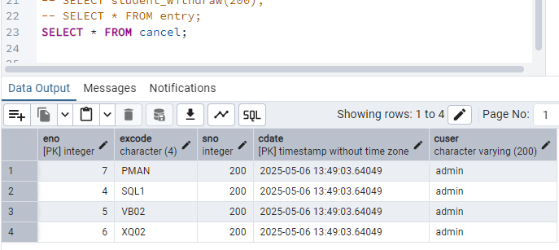

SHOW THE CONTENT OF THE CANCEL TABLE AT THE END OF THE TASK

Marks: /3

--------------------------------------------------------------------------------------------------------------------------------------------------

Testing task D

--------------------------------------------------------------------------------------------------------------------------------------------------

D. Delete an examination. Examinations that have no entries may be deleted from the database. The examination must not have any current (not cancelled) entries.

- Delete examination with code ‘VB01’;

INSERT YOUR SQL QUERY AND OUTPUT HERE

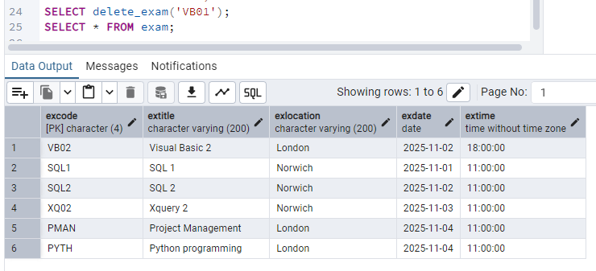

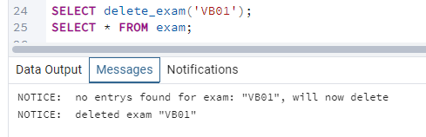

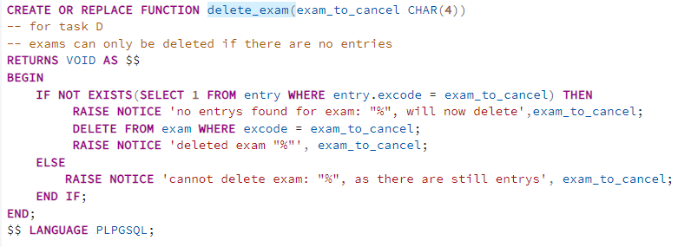

Marks: /3

- Delete examination with code ‘PYTH’;

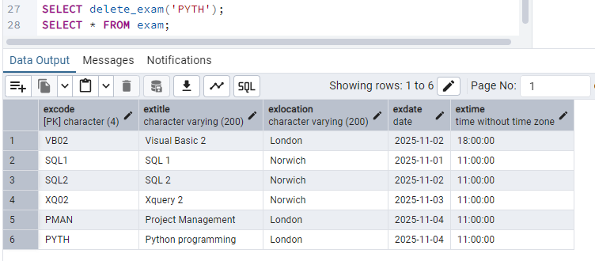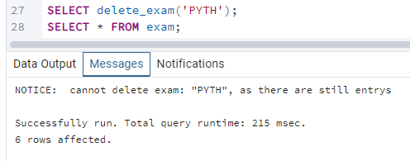

INSERT YOUR SQL QUERY AND OUTPUT HERE

Marks: /2

SHOW THE CONTENT OF THE EXAM TABLE AT THE END OF THE TASK

Marks: /2

--------------------------------------------------------------------------------------------------------------------------------------------------

Testing task E

--------------------------------------------------------------------------------------------------------------------------------------------------

E. Insert an examination entry. A student can only enter a specific examination once in a year. The student cannot take more than one examination on the same day.

- Insert a new entry with examination code ‘VB02’ and student number 400. The examination entry number should be 10.

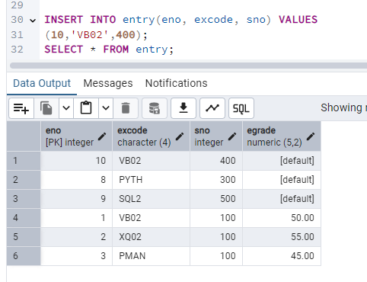INSERT YOUR SQL QUERY AND OUTPUT HERE

Marks: /4

- Insert a new entry with examination code ‘VB02’ and student number 100. The examination entry number should be 11.

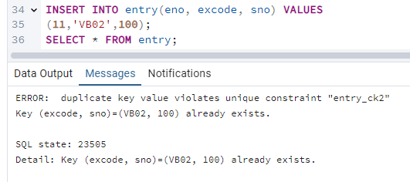

INSERT YOUR SQL QUERY AND OUTPUT HERE

Marks: /4
- Insert a new entry with examination code ‘VB02’ and student number 500. The examination entry number should be 12.

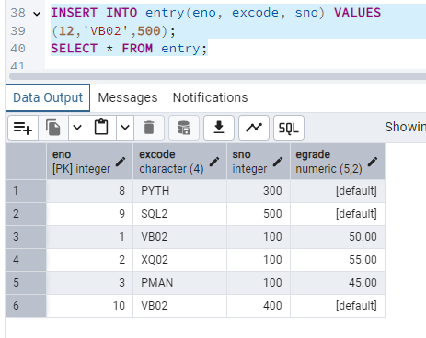

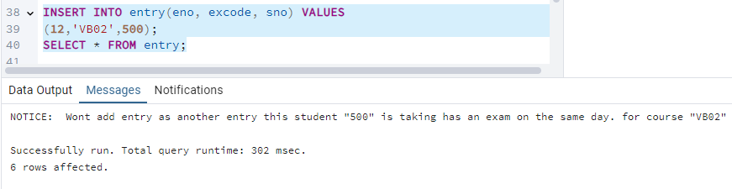INSERT YOUR SQL QUERY AND OUTPUT HERE

Marks: /4

--------------------------------------------------------------------------------------------------------------------------------------------------

Testing task F

--------------------------------------------------------------------------------------------------------------------------------------------------

F. Update an entry. This records the grade awarded by the examiners to an entry made by a student for an examination. The entry is specified by entry reference number.

- Update entry for exam ‘XQ02’ and student 200 with the mark of 60.

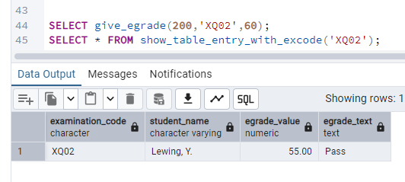

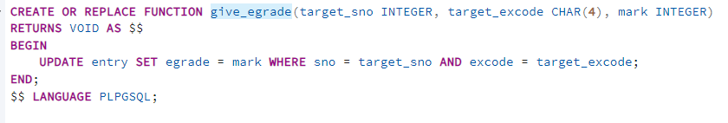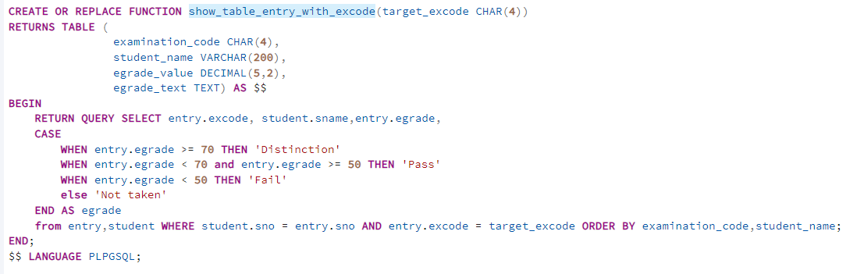

INSERT YOUR SQL QUERY AND OUTPUT HERE

Marks: /2

- Update entry for exam entry number 99 with the mark of 60.

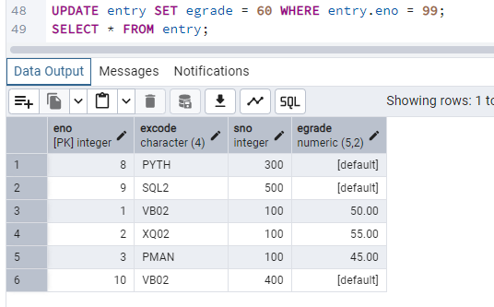

INSERT YOUR SQL QUERY AND OUTPUT HERE

Marks: /2

3 ) Update entry for exam entry number 9 with a mark of 110.

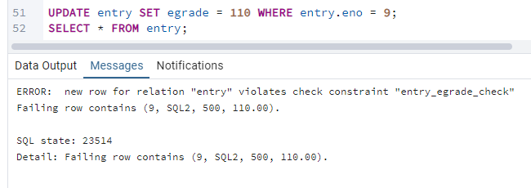

INSERT YOUR SQL QUERY AND OUTPUT HERE

Marks: /2

SHOW THE CONTENT OF THE ENTRY TABLE AT THE END OF THE TASK

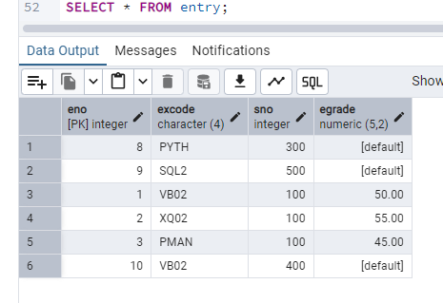

Marks: /2

--------------------------------------------------------------------------------------------------------------------------------------------------

Testing task G

--------------------------------------------------------------------------------------------------------------------------------------------------

P. Produce a table showing the examination timetable for a given student. The student is specified by his/her student membership number. The timetable should contain the student's name and the location, code, title, day and time of each examination for which the student has entered. There should be one row for each exam code.

- Show timetable for student number 100.

INSERT YOUR SQL QUERY AND OUTPUT HERE

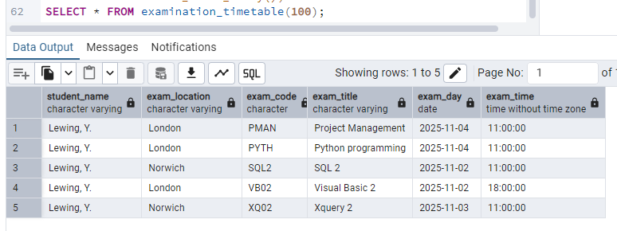

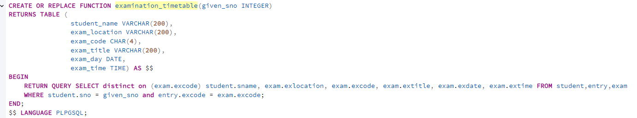

Marks: /8

--------------------------------------------------------------------------------------------------------------------------------------------------

Testing task H

--------------------------------------------------------------------------------------------------------------------------------------------------

Q. Produce a table showing the result obtained by each student for each examination. The table should be sorted by examination code and then by student name. If the student is awarded a grade of 70% or more then the result is to be shown as 'Distinction', a grade of at least 50% but less than 70% is to be shown as 'Pass' and grades below 50% are to be shown as 'Fail'. If the student has not taken the examination then the result is shown as 'Not taken'. The table should display the exam code, exam title, student name and exam result (e.g., 'Distinction', ‘Pass’, ‘Fail’, ‘Not taken’).

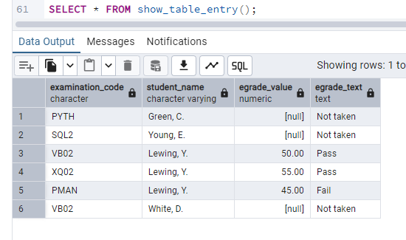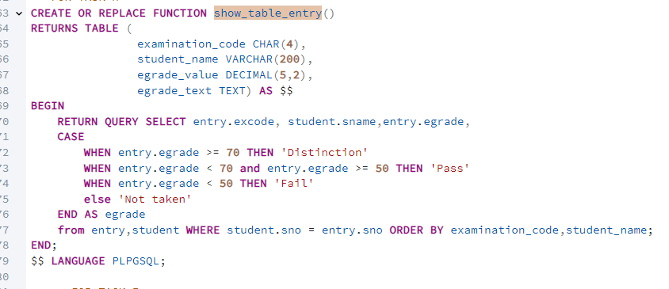

INSERT YOUR SQL QUERY AND OUTPUT HERE

Marks: /7

--------------------------------------------------------------------------------------------------------------------------------------------------

Testing task I

--------------------------------------------------------------------------------------------------------------------------------------------------

R. As H above but for a given examination. The examination is specified by examination code.

- Use examination code ‘VB02’.

INSERT YOUR SQL QUERY AND OUTPUT HERE

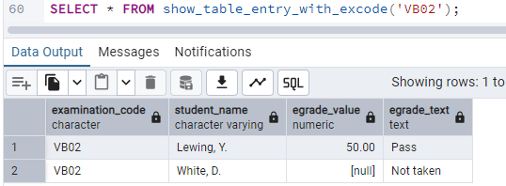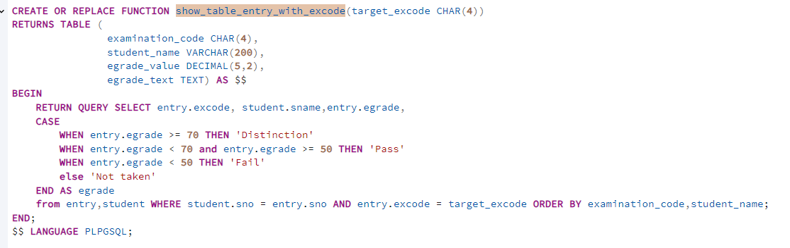

Marks: /7

GENERAL COMMENTS

Added a screenshot of the sql functions code whenever a function is used so it will be easier to mark

Quality of submission /8

MARKS DML section /67
MARKS MP4 demonstration section /25
Marks for quality of submission /8

TOTAL MARKS /100

APPENDIX: EXAMPLE OF HOW TO FILL THIS FORM/DOCUMENT (using different indicative tasks).

--------------------------------------------------------------------------------------------------------------------------------------------------

Testing task 1

--------------------------------------------------------------------------------------------------------------------------------------------------
1. Given flight details create new flight record
- Create a new flight with values: flight ID = 120, origin = 'STN', destination = 'OVD', flight date = '30/7/2020', maximum capacity = 5, and price per seat = 100.

INSERT YOUR SQL QUERY AND OUTPUT HERE

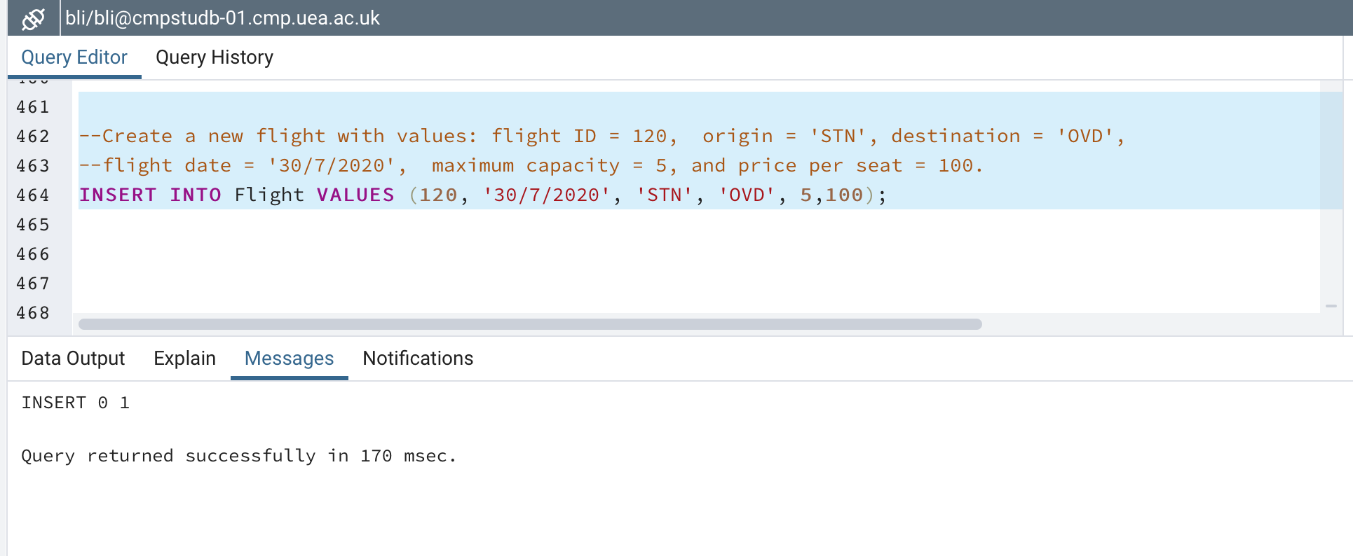

SHOW THE CONTENTS OF FLIGHT TABLE AT THE END OF THE TASK
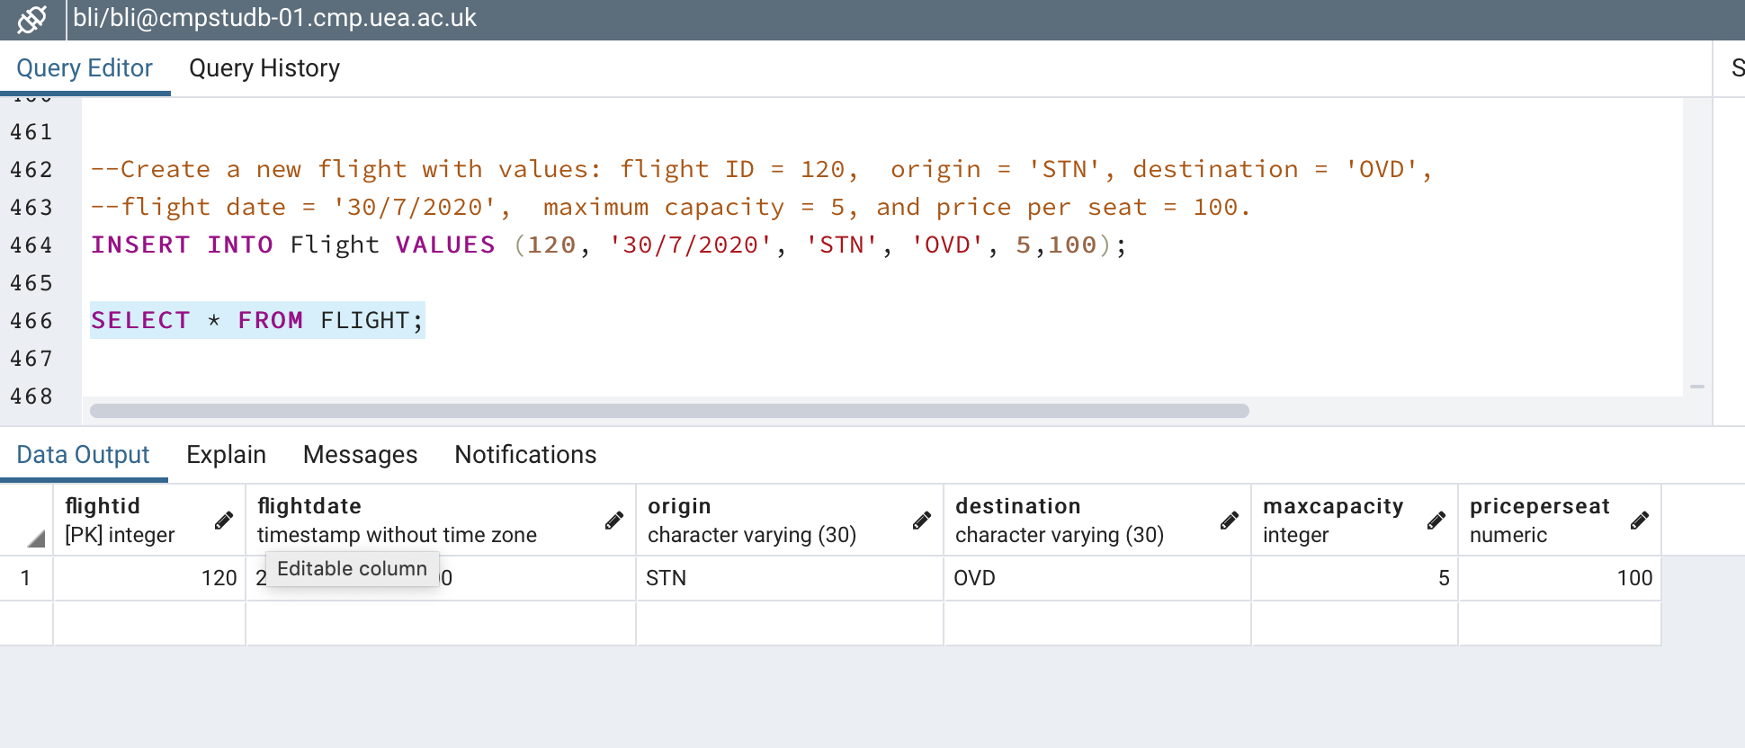

Marks: /1

2. Produce a query that counts the number of tuples in each table.

INSERT YOUR SQL QUERY AND OUTPUT HERE

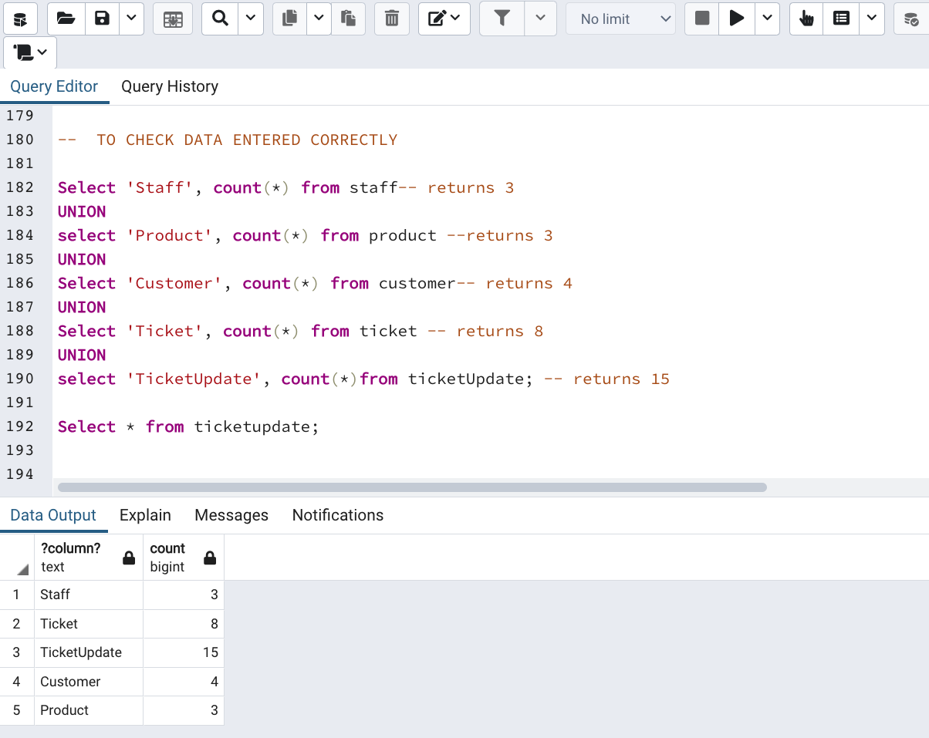

Marks: /1

