PERSONALIZED LEARNING RECOMMENDATION SYSTEM

A Python-Based Machine Learning Architecture for Adaptive Educational Path Finding

A PROJECT REPORT
SUBMITTED BY
Roll Number | Registration Number | Student Code | Student Name
24103460071 | 24103002852 of 2024-2025 | BWU/BCA/24/073 | MD.ALFAYEN MONDAL
Of in partial fulfillment for the award of the degree
BACHELOR OF COMPUTER APPLICATION
IN
DEPARTMENT OF COMPUTATIONAL SCIENCE
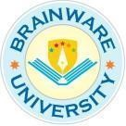
BRAINWARE UNIVERSITY
398, Ramkrishnapur Road, Barasat, North 24 Parganas, Kolkata - 700 125

PERSONALIZED LEARNING RECOMMENDATION SYSTEM

Submitted by

MD.ALFAYEN MONDAL

in partial fulfillment for the award of the degree

of

Bachelor of computer application(hons)

in
Department of computational Sciences
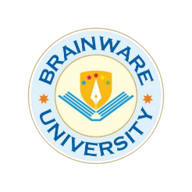

BRAINWARE UNIVERSITY
398, Ramkrishnapur Road, Barasat, North 24 Parganas, Kolkata - 700 125
BRAINWARE UNIVERSITY
398, Ramkrishnapur Road, Barasat, North 24 Parganas, Kolkata - 700 125

Department of Computational Sciences

BONAFIDE CERTIFICATE
Certified that this project report Personalized Learning Recommendation System is the bonafide work of MD.ALFAYEN MONDAL who carried out the project work under my supervision.

SIGNATURE SIGNATURE
Dr. Jayanta Aich Dr.Rahul Kumar Ghosh
HEAD OF THE DEPARTMENT SUPERVISOR
Department of Computational Sciences Department of Computational Sciences
Brainware University Brainware University
398, Ramkrishnapur Road, Barasat, Kolkata-
700125
ACKNOWLEDGEMENT
We would like to express our heartfelt gratitude to the Management and Faculty of Brainware University for providing us with the opportunity, guidance, and resources required to successfully complete this project. Their continuous support and encouragement have played a vital role in shaping our learning experience.
We extend our sincere thanks to our esteemed project supervisor, Dr. Rahul Kumar Ghosh, whose constant guidance, valuable suggestions, and insightful feedback have been instrumental throughout the development of this project. His expertise, patience, and motivation helped us overcome challenges and understand the core concepts effectively.
We are also deeply thankful to Dr. Jayanta Aich, Head of the Department of Computational Sciences, for providing a supportive academic environment and the necessary facilities that enabled us to complete this work successfully.
Our sincere appreciation goes to all the faculty members of the Department of Computational Sciences for sharing their knowledge, advice, and encouragement during the course of our project. Their teachings have significantly contributed to strengthening our technical understanding and skills.
Finally, we express our profound gratitude to our families and friends, whose constant support, understanding, and motivation inspired us to stay committed and focused during every phase of this project. Without their encouragement, this achievement would not have been possible.

signature :--
MD.ALFAYEN MONDAL
(BWU/BCA/24/073)
ABSTRACT
The Personalized Learning Recommendation System is a machine learning-based project developed to provide students with personalized learning topic and resource recommendations according to their academic performance, learning preferences, interests, and study habits. The main aim of this project is to make the learning process more effective and organized by suggesting suitable topics and educational resources based on individual student profiles.
The system uses various student-related parameters, including study hours, attendance, previous academic scores, quiz scores, study frequency, learning interests, preferred learning styles, difficulty levels, and completed topics. A Decision Tree Classifier algorithm is implemented using Python and Scikit-learn to predict suitable learning topics based on the provided student information. After predicting a topic, the system matches relevant learning resources according to the student's preferred learning style and difficulty level. These resources are then ranked to provide more suitable recommendations.
The project also incorporates data preprocessing, data cleaning, feature selection, Exploratory Data Analysis (EDA), data visualization, and model evaluation techniques. The machine learning model is evaluated using accuracy, precision, recall, F1-score, and a confusion matrix. The current implementation achieved 98% accuracy on a test dataset containing 100 records generated from a synthetic dataset of 500 student records.
The system is developed using Python libraries such as NumPy, Pandas, Matplotlib, and Scikit-learn. It provides a simple console-based interface through which users can enter student details and receive personalized learning recommendations.
In conclusion, this project demonstrates the application of machine learning in the field of education and provides a foundation for intelligent and personalized learning solutions. Future improvements may include real-world student data, a web-based interface, student progress tracking, and adaptive recommendations based on continuous feedback.
INDEX

❖ COVER PAGE
❖ TITLE PAGE
❖ Bonafide Certificate
❖ Acknowledgement
❖ Abstract

1. INTRODUCTION
2. PROBLEM STATEMENT
3. OBEJECTIVES OF THE PROJECT
4. SCOPE OF THE PROJECT
5. EXISTING SYSTEM
6. PROPOSED SYSTEM
7. SYSTEM REQUIREMENTS
8. TECHNOLOGIES AND TOOLS USED
9. DATASET DESCRIPTION
10.SYSTEM METHODOLOGY
11.SYSTEM ARCHITECTURE AND OVERFLOW
12.IMPLEMENTATION
13.RESULTS AND DISCUSSION
14.LIMITATIONS OF THE PROJECT
15.FUTURE ENHANCEMENTS
16.CONCLUSION
17.REFERENCES
1. INTRODUCTION
Education plays an important role in the development of knowledge and skills. Every student has different learning abilities, academic performance, interests, and learning preferences. However, traditional learning methods generally provide similar study materials and learning approaches to all students without considering their individual requirements.
The Personalized Learning Recommendation System is a Python-based machine learning project developed to provide suitable learning topic and resource recommendations according to individual student profiles and academic behaviour.
The system collects different types of student information, such as age, daily study hours, attendance, previous academic scores, quiz scores, study frequency, areas of interest, preferred learning style, preferred difficulty level, and completed topics. Based on these inputs, the system uses a Decision Tree Classifier to predict a suitable learning topic for the student.
After predicting the learning topic, the system matches relevant learning resources according to the student's preferred learning style and difficulty level. It also ranks the available resources based on their matching scores to provide more suitable recommendations.
The project uses Python programming along with libraries such as Pandas, NumPy, Matplotlib, and Scikit-learn. It includes data preprocessing, exploratory data analysis, feature selection, machine learning model training, evaluation, and visualization.
The system provides a console-based interface through which users can enter student details, generate personalized recommendations, view dataset summaries, check model performance, and explore visualizations.
The main purpose of this project is to demonstrate how machine learning can be used to support personalized education by recommending suitable learning topics and resources based on individual student profiles.

2. PROBLEM STATEMENT
In the traditional education system, students are often provided with similar study materials and learning methods without considering their individual learning abilities, academic performance, interests, and personal preferences. However, every student has a different learning speed, level of understanding, and way of gaining knowledge. Because of these differences, a common learning approach may not be equally effective for all students.
Students may face difficulties in identifying suitable learning topics and resources according to their current knowledge level, preferred learning style, and difficulty level. Some students may require basic learning materials to understand a topic, while others may prefer advanced resources to improve their knowledge. Without proper guidance and personalized recommendations, students may spend additional time searching for relevant study materials that match their learning requirements.
Another challenge is the effective use of student-related information, such as daily study hours, attendance, previous academic scores, quiz performance, study frequency, interests, and completed topics. These details can help in understanding individual learning patterns, but analysing them manually and providing suitable recommendations can be difficult and time-consuming.
Therefore, there is a need for a system that can analyse student information and recommend appropriate learning topics and resources based on individual requirements. The Personalized Learning Recommendation System addresses this problem by using machine learning techniques, particularly a Decision Tree Classifier, to predict suitable learning topics from student data. It further matches available learning resources according to the student's preferred learning style and difficulty level.
The main problem addressed by this project is to develop a machine learning-based approach that can use student-related information to generate more relevant and personalized learning recommendations, helping students identify suitable topics and learning resources according to their individual learning needs.

3. OBJECTIVES OF THE PROJECT
The main objective of the Personalized Learning Recommendation System is to use machine learning techniques to provide suitable learning topic and resource recommendations according to individual student profiles and learning preferences.

The specific objectives of this project are as follows:

- To analyse student information: To use student-related data such as study hours, attendance, academic scores, quiz performance, interests, and learning preferences to understand individual learning patterns.
- To preprocess student data: To clean, organize, and prepare the dataset so that it can be used effectively for machine learning model training and analysis.
- To develop a machine learning model: To implement a Decision Tree Classifier that predicts suitable learning topics based on the selected student features.
- To provide personalized recommendations: To recommend relevant learning resources according to the predicted topic, preferred learning style, and difficulty level of each student.
- To evaluate model performance: To measure the performance of the trained model using evaluation metrics such as accuracy, precision, recall, F1-score, and confusion matrix.
- To visualize learning data: To use graphical representations and exploratory data analysis to understand student information, learning patterns, and model performance.
- To demonstrate the use of machine learning in education: To show how data-driven techniques can support personalized learning and help students identify suitable learning topics and resources.

4. SCOPE OF THE PROJECT
The scope of the Personalized Learning Recommendation System is to develop a machine learning-based application that helps students identify suitable learning topics and learning resources according to their academic performance, interests, and learning preferences.
The system focuses on the following areas:
1. Student Profile Analysis
The system collects student information such as study hours, attendance, previous academic scores, quiz scores, study frequency, interests, learning style, preferred difficulty level, and completed topics.
2. Data Processing
The system performs data cleaning and preprocessing to identify missing values, duplicate records, invalid numerical values, and other data-related issues.
3. Learning Topic Prediction
The system uses a Decision Tree Classifier to predict a suitable learning topic based on the student's learning profile.
4. Personalized Resource Recommendation
After predicting a learning topic, the system searches for relevant learning resources and ranks them according to learning-style compatibility and difficulty-level compatibility.
5. Model Evaluation
The system evaluates its machine learning model using accuracy, precision, recall, F1-score, and a confusion matrix.
6. Data Visualization
The application generates visualizations to understand student interests, learning styles, academic performance patterns, recommendation distribution, and feature importance.
7. Console-Based Application
The project provides an interactive command-line menu through which users can get recommendations, view dataset information, check model performance, and explore visualizations.
The current project uses a synthetically generated dataset containing 500 student records. It is developed as an academic demonstration of personalized learning recommendations using Python and machine learning.

5. EXISTING SYSTEM
In the traditional learning system, students generally follow a common learning approach where the same study materials and topics may be provided to many students without considering their individual learning needs.
Students often select learning topics and resources manually based on their interests, academic performance, or suggestions from teachers and friends. This approach may not always identify the specific topics where a student needs improvement.
Traditional learning methods have the following limitations:
1. Lack of Personalization
The same learning materials may be used for different students, even though their abilities, interests, and learning preferences are different.
2. Manual Resource Selection
Students have to search for suitable learning materials themselves, which can take additional time and effort.
3. Difficulty in Identifying Weak Areas
It may be difficult for students to identify which topics require more attention based on their academic performance.
4. No Automated Topic Recommendation
Traditional systems generally do not use machine learning algorithms to automatically suggest suitable learning topics based on student information.
5. Limited Learning-Style Consideration
Different students may prefer visual, reading, practical, or audio-based learning resources, but traditional methods may not consider these preferences effectively.
Therefore, a system that analyzes student information and provides personalized learning topic and resource recommendations can help address these limitations.

6. PROPOSED SYSTEM
The proposed system is a Personalized Learning Recommendation System developed using Python and Machine Learning. It is designed to analyze students' academic information, interests, and learning preferences to recommend suitable learning topics and educational resources.

The system uses a Decision Tree Classifier to predict the most appropriate learning topic based on the student's profile. After predicting the topic, the system searches for relevant learning resources and ranks them according to the student's preferred learning style and difficulty level.

The proposed system includes the following features:

1. Student Information Input
The system collects information such as study hours, attendance, previous scores, quiz scores, study frequency, interests, learning style, preferred difficulty, and completed topics.

2. Data Preprocessing
The collected dataset is cleaned and prepared for machine learning by handling missing values, duplicate records, invalid values, and categorical data.

3. Machine Learning-Based Prediction
A Decision Tree Classifier is trained using the prepared student dataset to predict suitable learning topics.

4. Personalized Learning Recommendations
The system recommends a learning topic based on the student's profile and academic information.

5. Learning Resource Matching
The system matches available learning resources with the predicted topic. It gives additional ranking scores when a resource matches the student's preferred learning style and difficulty level.

6. Model Performance Evaluation
The system evaluates its performance using accuracy, precision, recall, F1-score, and a confusion matrix.

7. Data Visualization
The system provides graphs and charts to display student interests, learning styles, academic patterns, recommendation distribution, and feature importance.

8. Interactive Console Menu
Users can interact with the application through a console-based menu to access recommendations, dataset summaries, model performance, visualizations, and feature importance.

7. SYSTEM REQUIREMENTS

System requirements describe the hardware and software needed to develop and run the Personalized Learning Recommendation System successfully.
Hardware Requirements :
The following hardware configuration is recommended for running the project:
- Processor: Intel Core i3 or equivalent and above.
- RAM: Minimum 4 GB.
- Hard Disk: At least 500 MB of free storage space for the project and its required files.
- Display: Standard monitor with a minimum resolution of 1366 × 768.
- Input Devices: Keyboard and mouse.
Software Requirements :
The following software and technologies are used in the development of the project:
- Operating System: Windows, Linux, or macOS.
- Programming Language: Python.
- Code Editor: Visual Studio Code (VS Code).
- Libraries: NumPy, Pandas, Matplotlib, Scikit-learn, and Joblib.
- Machine Learning Algorithm: Decision Tree Classifier.
- Data Storage: CSV (Comma-Separated Values) files.
- Model Storage: Pickle file (.pkl).
- Python Environment: Python virtual environment.
Development Environment :

The project is developed using Python in Visual Studio Code. A Python virtual environment is used to manage the required libraries and dependencies.

The project dependencies can be installed using the following command:
pip install -r requirements.txt

The application can be executed using:
python main.py

These requirements provide the basic environment needed to execute the recommendation system and view its results.

8. TECHNOLOGIES AND TOOLS USED

The Personalized Learning Recommendation System is developed using Python and various data science and machine learning libraries. These technologies help in data processing, analysis, model development, prediction, and visualization.
Python :
Python is the main programming language used to develop the project, process student data, and build the recommendation system.
NumPy :
NumPy is used for numerical operations, mathematical calculations, and handling numerical data.
Pandas :
Pandas is used to read CSV files, clean student data, handle missing values, and prepare datasets for machine learning.
Matplotlib :
Matplotlib is used to create graphs and visualizations of student interests, learning styles, academic performance, and model results.
Scikit-Learn :
Scikit-learn is used to train the Decision Tree Classifier, make predictions, and evaluate model performance.
Decision Tree Classifier :
It is a supervised machine learning algorithm used in this project to predict suitable learning topics based on student information.
Python Virtual Environment :
A virtual environment is used to manage project dependencies and install the required Python libraries separately.
CSV files :
CSV files are used to store student learning data and learning resources in a structured tabular format.

9. DATASET DESCRIPTION
The project uses a synthetically generated dataset containing 500 student records. It includes students' academic performance, study habits, interests, and learning preferences. This dataset is used to train and test the machine learning model.

Dataset Attributes :
The dataset contains the following attributes:
- Student_ID: Unique student identification number.
- Age: Student's age.
- Study_Hours: Daily study hours.
- Attendance: Attendance percentage.
- Previous_Score: Previous academic score.
- Quiz_Score: Quiz performance.
- Study_Frequency: Study sessions per week.
- Interest: Student's learning interest.
- Learning_Style: Preferred learning style.
- Preferred_Difficulty: Easy, Medium, or Hard.
- Completed_Topics: Number of completed topics.
- Weak_Topic: Topic requiring improvement.
- Preferred_Resource: Preferred learning resource type.
- Recommended_Topic: Target topic predicted by the model.

Learning Categories :
- Interests: Programming, Data Science, Web Development, Mathematics.
- Learning Styles: Visual, Reading, Practical, Audio.
- Difficulty Levels: Easy, Medium, Hard.
Dataset Usage :
The dataset is cleaned and preprocessed before model training. The Decision Tree Classifier uses selected student attributes to predict the Recommended_Topic.
Student_ID and Weak_Topic are excluded from model inputs, while Recommended_Topic is used as the target variable. The dataset is divided into 80% training data and 20% testing data.
Note: The dataset is synthetically generated for academic purposes and does not contain actual student records.

10. SYSTEM METHODOLOGY
The methodology describes the steps followed to develop the Personalized Learning Recommendation System using Python and Machine Learning.
Dataset Generation :

A synthetic dataset containing 500 student records is generated with information such as study hours, attendance, academic scores, interests, and learning preferences.

Data Preprocessing :

The dataset is cleaned by checking missing values, duplicate records, invalid numerical values, and categorical data. The processed data is saved for further analysis.

Exploratory Data Analysis (EDA) :

Graphs and visualizations are created to understand student interests, learning styles, study hours, attendance, and recommendation patterns.

Feature Selection :

Relevant student attributes are selected as inputs for the machine learning model. Student_ID and Weak_Topic are excluded, while Recommended_Topic is used as the target.

Model Training :

A Decision Tree Classifier is trained using 80% of the dataset. The remaining 20% is used for testing the model.

Topic Prediction :

The trained model analyzes the student's information and predicts a suitable learning topic.

Resource Matching :

Learning resources related to the predicted topic are selected and ranked according to the student's preferred learning style and difficulty level.

Model Evaluation :

The model is evaluated using accuracy, precision, recall, F1-score, and a confusion matrix to understand its performance.

Summary: The methodology combines data preprocessing, machine learning, topic prediction, and resource matching to generate personalized learning recommendations.

11. SYSTEM ARCHITECTURE AND OVERFLOW
System architecture describes the overall structure of the Personalized Learning Recommendation System and explains how its different components interact to generate personalized recommendations.

System Architecture :
The system consists of the following main components:
- Student Dataset: Stores student academic information, interests, and learning preferences.
- Data Preprocessing: Cleans and prepares the dataset for analysis.
- Feature Selection: Selects relevant attributes for model training.
- Machine Learning Model: Uses a Decision Tree Classifier to predict suitable learning topics.
- Student Input: Collects the student's information through the application.
- Recommendation Engine: Matches the predicted topic with suitable learning resources and ranks them.
- Evaluation and Visualization: Displays model performance and data analysis results.

System Workflow :
The system follows these steps:
- Generate the student learning dataset.
- Clean and preprocess the data.
- Perform exploratory data analysis.
- Select relevant features.
- Train the Decision Tree Classifier.
- Collect student information.
- Predict a suitable learning topic.
- Match and rank relevant learning resources.
- Display personalized recommendations.
- Evaluate the model and visualize results.

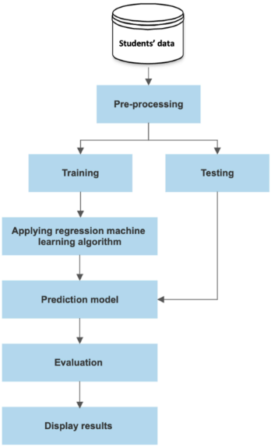

12. IMPLEMENTATION
Implementation describes how the Personalized Learning Recommendation System is developed using Python and machine learning libraries. The project is divided into different modules, where each module performs a specific task.
Project Structure :
The project contains the following main files and folders:
- main.py: Runs the main application and displays the interactive menu.
- generate_dataset.py: Generates the synthetic student learning dataset.
- preprocessing.py: Cleans and prepares the dataset.
- eda.py: Performs exploratory data analysis and generates graphs.
- feature_selection.py: Selects relevant features for the model.
- recommendation_model.py: Trains the Decision Tree Classifier.
- recommender.py: Generates learning topic and resource recommendations.
- evaluation.py: Evaluates model performance.
- student.py: Defines the Student class to manage student information.
- data/: Stores student datasets and learning resources.
- models/: Stores the trained machine learning model.
- visualizations/: Stores generated graphs and charts.
Dataset Generation and Preprocessing :
The system generates 500 synthetic student records. The preprocessing module checks the data, handles missing and invalid values, removes duplicate records, and prepares the cleaned dataset for further processing.
Machine Learning Model Implementation :
The project uses a Decision Tree Classifier from Scikit-learn. The model is trained using student information to predict a suitable learning topic. The dataset is divided into 80% training data and 20% testing data.
Recommendation Implementation :
After receiving student information, the system predicts a suitable learning topic. It then matches available resources with that topic and ranks them according to learning style and difficulty-level preferences.
Model Evaluation :
The evaluation module measures model performance using accuracy, precision, recall, F1-score, and a confusion matrix.
Application Execution :
The application is executed through the main Python file using the following command:
python main.py
The program displays an interactive menu that allows users to access personalized recommendations, dataset summaries, model performance, visualizations, and feature importance.
Summary: The implementation combines different Python modules to generate student data, train the recommendation model, predict learning topics, match resources, and evaluate results.

1.PROJECT FOLDER STRUCTURE :

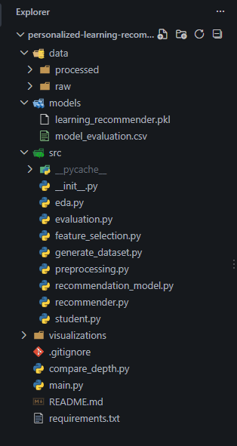
2.Student Learning Dataset in Microsoft Excel
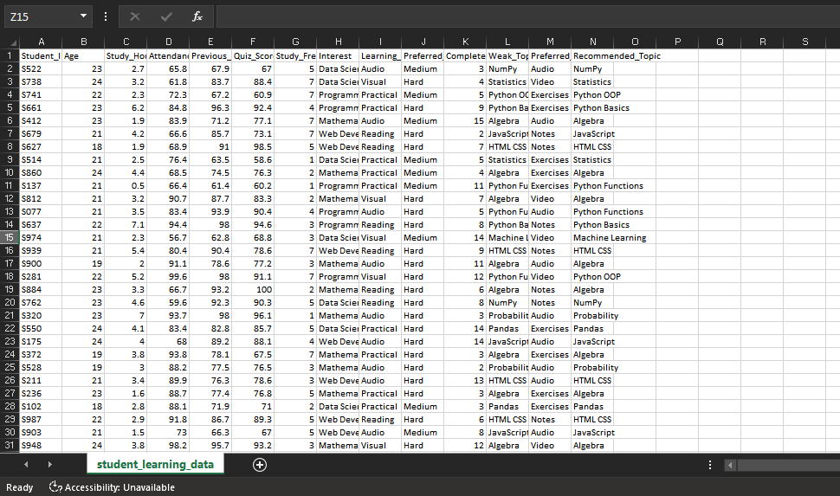
3.Dataset Generation Code
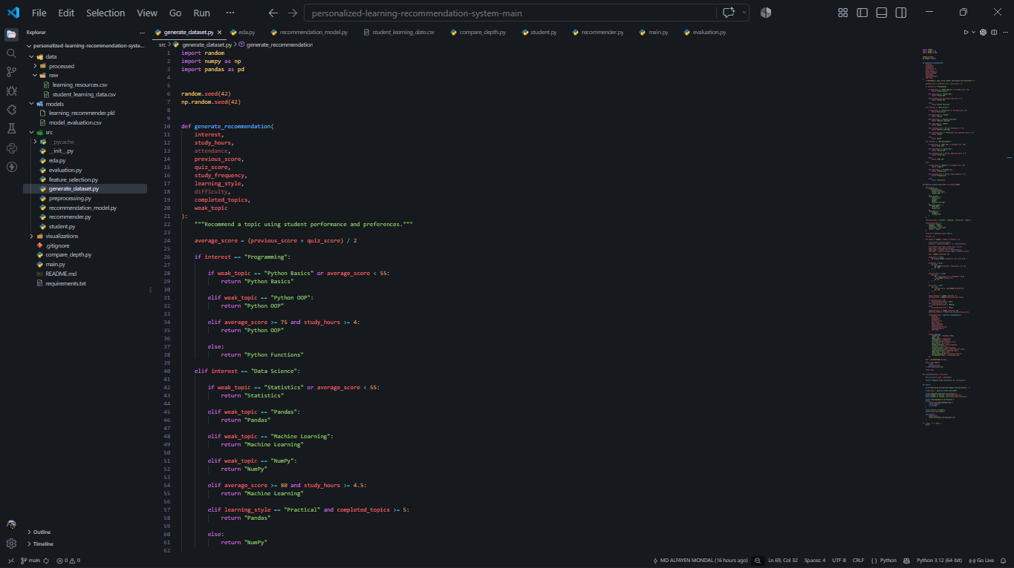

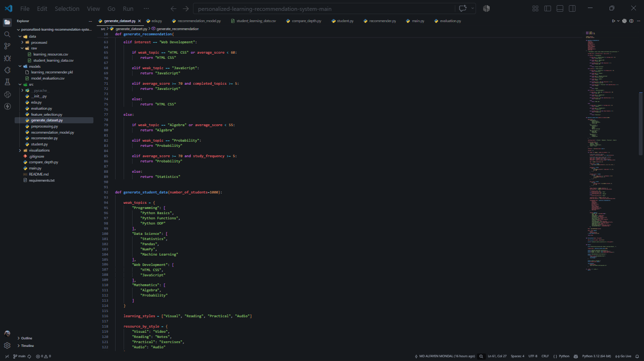

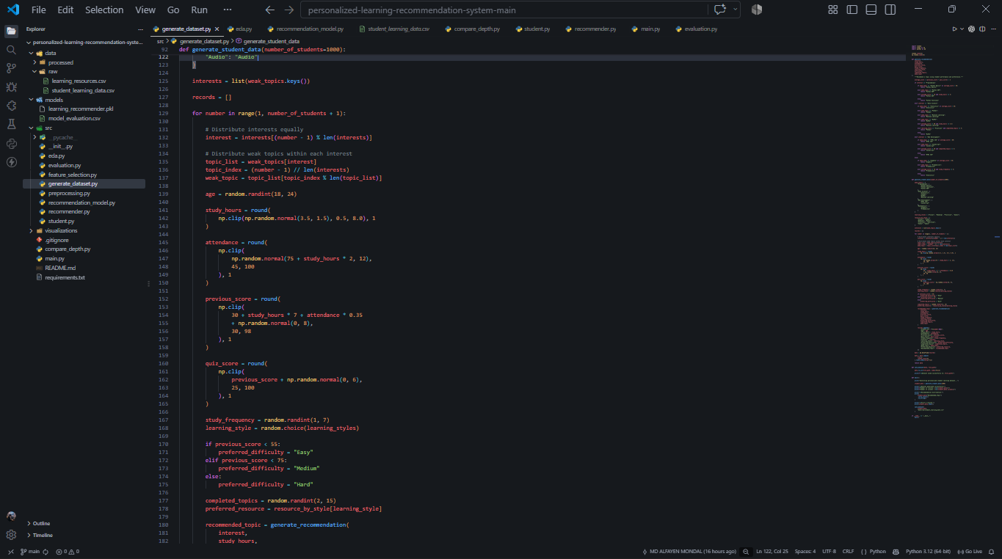
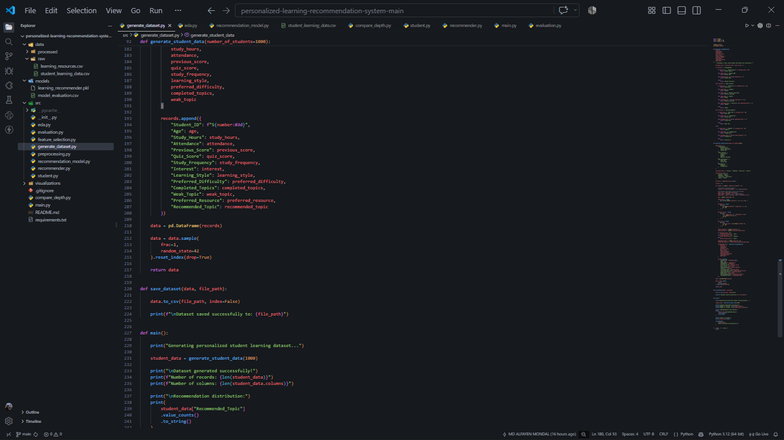

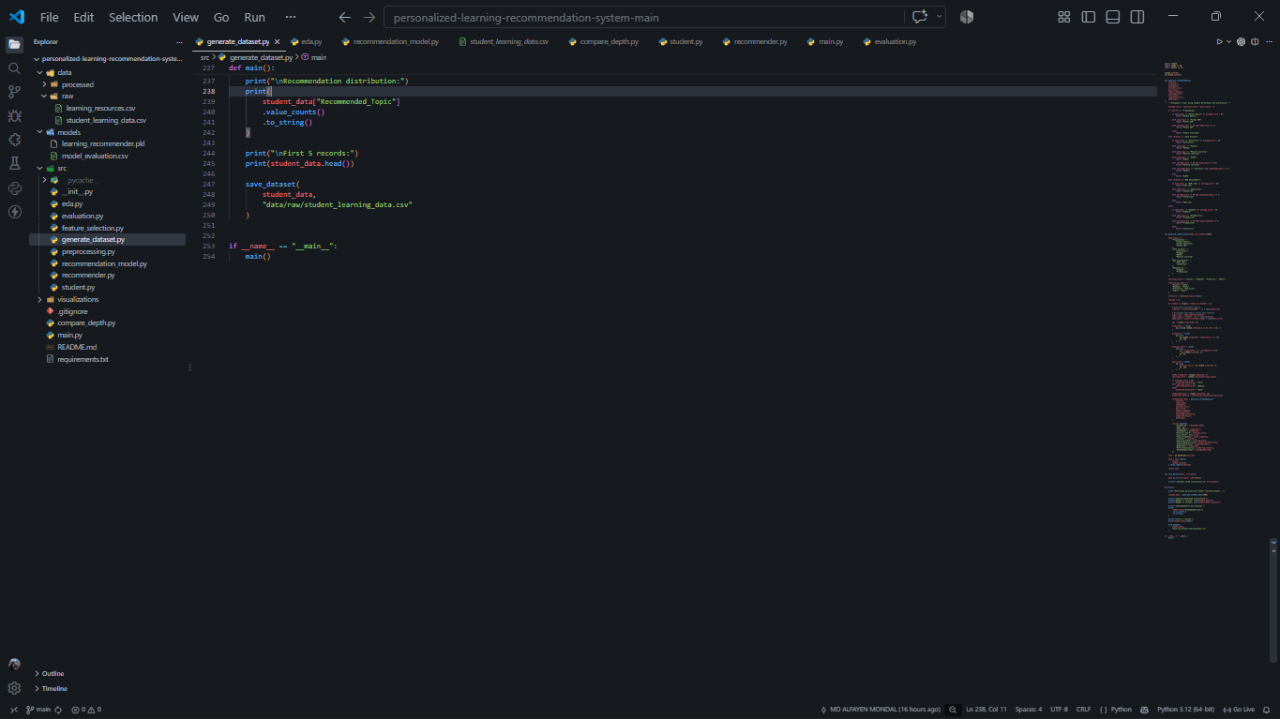
4.OUTPUT WINDOW
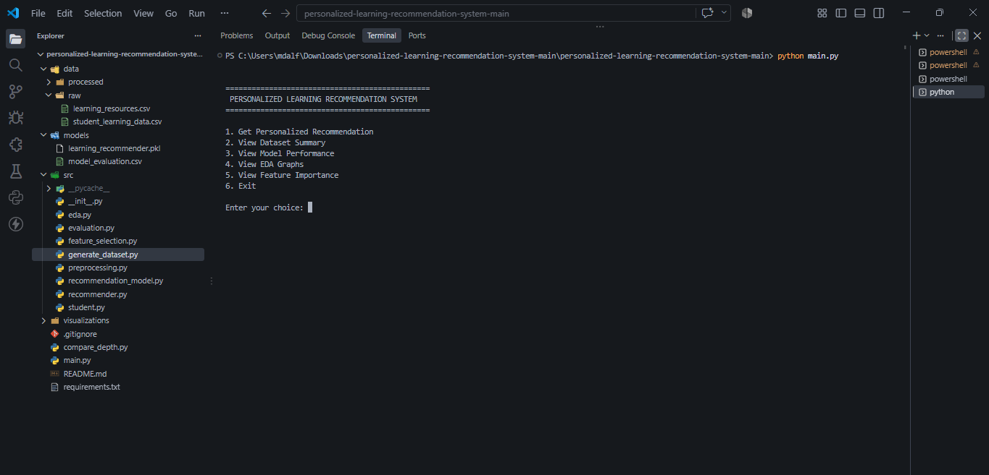

13. RESULTS AND DISCUSSION
The Personalized Learning Recommendation System was successfully developed and tested using a synthetic dataset containing 500 student records. The system analyzes student learning information and predicts suitable learning topics using a Decision Tree Classifier.
The model achieved an accuracy of 98.00% on the test dataset. It also obtained a precision of 98.67%, recall of 98.00%, and F1-score of 98.15%.
The system generates personalized learning recommendations based on student details such as study hours, attendance, previous scores, quiz scores, interests, learning style, and preferred difficulty level.
The recommendation module also matches suitable learning resources according to the predicted topic, learning style, and difficulty preference.
The project provides the following results:
- Successfully generates and preprocesses student learning data.
- Identifies patterns in student learning behaviour through data visualization.
- Predicts suitable learning topics using machine learning.
- Recommends relevant learning resources.
- Displays model performance and feature importance.
The results show that the system can generate personalized learning recommendations based on the available student information. However, since the dataset is synthetic and the target values are rule-generated, the high accuracy does not guarantee similar performance on real-world student data.
Model Performance Evaluation :
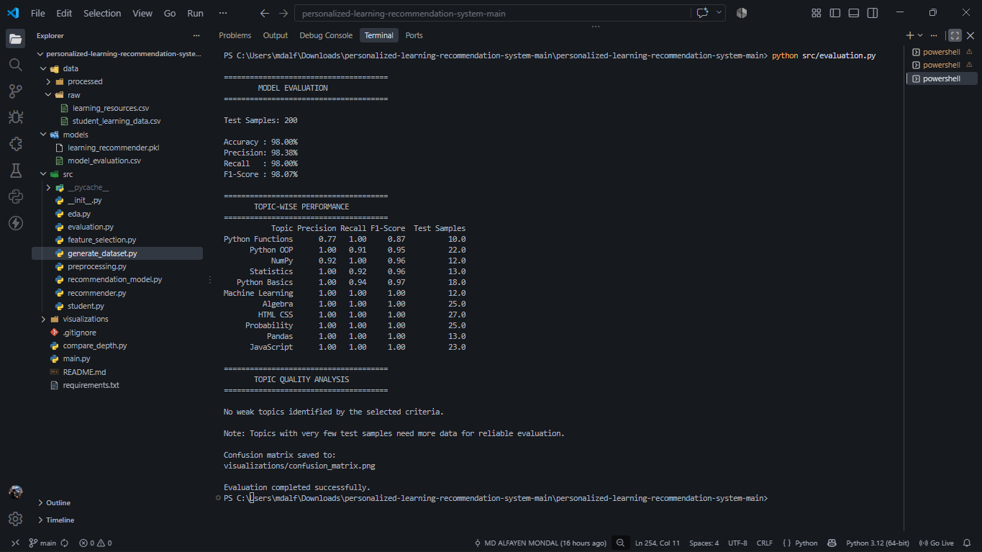
14.LIMITATIONS OF THE PROJECT
Although the Personalized Learning Recommendation System successfully provides personalized learning recommendations, it has some limitations:
- Synthetic Dataset: The system uses 500 synthetic student records instead of real student data.
- Limited Learning Resources: The project contains a limited collection of learning resources.
- Console-Based Application: The system currently operates through a command-line interface and does not have a graphical user interface.
- Single Machine Learning Algorithm: The project uses a Decision Tree Classifier without comparing it with other algorithms.
- No Student Feedback System: The system does not automatically improve recommendations based on student feedback.
- Limited Personalization: Recommendations depend on the available student information and predefined learning resources.
These limitations can be improved in future versions by using real student data, adding more learning resources, and developing an interactive web-based application.

15.FUTURE ENHANCEMENTS
The Personalized Learning Recommendation System can be improved in several ways in the future to make it more useful, accurate, and user-friendly.
- Real Student Dataset: The system can be trained using real student data instead of synthetic data to improve its practical usefulness.
- Web-Based Application: A user-friendly website can be developed so that students can access the system through a browser.
- More Learning Resources: Additional educational videos, tutorials, books, and practice materials can be included.
- Advanced Machine Learning: Other machine learning algorithms can be tested and compared to improve recommendation performance.
- Student Feedback System: Students can provide feedback on recommendations, helping improve future suggestions.
- Learning Progress Tracking: The system can track student progress, completed topics, and performance over time.
- Adaptive Recommendations: Recommendations can be updated according to students' changing performance, interests, and learning needs.
These enhancements can make the system more interactive, intelligent, and effective in supporting personalized learning.

16.CONCLUSION
The Personalized Learning Recommendation System was successfully developed using Python and Machine Learning techniques. The main aim of this project was to provide personalized learning recommendations based on students' interests, learning styles, academic performance, and learning preferences.
The system uses a Decision Tree Classifier to predict suitable learning topics and recommends relevant learning resources according to the student's profile.
The model achieved 98.00% accuracy on the test dataset, with 98.67% precision, 98.00% recall, and 98.15% F1-score.
Through this project, we learned how to generate datasets, preprocess data, perform exploratory data analysis, train a machine learning model, and generate personalized recommendations.
Although the current system uses synthetic data and has some limitations, it provides a foundation for developing more advanced personalized learning applications in the future.
In conclusion, this project demonstrates how Machine Learning can be used to support personalized education and help students identify suitable learning topics and resources according to their needs.

17.REFERENCES
The following resources and documentation were referred to during the development of the Personalized Learning Recommendation System.
- Python Documentation: https://docs.python.org/3/
- Pandas Documentation: https://pandas.pydata.org/docs/
- NumPy Documentation: https://numpy.org/doc/
- Matplotlib Documentation: https://matplotlib.org/stable/
- Scikit-learn Documentation: https://scikit-learn.org/stable/
- Joblib Documentation: https://joblib.readthedocs.io/
- Visual Studio Code: https://code.visualstudio.com/docs
- GitHub Project Repository: https://github.com/bwubca24073/personalized-learning-recommendation-system
These resources helped in understanding Python programming, data processing, data visualization, machine learning model development, and project implementation.

