Compx341 Report
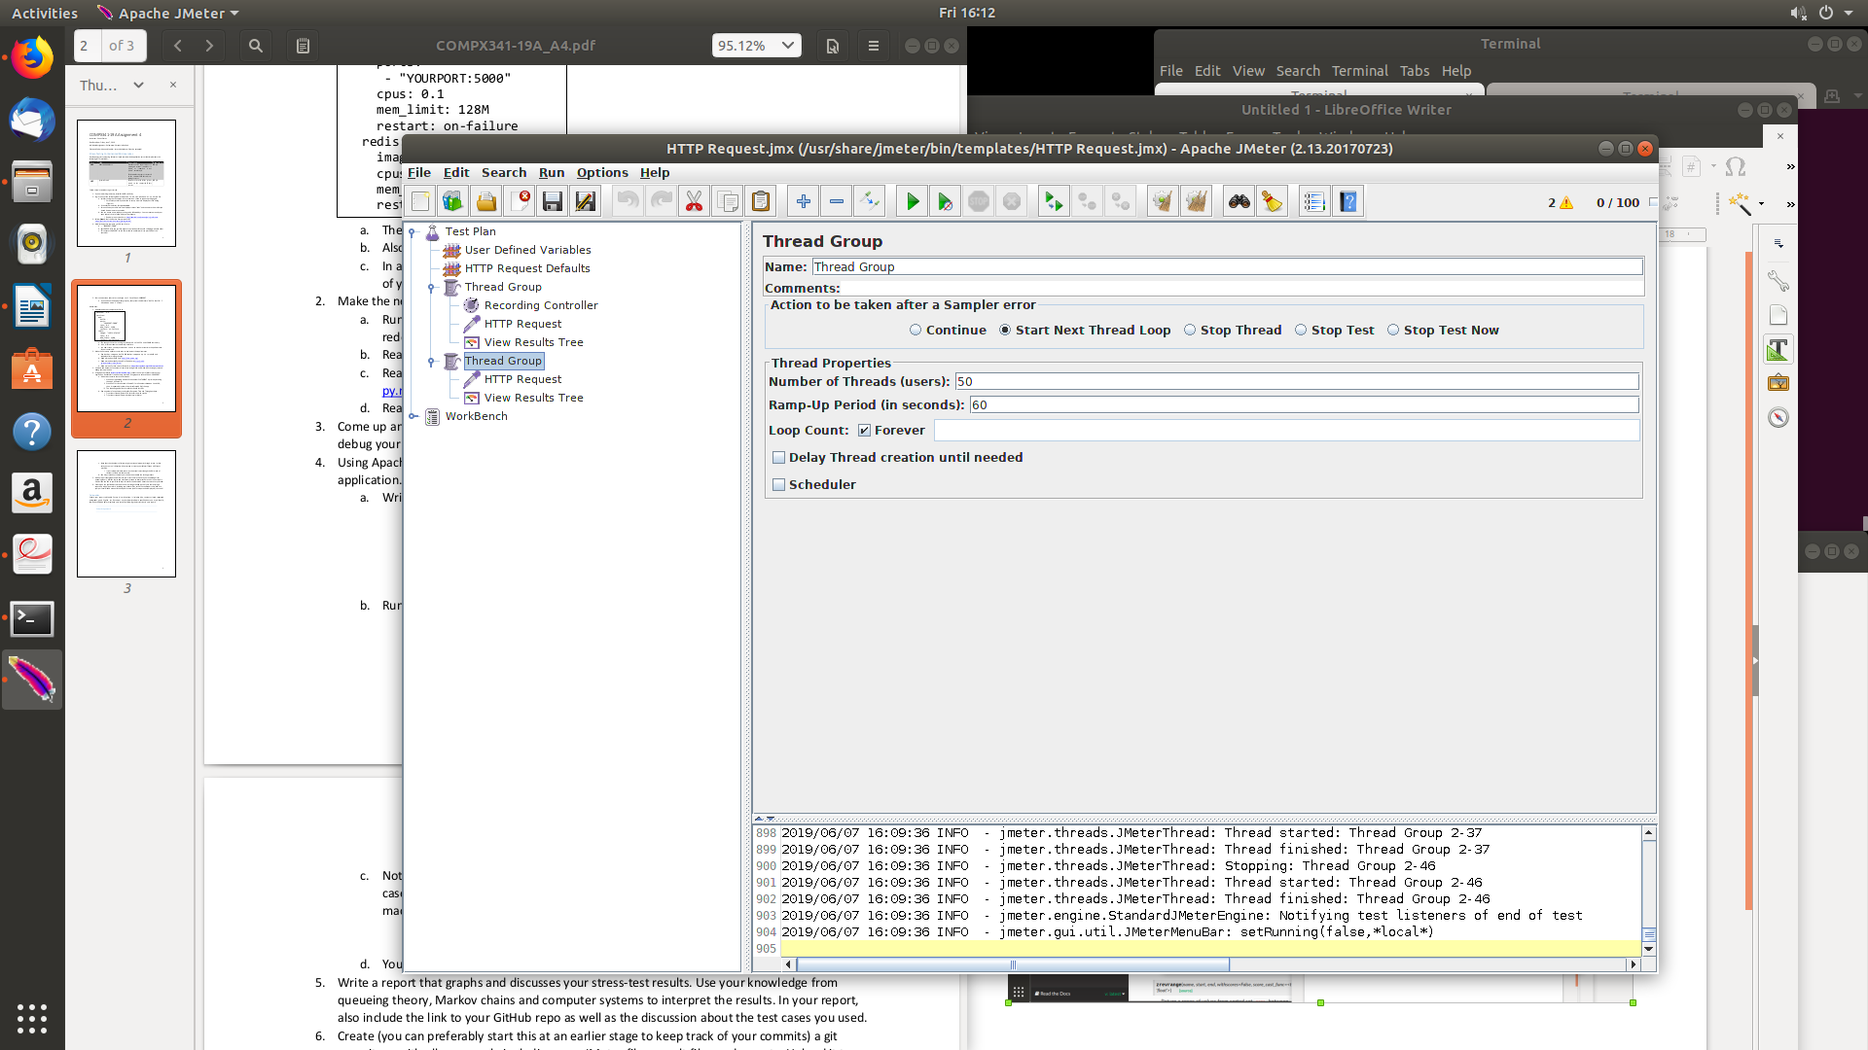
These pictures show the test properties used for the tests following;
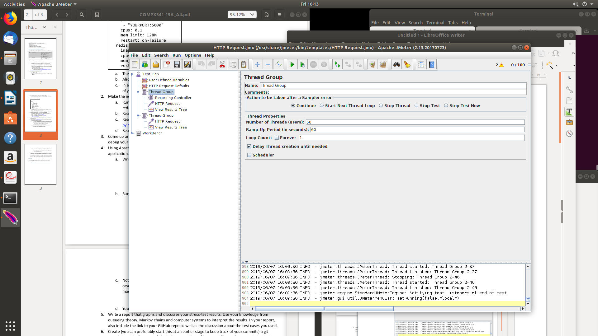

CPU set at 0.1

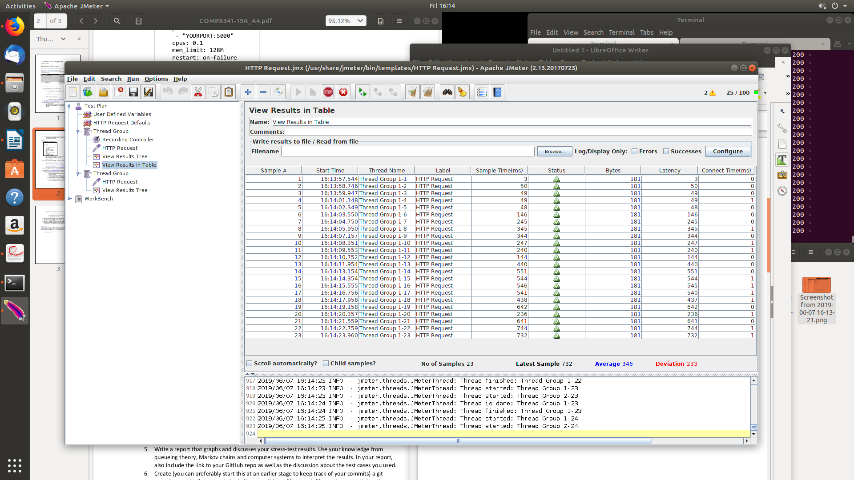

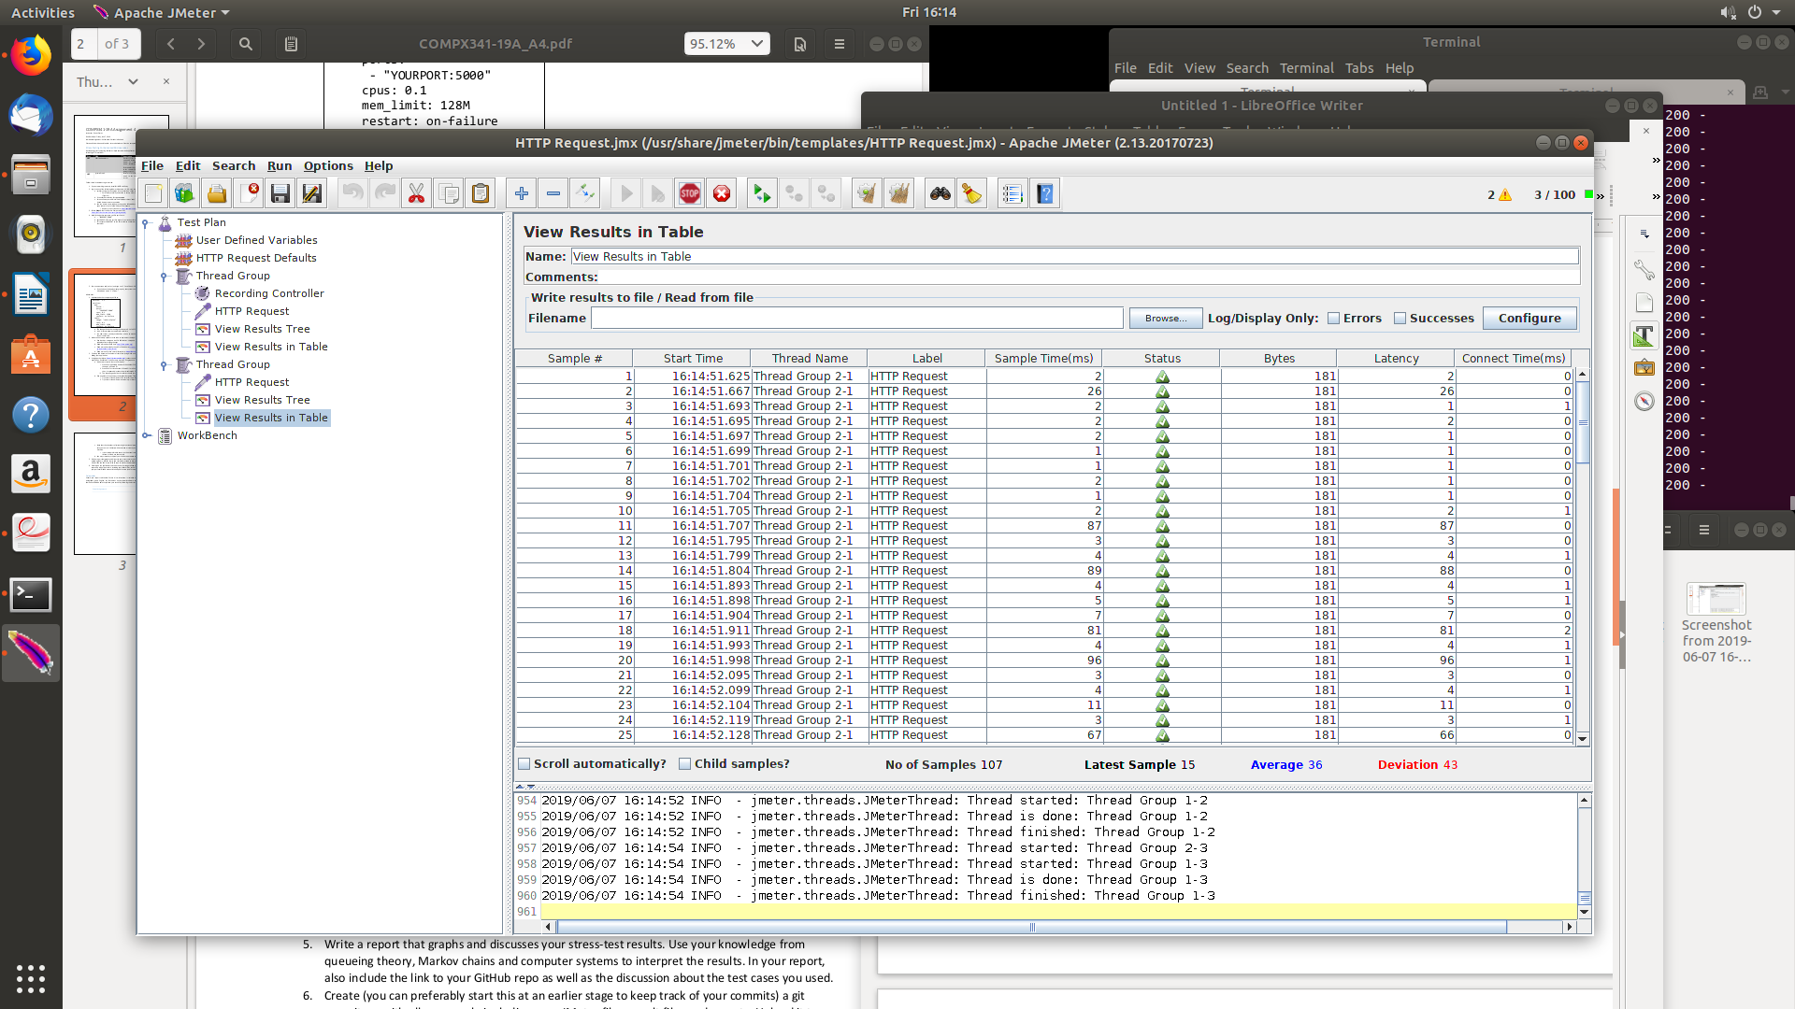

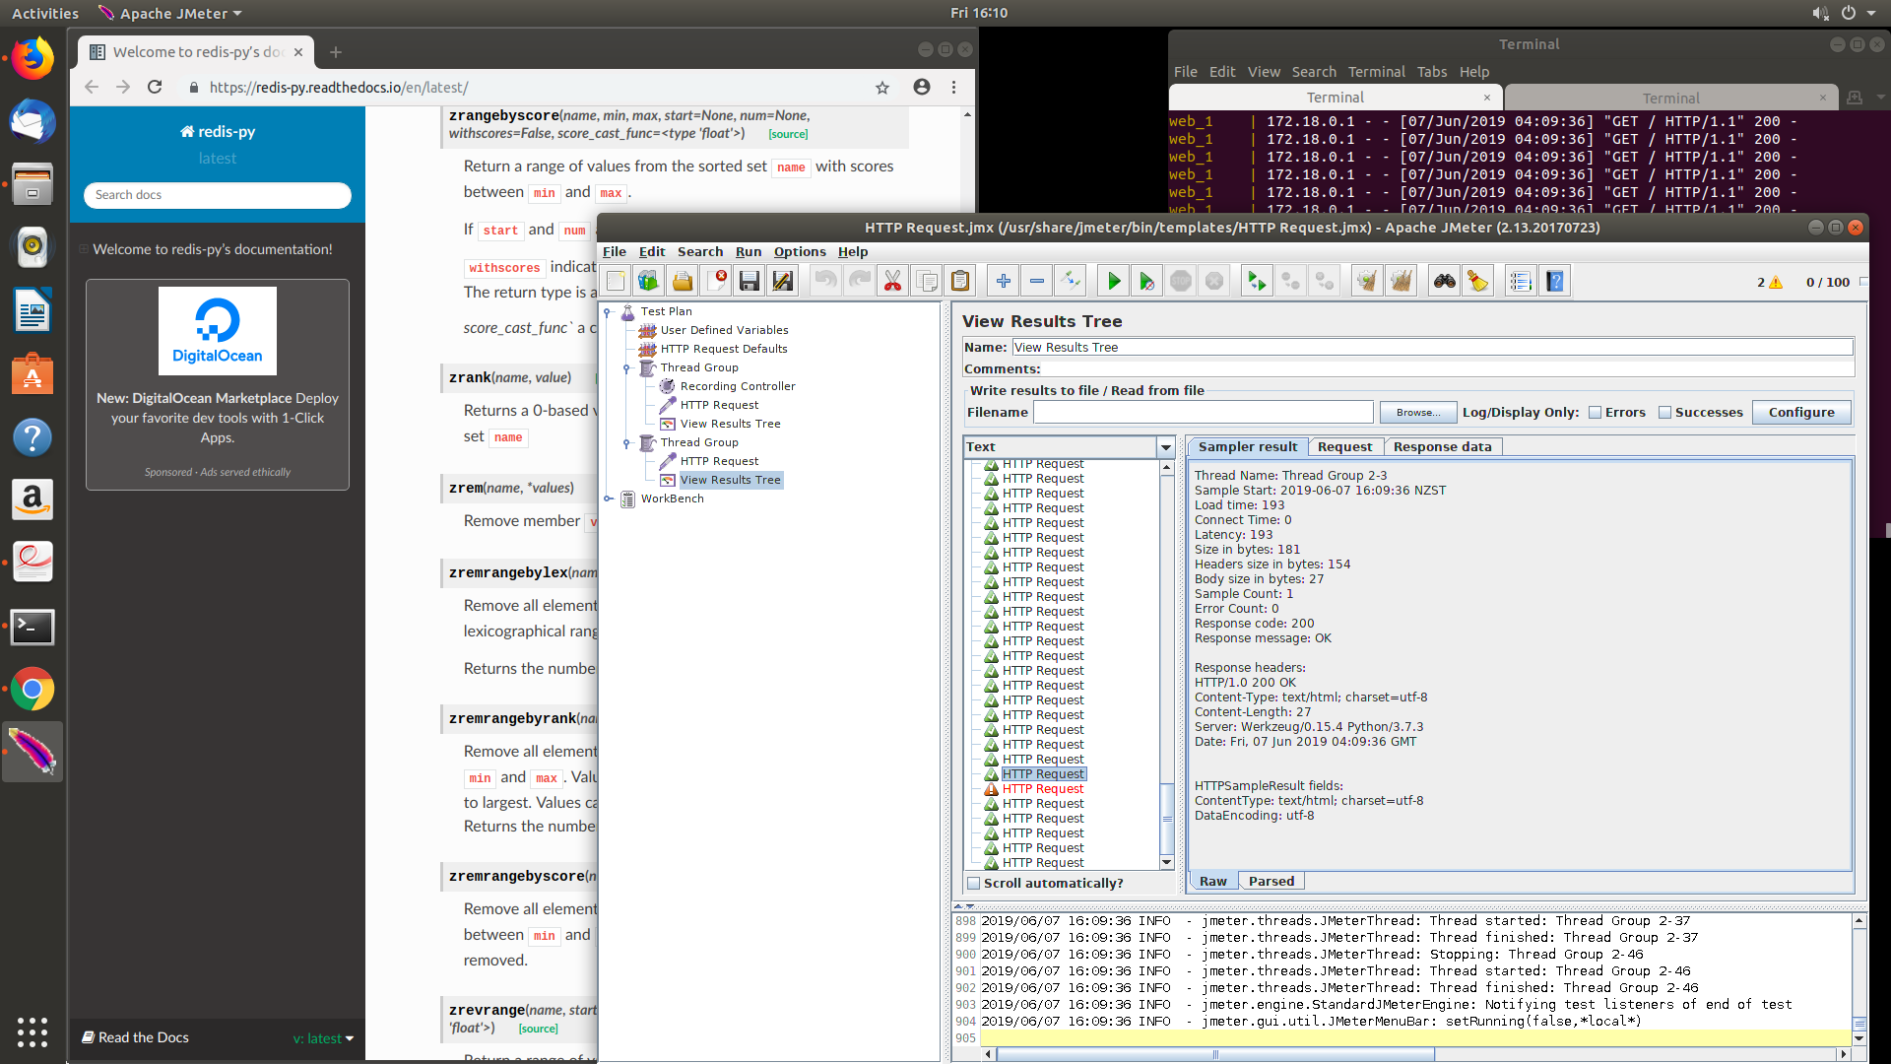
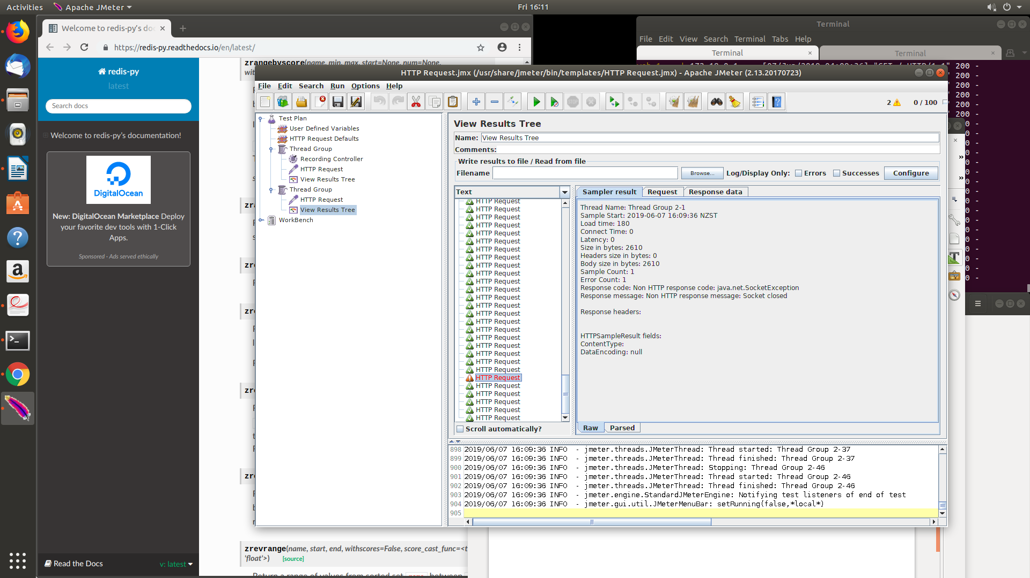

CPU set at 0.5

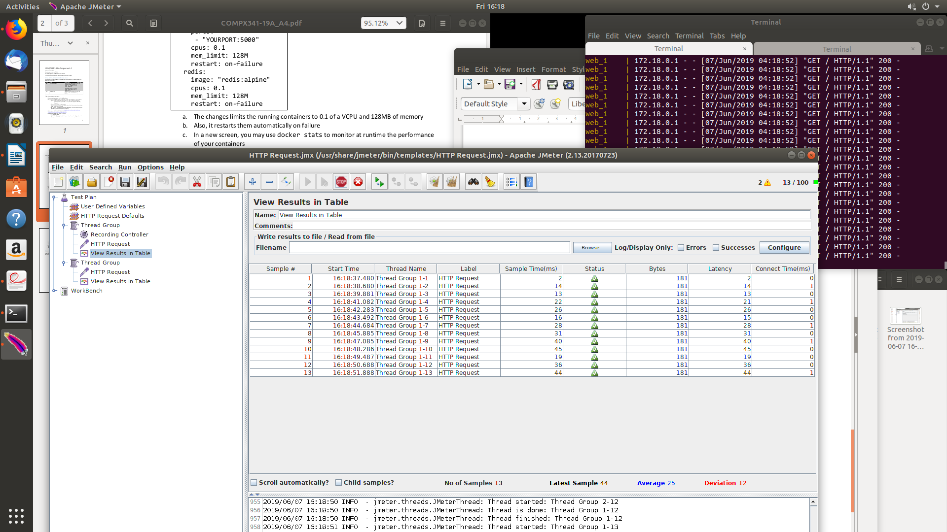

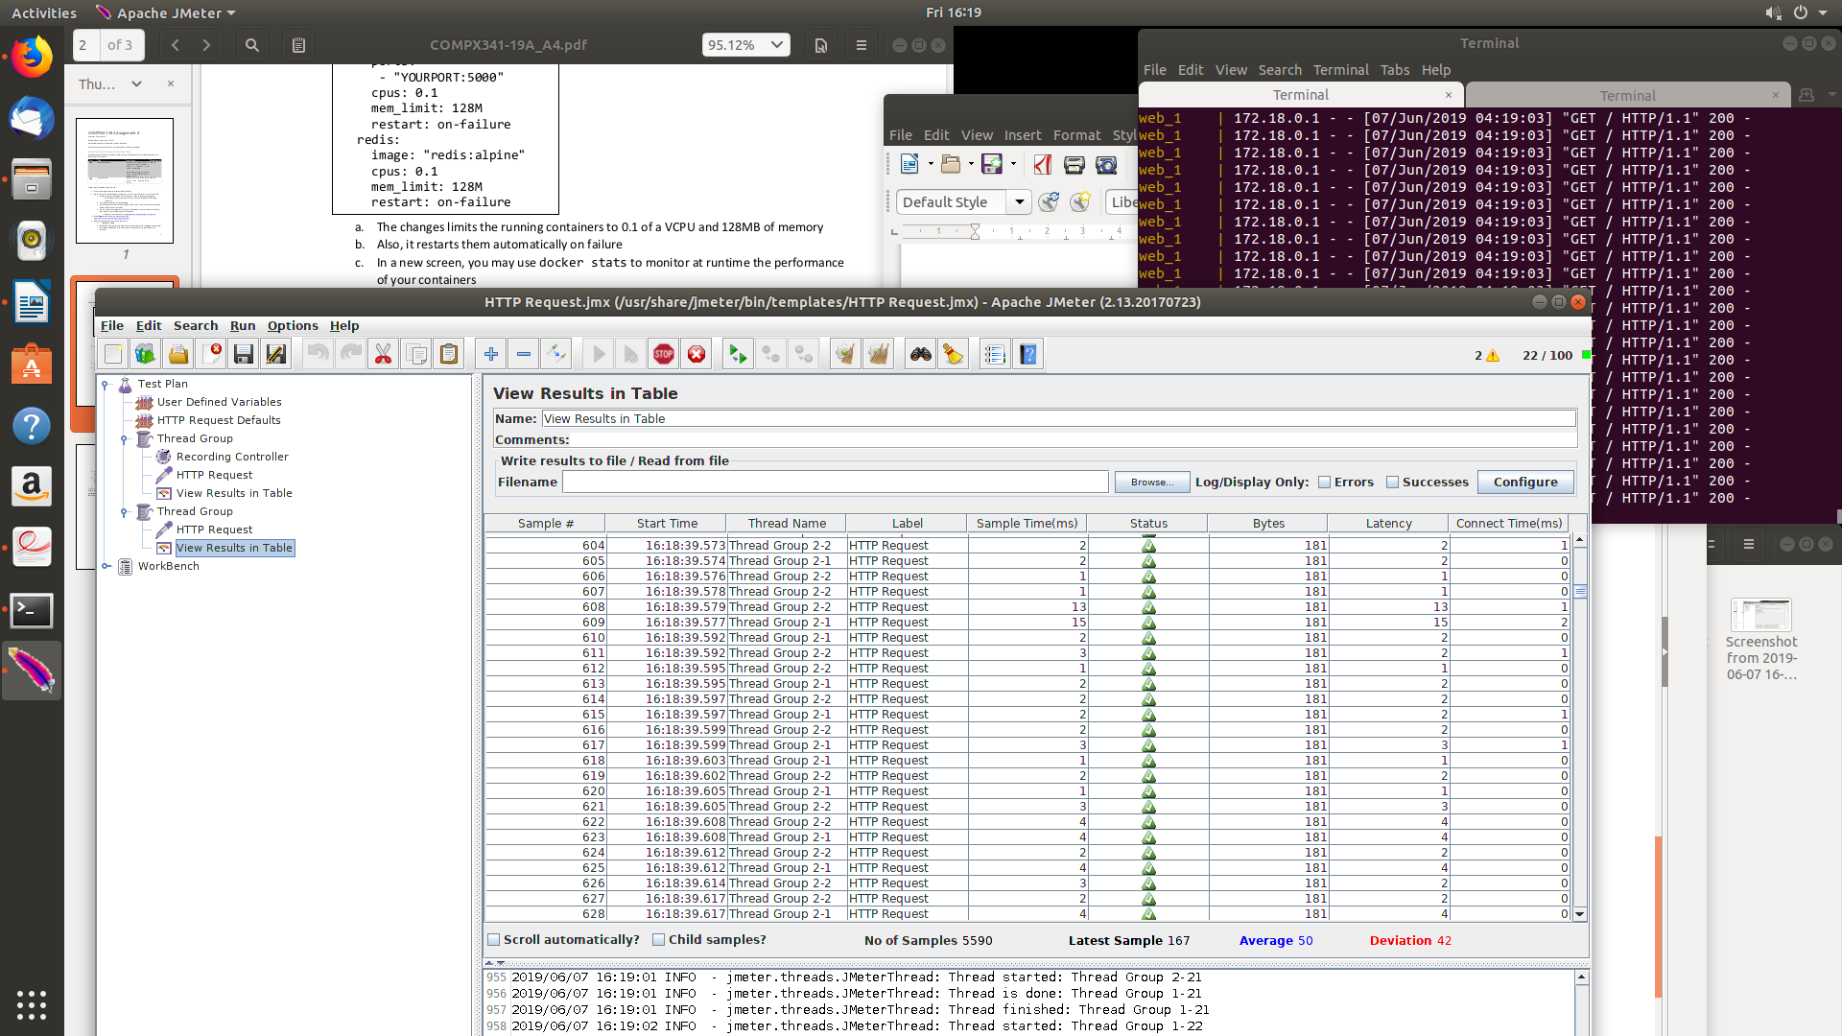

CPU set to 1.0

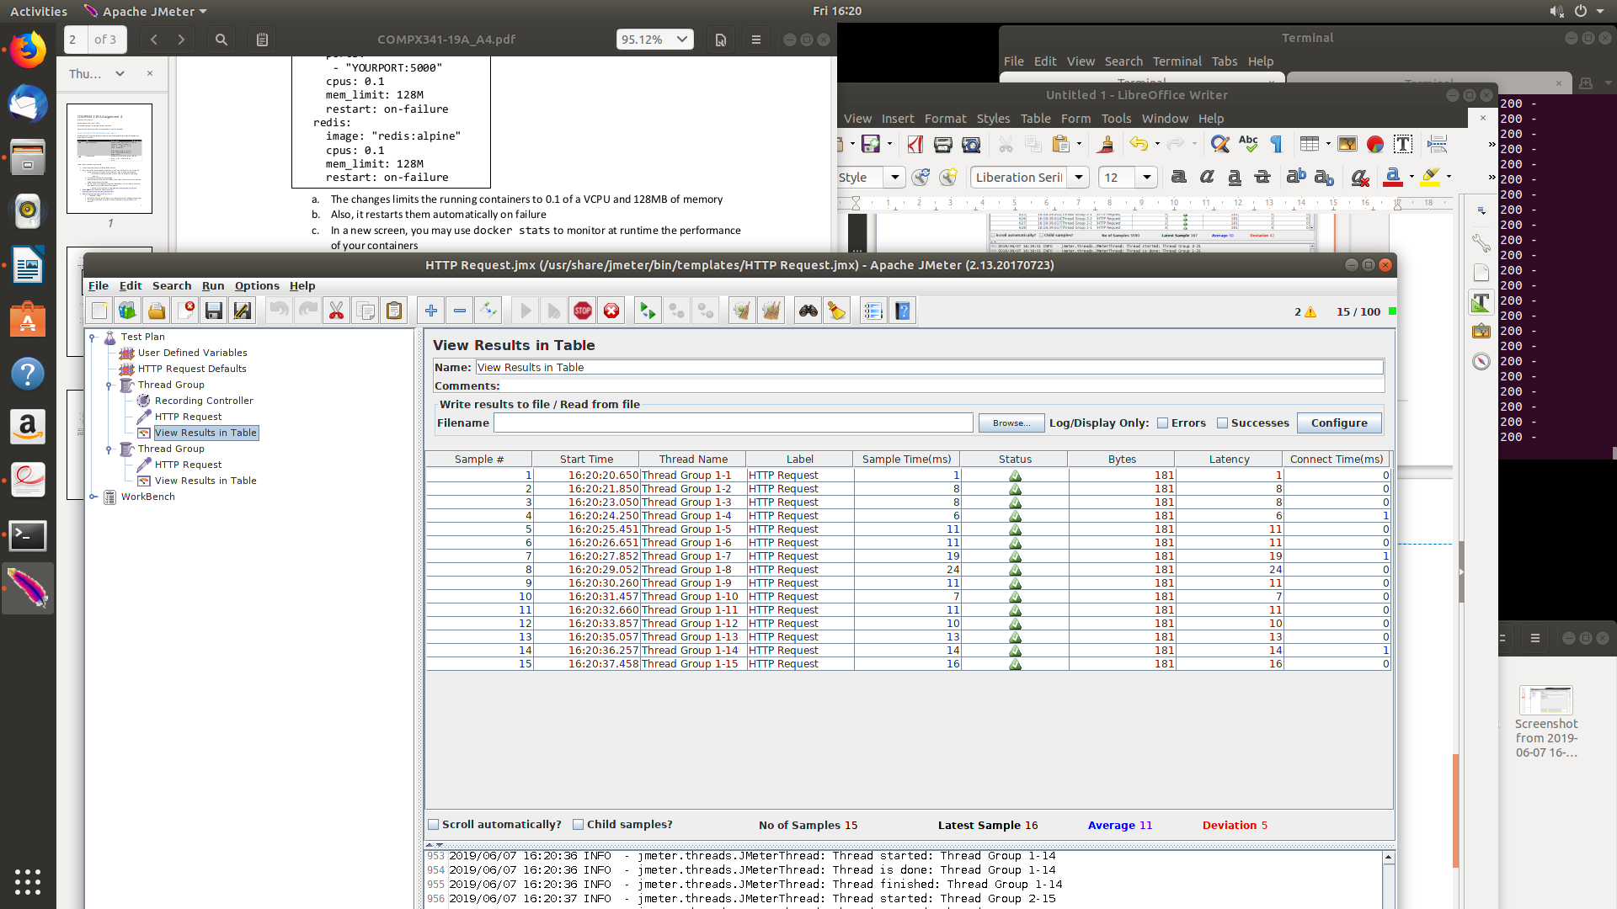
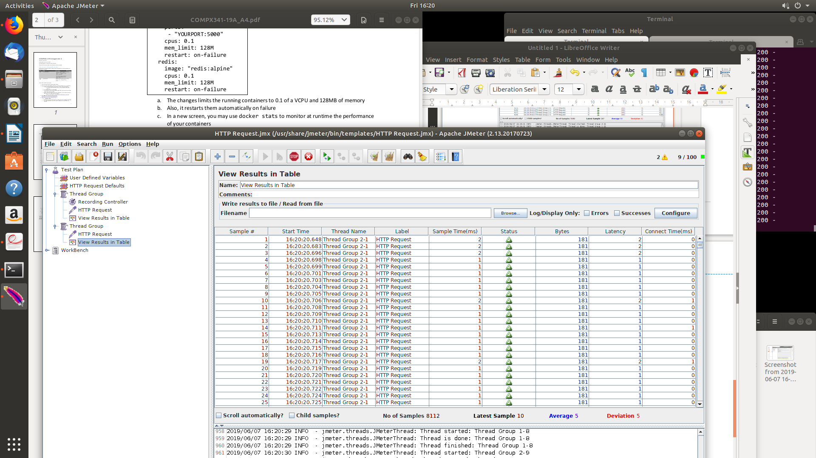

Discussion

Tests were done in Jmeter.
As i increased the CPU usage, the test results took less and less time, increasing in efficiency. The bytes for results were all the same except for failed ones which had much higher byte amounts, along with much higher latency etc.

This was done on an optiplex 7050 Dell run computer using the linux operating system. It has access to 4 CPU’s that can run threads sending http requests to my server.

Access to github:
https://github.com/bww7/Compx341

