**Digital image processing and vision systems – lab #5**

|  |  |
| --- | --- |
| Date performed: 20.04.2021 | Group 2 |
| Author name: Krzysztof Klimczyk | |

1. **Source codes and screenshots:**

Task 6.3. Histogram based binarization:

1. image = imread("coins.png");
3. figure('Name','Histogram and binarization','NumberTitle','off');
4. subplot(1,2,1)
5. imhist(image);
6. title("Histogram of original image");
7. subplot(1,2,2)
8. bw = im2bw(image,0.4);
9. imshow(bw);
10. 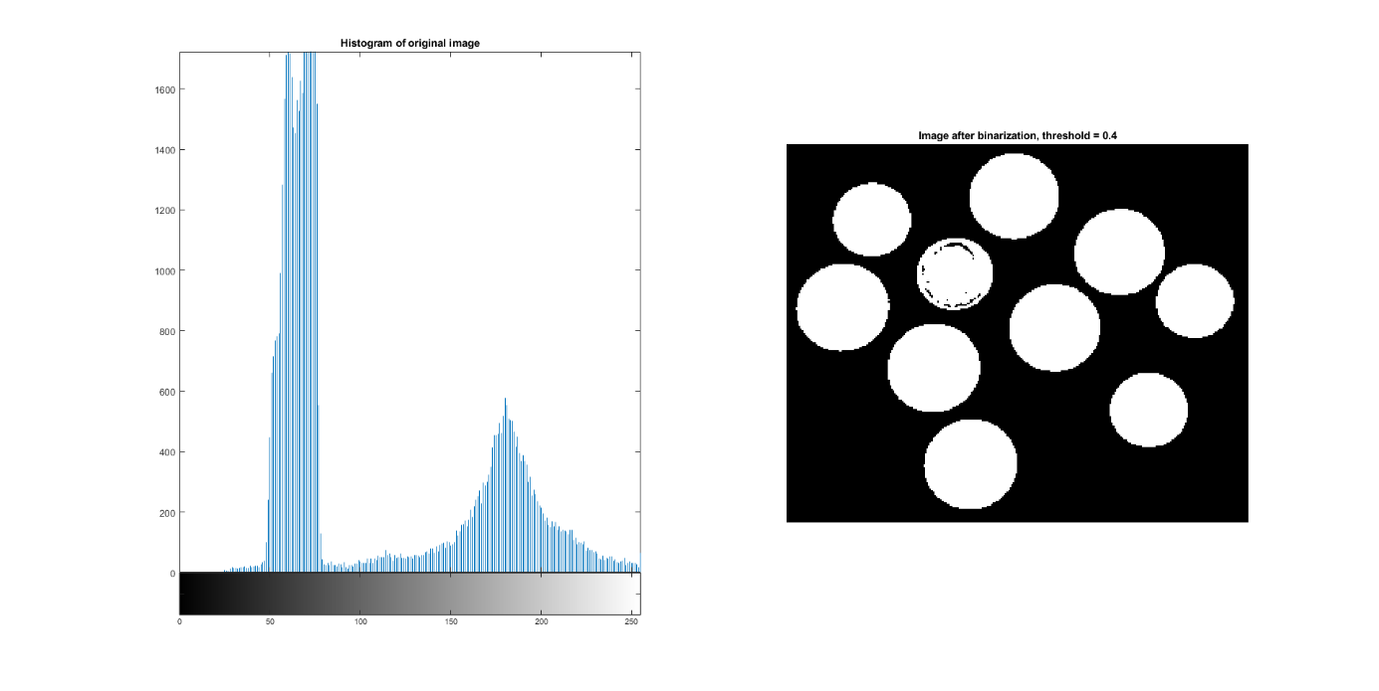title("Image after binarization, threshold = 0.4");
11. shape1 = imread("shape1.png");
12. shape2 = imread("shape2.png");
13. shape3 = imread("shape3.png");
14. shape4 = imread("shape4.png");
16. figure('Name','Shape 1','NumberTitle','off');
17. subplot(1,2,1)
18. imhist(shape1);
19. title("Histogram of original image(shape1.png)");
20. subplot(1,2,2)
21. bw = im2bw(shape1,0.4);
22. imshow(bw);
23. title("Image after binarization, threshold = 0.4");

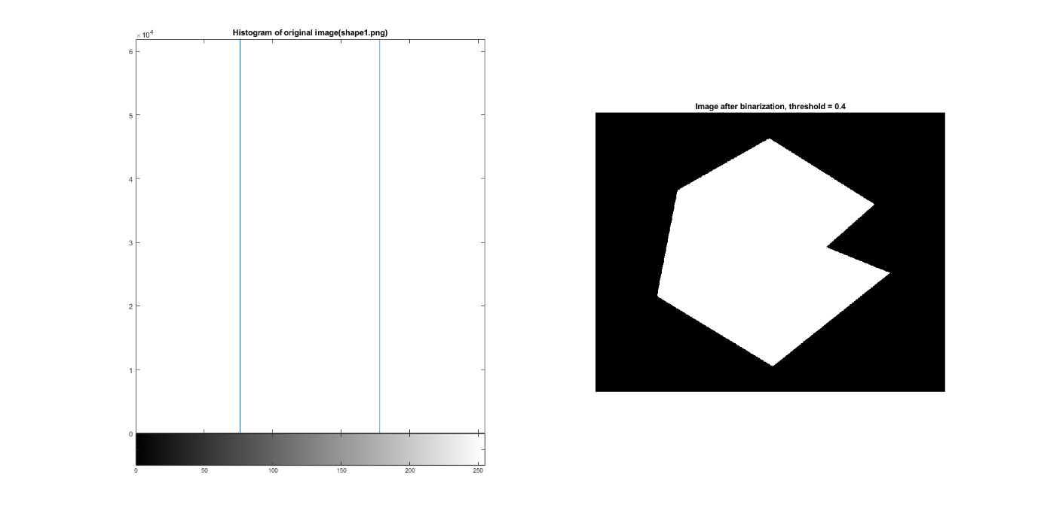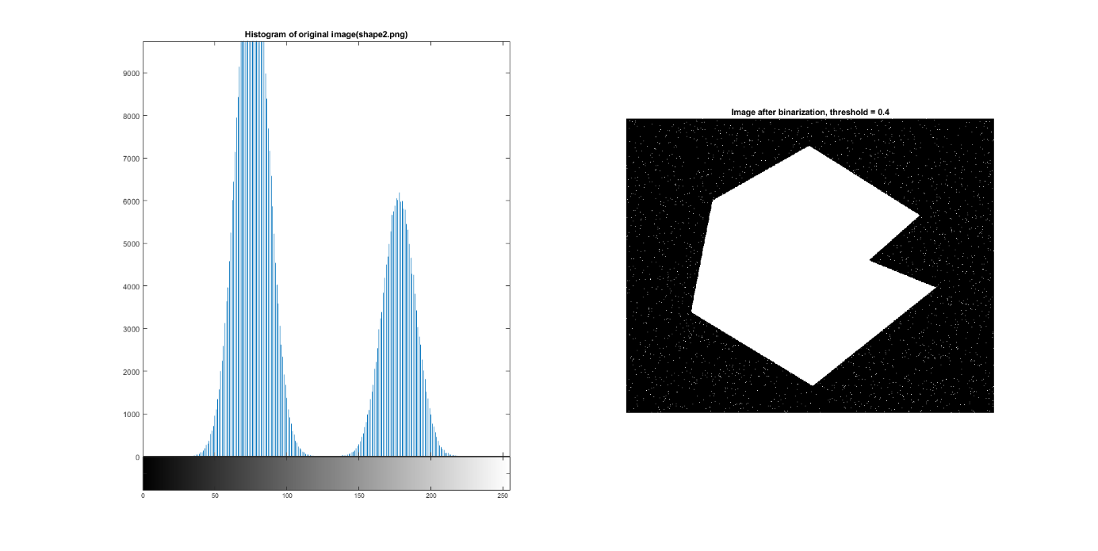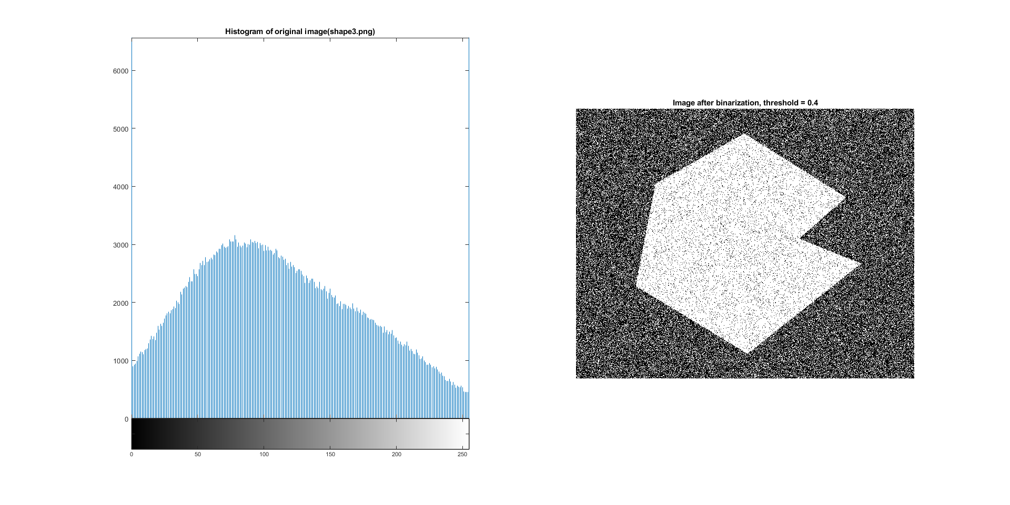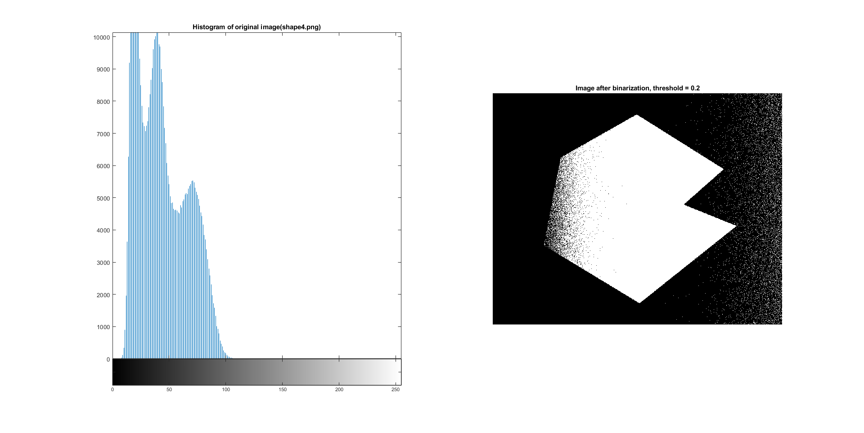

1. figure('Name','Otsu and manually selection','NumberTitle','off');
2. subplot(1,2,1)
3. level = graythresh(image);
4. bw = im2bw(image,level);
5. imshow(bw);
6. title("Otsu level selection, threshold = " + level);
7. subplot(1,2,2)
8. bw = im2bw(image,0.4);
9. imshow(bw);
10. 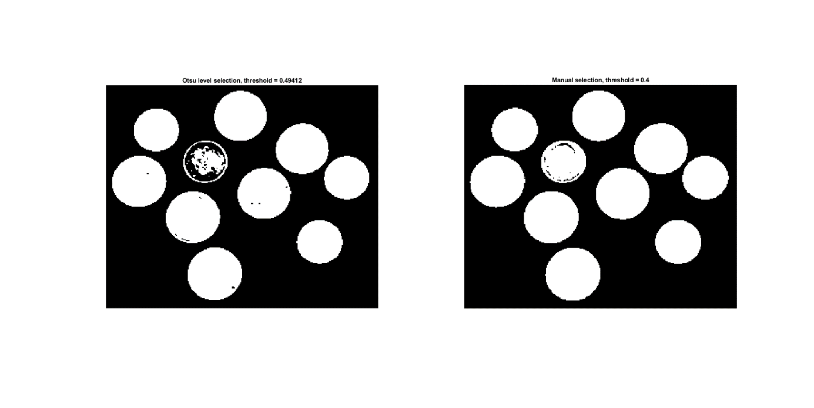title("Manual selection, threshold = 0.4");
11. image = imread("catalogue.bmp");
13. figure('Name','Kittle/Yen','NumberTitle','off');
14. subplot(1,6,1)
15. imshow(image)
16. title("Input image");
17. subplot(1,6,2)
18. imhist(image)
19. title("Histogram of input image");
20. subplot(1,6,3)
21. level = 0.4;
22. bw = im2bw(image,level);
23. imshow(bw);
24. title("Manual selection, threshold = " + level);
25. subplot(1,6,4)
26. level = graythresh(image);
27. bw = im2bw(image,level);
28. imshow(bw);
29. title("Otsu level selection, threshold = " + level);
30. subplot(1,6,5)
31. Kit = clusterKittler(image);
32. bw = im2bw(image,Kit/255);
33. imshow(bw);
34. title("Kittler, threshold = " + Kit);
35. subplot(1,6,6)
36. Yen = entropyYen(image);
37. bw = im2bw(image,Yen/255);
38. imshow(bw);
39. 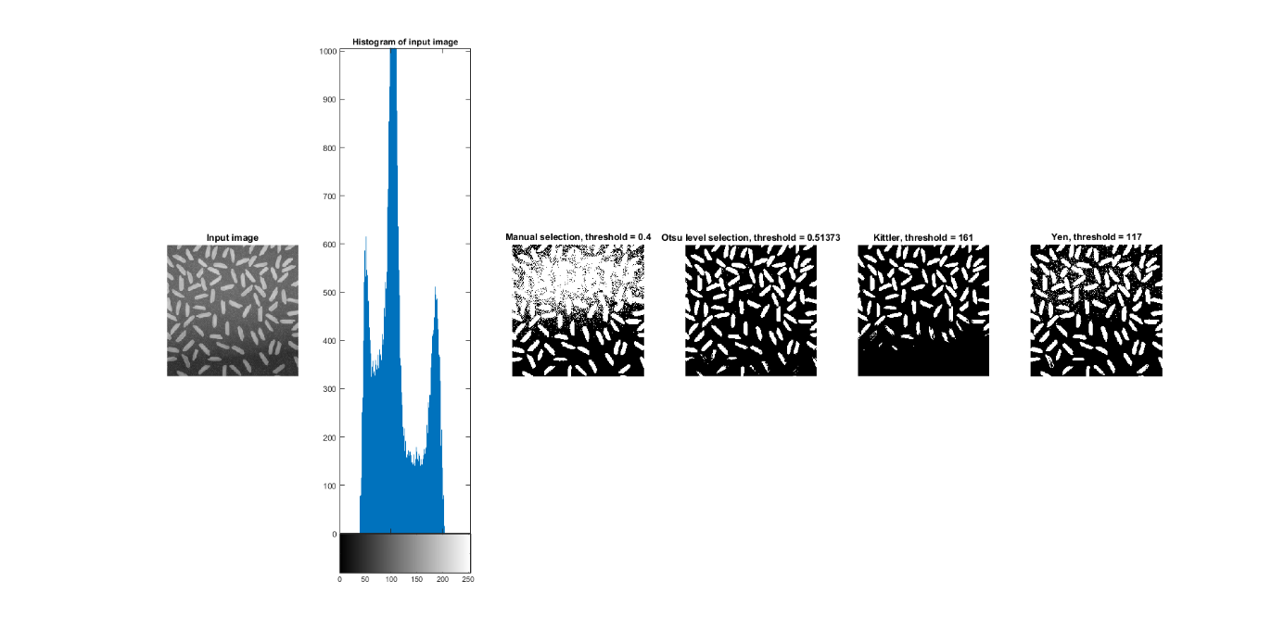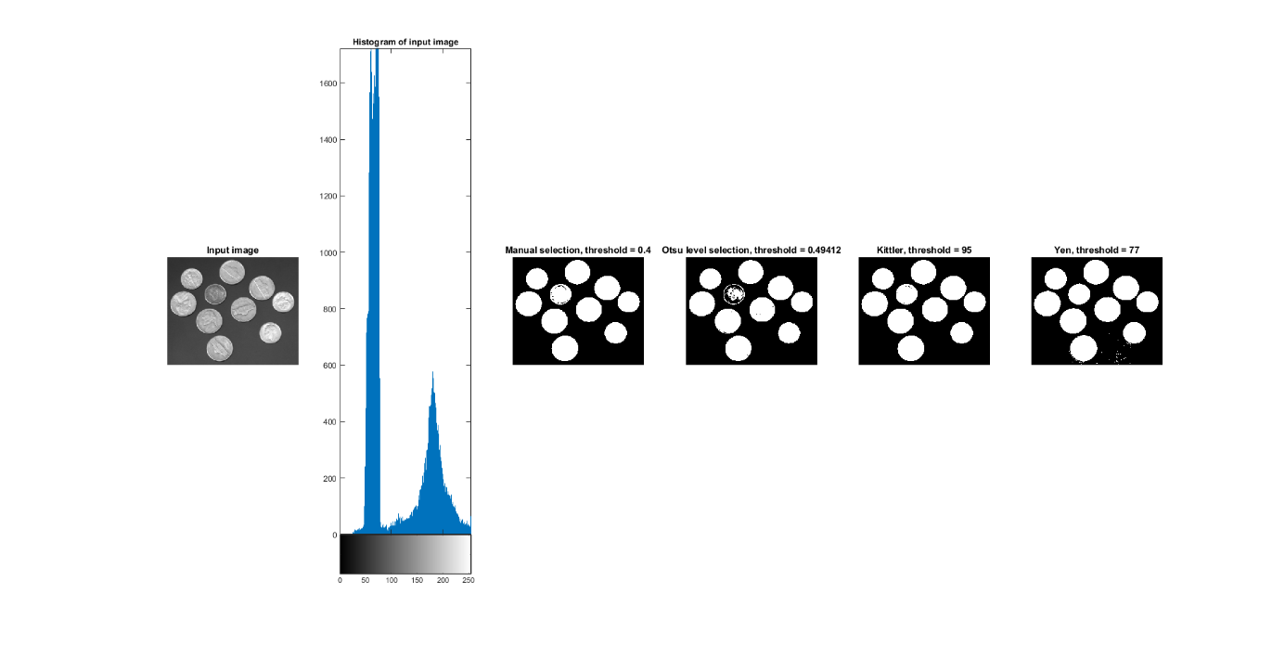title("Yen, threshold = " + Yen);

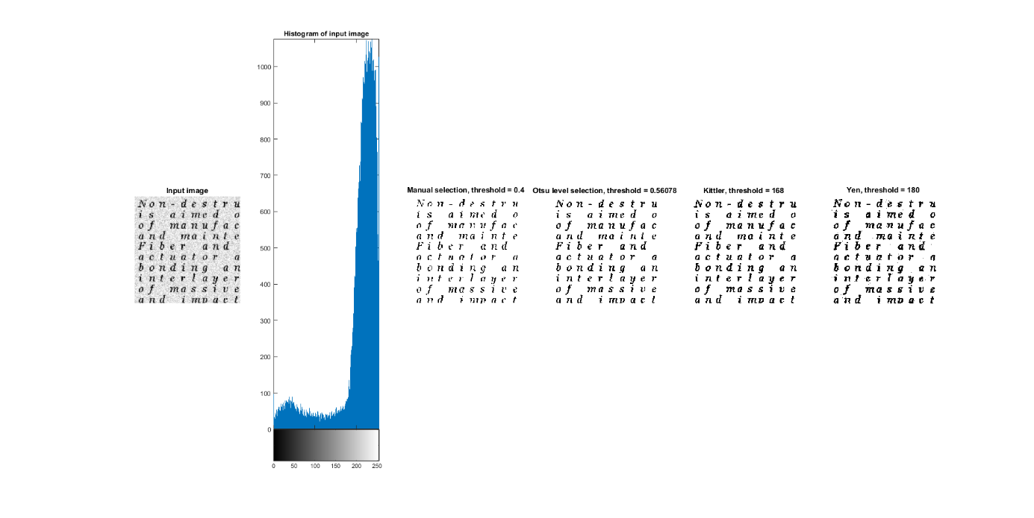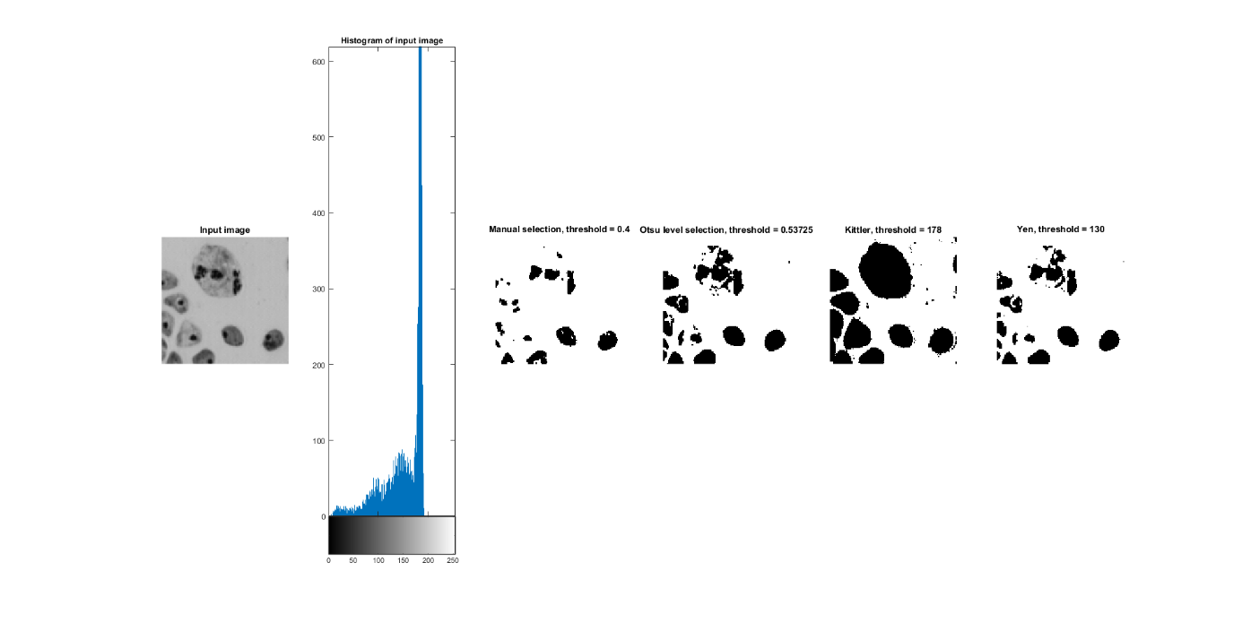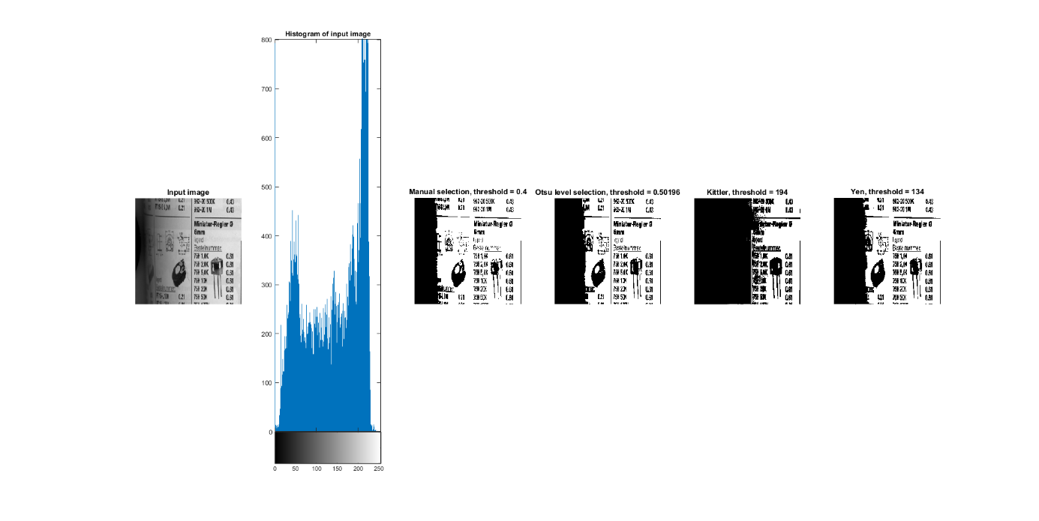

Task 6.4. Local binarization:

1. image = imread("rice.png");
2. imageBW = image;
3. figure('Name','Local binarization','NumberTitle','off');
4. [X, Y] = size(image);
5. W2 = 128;
7. for i = 1:X
8. for j = 1:Y
9. if imageBW(i,j) > meanLT(i,j,W2,image,X,Y)
10. imageBW(i,j) = 255;
11. else
12. imageBW(i,j) = 0;
13. end
14. end
15. end
17. subplot(1,2,1)
18. imshow(image);
19. title("Input image");
20. subplot(1,2,2)
21. imshow(imageBW);
22. 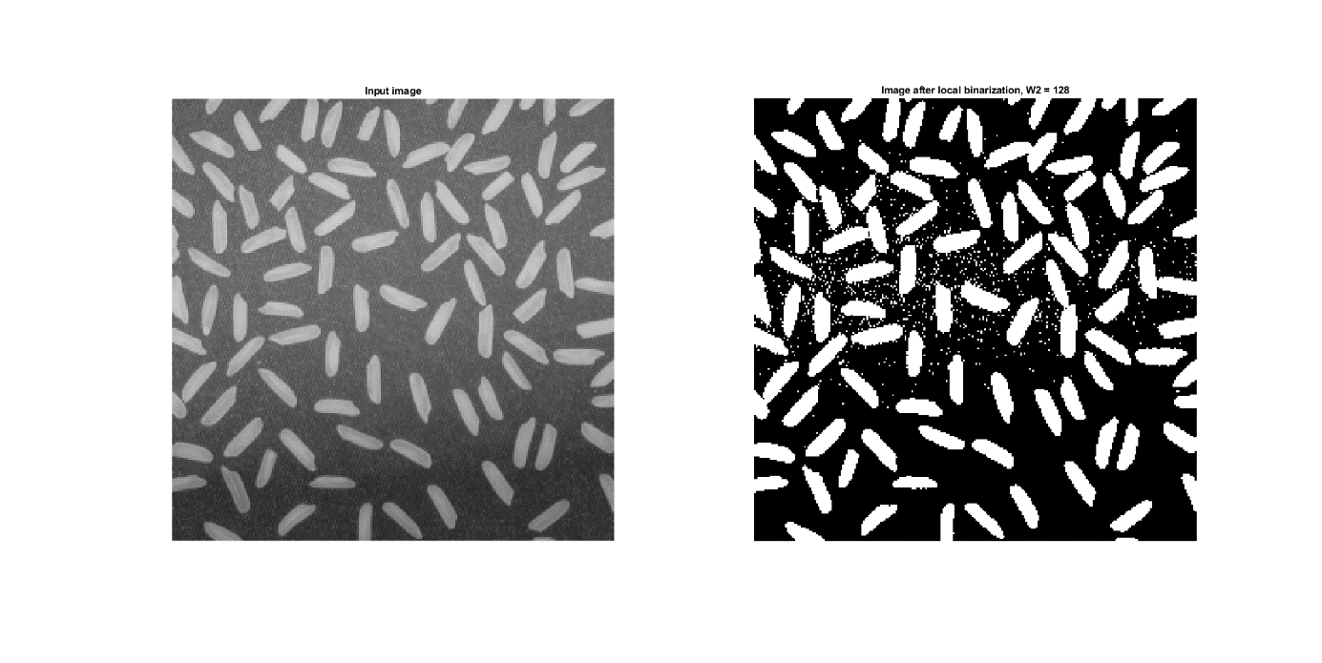title("Image after local binarization, W2 = " + W2);

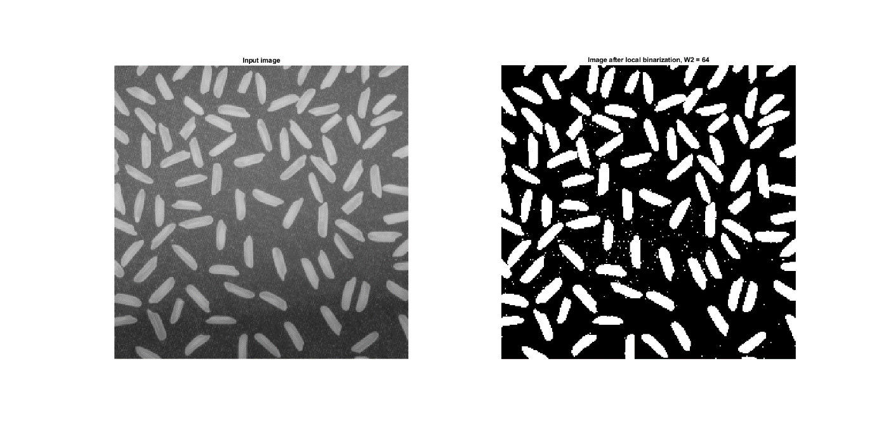

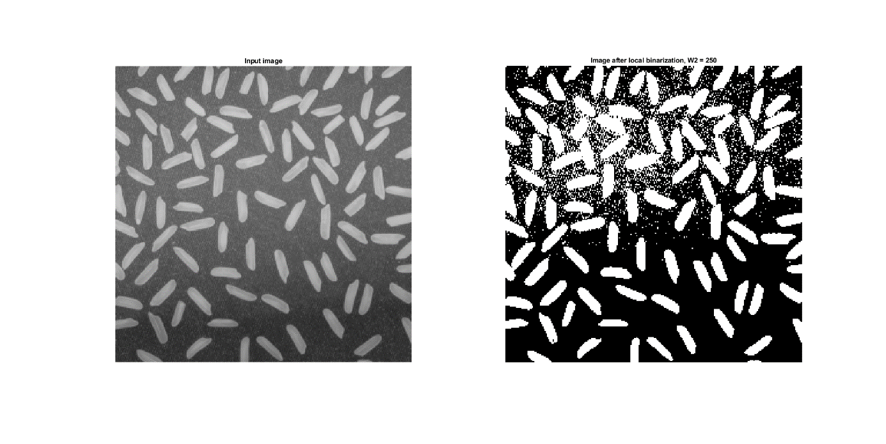

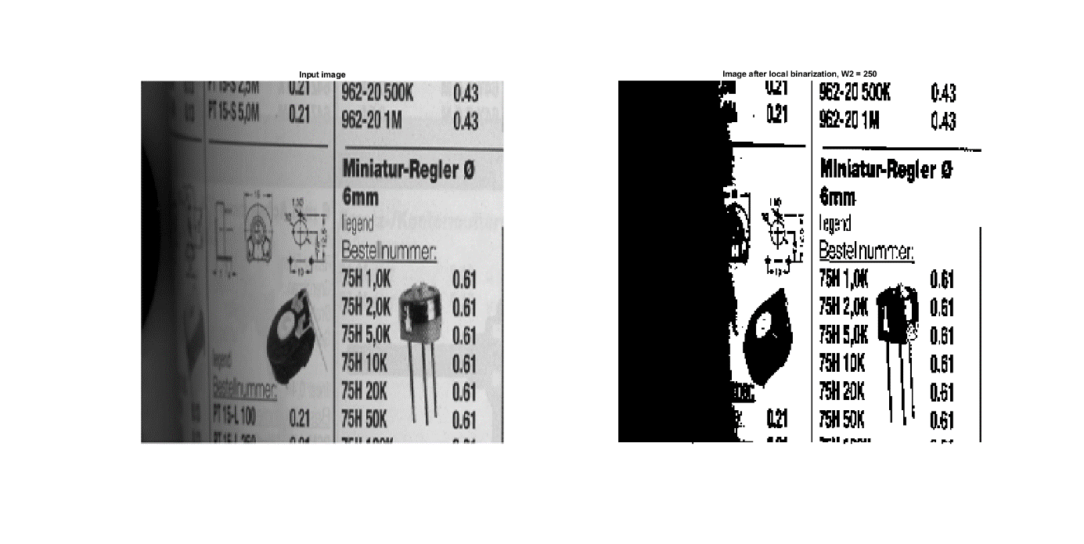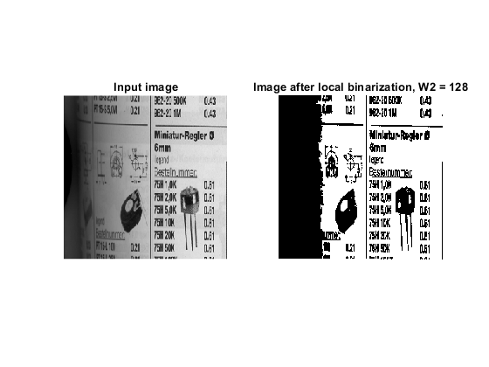

Sauvola method:

1. image = imread("rice.png");
2. imageBW = image;
3. p_imageBW_improved = image;
4. m_imageBW_improved = image;
5. figure('Name','Improved local binarization','NumberTitle','off');
6. [X, Y] = size(image);
7. W2 = 128;
8. k = 0.15;
9. R = 128;
10. for i = 1:X
11. for j = 1:Y
12. mean = meanLT(i,j,W2,image,X,Y);
13. stddev = stddevLT(i,j,W2,image,mean,X,Y);
14. T_p = mean * (1 + k*(stddev/R - 1));
15. T_m = mean * (1 - k*(stddev/R - 1));
17. if image(i,j) > T_p
18. p_imageBW_improved(i,j) = 255;
19. else
20. p_imageBW_improved(i,j) = 0;
21. end
23. if image(i,j) > T_m
24. m_imageBW_improved(i,j) = 255;
25. else
26. m_imageBW_improved(i,j) = 0;
27. end
29. if image(i,j) > mean
30. imageBW(i,j) = 255;
31. else
32. imageBW(i,j) = 0;
33. end
34. end
35. end
36. subplot(1,4,1)
37. imshow(image);
38. title("Input image");
39. subplot(1,4,2)
40. imshow(imageBW);
41. title("Image after local binarization, W2 = " + W2);
42. subplot(1,4,3)
43. imshow(p_imageBW_improved);
44. title("Image after local improved binarization(+)," + newline + "W2 = " + W2 + ", k = " + k + ", R = " + R);
45. subplot(1,4,4)
46. imshow(m_imageBW_improved);
47. title("Image after local improved binarization(-)," + newline + "W2 = " + W2 + ", k = " + k + ", R = " + R);

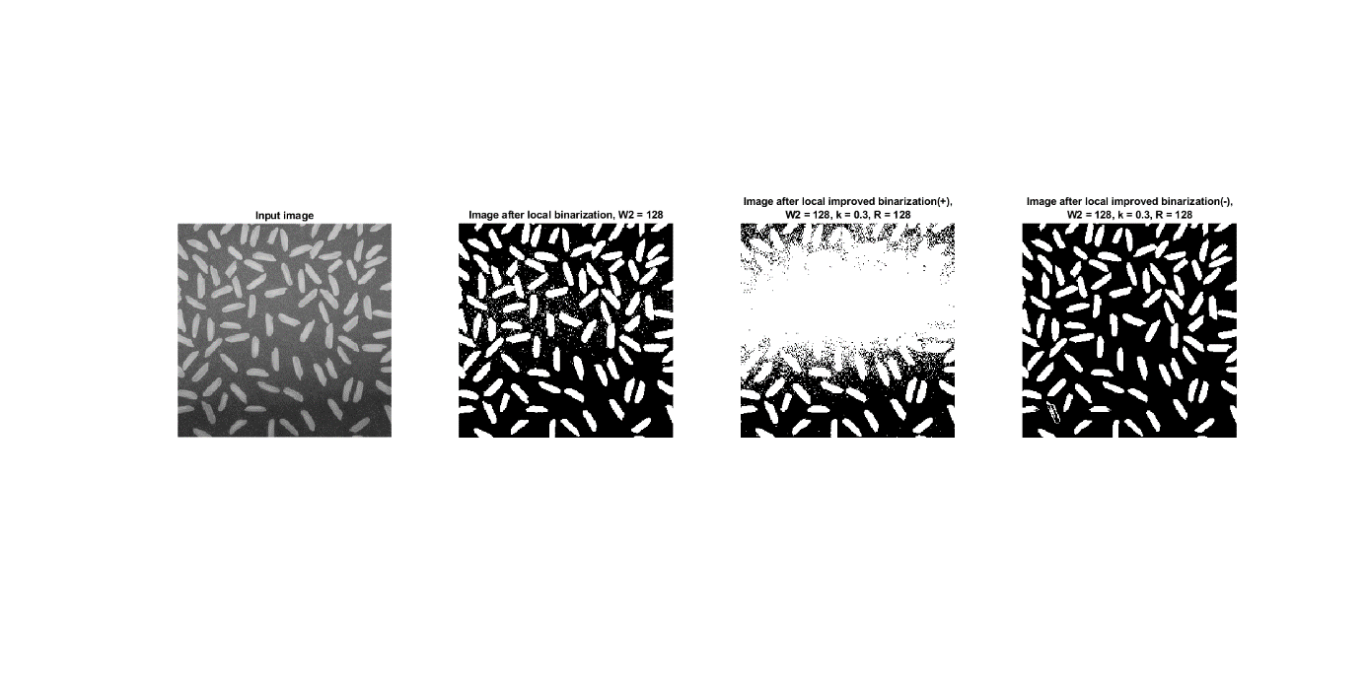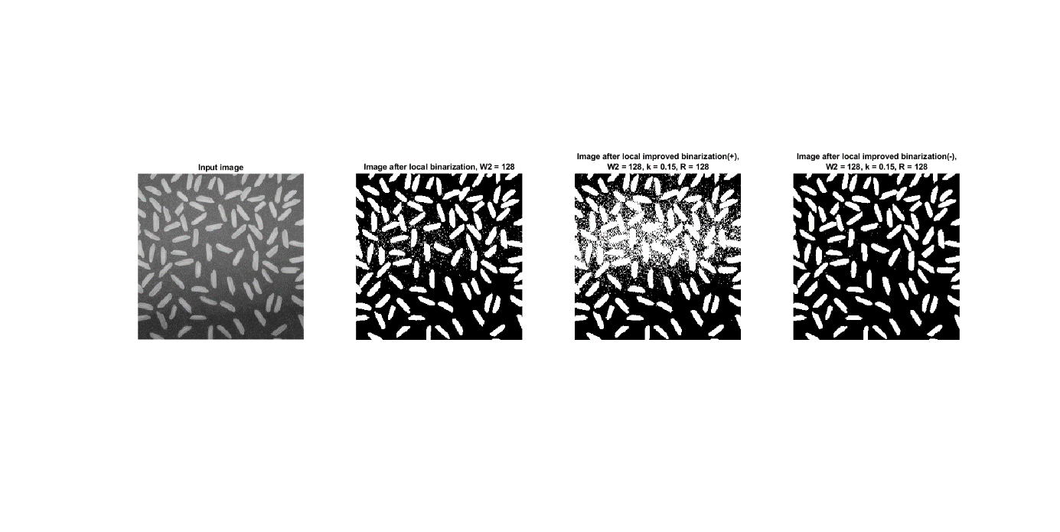

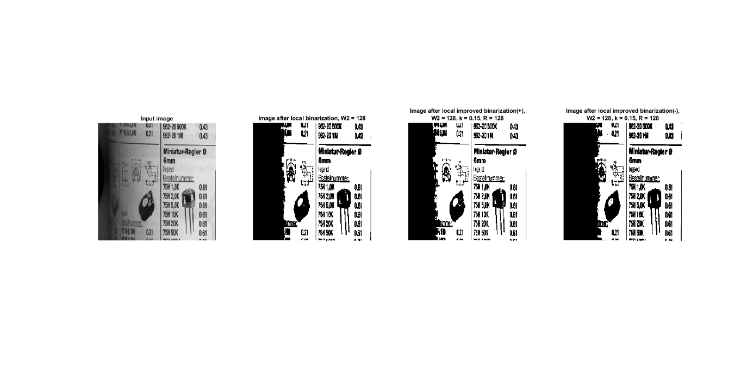

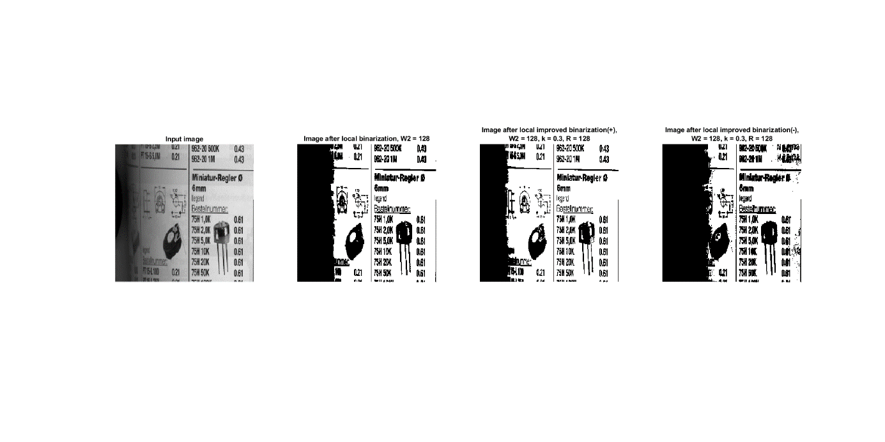

Task 6.5. Binarization with two thresholds:

1. image = imread("bart.bmp");
3. figure('Name','Binarization with two thresholds','NumberTitle','off');
4. subplot(1,3,1);
5. imshow(image);
6. title("Input image");
7. subplot(1,3,2);
8. imhist(image);
9. title("Histogram of input image");
11. subplot(1,3,3);
12. lowerThreshold = 145;
13. upperThreshold = 225;
14. imageBW = image > lowerThreshold & image < upperThreshold;
15. imageBW = uint8(imageBW);
16. imshow(imageBW, []);
17. title("Binarization with two thresholds");

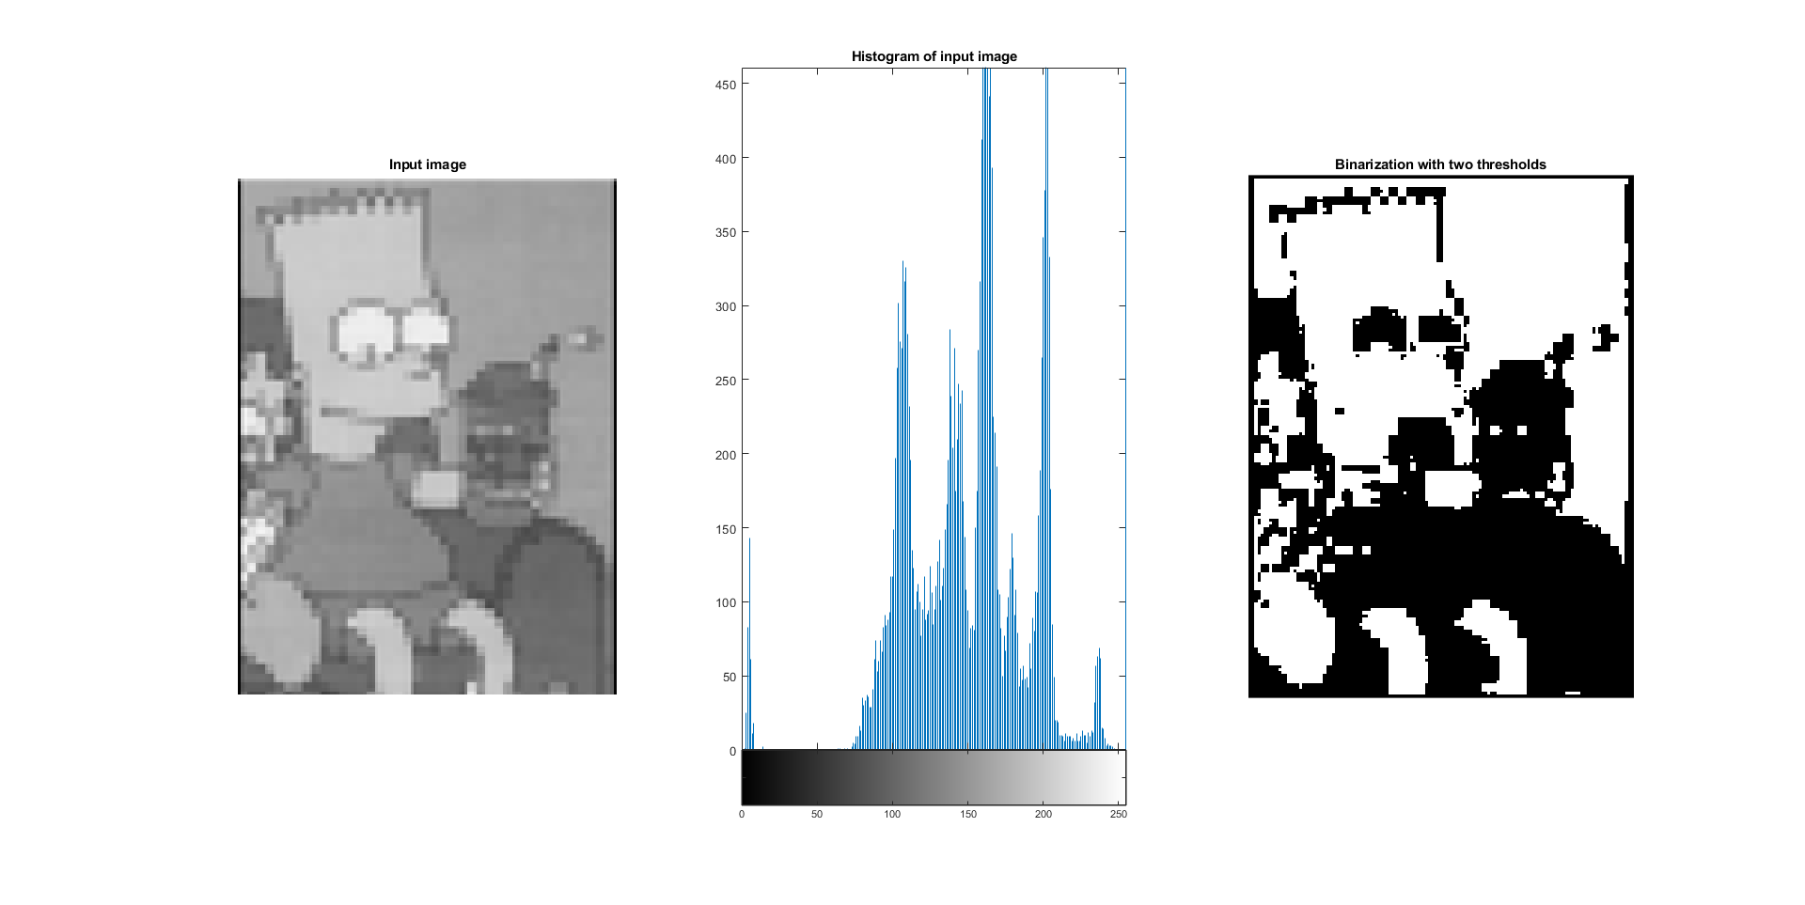

1. **Conclusions:**

Considering the picture of coins, the threshold with a value of 0.4 gives the best result of the simple binarization effect. The shape of white circles is similar to real coins in the input image and only one shape has a bit of black noise inside.

The output image after binarization by im2bw() method has a clear and sharp shape but there is no build-in algorithm to remove the noise.

The Otsu method gives a little bigger threshold (0.49412) than the manually selected (0.4). Comparing the binary images, the otsu version has more black pixels inside the white circles, and the shape of these circles is less round.

The Yen method gives the best result if the lighting is not uniform. Kittler method has a problem with darker areas of an image and after processing there are black spots on the resulting picture. The most readable output of text pictures is given by Kittle and Otsu methods, the text is sharp and letter shapes are not distorted.

Local binarization with meanLT method can handle with non-uniform lighting. In a picture called rice.png, the value of the W2 parameter affects noise in the brightened area so the higher value means more disturbance. But on the other image called catalogue.bmp the higher value of this parameter affects text sharpness.

The equation in the Sauvola method has two versions. One is with "+" symbol and it gives better results with brightened images and the second with "-"symbol should be used in dimmed images.

Binarization with two thresholds gives more control of image processing because we can define the range of greyscale we want to separate from the rest of the image.