**Digital image processing and vision systems – lab #7**

|  |  |
| --- | --- |
| Date performed: 04.05.2021 | Group 2 |
| Author name: Krzysztof Klimczyk | |

1. **Source codes and screenshots:**

Task 7.3. Basic morphological operations:

1. figure(1);
2. se = strel('square',3);
3. erodedIm = imerode(image,se);
4. subplot(1,2,1);
5. imshow(image);
6. title('Input image')
7. subplot(1,2,2);
8. imshow(erodedIm);
9. title('Image after erosion, SE = square 3x3')
11. figure(2);
12. se = strel('cube',5);
13. erodedIm = imerode(image,se);
14. subplot(1,2,1);
15. imshow(image);
16. title('Input image')
17. subplot(1,2,2);
18. imshow(erodedIm);
19. title('Image after erosion, SE = cube 5x5x5')
21. figure(3);
22. se = strel('diamond',4);
23. erodedIm = imerode(image,se);
24. subplot(1,2,1);
25. imshow(image);
26. title('Input image')
27. subplot(1,2,2);
28. imshow(erodedIm);
29. title('Image after erosion, SE = diamond r=4')
31. figure(4);
32. se = strel('square',3);
33. subplot(1,4,1);
34. imshow(image);
35. title('Input image')
36. subplot(1,4,2);
37. erodedIm = imerode(image,se);
38. imshow(erodedIm);
39. title('Image after 1x erosion, SE = square 3x3')
40. subplot(1,4,3);
41. erodedIm = imerode(erodedIm,se);
42. imshow(erodedIm);
43. title('Image after 2x erosion, SE = square 3x3')
44. subplot(1,4,4);
45. erodedIm = imerode(erodedIm,se);
46. imshow(erodedIm);
47. 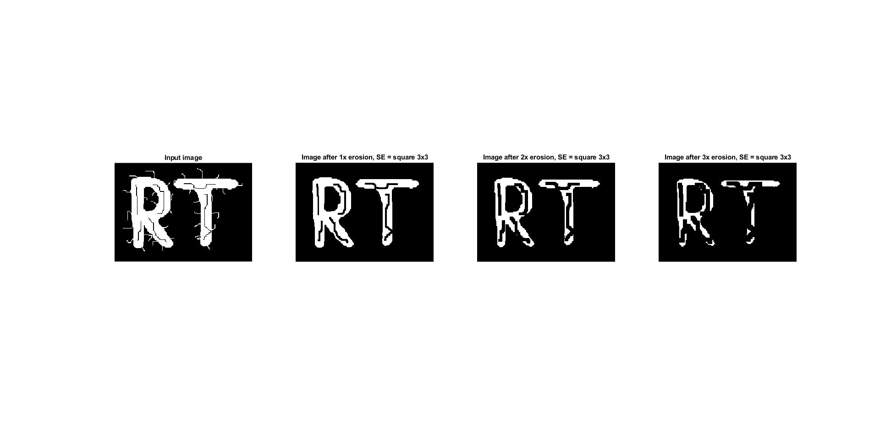title('Image after 3x erosion, SE = square 3x3')

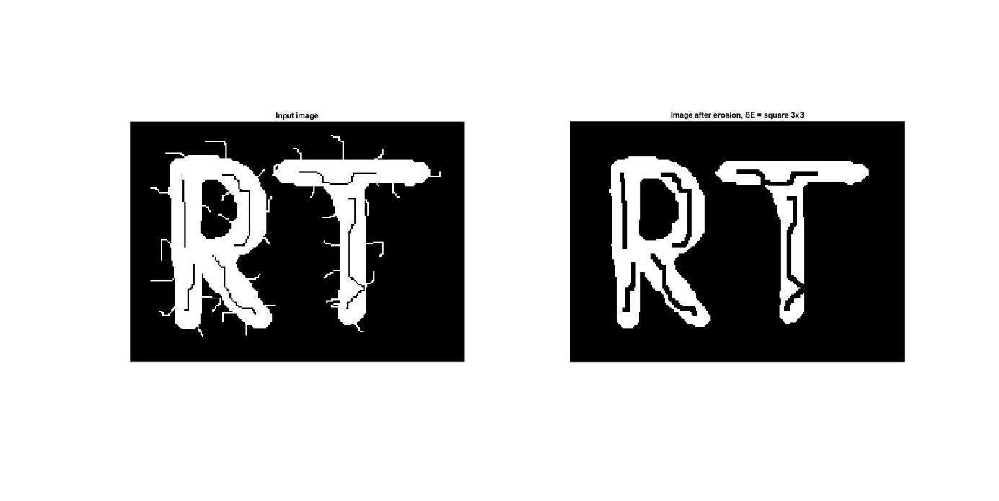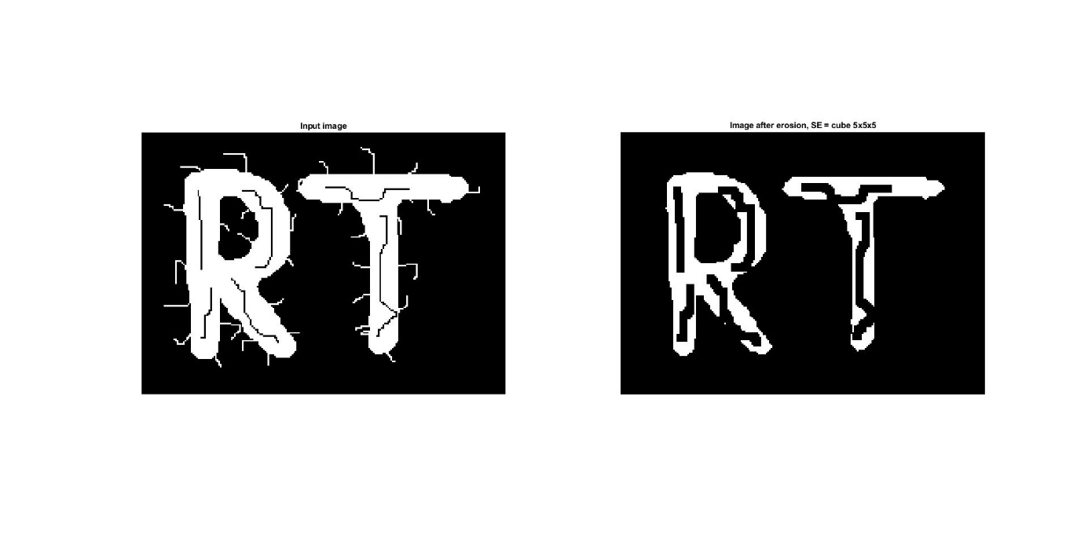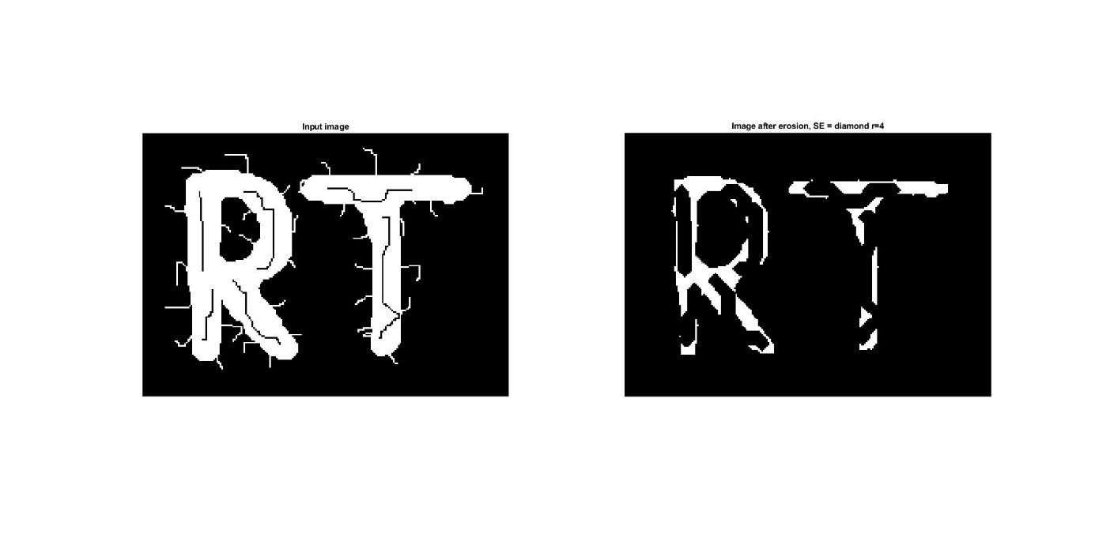

1. figure(1);
2. se = ones(4,4);
3. se = triu(se);
4. erodedIm = imerode(image,se);
5. subplot(1,2,1);
6. imshow(image);
7. title('Input image')
8. subplot(1,2,2);
9. imshow(erodedIm);
10. title('Image after erosion, SE = matrix 4x4 filled with 1 and 0')

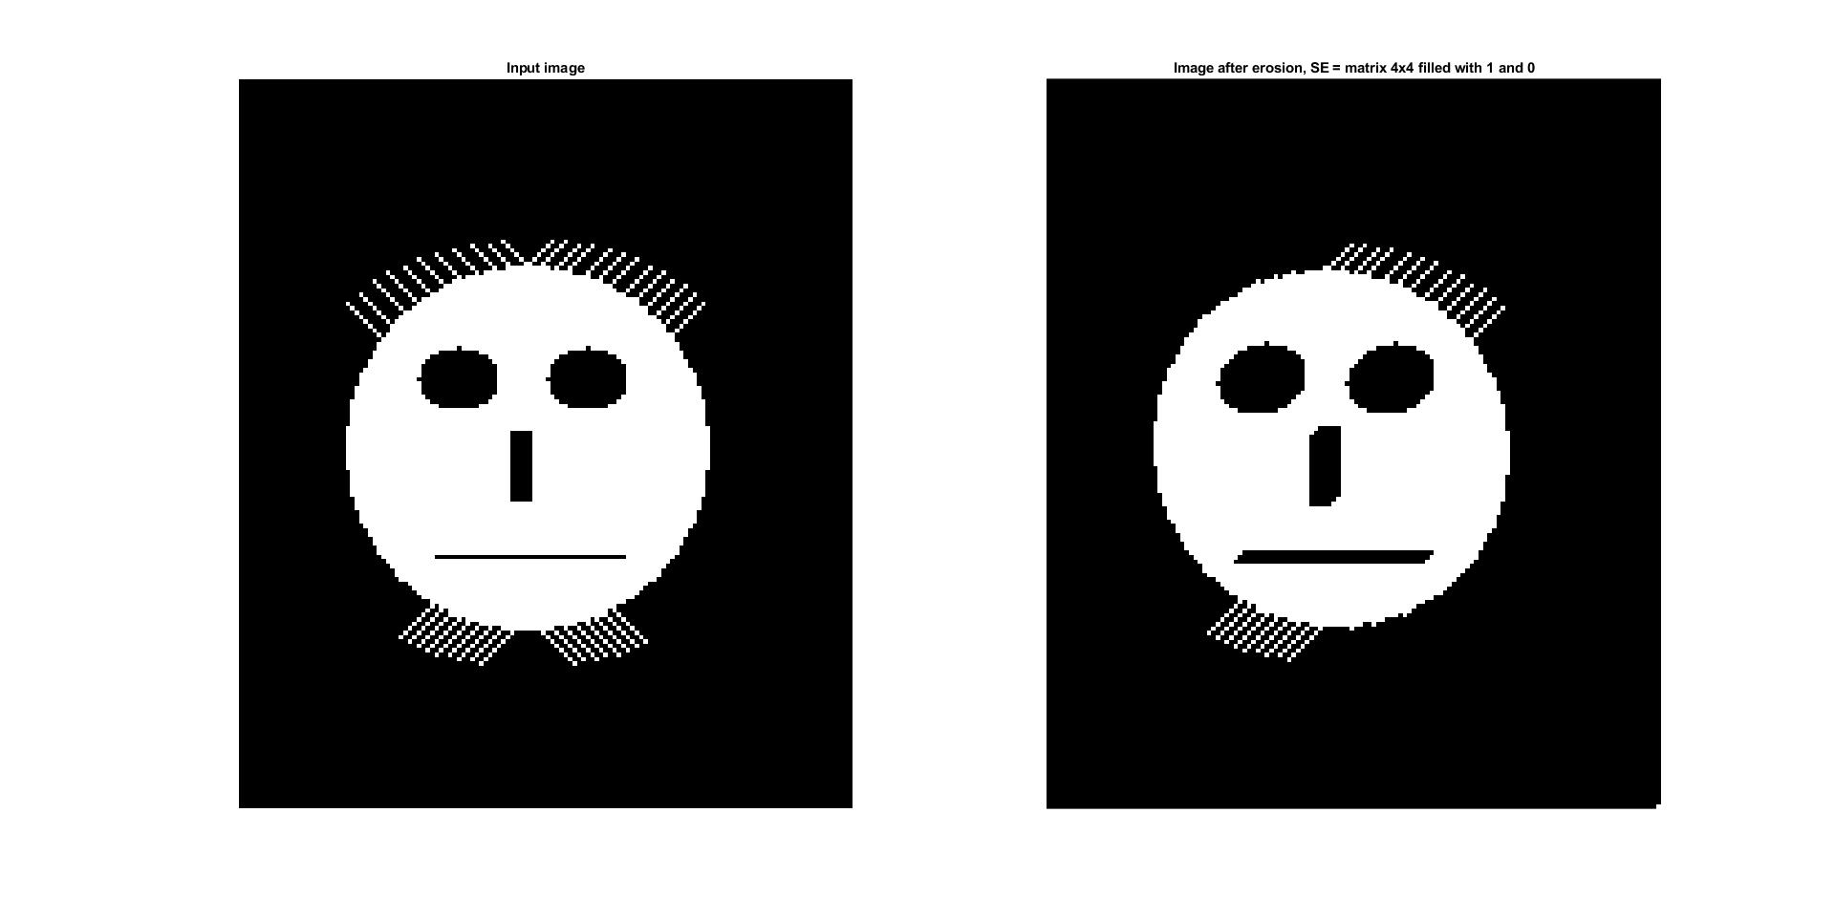

1. figure(1);
2. se = strel('square',3);
3. erodedIm = imdilate(image,se);
4. subplot(1,2,1);
5. imshow(image);
6. title('Input image')
7. subplot(1,2,2);
8. imshow(erodedIm);
9. title('Image after dilation, SE = square 3x3')

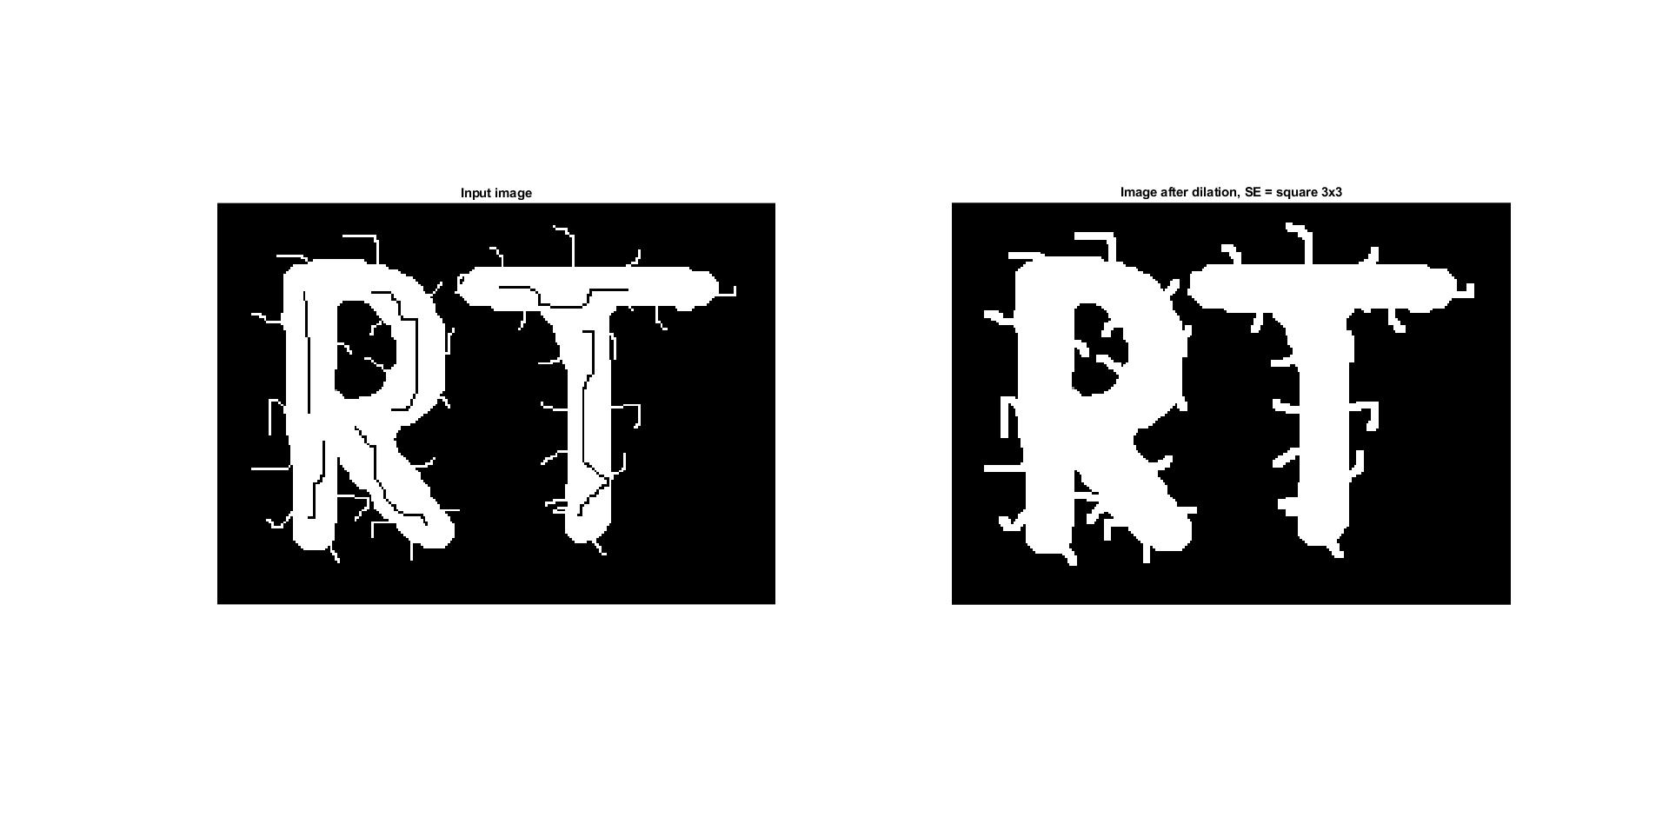

1. figure(1);
2. se = strel('square',3);
3. subplot(2,3,1:2);
4. imshow(image);
5. title('Input image')
6. subplot(2,3,3);
7. erodedIm = imerode(image,se);
8. imshow(erodedIm);
9. title('Image after erosion, SE = square 3x3')
10. subplot(2,3,4);
11. erodedIm = imdilate(image,se);
12. imshow(erodedIm);
13. title('Image after dilation, SE = square 3x3')
14. subplot(2,3,5);
15. erodedIm = imopen(image,se);
16. imshow(erodedIm);
17. title('Image after morphologically open, SE = square 3x3')
18. subplot(2,3,6);
19. erodedIm = imclose(image,se);
20. imshow(erodedIm);
21. 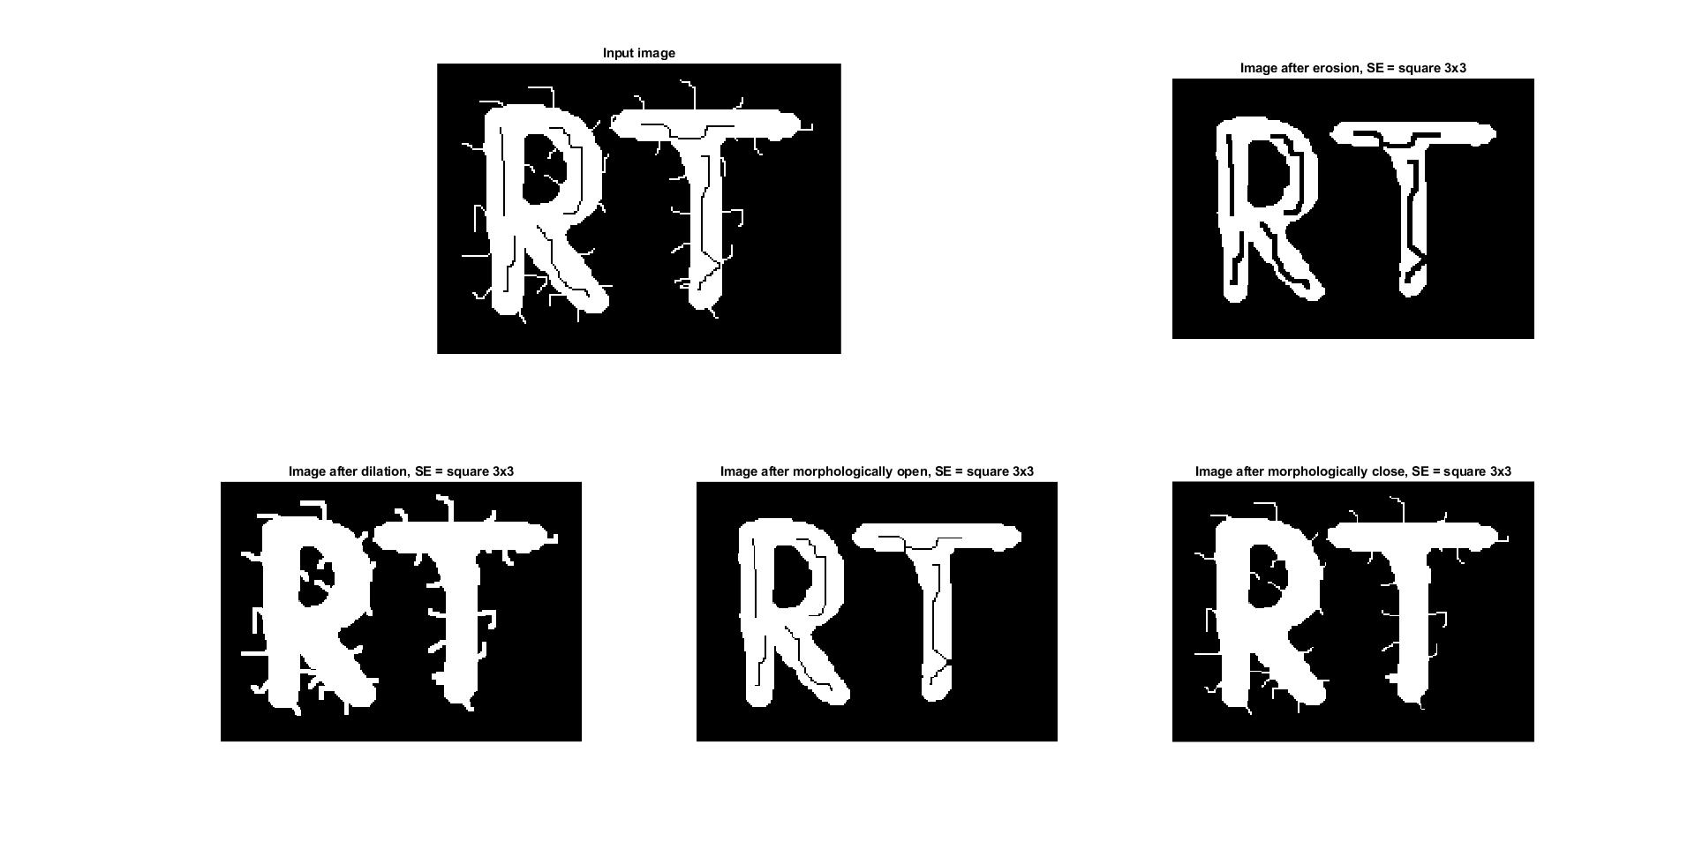title('Image after morphologically close, SE = square 3x3')

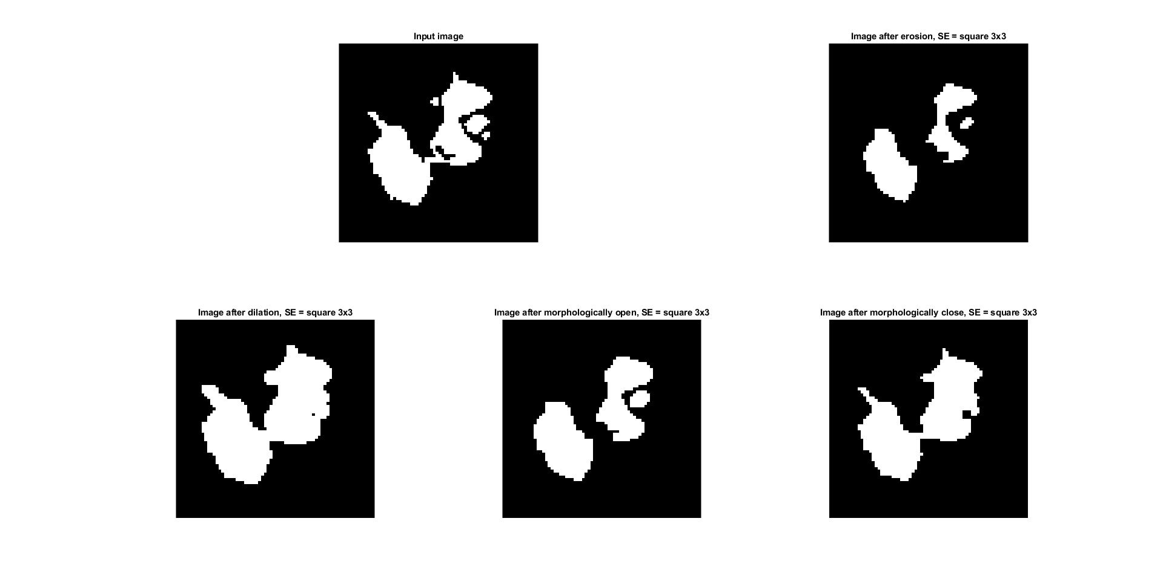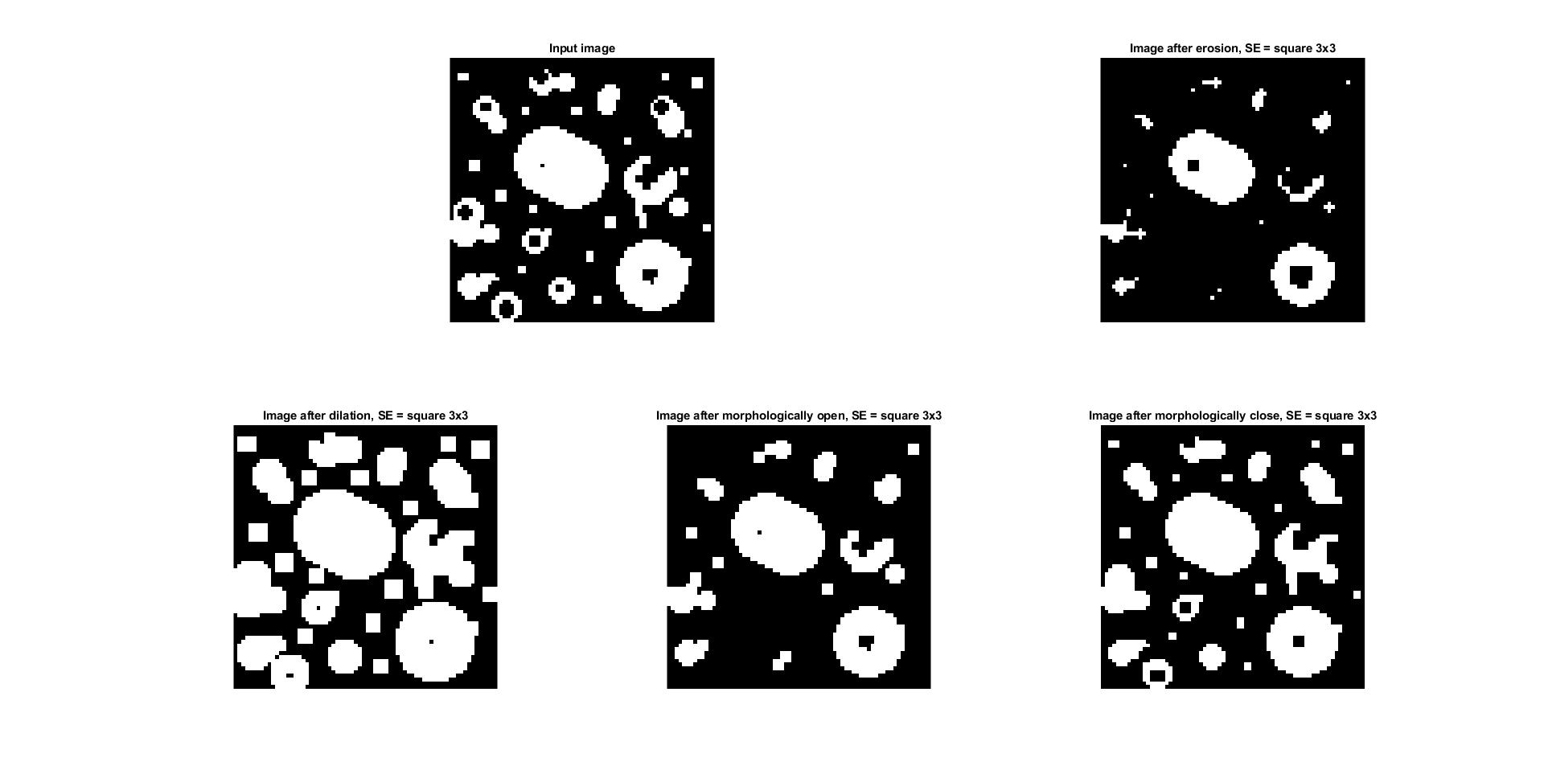

1. figure(1);
2. se = strel('square',3);
3. ertka = imopen(image,se);
4. se = strel('square',5);
5. ertka = imdilate(ertka,se);
6. subplot(1,2,1);
7. imshow(image);
8. title('Input image')
9. subplot(1,2,2);
10. imshow(ertka);
11. title('Image after morphologically open(SE=square3x3) and dilation(SE=square5x5)')

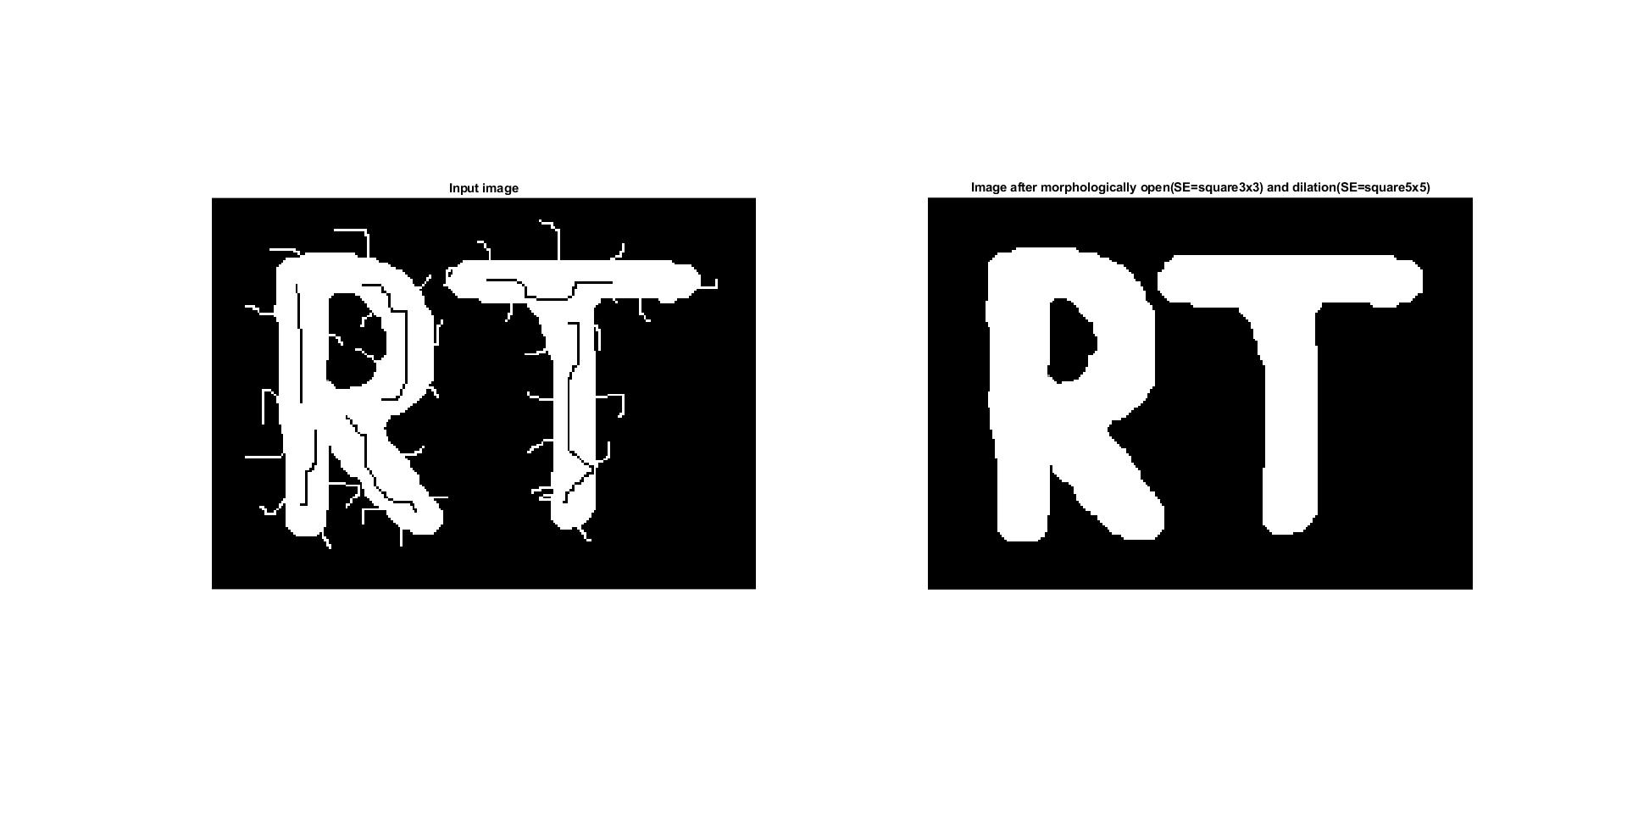

1. figure(1);
2. SE1 = [0 1 0; 1 1 1; 0 1 0];
3. SE2 = [1 0 1; 0 0 0; 1 0 1];
4. subplot(1,2,1);
5. imshow(image);
6. title('Input image')
7. subplot(1,2,2);
8. image = bwhitmiss(image,SE1,SE2);
9. imshow(image);
10. title('Image after hit-miss transformation')

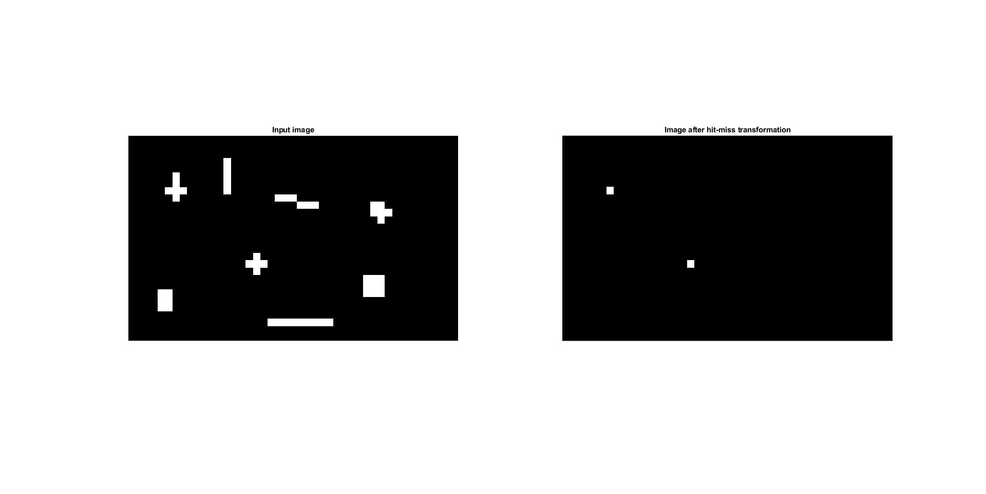

Task 7.4. Other morphological operations:

1. figure(1);
2. subplot(2,3,1);
3. imshow(image);
4. title('Input image')
5. subplot(2,3,2);
6. image = bwmorph(image,'thin');
7. imshow(image);
8. title('Image after thinning')
9. subplot(2,3,3);
10. image = bwmorph(image,'thin');
11. imshow(image);
12. title('Image after thinning x2')
13. subplot(2,3,4);
14. image = bwmorph(image,'thin');
15. imshow(image);
16. title('Image after thinning x3')
17. subplot(2,3,5);
18. image = bwmorph(image,'thin');
19. imshow(image);
20. title('Image after thinning x4')
21. subplot(2,3,6);
22. image = bwmorph(image,'thin');
23. imshow(image);
24. 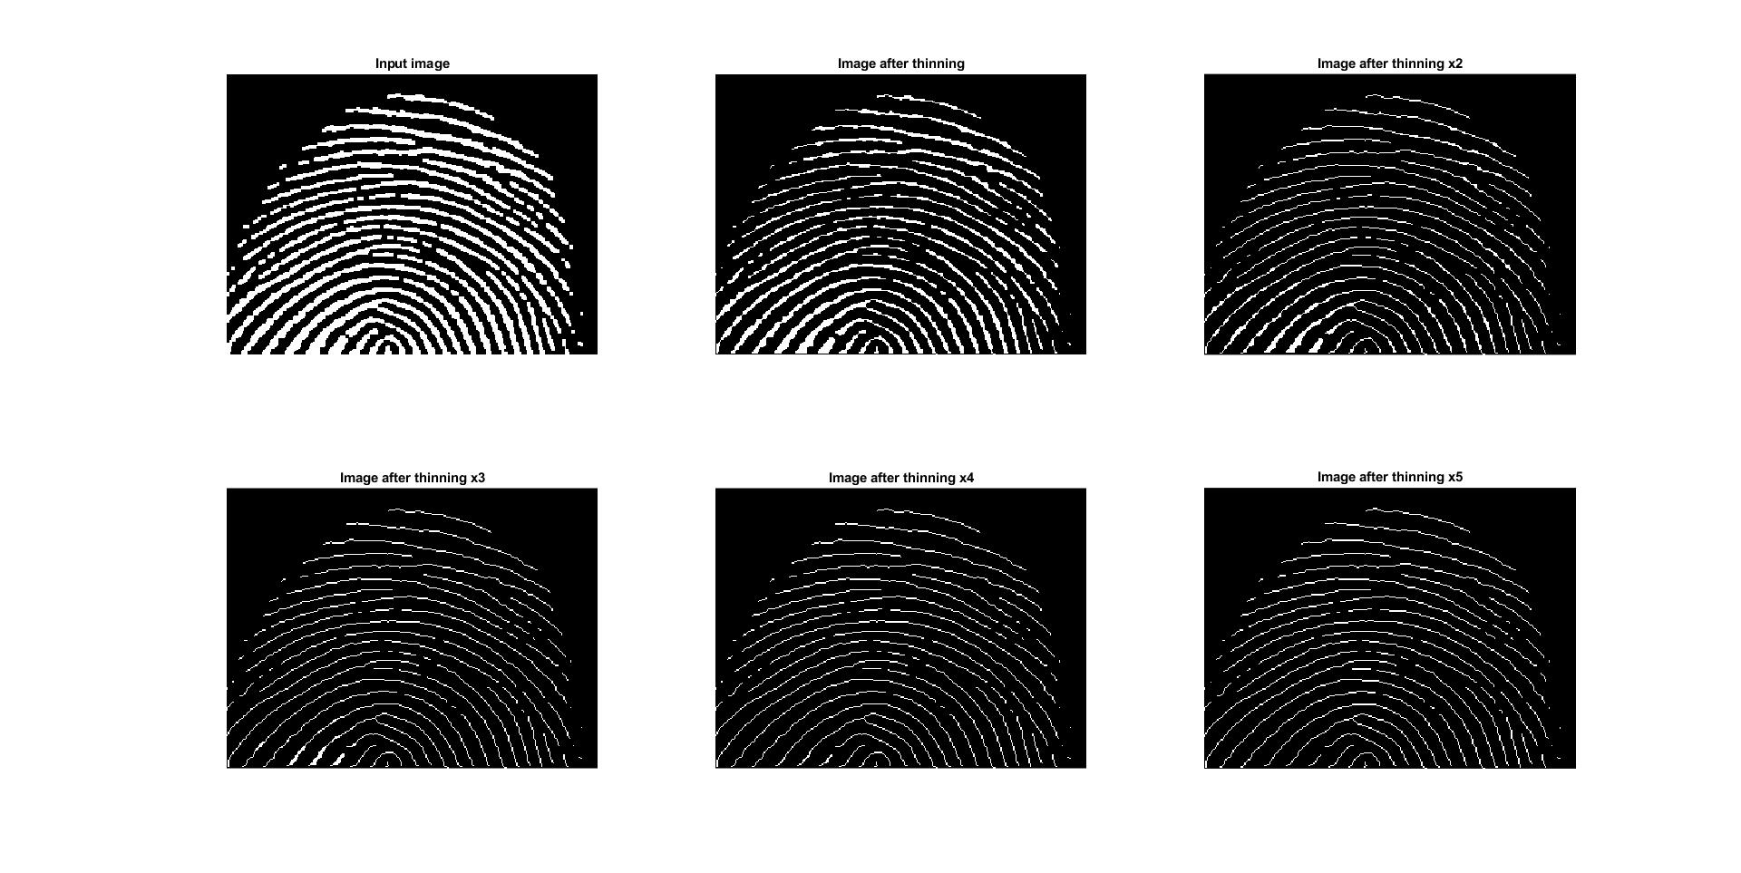title('Image after thinning x5')
25. figure(1);
26. subplot(1,2,1);
27. imshow(image);
28. title('Input image')
29. subplot(1,2,2);
30. image = bwmorph(image,'skel',Inf);
31. imshow(image);
32. 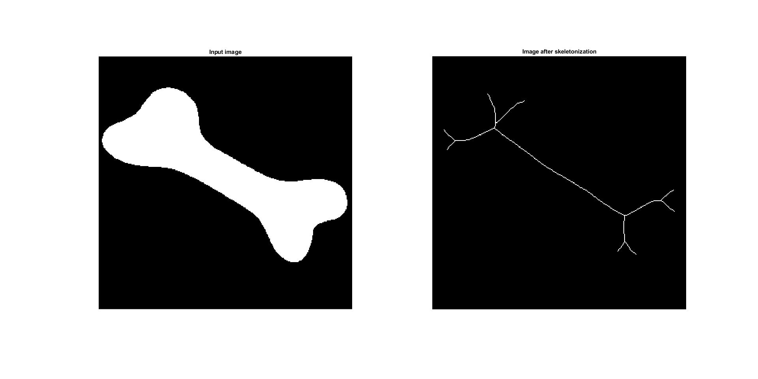title('Image after skeletonization')
33. figure(1);
34. subplot(1,3,1);
35. imshow(image);
36. title('Input image')
37. subplot(1,3,2);
38. se = ones(51,1);
39. image2 = imopen(image,se);
40. imshow(image2);
41. title('Image after morphological open');
42. subplot(1,3,3);
43. image3 = imreconstruct(image2,image);
44. imshow(image3);
45. 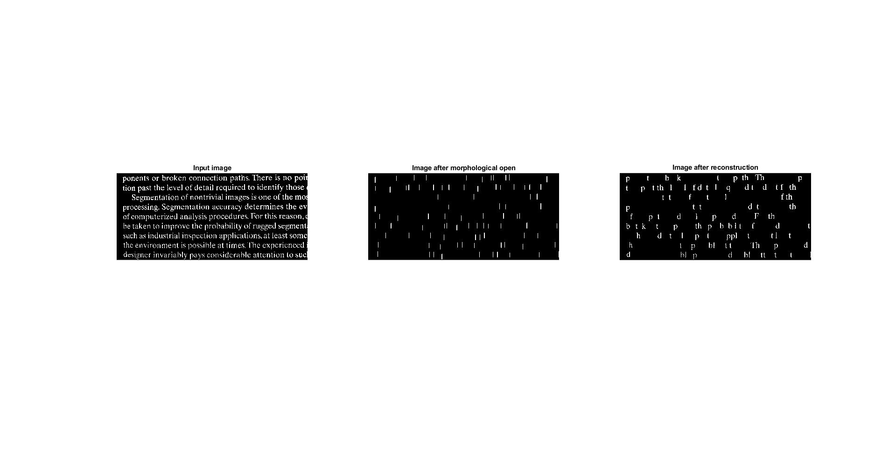title('Image after reconstruction')
46. figure(1);
47. subplot(1,2,1);
48. imshow(image);
49. title('Input image')
50. subplot(1,2,2);
51. image2 = imfill(image,'holes');
52. imshow(image2);
53. title('Image after filling the holes');

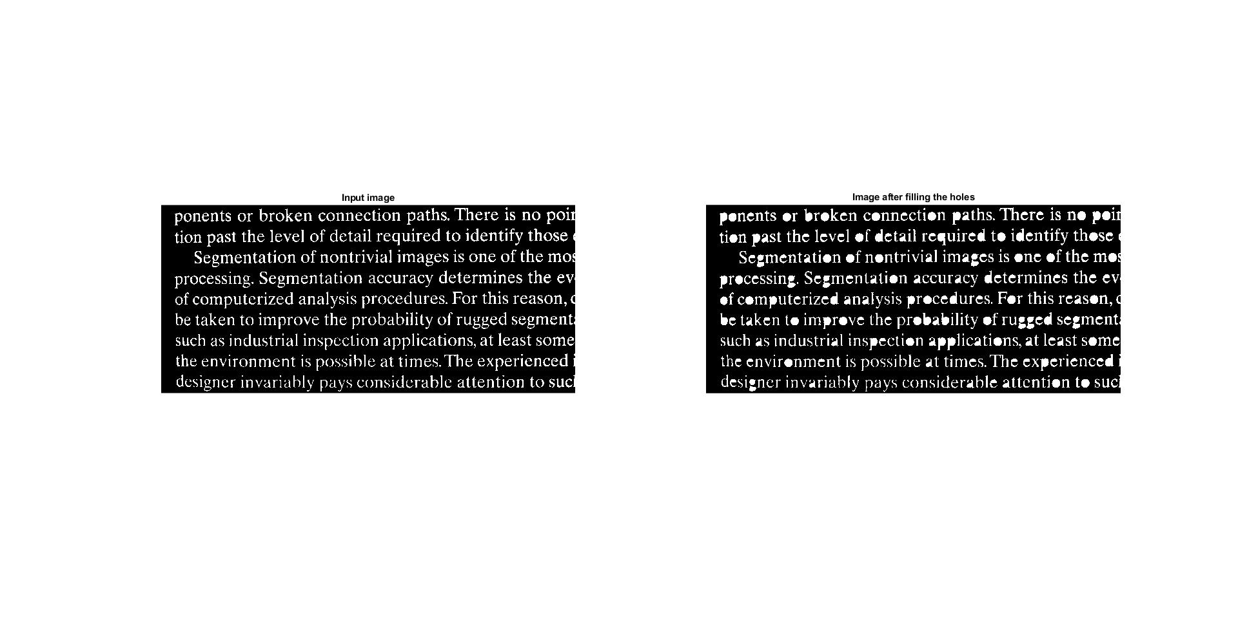

1. figure(1);
2. subplot(1,2,1);
3. imshow(image);
4. title('Input image')
5. subplot(1,2,2);
6. image2 = imclearborder(image);
7. imshow(image2);
8. 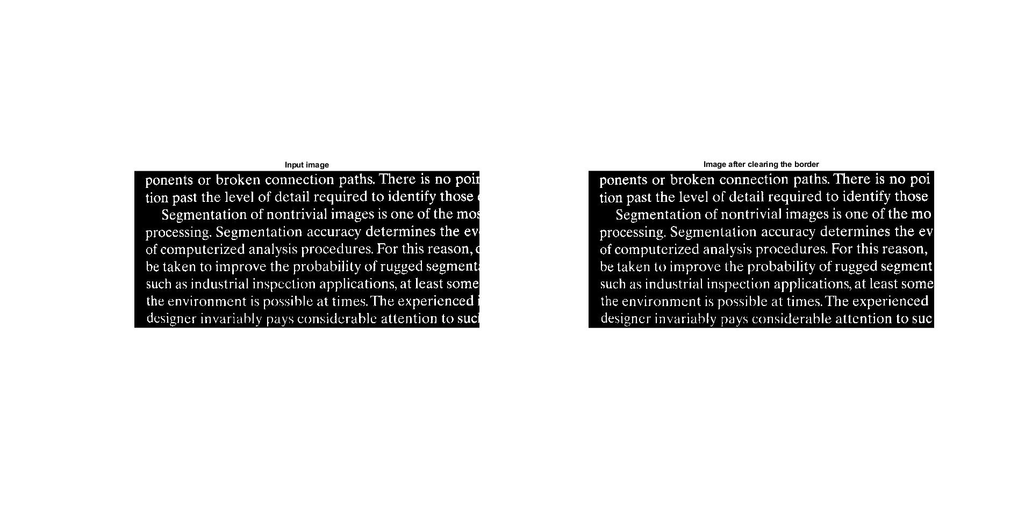title('Image after clearing the border');

Task 7.5. Morphological operations for greyscale images:

1. figure(1);
2. subplot(2,3,1);
3. imshow(image);
4. title('Input image')
5. subplot(2,3,2);
6. se = strel('square',3);
7. image2 = imerode(image,se);
8. imshow(image2);
9. title('Image after erosion');
10. subplot(2,3,3);
11. se = strel('square',3);
12. image3 = imdilate(image,se);
13. imshow(image3);
14. title('Image after dilation');
15. subplot(2,3,4:6);
16. basic_gradient = imdilate(image, se) - imerode(image, se);
17. imshow(basic_gradient);
18. title('Morphological gradient');
20. figure(2);
21. subplot(1,3,1);
22. imshow(image);
23. title('Input image')
24. subplot(1,3,2);
25. se = strel('square',3);
26. image2 = imopen(image,se);
27. imshow(image2);
28. title('Image after morphological open');
29. subplot(1,3,3);
30. image3 = imclose(image,se);
31. imshow(image3);
32. 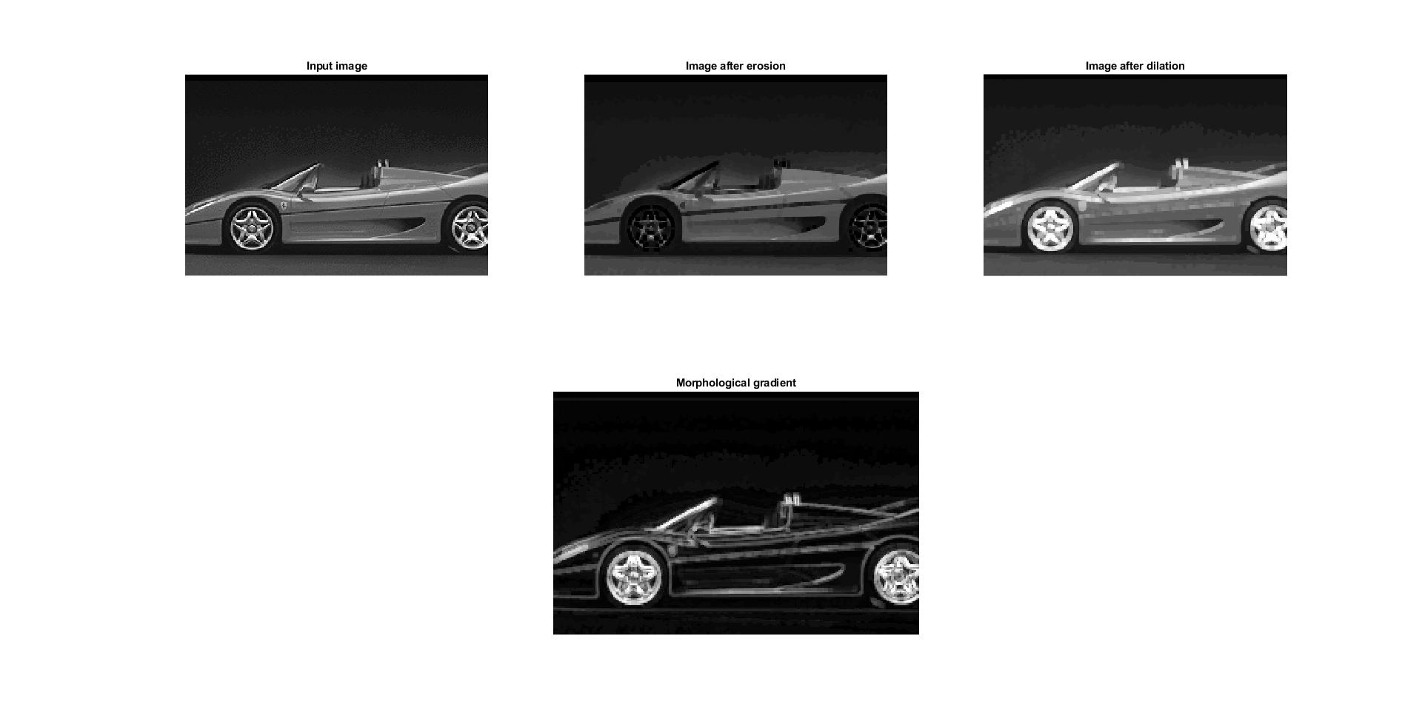title('Image after morphological close');

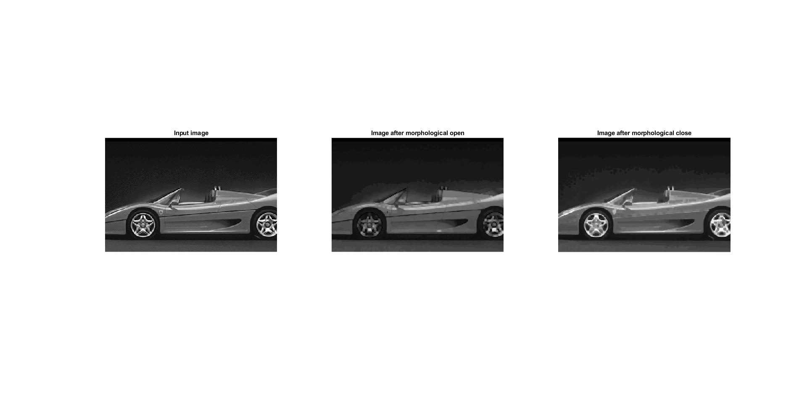

1. figure(1);
2. subplot(1,3,1);
3. imshow(image);
4. title('Input image')
5. subplot(1,3,2);
6. se = strel('square',3);
7. image2 = imtophat(image,se);
8. imshow(image2);
9. title('Image after top-hat operation');
10. subplot(1,3,3);
11. se = strel('square',3);
12. image3 = imbothat(image,se);
13. imshow(image3);
14. 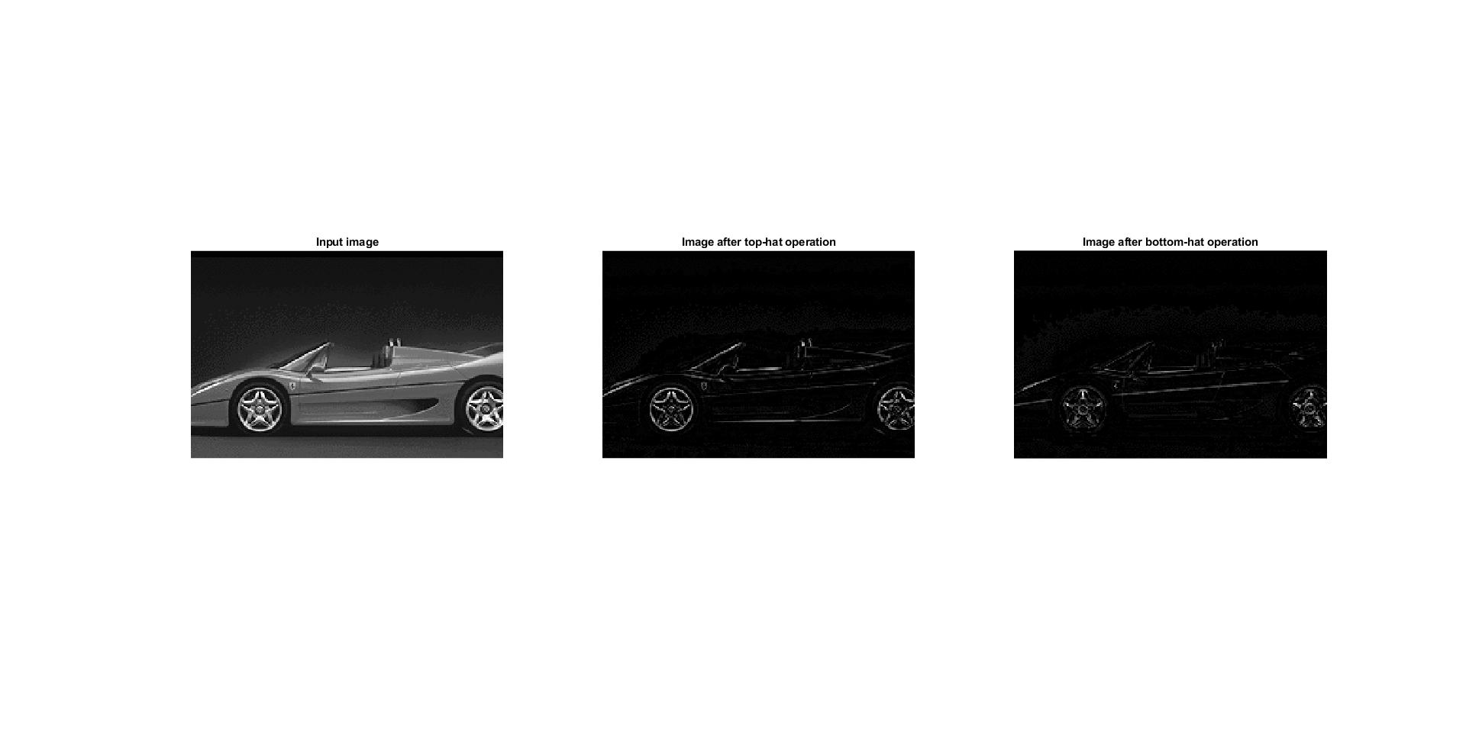title('Image after bottom-hat operation');
15. figure(1);
16. subplot(1,2,1);
17. imshow(image);
18. title('Input image')
19. subplot(1,2,2);
20. se = strel('disk',15);
21. image2 = imtophat(image,se);
22. imshow(image2);
23. 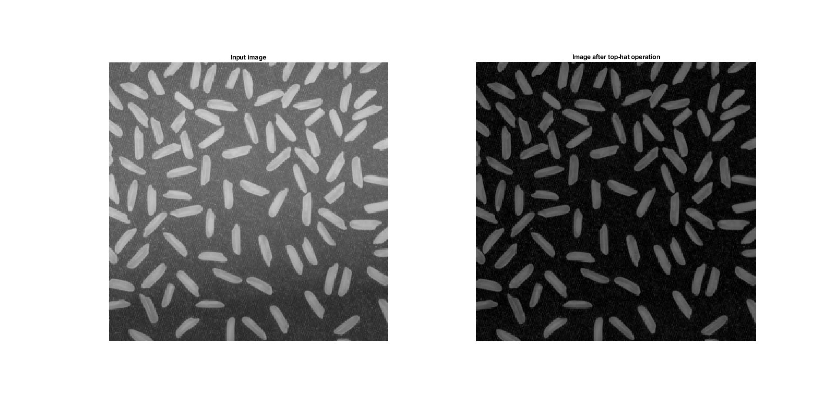title('Image after top-hat operation');

Task 7.6. Case study:

1. figure(1);
2. subplot(2,3,1);
3. imshow(image);
4. title('Input image')
5. subplot(2,3,2);
6. se = ones(1,71);
7. image_e = imerode(image,se);
8. imshow(image_e);
9. title('Image after erosion');
10. subplot(2,3,3);
11. se = ones(1,71);
12. image_o = imopen(image,se);
13. imshow(image_o);
14. title('Image after morphological open');
15. subplot(2,3,5);
16. image3 = imreconstruct(image_e,image);
17. imshow(image3);
18. title('Image after reconstruction(erosion)')
19. subplot(2,3,6);
20. image4 = imreconstruct(image_o,image);
21. imshow(image4);
22. title('Image after reconstruction(open)')
24. figure(2);
25. subplot(1,2,1);
26. image5 = image-image3;
27. imshow(image5);
28. title('Result of inputImage - reconstructedImage(erosion)')
29. subplot(1,2,2);
30. image5 = image-image4;
31. imshow(image5);
32. title('Result of inputImage - reconstructedImage(open)')
34. figure(3);
35. se = ones(1,71);
36. image2 = imtophat(image,se);
37. imshow(image2);
38. 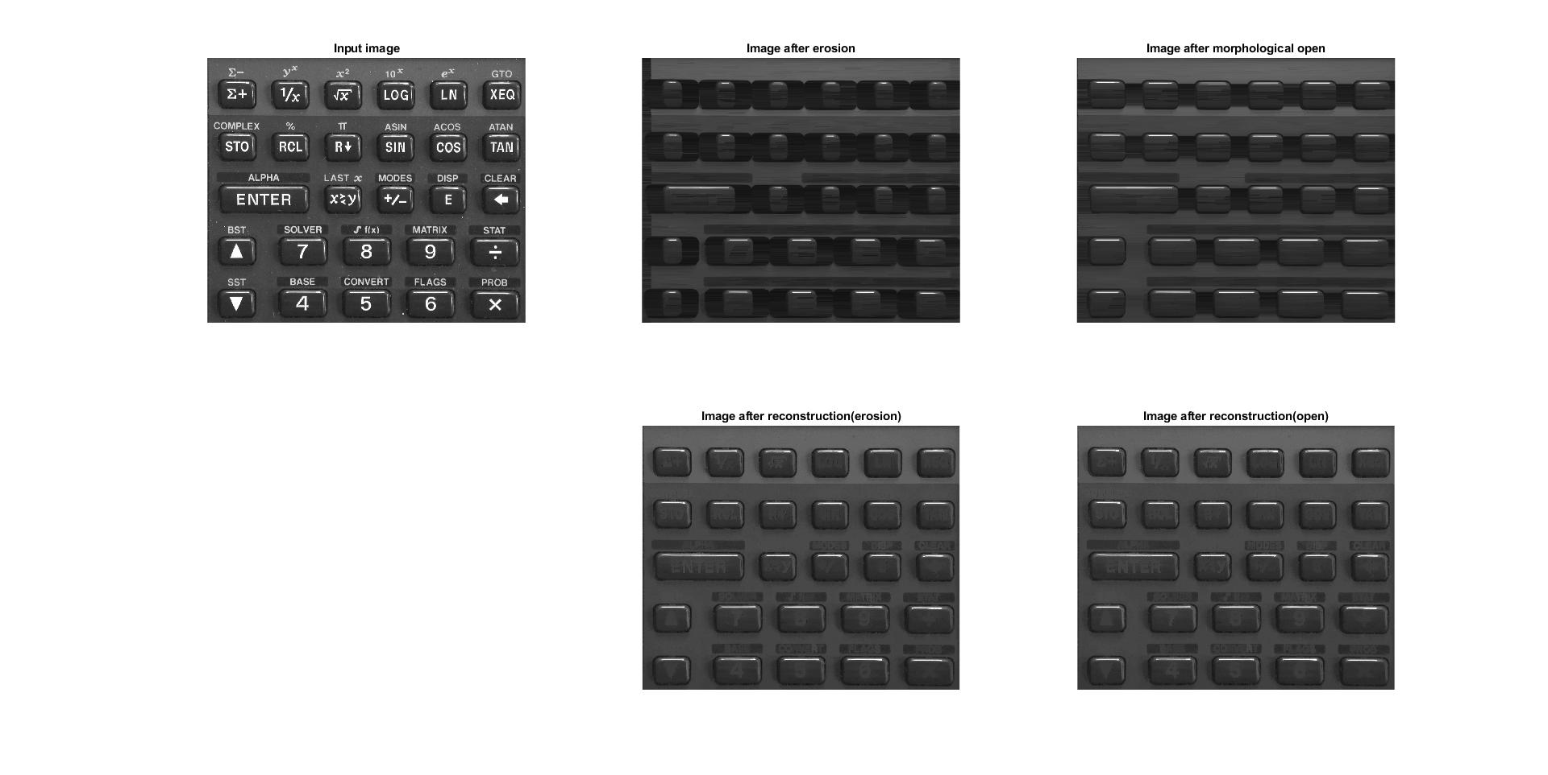title('Image after top-hat operation');

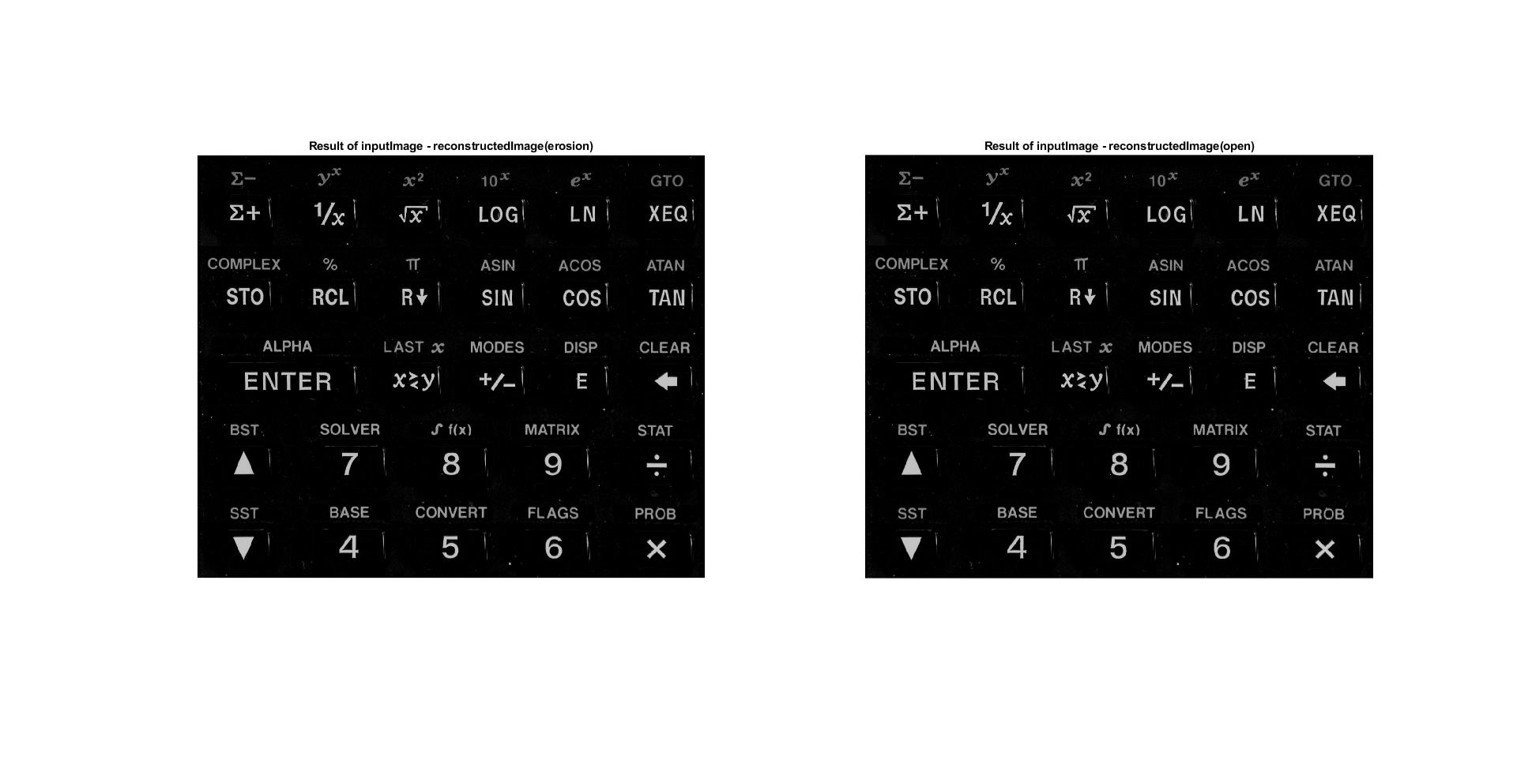

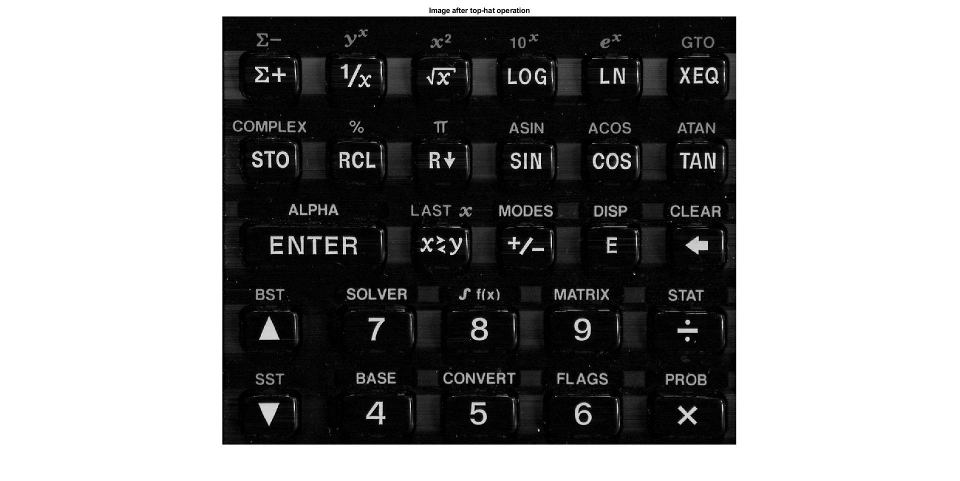

1. **Conclusions:**

Every structuring element from strel function has its dimensions to specify. The size of the element impact on strength of morphological operation.

Repeating the same operation multiple times deepens the result from the first attempt.

Matrix with ones on the diagonal and zeros in the rest can give a result with eroded lines from specific orientation.

The dilation enlarges the entire object and also can file small holes inside the figure.

Morphological opening and closing is a weaker and softer version of erosion and dilation.

The best way to clean the ertka image is to use morphological opening and then dilate the result.

The proper masks in hit-miss transformation can detect the specific shape like crosses.

Performing thinning operation multiple times will decrease the width but also enlarges the free spaces between lines.

Morphological opening with vertical mask of 51 ones on text image will give the result of lines with specific height. Performing reconstruction with previous result as a marker will give an image of entire characters with 51 pixel height.

In this case, clearing border operation removes entire characters which are touching the border.

Using erosion on greyscale images will enlarge the darker areas and remove the bright pixels. Dilations work oppositely. Morphological gradient show the edges between dark and bright areas.

The result of top-hat operation is an image of bright(reflections) areas of the input image. Bottom-hat shows the dark areas. Top-hat filtering removes the non-uniform illumination from rice image.

Opening by reconstruction is better because it does not contain darker areas between buttons. Classical top-hat filtering also removes the reflections but there is little noise in the space between buttons.