**Digital image processing and vision systems – lab #9**

|  |  |
| --- | --- |
| Date performed: 01.06.2021 | Group 2 |
| Author name: Krzysztof Klimczyk | |

1. **Source codes and screenshots:**

Task 9.4. – Region growing segmentation:

1. image = imread("knee.png");
2. subplot(1,2,1)
3. imshow(image);
4. title("Input image");
5. thresh = 4;
6. [s_x,s_y] = ginput(1);
7. s_x = round(s_x);
8. s_y = round(s_y);
9. hold on;
10. plot(s_x,s_y,'d','color',[1 1 0]);
11. image = double(image);
12. [n,m] = size(image);
13. visited = zeros(n,m);
14. segmented = zeros(n,m);
15. fQueue = 1;
16. lQueue = 2;
17. queue = zeros(10000,2);
19. %add to queue
20. queue(fQueue,1)=s_x;
21. queue(fQueue,2)=s_y;
23. %mark as visited and segmented
24. segmented(s_y,s_x)=1;
25. visited(s_y,s_x)=1;
27. while(fQueue < lQueue)
28. %queue pop
29. x = queue(fQueue,1);
30. y = queue(fQueue,2);
31. fQueue = fQueue + 1;
33. if x > m-1 || y > m-1 || x < 2 || y < 2
34. continue
35. end
37. for i=-1:1:1
38. for j=-1:1:1
39. temp_x = x + i;
40. temp_y = y + j;
41. diff = abs(image(y,x) - image(temp_y,temp_x));
42. if diff < thresh && visited(temp_y,temp_x)==0
43. queue(lQueue,1) = temp_x;
44. queue(lQueue,2) = temp_y;
45. lQueue = lQueue + 1;
46. segmented(temp_y,temp_x)=1;
47. end
48. %mark as visited
49. visited(temp_y,temp_x)=1;
50. end
51. end
52. end
54. subplot(1,2,2);
55. imshow(segmented);
56. title("[x,y] = [" + s_x + ","+s_y+"], threshold = " + thresh);

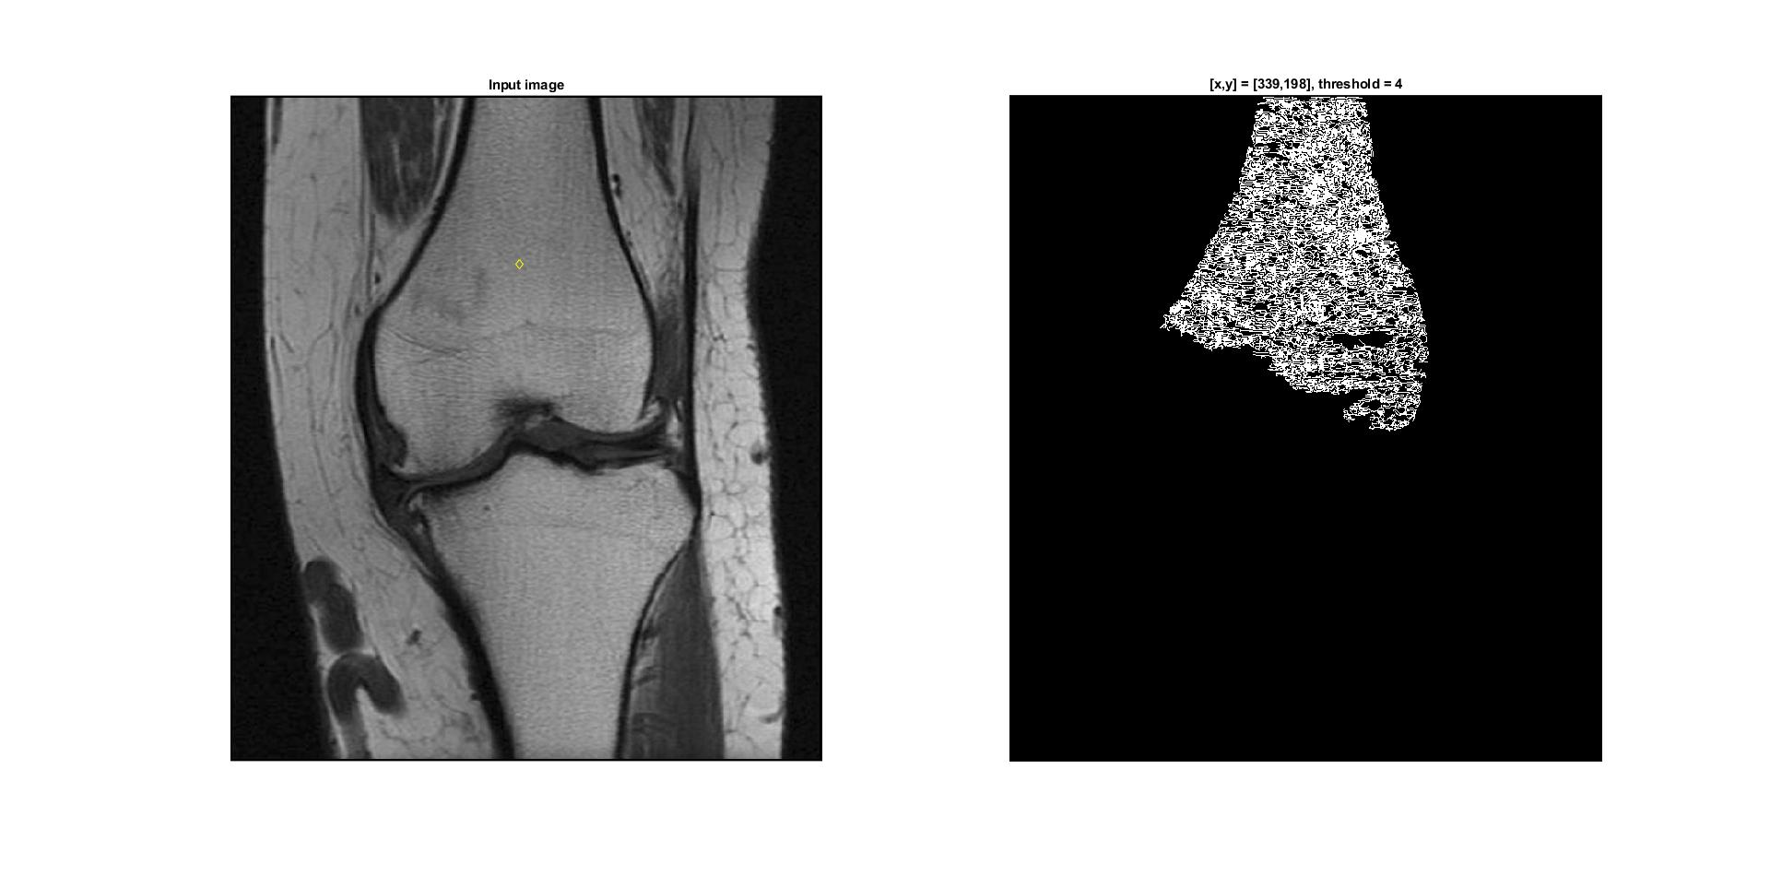

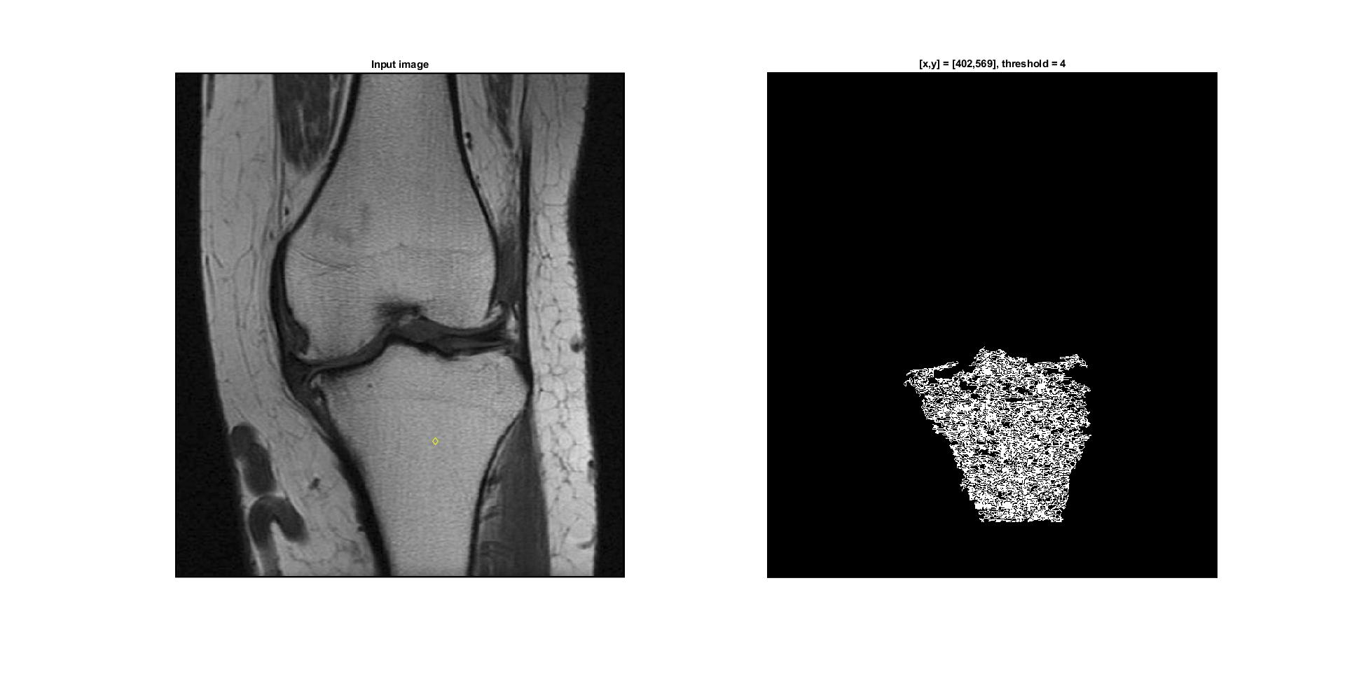

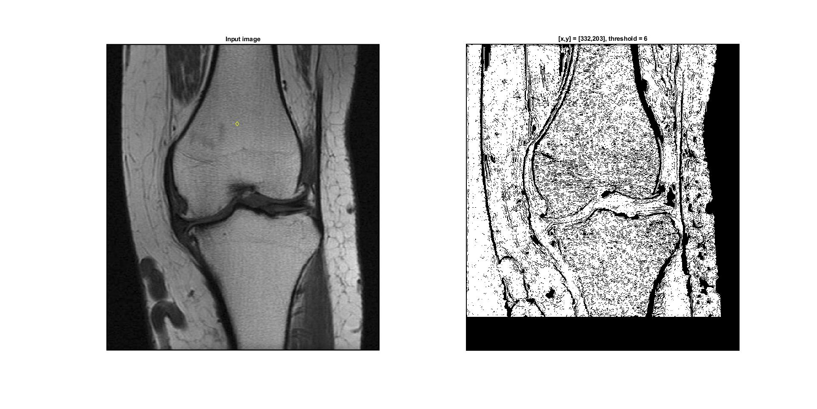

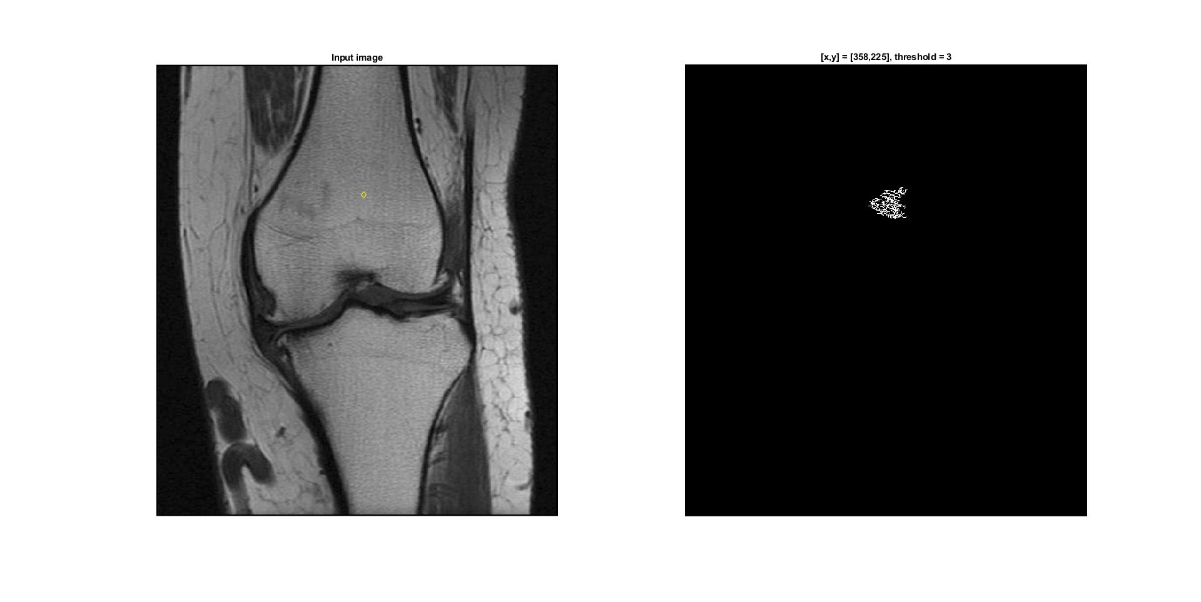

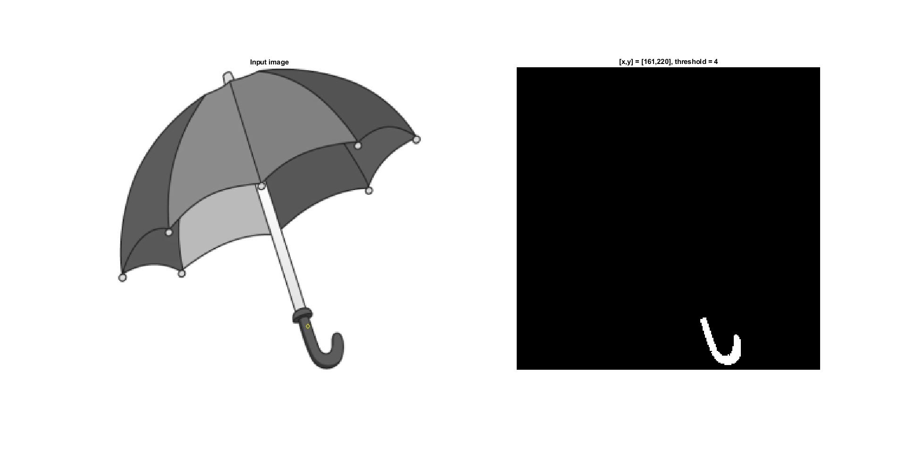

1. **Conclusions:**

This implementation can not analyze RGB images properly so the additional rgb2grey operation is required. Threshold with the value of 4 is the most optimal when the algorithm is working on kneel.png and umbrella.png images. Increasing the threshold value by 2 significantly lengthens the computation time and gives the most of the input image as the result area. Decreasing the threshold value gives the opposite result so the output contains a small area around the starting point.