RESULTS OF PROJECT1: PROBLEM3=> THE KALMAN FILTER

Note: Blue for ground truth |Orange for observation | Yellow for estimation

Case1: By adding 0.01 as the variance of the observation error in each direction.

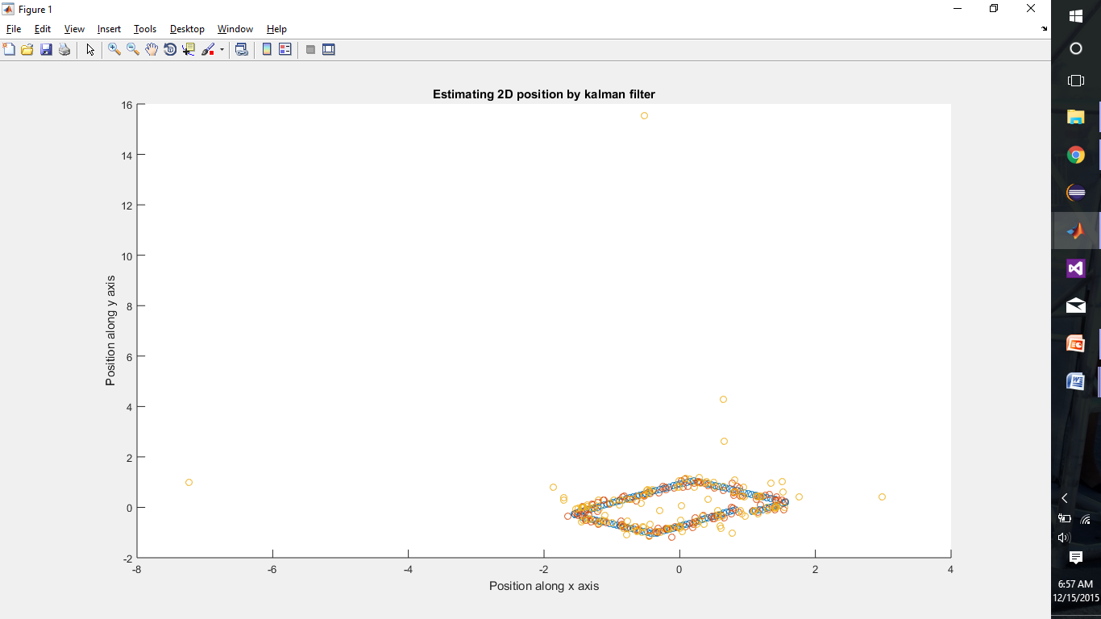

Case2: By subtracting 0.01 as the variance of the observation error in each direction.

