博客链接：<https://blog.csdn.net/BelieveScience/article/details/88726780>

a）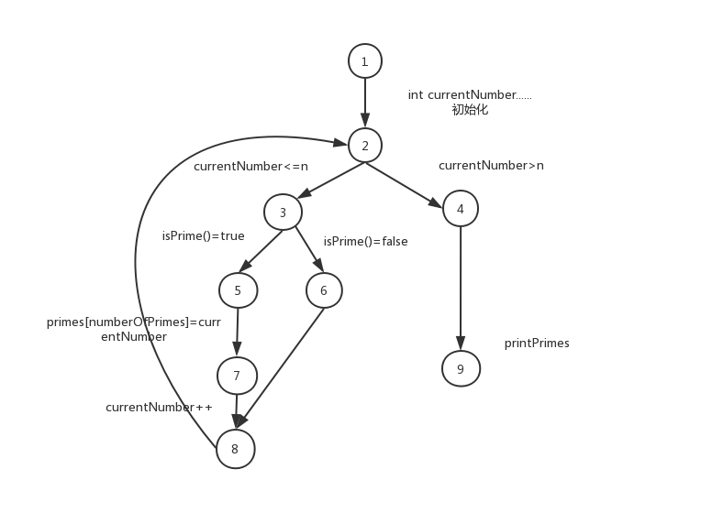

b）对于输入的n=4，t1（n=3）正常，t2（m=5）数组越界错误。

c）n=1时跳出循环。

d）

Node coverage:{1,2,3,4,5,6,7,8,9}

Edge coverage:{[1,2],[2,3],[2,4],[4,9],[3,5],[3,6],[5,7],[7,8],[6,8]}

Prime path coverage:{[1,2,3,5,7,8],[1,2,3,6,8],[1,2,4,9],[1,2,3,5,7,8,2,3,6,8],[1,2,3,6,8,2,3,5,7,8],[1,2,3,5,7,8,2,4,9],[1,2,3,6,8,2,4,9],[1,2,3,5,7,8,2,3,6,8,2,4,9],[1,2,3,6,8,2,3,5,7,8,2,4,9]}

有任何疑惑请点击博客，上面有截图。