Electronics:

Cytron **10A 5-25V Dual Channel DC Motor Driver $27**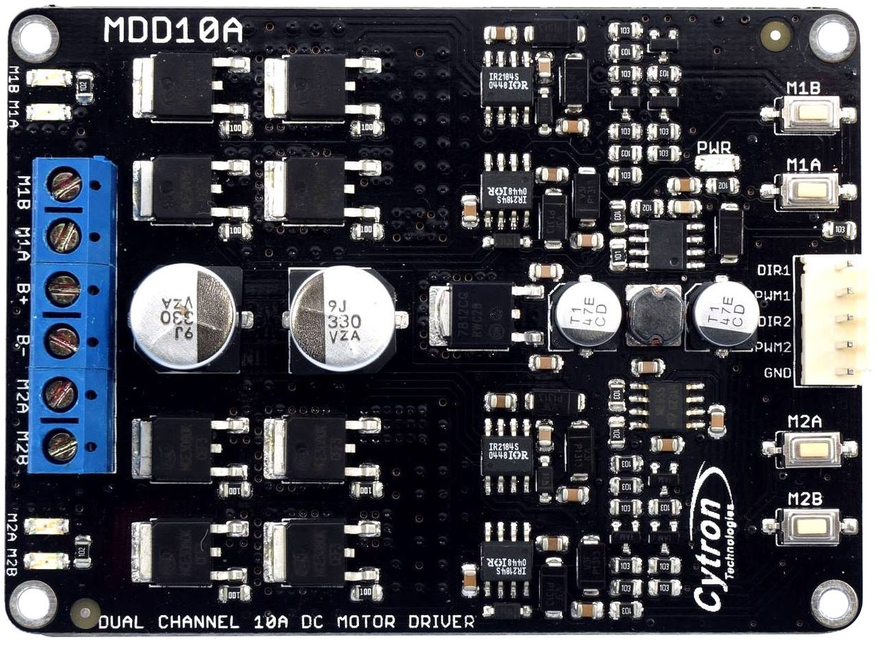

**Motors:**

# **Trossen robotics DC gearhead motor** 6v 180rpm w/ Encoder $29.95 x2

|  |  |
| --- | --- |
| **Characteristic** | **Value** |
| Operating Voltage | 6-8.4v |
| Gear Ratio | 40:1 |
| Rated Load Speed | 163 RPM +/- 10% |
| No Load Speed | 212 RPM +/- 10% |
| No Load Current | <400mA |
| Rated Current | 3A |
| Stall Current | 6A |
| Encoder type | Hall Effect Quadrature |
| Encoder PPR | 13 PPR |
| Encoder Output Resolution | 520 ticks/revolution |
| Encoder Voltage | 5v |
| Shaft Diameter | 6mm |

# http://www.trossenrobotics.com/resize/shared/images/PImages/KIT-MTR-36-06-180-a.jpg?bw=1000&bh=1000

Charmed Labs Pixy Camera-$70

Fast vision sensor for robotics

Connects directly to Arduino

Track Objects 50fps

Finds objects by color

Dedicated processor

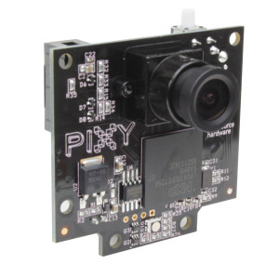

• Lens field-of-view: 75 degrees horizontal, 47 degrees vertical

Resolution: 1280×800

# 7.4v Kingmax 1000mAh Lipo for Arduino-$10

# http://i.ebayimg.com/00/s/NTAwWDUwMA==/z/WC4AAOxynwlTczyL/$_12.JPG

# Duratrax LiPo Onyx 2S 7.4V 5000mAh 25C-$44

# For motors

# http://ecx.images-amazon.com/images/I/61Qnm2ynJzL._SL1000_.jpg

# DPDT toggle switch-$1

# http://ecx.images-amazon.com/images/I/41z4Ir3DwaL.jpg

# Breadboard Jumper Wire 75pcs pack-$5

# http://ecx.images-amazon.com/images/I/71BMjzyTYRL._SL1500_.jpg

# Stepper Motor 28BYJ-48 5V DC 4-Phase 5-Wire + ULN2003 Driver Board-$3 x2

# http://ecx.images-amazon.com/images/I/71G62L-fThL._SL1001_.jpgRated voltage ： 5VDC Number of Phase 4 Speed Variation Ratio 1/64 Stride Angle 5.625° /64 Frequency 100Hz DC resistance 50Ω±7%(25℃) Idle In-traction Frequency > 600Hz Idle Out-traction Frequency > 1000Hz In-traction Torque >34.3mN.m(120Hz) Self-positioning Torque >34.3mN.m Friction torque 600-1200 gf.cm Pull in torque 300 gf.cm Insulation grade A

# American Precision Rapidsyn Division Stepper Motor Model 23A-6102T-$29.95

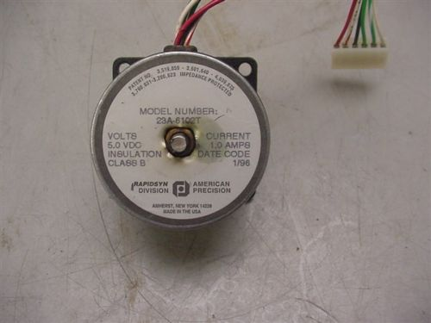

5V 1A

# Spark Fun EasyDriver - Stepper Motor Driver-$14.95

• Adjustable current control from 150mA/phase to 700mA/phase

• Power supply range from 6V to 30V. The higher the voltage, the higher the torque at high speeds

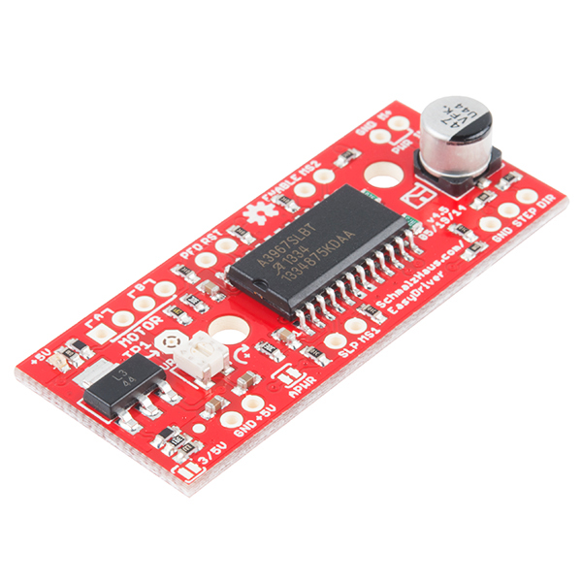

Arduino MEGA-$45

|  |  |
| --- | --- |
| Microcontroller | ATmega1280 |
| Operating Voltage | 5V |
| Input Voltage (recommended) | 7-12V |
| Input Voltage (limits) | 6-20V |
| Digital I/O Pins | 54 (of which 15 provide PWM output) |
| Analog Input Pins | 16 |
| DC Current per I/O Pin | 40 mA |
| DC Current for 3.3V Pin | 50 mA |
| Flash Memory | 128 KB of which 4 KB used by bootloader |
| SRAM | 8 KB |
| EEPROM | 4 KB |
| Clock Speed | 16 MHz |

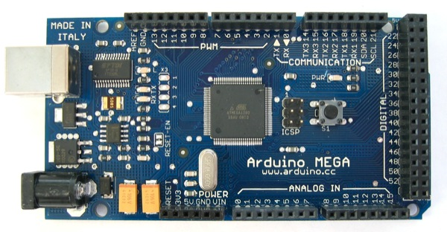

|  |  |
| --- | --- |
| Microcontroller | ATmega2560 |
| Operating Voltage | 5V |
| Input Voltage (recommended) | 7-12V |
| Input Voltage (limits) | 6-20V |
| Digital I/O Pins | 54 (of which 14 provide PWM output) |
| Analog Input Pins | 16 |

Interrupt Pins 6

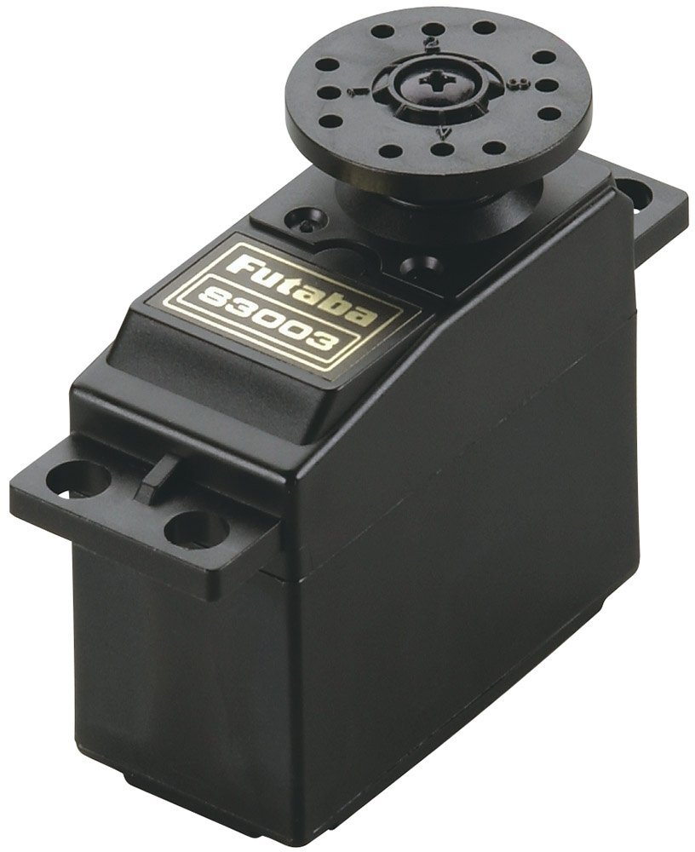

|  |  |  |  |
| --- | --- | --- | --- |
| http://www.rcplanet.com/v/vspfiles/templates/rcp-rwd/images/clear1x1.gif | |  | | --- | | **Speed:** 0.23 sec/60° @ 4.8V **Speed:** 0.19 sec/60° @ 6V **Torque:** 44 oz-in (3.2 kg-cm) @ 4.8V **Torque:** 57 oz-in (4.1 kg-cm) @ 6V **Dimensions:** 1.6 x 0.8 x 1.4" (1-9/16 x 13/16 x 1-7/16")(40 x 20 x 36mm) **Weight:** 1.3oz (1-5/16oz) (37g) **Connector:** "J" type with approx. 5" lead | | http://www.rcplanet.com/v/vspfiles/templates/rcp-rwd/images/clear1x1.gif |
|  | http://www.rcplanet.com/v/vspfiles/templates/rcp-rwd/images/clear1x1.gif |  |

**Robot Control**

The ATmega based Arduino microcontroller was chosen for its low cost, availability and third party support. Pre-made libraries simplified the basic control aspects of sensors and motors, and prevented extra time being spent on debugging basic component use, and allowed us to focus on the functionality of the robot. The Arduino Mega was chosen over the smaller and cheaper Arduino boards due to its large number of I/O pins. The initial robot design would have required at least 7 motors, each needing a pin capable of PWM and at least one switch per motor for a total of at least 14 pins. The Mega has 54 digital I/O pins, 15 of which are capable of PWM. As the design changed, the Mega continued to be the best option for control because of the number of interrupt pins it can use. The Mega has 6 interrupt pins, 4 were used for the motor encoders and the other two needed to be left unused because they are required for other functions on the board, such as tracking time and servo control.

**Power**

The original design called for a large number of stepper motors that collectively would have put a large current draw on the power source