?????????????????
TOEIC Practice Studio / TypeScript + Next.js

1. ??????
- ?????E:\toelic\toelic
- ???TypeScript / TSX / Node.js
- ????Next.js App Router?React?Prisma?SQLite?Tailwind CSS?shadcn/ui

2. ??????
?? | ?? | ?? | ??
ESLint | npm.cmd run lint | 0 error?4 warning | ?? presentation ?? warning????????
TypeScript | npm.cmd run typecheck | PASS | ???????
Semgrep | semgrep scan ... | 0 findings | ????????
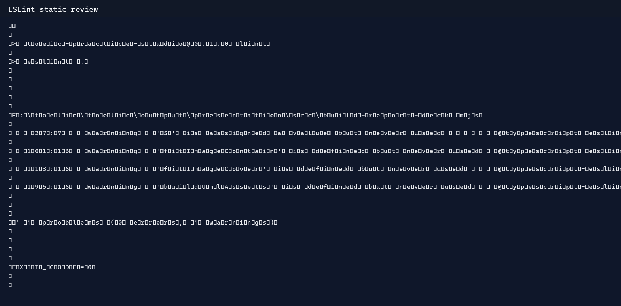
? 1 ESLint ????
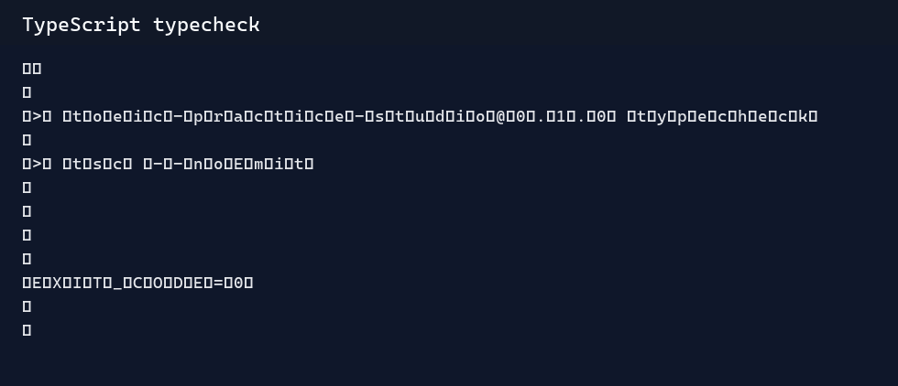
? 2 TypeScript ????
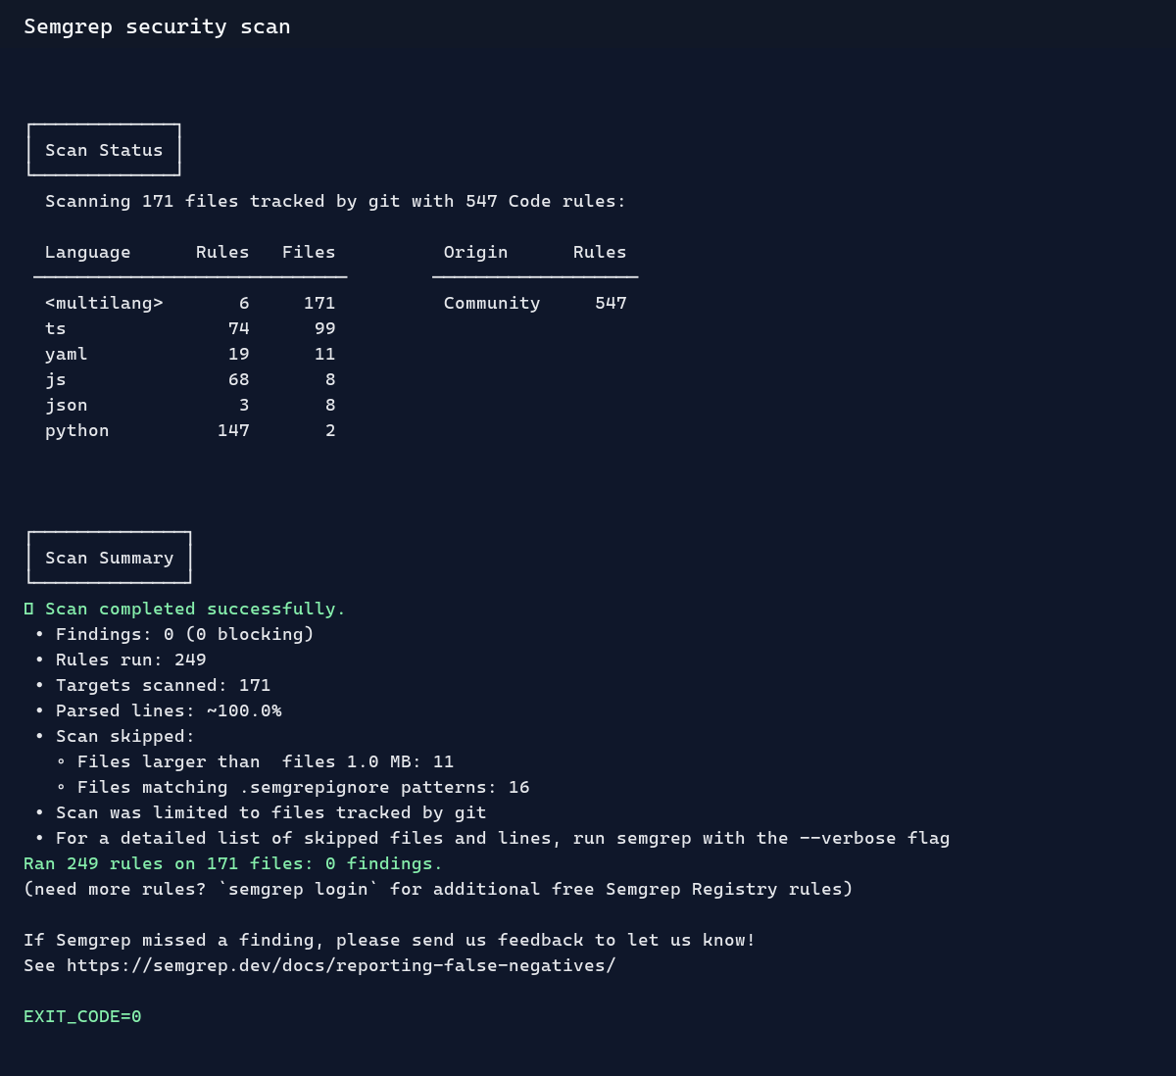
? 3 Semgrep ??

3. ???????
- ???Node.js CPU Profiler?CPU Profile?profiles/CPU.20260629.225351.21364.0.001.cpuprofile
- ?????? 7 ?????? filter ???? Map ???
- ??????????????????????
?? | ??? | ??? | ??
???? | 22.713 ms | 4.947 ms | ?? 78.22%
P95 ?? | 24.835 ms | 5.571 ms | ??
??? | 2725.547 ms | 593.677 ms | ??
checksum | 9999960 | 9999960 | ??
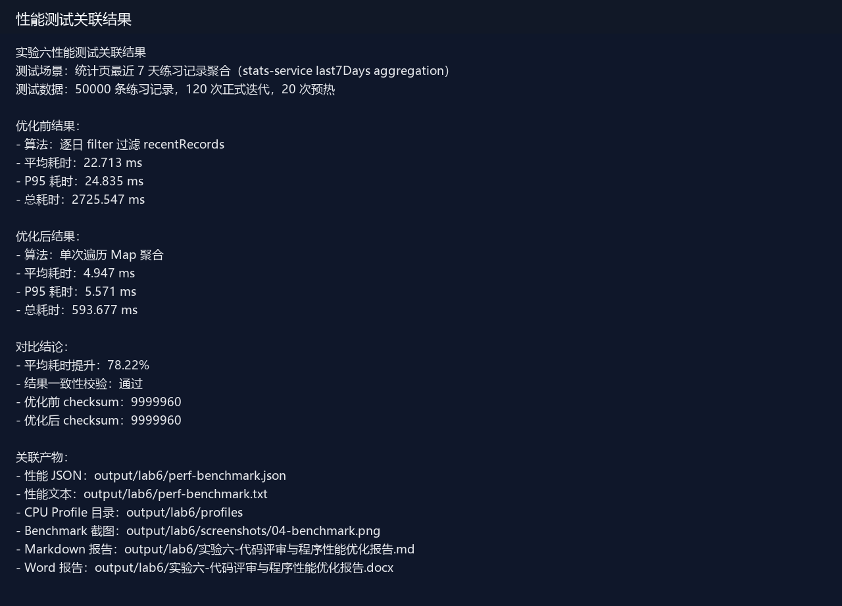
? 4 ??????????
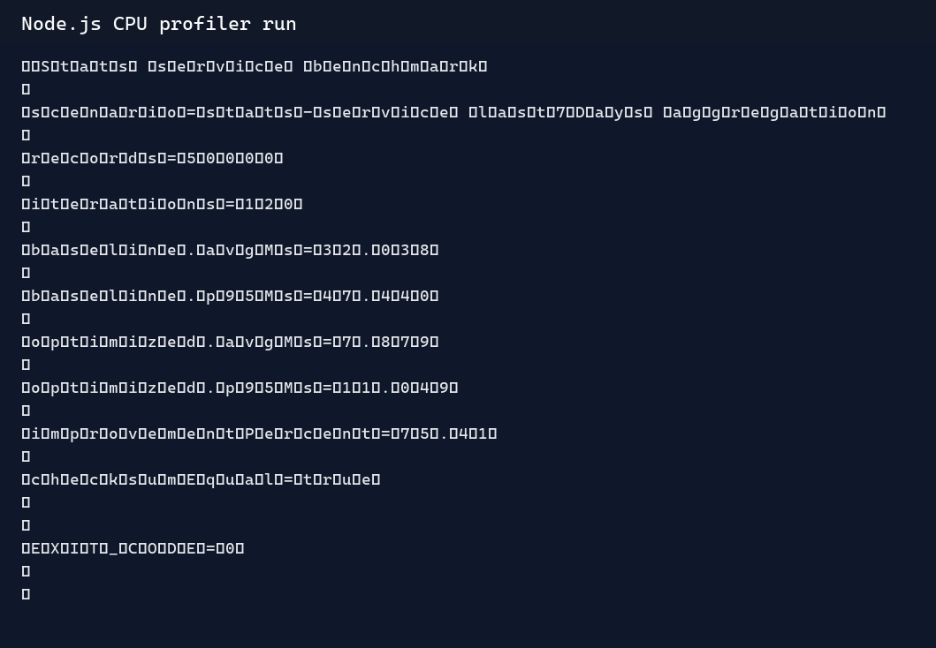
? 5 Node.js CPU Profiler ????
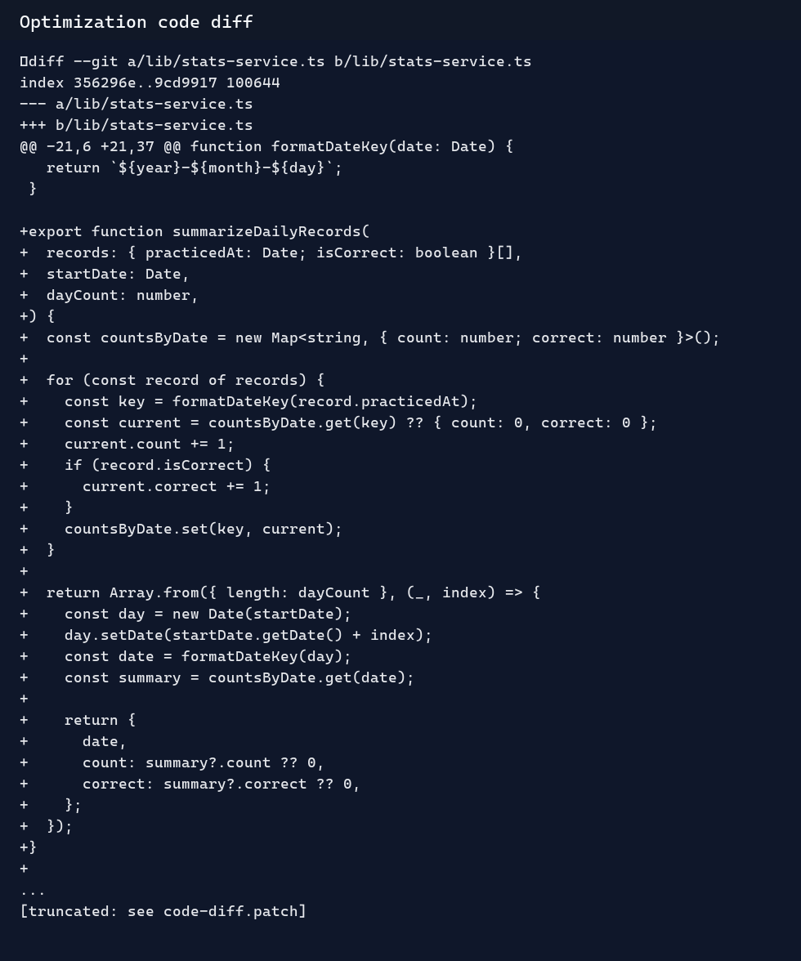
? 6 ???? diff

4. ????
- lint PASS?typecheck PASS?Semgrep PASS?
- Vitest PASS?14 ????? / 48 ??????
- Next.js build PASS?
- Benchmark PASS??????? 78.22%?checksum ???
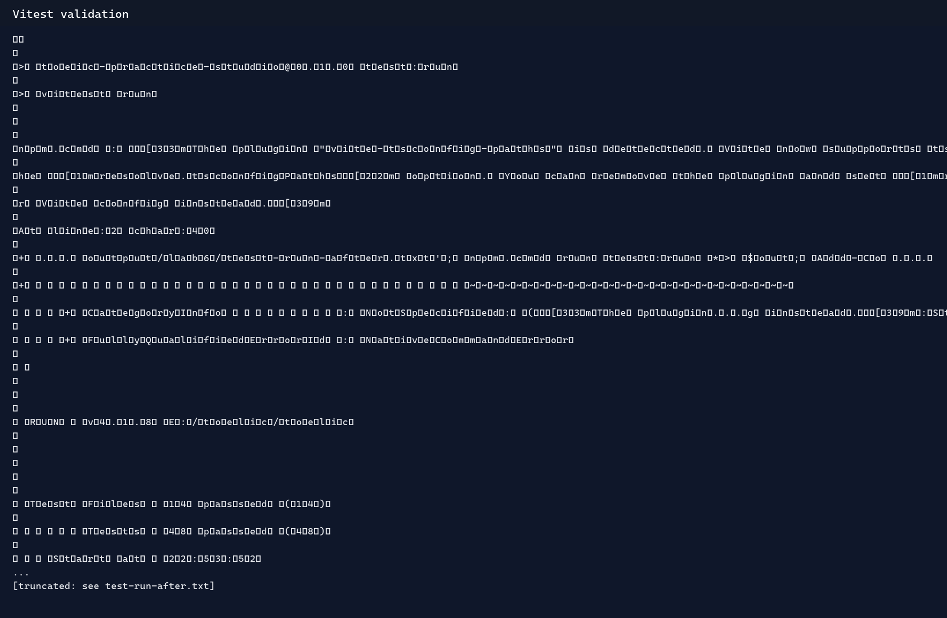
? 7 Vitest ????
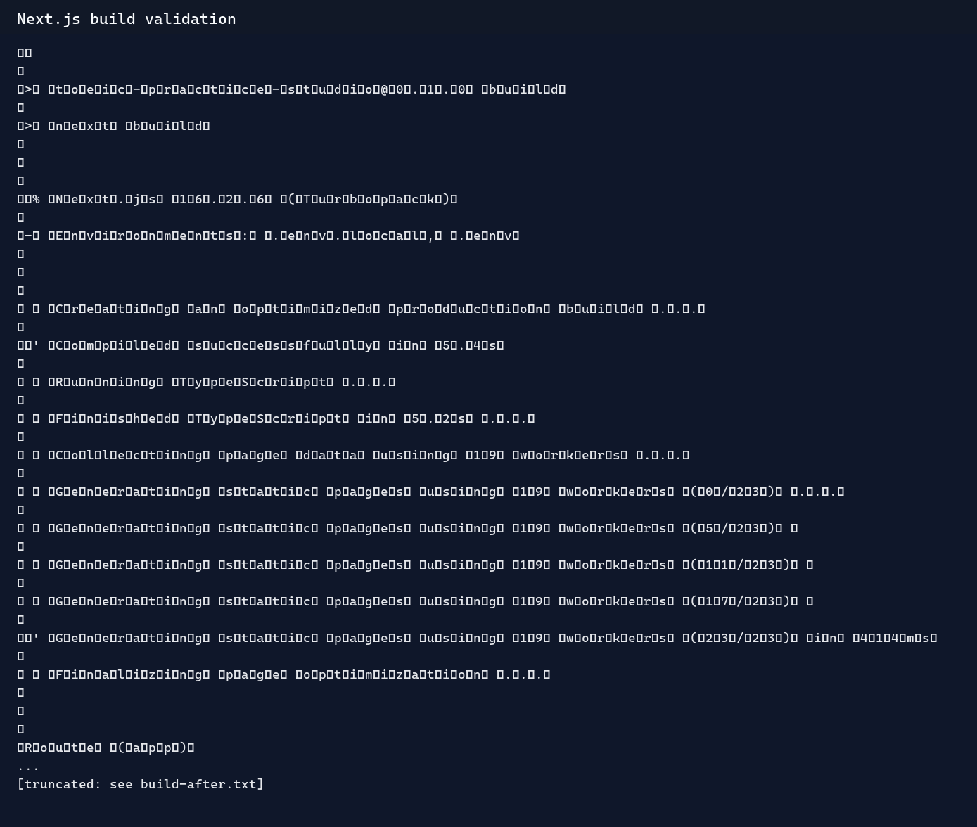
? 8 Next.js ????

