**Supplemental Information to the paper**

Decomposition of 2,6-diamino-3,5-dinitropyrazine-1-oxide:

from thermodynamics to kinetics

Qifeng Houa, Shiyao Niub,c, Can Huangd, Xiaoqing Wue, Wengang Qub, Feng Zhanga,[1]*

*a Hefei National Laboratory for Physical Sciences at the Microscale, University of Science and Technology of China, Hefei, Anhui 230029, China*

*b Science and Technology on Combustion and Explosion Laboratory, Xi'an Modern Chemistry Research Institute, Xi'an, Shaanxi 710065, China*

*c School of Chemistry and Materials Science, University of Science and Technology of China, Hefei, Anhui 230029, China*

*d Chair of Technical Thermodynamics, RWTH Aachen University, 52062 Aachen, Germany*

*e National Synchrotron Radiation Laboratory, University of Science and Technology of China, Hefei, Anhui 230029, China*

**Table of Contents**

1. Structures and frequencies of the stationary points…….…….…….……..…….…........S-2
2. The potential energy surface including several unimportant pathways………………..S-23
3. Rate coefficients (s-1) of various reaction channels for LLM-105 at 1-100 atm, 300-1500 K..…….…….…….….….….……...…..…….……….…….…….…....……………....S-24
4. Rate coefficients (s-1) of various reaction channels in the format of k=A·Tn·exp(-Ea/RT) at 1atm, 300-1500K.…….…….….…….…….………………………………………..S-28
5. Branching ratio of different channels at 10, 100atm, 300-1500K..................................S-29

**1) Table S1**. Structures and frequencies of all stationary points shown on the LLM-105 decomposition PES optimized by the M06-2X-D3/6-311++G(d,p) method.

**R #LLM-105**

C 1.20044600 0.97774900 0.00000600

C -1.20044600 0.97774900 0.00000400

C -1.12582300 -0.43871500 -0.00000300

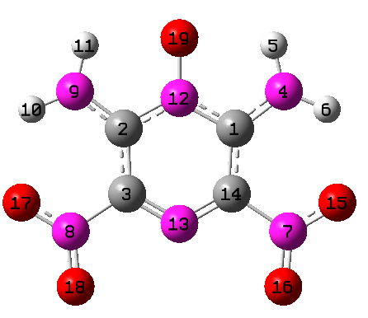N 2.26058900 1.77163200 0.00001000

H 2.06299600 2.76610900 0.00001500

H 3.18500900 1.37058500 0.00000900

N 2.35082200 -1.25200300 -0.00000500

N -2.35082200 -1.25200300 -0.00000700

N -2.26058900 1.77163200 0.00000800

H -3.18500900 1.37058500 0.00000400

H -2.06299600 2.76610900 0.00001200

N 0.00000000 1.63634100 0.00000800

N 0.00000000 -1.09239300 -0.00000500

C 1.12582300 -0.43871500 -0.00000100

O 3.40875000 -0.63497900 -0.00000200

O 2.24351400 -2.44506800 -0.00001100

O -3.40875000 -0.63497900 -0.00000600

O -2.24351400 -2.44506800 -0.00001300

O 0.00000000 2.93206400 0.00001500

Frequencies[1/cm]

44.14 51.23 86.79 126.25 141.92 182.64 292.05 334.39 347.81 354.22 374.75

392.56 410.19 425.56 426.13 469.44 483.35 555.01 555.15 593.43 611.81 677.53

689.64 714.74 731.71 734.11 739.82 753.93 852.93 931.97 972.83 1128.83 1157.00

1238.42 1316.64 1329.65 1427.59 1436.94 1450.46 1500.77 1512.32 1563.80 1586.59 1660.49

1698.55 1728.10 1732.01 3555.52 3558.04 3715.45 3717.16

**IM1**

C -1.49074800 0.66208500 0.06176600

C 0.76487800 1.39910000 -0.11301900

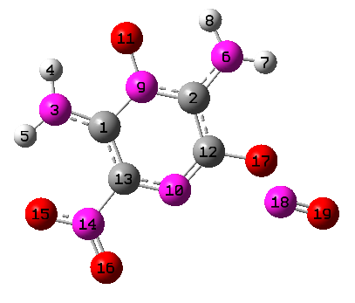N -2.73699800 1.10032300 0.21564800

H -2.84174700 2.10521300 0.28656200

H -3.49535300 0.43965500 0.25274000

N 1.60343400 2.43894000 -0.09933100

H 2.57205100 2.29742600 -0.33138000

H 1.18077700 3.35816300 -0.07643700

N -0.54748600 1.67289200 0.02180000

N 0.29173500 -0.92888300 -0.23522200

O -0.93227700 2.90539800 0.13529300

C 1.14591300 0.04207100 -0.25062300

C -0.99373000 -0.64424000 -0.07054100

N -1.90101500 -1.78414300 -0.04721100

O -3.09429200 -1.53415300 0.09354500

O -1.44203300 -2.88962100 -0.16334100

O 2.47659900 -0.19073000 -0.42117900

N 2.96358400 -1.22763500 0.54050100

O 4.03120500 -1.52277000 0.27189700

Frequencies[1/cm]

48.15 61.06 83.99 100.70 144.88 157.24 219.80 255.20 282.45 289.17 338.19

354.99 363.46 386.87 414.19 426.84 468.26 477.29 533.62 557.50 585.62 600.19

624.86 669.24 694.66 719.39 744.93 748.20 775.06 870.33 962.98 1004.39 1137.63

1194.49 1245.36 1317.49 1342.68 1428.06 1442.03 1498.04 1528.06 1575.53 1605.96 1670.81

1690.94 1715.76 1938.89 3571.69 3586.46 3738.46 3748.08

**IM2**

C 1.25479300 1.03533700 0.00001900

C -1.22756800 0.95334900 0.00003300

C -1.11132100 -0.46598300 -0.00000400

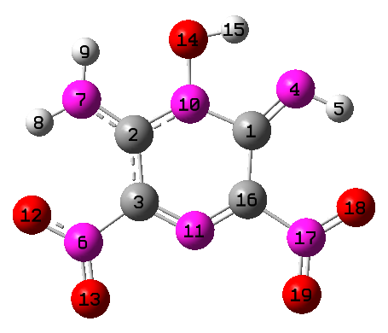N 2.17680100 1.90868800 0.00003300

H 3.10437400 1.49939800 0.00001400

N -2.28962100 -1.31530300 -0.00002000

N -2.33112000 1.68902500 0.00005700

H -3.22018400 1.20869400 0.00005100

H -2.25112400 2.69481200 0.00008300

N -0.04779100 1.59318600 0.00004300

N 0.05703300 -1.06746600 -0.00002600

O -3.37811300 -0.74108500 0.00000300

O -2.14403700 -2.50578000 -0.00005400

O -0.08235600 2.95431400 0.00007700

H 0.89258800 3.16103000 0.00007600

C 1.16669100 -0.41702400 -0.00001700

N 2.40157000 -1.21733200 -0.00004600

O 3.44745400 -0.58533500 -0.00004200

O 2.30838600 -2.41381300 -0.00007100

Frequencies[1/cm]

39.21 58.73 82.96 109.21 125.13 177.25 252.39 277.60 328.62 351.04 376.50

385.63 406.10 410.12 437.92 475.54 499.83 547.69 591.01 628.93 649.82 674.30

713.72 732.78 738.98 743.57 756.87 831.14 846.08 936.86 963.04 1141.02 1150.74

1206.50 1296.19 1320.40 1391.15 1435.00 1445.46 1493.05 1541.09 1582.14 1637.46 1676.43

1704.00 1721.88 1753.49 3267.71 3580.40 3616.45 3721.06

**IM4i**

C 1.16167800 1.15945200 -0.20992100

C -1.16167800 1.15945300 0.20992100

N 2.27670800 1.90985900 -0.35503500

H 2.10324900 2.89683000 -0.49994000

H 3.07391000 1.47640800 -0.79155300

N -2.27670800 1.90985900 0.35503500

H -3.07390900 1.47640800 0.79155400

H -2.10324900 2.89683000 0.49994000

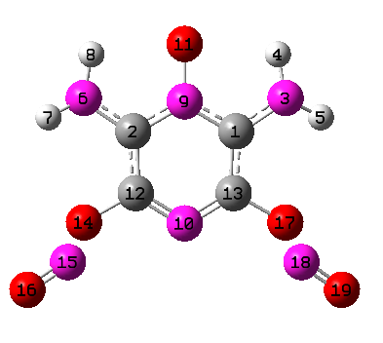 N 0.00000000 1.83777300 0.00000000

N 0.00000000 -0.91631000 0.00000000

O 0.00000000 3.13048400 0.00000000

C -1.10310000 -0.23530500 0.21799900

C 1.10310000 -0.23530500 -0.21800000

O -2.27197300 -0.89648000 0.48402500

N -2.63351900 -1.78958500 -0.62209500

O -3.54769700 -2.41690600 -0.33043600

O 2.27197200 -0.89648100 -0.48402500

N 2.63351900 -1.78958600 0.62209400

O 3.54769700 -2.41690600 0.33043600

Frequencies[1/cm]

39.06 57.64 80.14 101.30 150.67 151.53 170.04 194.69

284.63 293.11 296.51 358.83 374.12 391.42 395.39 410.91

427.66 449.24 489.47 518.71 520.18 536.26 591.46 608.79

657.56 700.16 704.97 726.03 747.94 818.46 900.08 1011.15

1037.18 1164.81 1228.59 1253.98 1314.10 1353.33 1462.20 1521.77

1536.00 1584.46 1595.82 1663.86 1707.31 1904.03 1910.37 3580.73

3582.04 3728.96 3729.49

**IM4is**

C -1.20201500 1.06559200 0.22824200

C 1.18984000 1.25141200 -0.24656500

N -2.37024900 1.73549100 0.39755300

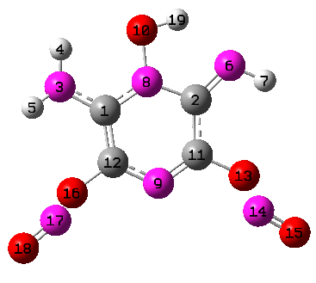 H -2.31107300 2.72154600 0.60386100

H -3.11323900 1.21359300 0.83632800

N 2.11971700 2.11694600 -0.42504200

H 3.02012900 1.68475500 -0.59622400

N -0.07862400 1.77507700 -0.02083400

N 0.12084200 -0.90484600 0.01573900

O -0.15816100 3.13730000 0.00403400

C 1.17286500 -0.19541200 -0.21971900

C -1.05294000 -0.30912700 0.24734600

O 2.37597800 -0.79360500 -0.46092000

N 2.72183100 -1.73996400 0.60312500

O 3.65092500 -2.34083300 0.30175300

O -2.15804000 -1.07062600 0.53141700

N -2.62199300 -1.77586400 -0.66034800

O -3.49428300 -2.47262800 -0.38807200

H 0.78566100 3.38058400 -0.17682000

Frequencies[1/cm]

39.73 58.83 77.06 93.28 138.85 145.10 165.83 188.48

229.11 291.07 300.30 347.96 353.30 376.96 420.49 423.04

437.89 459.80 502.19 518.38 524.72 554.10 597.57 653.28

691.97 713.66 724.70 739.20 751.82 822.12 897.22 1002.05

1048.55 1147.30 1197.83 1265.55 1306.79 1358.39 1445.54 1482.26

1571.70 1609.89 1647.34 1680.50 1717.57 1895.96 1905.60 3363.70

3609.30 3617.86 3730.11

**IM5s**

C -1.54869800 0.77314300 0.05448700

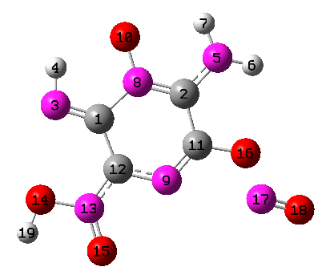 C 0.78120900 1.46048300 -0.07389800

N -2.74444900 1.14978900 0.16660600

H -2.73395200 2.17574200 0.21396900

N 1.69214100 2.44572700 -0.04506800

H 2.64732700 2.24299000 -0.28700800

H 1.32255900 3.38712700 -0.07969900

N -0.49169200 1.77824100 0.01510700

N 0.30132000 -0.90410500 -0.18677500

O -0.84273000 3.01366500 0.09903400

C 1.13806400 0.05543000 -0.18163400

C -1.02688100 -0.59924500 -0.05404100

N -1.81829100 -1.67391600 -0.04603800

O -3.15254900 -1.43901800 0.07108400

O -1.47317700 -2.84343300 -0.13039700

O 2.46321100 -0.16630600 -0.30059400

N 2.88878800 -1.42274000 0.46566400

O 3.93313600 -1.71695600 0.14091300

H -3.51593900 -2.33931000 0.05647100

Frequencies[1/cm]

34.37 62.22 79.33 98.24 121.43 150.48 208.37 240.88

272.60 275.14 306.09 348.51 359.47 376.95 410.93 424.85

449.37 463.51 508.25 531.06 565.68 580.69 627.33 664.52

694.32 701.39 727.24 733.94 827.72 942.79 947.58 995.76

1134.61 1196.45 1240.81 1280.26 1326.62 1357.18 1387.36 1441.07

1508.09 1597.08 1662.55 1701.19 1743.57 1757.26 1970.11 3439.23

3589.30 3748.08 3777.18

**IM5ss**

C  -1.56219000 0.69615400 0.14200900

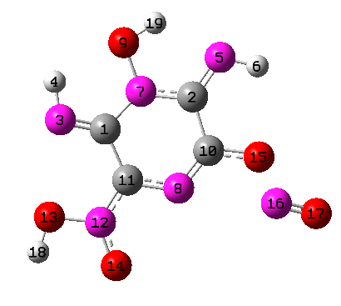 C 0.75129900 1.54834100 -0.14217300

N -2.74785100 0.94196200 0.50304500

H -2.89738000 1.94912400 0.55081500

N 1.47841700 2.59066200 -0.09417200

H 2.46706800 2.35800200 -0.10842900

N -0.61572000 1.69252000 -0.17332000

N 0.38273600 -0.86287300 -0.17247900

O -1.07248100 2.97950000 -0.00827200

C 1.17516300 0.12766600 -0.19566000

C -0.96734900 -0.64759700 -0.04286200

N -1.68701300 -1.76413800 -0.08865700

O -3.03968000 -1.62305800 -0.00266600

O -1.26847200 -2.90774700 -0.21640800

O 2.50538200 -0.03723700 -0.28048800

N 2.96789800 -1.26327700 0.51739900

O 4.02278500 -1.53052100 0.20495400

H -3.33602100 -2.54481900 -0.07201500

H -0.24473700 3.49881500 0.04206400

Frequencies[1/cm]

39.92 67.12 78.30 89.69 103.17 152.33 204.10 232.74

247.94 277.82 361.79 364.63 377.07 382.71 406.57 422.63

441.54 469.10 509.32 521.56 559.46 650.94 671.16 719.37

731.27 738.14 761.97 826.06 841.86 877.78 941.35 1021.98

1136.20 1184.62 1225.02 1285.03 1331.88 1354.02 1386.05 1440.92

1507.62 1529.94 1705.11 1709.35 1743.87 1761.46 1972.41 3545.64

3589.31 3602.11 3779.55

**IM6s**

C -1.55153100 0.69985000 0.08296000

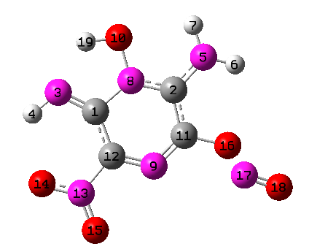 C 0.81298000 1.35460300 -0.13792000

N -2.67666500 1.27944700 0.25564500

H -3.45118000 0.62867000 0.29849200

N 1.71308300 2.34252700 -0.14258300

H 2.66633700 2.11653300 -0.37766400

H 1.40490500 3.30213600 -0.11054800

N -0.47760100 1.63000300 0.02007400

N 0.21341800 -0.93874100 -0.25876800

O -0.84762400 2.92926000 0.15140500

C 1.12994800 -0.01748000 -0.28973900

C -1.05154700 -0.64263300 -0.07596100

N -1.98220200 -1.75782100 -0.04731300

O -3.16358900 -1.47461700 0.11246700

O -1.55378500 -2.87774500 -0.17781500

O 2.44604600 -0.32267700 -0.48685800

N 2.94570800 -1.21650900 0.59508400

O 3.99791200 -1.57790000 0.33819400

H -1.84103400 2.80371200 0.25956200

Frequencies[1/cm]

47.89 58.36 83.97 96.83 134.36 158.10 208.16 234.12

276.15 291.08 300.74 338.77 378.87 384.92 409.25 456.91

473.88 511.28 529.90 542.46 593.80 632.99 698.51 705.63

730.52 746.53 747.61 784.38 805.65 863.45 962.76 999.69

1137.22 1181.92 1201.03 1282.04 1348.50 1418.24 1447.31 1489.02

1547.60 1582.17 1634.54 1670.86 1727.72 1734.90 1927.30 3094.54

3617.78 3641.08 3750.45

**IM7s**

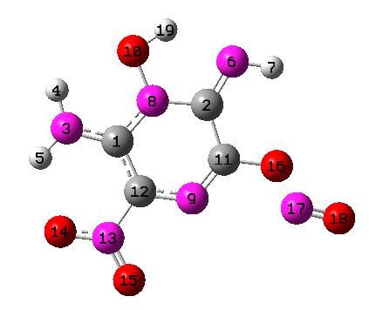C -1.52217000 0.58370600 0.05370100

C 0.75329100 1.50752500 -0.11724800

N -2.80550600 0.91085600 0.20627200

H -3.06090100 1.88279600 0.27844200

H -3.47925800 0.15913700 0.23841900

N 1.39768900 2.60702300 -0.10338800

H 2.39700700 2.46467400 -0.20693400

N -0.62994500 1.60541900 0.00111900

N 0.37876900 -0.87390600 -0.22485300

O -1.12350700 2.87390300 0.13307700

C 1.18160200 0.11946300 -0.24264200

C -0.94563900 -0.69083400 -0.06881700

N -1.75830200 -1.87498000 -0.04793700

O -2.97486600 -1.71653500 0.08951200

O -1.22737900 -2.95100400 -0.16113900

O 2.51994800 -0.05039200 -0.38730300

N 3.02730100 -1.12273400 0.52432300

O 4.10180500 -1.38093100 0.24591500

H -0.29740500 3.41215100 0.09085500

Frequencies[1/cm]

49.26 70.06 84.60 90.93 123.68 151.80 206.36 238.01

258.12 287.50 312.48 354.93 387.43 400.59 418.85 462.28

466.13 475.26 520.97 535.73 589.31 626.51 642.33 711.94

726.63 742.01 749.55 777.05 791.84 871.43 961.37 1031.10

1142.49 1171.97 1252.74 1338.20 1340.71 1382.28 1413.30 1488.89

1563.54 1598.84 1662.52 1670.61 1699.05 1726.78 1938.71 3450.94

3591.38 3603.09 3736.64

**P1**

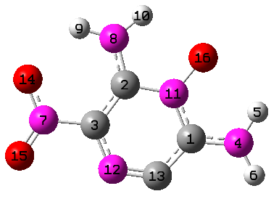C 1.83710200 -0.73970500 -0.00003800

C -0.01575000 0.77055100 0.00003900

C -0.85492500 -0.35441500 -0.00001700

N 3.16737300 -0.85446700 -0.00004200

H 3.70046300 0.00545600 -0.00000900

H 3.60323100 -1.75952100 -0.00010300

N -2.29791600 -0.21862800 -0.00000900

N -0.32343800 2.06407900 0.00010400

H -1.29031500 2.34481200 0.00011800

H 0.46336900 2.70203200 0.00013500

N 1.34805700 0.52382300 0.00002500

N -0.36081000 -1.59547100 -0.00008000

C 0.88689800 -1.77633500 -0.00009000

O -2.74178100 0.92585200 0.00005100

O -2.97042600 -1.21659400 -0.00006100

O 2.17101300 1.52465500 0.00007500

Frequencies[1/cm]

66.92 89.93 110.83 153.40 244.14 289.48 331.44 349.87

361.43 376.74 413.19 461.79 529.21 531.34 569.11 606.63

633.26 635.34 667.05 674.58 722.31 743.25 830.31 939.45

1022.04 1139.14 1210.86 1280.46 1308.76 1408.05 1438.31 1482.10

1518.34 1539.31 1630.96 1665.11 1704.17 1728.61 3564.74 3594.74

3730.64 3763.65

**P2**

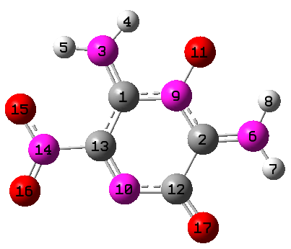 C -0.30239200 0.98759600 0.00000000

C 1.77116000 -0.13165900 0.00000000

N -0.85434100 2.18771100 0.00000000

H -0.19401400 2.96127400 -0.00000100

H -1.85852100 2.28144400 0.00000100

N 3.08702400 -0.05061700 0.00000000

H 3.61893300 -0.90890100 0.00000100

H 3.50619100 0.87131700 0.00000000

N 1.07609300 1.01192100 0.00000000

N -0.27957500 -1.43940800 0.00000100

O 1.69388100 2.15861700 -0.00000100

C 1.08617900 -1.44187700 0.00000000

C -0.90821500 -0.30835400 0.00000000

N -2.39169300 -0.40104900 0.00000000

O -3.00847600 0.65835900 0.00000200

O -2.88775800 -1.48936600 -0.00000200

O 1.77541200 -2.45252000 0.00000000

Frequencies[1/cm]

35.47 81.40 135.02 162.85 241.83 292.73 322.35 352.12

386.17 394.28 419.86 442.32 467.36 484.64 502.05 532.00

553.04 568.21 665.44 687.58 709.55 725.01 730.05 733.94

819.62 941.19 970.55 1103.47 1213.56 1246.48 1282.85 1370.80

1425.03 1457.05 1494.66 1534.90 1569.54 1656.34 1675.00 1702.66

1731.82 3517.88 3568.28 3696.84 3717.86

**P3**

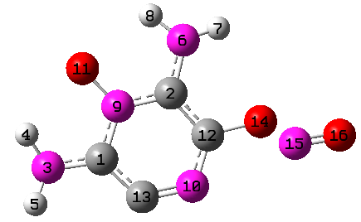 C -1.88922100 -0.81151000 0.03594000

C -0.17329700 0.82117500 -0.11576900

N -3.22150300 -1.01845000 0.15273100

H -3.75186700 -0.20461500 0.43811400

H -3.53474300 -1.93295000 0.43037700

N 0.12816500 2.13949300 -0.03626100

H 0.99872400 2.43618500 -0.44683100

H -0.67596200 2.75273500 -0.09220800

N -1.49231100 0.49745500 0.03606900

N 0.35827400 -1.48372300 -0.30481600

O -2.36688500 1.43529400 0.19456300

C 0.73933800 -0.21439300 -0.30132900

C -0.88278100 -1.75041400 -0.13334900

O 2.04696600 0.12120300 -0.50816000

N 2.90312300 -0.42409600 0.55328900

O 4.00359200 -0.21840300 0.30741100

Frequencies[1/cm]

48.19 89.01 148.85 164.88 212.85 292.35 310.03 338.09

367.16 392.79 407.48 438.75 466.49 494.61 517.28 528.05

565.37 597.35 636.71 641.54 689.88 721.94 735.83 879.73

1007.06 1051.04 1171.00 1234.99 1284.39 1323.77 1452.57 1501.41

1517.59 1566.10 1600.96 1654.22 1715.43 1908.13 3578.88 3583.60

3725.92 3739.76

**P4i**

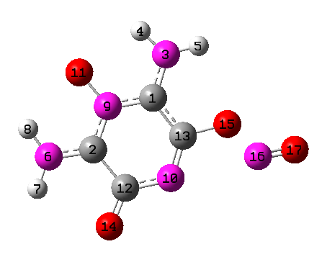 C -0.04010100 1.13521000 -0.06472700

C -1.80423700 -0.38497900 0.03566500

N 0.33674300 2.41591700 -0.03088800

H -0.40974600 3.10052800 -0.00429800

H 1.29742200 2.66298200 -0.19905700

N -3.10965900 -0.58993500 0.13668400

H -3.44041700 -1.54304800 0.14394300

H -3.71461100 0.21755400 0.20701700

N -1.37411700 0.89092200 0.02675900

N 0.47585700 -1.22451800 -0.20214400

O -2.21241200 1.88214200 0.11926300

C -0.86227500 -1.51313300 -0.07125100

C 0.83710500 0.01748300 -0.18634900

O -1.32139900 -2.64785800 -0.05181600

O 2.14320400 0.36467600 -0.31658700

N 3.04544500 -0.58188000 0.43497900

O 4.12367200 -0.39134100 0.12597000

Frequencies[1/cm]

56.03 86.26 112.53 143.60 160.99 238.88 275.99 287.58

304.55 317.26 363.49 366.93 400.52 423.43 452.08 507.45

515.55 558.29 588.21 615.66 639.61 678.25 716.33 721.20

732.95 831.53 969.74 998.93 1171.07 1209.77 1255.48 1309.31

1363.29 1486.78 1511.26 1554.32 1582.38 1659.67 1682.83 1702.92

1943.24 3573.39 3584.02 3731.25 3745.68

**P4isa**

C -1.87557000 -0.44852700 0.04866900

C -0.03887200 1.12150800 -0.07237200

N -3.13921600 -0.53410100 0.15701900

H -3.42141400 -1.51283900 0.16019400

N 0.37339600 2.40229200 -0.01675000

H 1.32993700 2.59200300 -0.27115300

H -0.31242500 3.13912200 -0.07873700

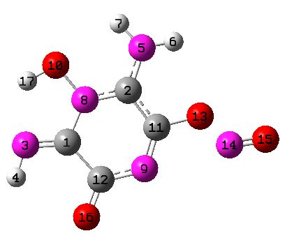 N -1.34721600 0.83421900 0.02892800

N 0.45419800 -1.24707100 -0.22635900

O -2.22682700 1.87860500 0.12453300

C 0.82111700 0.00504300 -0.21468700

C -0.86608400 -1.57101200 -0.07266000

O 2.13179300 0.33931400 -0.37363300

N 3.02092300 -0.52618600 0.46899000

O 4.10628600 -0.35743700 0.16450700

O -1.29711000 -2.70672000 -0.04277200

H -3.08737500 1.40547500 0.19211400

Frequencies[1/cm]

51.79 80.79 108.18 117.12 156.76 189.05 272.90 281.20

317.12 336.78 347.24 379.88 406.52 444.71 452.17 471.06

493.32 512.61 525.56 599.84 668.23 713.69 743.21 750.02

833.92 857.77 987.97 1019.12 1168.76 1190.31 1260.74 1303.06

1389.09 1469.63 1524.78 1585.30 1621.99 1696.56 1713.38 1740.91

1932.36 3508.04 3558.84 3613.88 3743.32

**P4isb**

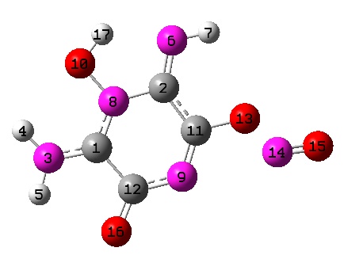 C -1.79137900 -0.40745700 0.03721000

C 0.00558800 1.20571400 -0.07769400

N -3.08597300 -0.67813300 0.14793500

H -3.77689600 0.05067200 0.22610300

H -3.33125000 -1.65939100 0.15129200

N 0.22560400 2.47562500 -0.04572800

H 1.21375500 2.68979200 -0.13300100

N -1.34232400 0.83784800 0.01878600

N 0.49760000 -1.18294500 -0.21402000

O -2.24307500 1.85665700 0.12941500

C 0.86951300 0.05913400 -0.20475400

C -0.81990400 -1.51402700 -0.07767900

O 2.18088600 0.38137600 -0.34279300

N 3.05609500 -0.52585500 0.45487900

O 4.14407000 -0.36377700 0.15035800

O -1.26908200 -2.65831300 -0.05546400

H -1.64792600 2.64540900 0.10801200

Frequencies[1/cm]

55.09 87.26 115.74 137.89 164.23 223.08 286.11 288.20

313.19 314.90 354.37 398.11 424.27 461.84 497.94 502.30

528.56 560.17 609.51 614.41 697.31 715.08 729.35 738.17

740.42 845.98 951.67 1002.10 1111.57 1189.66 1211.27 1301.72

1347.22 1475.91 1510.68 1555.60 1583.83 1656.33 1690.95 1750.03

1925.92 3430.57 3589.74 3603.02 3738.06

**P4isc**

C -1.16009400 1.52807800 0.13933500

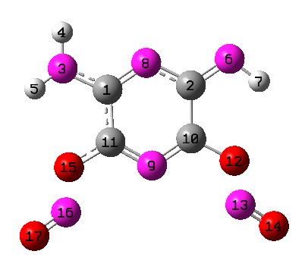 C 1.12307400 1.64341500 -0.16733600

N -2.39094500 2.10218500 0.24686700

H -2.40586600 3.09896100 0.39647900

H -3.15382900 1.55341700 0.60791600

N 2.19059500 2.36717600 -0.30467800

H 2.99915600 1.75332200 -0.41069300

N -0.09881300 2.26017300 -0.00890700

N 0.06152400 -0.55798400 0.00077300

C 1.13576700 0.18329800 -0.16043600

C -1.07820300 0.08323700 0.15174900

O 2.32280600 -0.42681300 -0.33736000

N 2.48688200 -1.63180200 0.54665000

O 3.40570800 -2.21773000 0.21493600

O -2.21691300 -0.60478500 0.33813100

N -2.29777300 -1.84250900 -0.54807500

O -3.16447800 -2.48999100 -0.20345500

Frequencies[1/cm]

42.11 66.01 71.83 109.93 114.54 152.83 183.37 211.01

262.30 293.78 314.67 343.50 382.30 426.26 441.42 467.26

489.30 512.48 525.06 536.32 670.87 684.92 721.10 732.20

750.17 782.81 821.23 885.37 1018.86 1084.74 1196.72 1234.30

1308.38 1330.86 1394.19 1451.72 1499.33 1544.25 1603.58 1678.02

1932.81 1952.48 3524.23 3621.60 3751.07

**P5s**

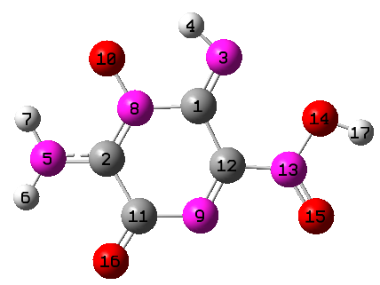 C 0.26623000 1.06688700 0.08746500

C -1.81111600 -0.12582300 -0.04514500

N 0.84074300 2.16980900 0.25477900

H 0.10262500 2.88937000 0.25565500

N -3.13891500 -0.12071300 -0.10648800

H -3.63216300 -0.99867900 -0.07118100

H -3.60379900 0.77705100 -0.11860500

N -1.16715400 1.01657000 -0.04987400

N 0.30932800 -1.41270400 0.02715400

O -1.80490500 2.14096200 -0.07163800

C -1.07862500 -1.42342800 0.03669800

C 0.91776000 -0.27674200 0.02333600

N 2.30952100 -0.37091100 -0.02668500

O 3.01885300 0.78414200 -0.17965800

O 2.92458400 -1.42768700 0.00807700

O -1.71900400 -2.44211100 0.09393100

H 3.93696500 0.47008500 -0.17788200

Frequencies[1/cm]

30.72 50.19 104.65 140.59 223.61 262.65 286.81 315.31

320.76 339.02 353.58 384.90 402.27 440.91 478.30 497.68

534.11 545.40 618.86 672.59 678.74 717.80 727.31 755.80

903.68 968.04 1003.55 1117.83 1207.61 1250.19 1257.23 1287.11

1392.15 1425.33 1462.43 1588.29 1598.09 1651.03 1725.94 1767.47

1809.41 3395.40 3592.79 3741.59 3788.52

**P5ss**

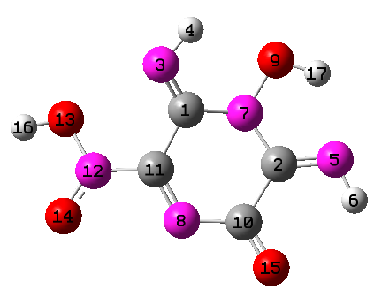 C -0.21677500 1.03541000 0.18188500

C 1.86076800 -0.18282800 -0.12493300

N -0.77871000 2.04744800 0.67737900

H -0.11845200 2.82494900 0.73271300

N 3.11983800 -0.07728100 -0.10688900

H 3.55305900 -0.99206600 0.01075600

N 1.09880400 0.96259800 -0.28428100

N -0.31360500 -1.43969100 0.00039900

O 1.79363100 2.14921100 -0.18058100

C 1.07649200 -1.47970900 0.04143400

C -0.89668800 -0.29442500 0.02516400

N -2.28832800 -0.32939800 -0.05015900

O -2.91160300 0.82731700 -0.42920300

O -2.96129300 -1.34516300 0.07250200

O 1.68941300 -2.49939600 0.18975700

H -3.84723900 0.64241100 -0.25641000

H 2.72269000 1.85254300 -0.10329900

Frequencies[1/cm]

48.06 56.43 95.85 137.35 216.31 224.28 238.24 318.66

342.68 360.44 378.54 393.02 411.02 431.49 496.91 511.96

528.55 544.32 668.46 731.12 742.35 767.55 792.22 891.17

897.23 933.72 1000.15 1111.10 1186.30 1220.49 1253.72 1281.90

1386.67 1416.94 1471.71 1531.89 1617.15 1646.82 1743.33 1775.50

1838.72 3523.77 3551.76 3611.05 3803.18

**P6sa**

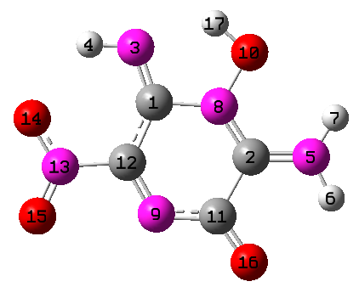 C -0.35609200 1.04595400 -0.00006900

C 1.76982600 -0.15225500 0.00009400

N -0.76462000 2.25622800 0.00015100

H -1.77762200 2.31908700 -0.00042700

N 3.08740500 -0.15225100 0.00037900

H 3.53095500 -1.06285400 0.00042400

H 3.61880000 0.70538100 0.00128300

N 1.06942400 0.95744300 0.00012300

N -0.31271400 -1.40834900 -0.00054900

O 1.73768900 2.14280000 0.00078900

C 1.03675900 -1.45778900 -0.00060700

C -0.94886400 -0.27371100 -0.00043600

N -2.42139500 -0.36573700 0.00012300

O -3.03874200 0.69305900 -0.00252100

O -2.92160800 -1.45727700 0.00310000

O 1.72688100 -2.46984300 -0.00107500

H 0.97763300 2.78393900 0.00088900

Frequencies[1/cm]

36.03 76.71 124.38 163.50 228.35 246.01 318.64 346.86

373.64 380.40 422.53 437.39 456.93 499.40 505.14 543.33

581.41 645.44 659.46 701.26 713.93 732.57 752.24 815.40

831.84 947.80 955.35 1126.64 1189.21 1217.62 1246.59 1351.82

1397.81 1459.58 1496.15 1542.38 1602.28 1666.33 1699.53 1713.23

1778.15 3314.61 3573.47 3597.94 3720.29

**P6sb**

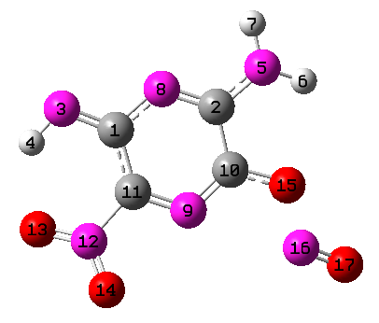 C -1.49532600 1.15753600 0.10169900

C 0.76261400 1.67853800 -0.01192400

N -2.70444200 1.63266900 0.24700800

H -3.38410500 0.87423300 0.20400600

N 1.79185800 2.55700900 0.01790800

H 2.71713600 2.25405200 -0.23570200

H 1.56911800 3.53951600 0.01049900

N -0.46442000 2.07700400 0.10639000

N 0.13520800 -0.64215000 -0.16843000

C 1.07411800 0.26355900 -0.15395700

C -1.11134000 -0.22948800 -0.04608500

N -2.09427500 -1.33606900 -0.04307900

O -3.23740900 -1.07095100 -0.37142400

O -1.69934700 -2.42772600 0.27922200

O 2.35107800 -0.07813100 -0.29035900

N 2.65865000 -1.48595300 0.38208300

O 3.64310200 -1.86147100 -0.00623300

Frequencies[1/cm]

38.17 49.03 66.49 87.32 143.70 187.53 222.21 244.48

258.51 268.24 350.98 374.55 392.14 447.19 453.05 478.31

520.72 548.06 615.80 650.72 691.35 716.96 741.85 753.47

779.53 797.95 865.02 975.54 1050.09 1163.55 1207.38 1228.88

1308.90 1362.02 1429.65 1444.55 1505.27 1537.67 1601.87 1685.71

1694.81 2017.03 3539.07 3628.36 3762.30

**P7sa**

C -0.28537900 0.99249500 0.00004300

C 1.85370300 -0.18960400 -0.00002400

N -0.86605800 2.18599700 0.00008900

H -0.28677700 3.01246200 -0.00000900

H -1.87648800 2.22190300 -0.00022400

N 3.10462200 -0.00444000 -0.00025800

H 3.59388300 -0.89852500 -0.00045000

N 1.05992900 0.95661100 0.00021800

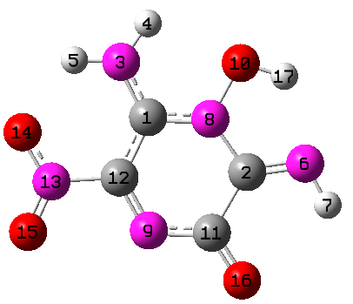 N -0.26807900 -1.44571300 -0.00002400

O 1.71467900 2.15913900 0.00015200

C 1.09347400 -1.49569100 0.00001200

C -0.90099400 -0.30471000 -0.00001000

N -2.36981100 -0.39055200 -0.00005000

O -2.99464800 0.67139800 -0.00038300

O -2.87382100 -1.47690600 0.00029100

O 1.74416700 -2.52132900 0.00002500

H 2.65732000 1.87748500 0.00005100

Frequencies[1/cm]

42.80 68.90 93.76 148.37 207.39 246.59 349.56 353.17

363.75 373.74 405.15 411.04 428.66 462.89 497.41 505.98

541.10 585.19 649.83 702.85 718.09 738.11 747.78 817.59

885.32 946.40 1002.77 1094.65 1187.51 1239.87 1270.40 1353.85

1397.75 1478.24 1510.71 1566.85 1607.25 1686.30 1709.01 1719.24

1739.73 3515.21 3553.90 3568.11 3712.73

**P7sb**

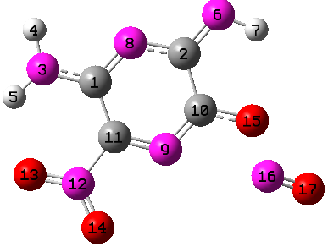 C -1.49712400 1.06507500 0.06683500

C 0.71436800 1.77607200 -0.03100500

N -2.79961600 1.38444900 0.20782500

H -3.01381300 2.36903800 0.22035800

H -3.51874300 0.69302500 0.08020400

N 1.56715100 2.75182700 -0.01350200

H 2.51205500 2.37177700 -0.09387600

N -0.62269300 2.04038200 0.05764300

N 0.25282800 -0.61236700 -0.15491000

C 1.11990300 0.36726000 -0.14722600

C -1.02185600 -0.30423300 -0.04044700

N -1.92345300 -1.46923300 -0.04264500

O -3.12255000 -1.24268000 -0.13120700

O -1.43378800 -2.56504100 0.04016100

O 2.41158000 0.09807000 -0.26405600

N 2.79421500 -1.28630400 0.41451600

O 3.80097500 -1.60536900 0.03283800

Frequencies[1/cm]

23.89 42.31 64.63 86.58 144.02 188.93 212.41 257.01

266.99 346.77 363.96 374.09 402.63 441.83 466.86 474.42

512.04 571.09 611.52 668.70 692.03 719.08 730.44 740.92

767.56 822.14 868.13 974.57 1067.74 1138.89 1233.17 1268.65

1322.16 1375.24 1415.28 1446.32 1520.67 1536.07 1569.60 1659.98

1701.08 2016.46 3515.06 3619.20 3757.68

**P8a**

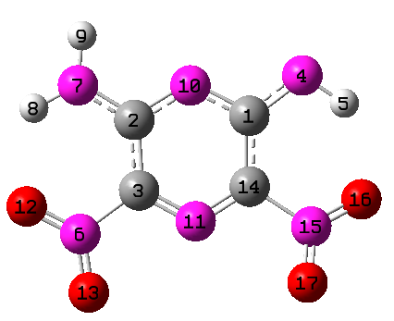 C 1.14463600 1.31874300 0.03092300

C -1.18537000 1.23492500 0.02271000

C -1.08880800 -0.19513400 -0.00941800

N 2.21684800 2.13400200 0.06264300

H 3.06905200 1.57040800 0.02731500

N -2.27831900 -1.07656200 -0.04793100

N -2.32508200 1.93454200 0.02839200

H -3.21883100 1.47066300 0.02699500

H -2.24379900 2.93904700 0.05745400

N -0.04980800 1.93226900 0.04761300

N 0.05726700 -0.81790000 -0.00788000

O -3.36476100 -0.51740100 -0.00362000

O -2.10672900 -2.25968400 -0.11890700

C 1.15265600 -0.11673600 0.00216200

N 2.39982300 -0.92633600 0.00479100

O 3.41307900 -0.37331900 -0.38705900

O 2.32213500 -2.06097100 0.38415900

Frequencies[1/cm]

25.27 42.31 55.07 137.03 177.15 216.05 305.67 326.51

353.42 373.78 377.63 387.33 429.36 437.59 505.44 531.89

607.24 611.53 656.91 674.39 704.85 730.46 743.06 763.17

780.56 874.49 916.94 1058.81 1146.21 1173.04 1249.46 1255.37

1318.01 1427.61 1435.06 1458.26 1493.28 1565.87 1578.08 1664.59

1718.37 1729.14 3503.22 3611.68 3751.33

**P8b**

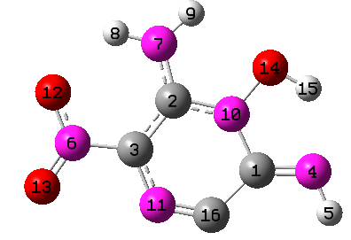 C 1.90337700 -0.82136500 0.00000400

C 0.00106800 0.76203500 0.00001700

C -0.86243100 -0.34669800 -0.00001800

N 3.17642400 -0.84711400 0.00001900

H 3.54675300 -1.79079000 0.00000100

N -2.28379600 -0.20099800 -0.00003200

N -0.31982800 2.05538600 0.00004300

H -1.30138900 2.29389500 0.00003600

H 0.41391500 2.74594600 0.00006700

N 1.32488900 0.45641400 0.00002700

N -0.35626600 -1.60396300 -0.00004100

O -2.72727500 0.95126300 -0.00001000

O -2.97194600 -1.19138900 -0.00006400

O 2.20235600 1.50732500 0.00006100

H 3.07043500 1.03874400 0.00006100

C 0.86719400 -1.83454900 -0.00003100

Frequencies[1/cm]

73.82 78.63 116.57 208.91 248.14 249.24 322.12 350.64

380.36 404.91 447.12 447.84 486.92 522.87 618.88 633.30

636.23 659.59 659.61 726.59 741.03 769.32 809.29 935.32

1044.48 1146.36 1180.12 1264.88 1300.93 1362.35 1381.61 1482.38

1552.87 1594.11 1658.71 1684.04 1708.79 1771.99 3456.51 3587.11

3610.96 3734.37

**TS1**

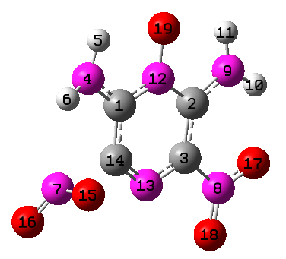C -1.10491900 1.10091900 0.04731400

C 1.27413600 0.88342000 -0.05869200

C 1.09474400 -0.49741800 0.04243100

N -2.17016600 1.90606400 0.04119400

H -1.96077900 2.89772100 0.06741800

H -3.04400800 1.55775900 0.40254100

N -2.57867500 -1.03355900 -0.30433600

N 2.22937000 -1.40036100 0.04658300

N 2.38687800 1.60479100 -0.15537700

H 3.27985100 1.13963800 -0.15996900

H 2.26015100 2.60834100 -0.20434700

N 0.11186500 1.65754100 -0.04705600

N -0.11569000 -1.06880700 0.12186600

C -1.12728400 -0.31308300 0.10290800

O -2.57762500 -0.85000400 0.97403900

O -3.04726500 -1.99154600 -0.80816400

O 3.33979500 -0.88323100 -0.03257200

O 2.02340100 -2.58250200 0.12842600

O 0.21165000 2.94401200 -0.11541900

Frequencies[1/cm]

-835.58 59.73 86.48 97.08 122.46 147.58 163.95 232.96 252.48 325.69 350.16

351.32 359.58 376.63 390.27 416.31 433.42 470.21 536.53 543.29 569.46 614.99

646.37 656.29 674.19 710.43 738.66 741.27 785.69 874.13 953.66 1061.15 1142.59

1212.78 1282.00 1303.15 1333.11 1400.12 1440.83 1499.20 1532.63 1560.16 1616.79 1676.16

1702.80 1709.94 1721.28 3567.50 3569.40 3722.42 3727.68

**TS2**

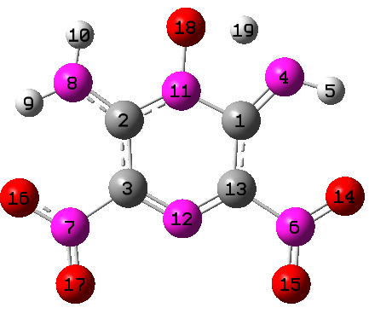C 1.23950800 0.96662000 0.00000600

C -1.20839200 0.97879600 0.00000500

C -1.12560100 -0.44808200 -0.00000300

N 2.15084300 1.87744700 0.00001100

H 3.11901700 1.58952900 0.00001000

N 2.37492600 -1.25772800 -0.00000700

N -2.33837000 -1.26337200 -0.00000700

N -2.28087200 1.75950000 0.00000900

H -3.19515800 1.33246900 0.00000700

H -2.13400600 2.75953600 0.00001500

N -0.01449000 1.58676000 0.00000900

N 0.01304900 -1.08846100 -0.00000600

C 1.14662000 -0.45927200 -0.00000200

O 3.41639800 -0.61746400 -0.00000300

O 2.28540900 -2.45447500 -0.00001400

O -3.40202900 -0.65056100 -0.00000400

O -2.22971900 -2.45671400 -0.00001400

O 0.08735800 2.92026700 0.00001600

H 1.30239400 2.86264900 0.00001600

Frequencies[1/cm]

-1325.25 50.19 57.76 91.57 116.08 145.54 174.97 274.51 288.72 340.96 354.09

373.52 379.65 412.69 440.18 478.40 526.39 562.94 612.13 631.59 657.36 664.86

714.33 729.79 739.75 740.60 766.04 792.97 851.48 937.62 989.20 1094.45 1141.58

1178.37 1256.63 1291.53 1347.66 1411.97 1445.18 1450.73 1540.93 1541.86 1613.52 1672.92

1705.56 1726.57 1754.16 2116.05 3585.01 3664.48 3723.14

**TS-IM4i**

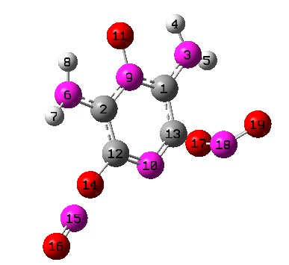 C -1.39528600 0.60734200 0.17848000

C 0.84989600 1.29890500 -0.14569800

N -2.66705200 0.99564100 0.37012800

H -2.79818200 1.99111000 0.49709500

H -3.32963300 0.33945100 0.75217300

N 1.71071900 2.34007100 -0.16572000

H 2.61772200 2.18832000 -0.57606000

H 1.27467400 3.25082500 -0.23792100

N -0.46348600 1.59956000 0.03780500

N 0.31630100 -1.02669800 -0.21414400

O -0.83087500 2.83080500 0.14581800

C 1.19860600 -0.05297200 -0.26360200

C -0.92003700 -0.69446600 -0.00575100

O 2.50982300 -0.32936800 -0.48882000

N 3.03053000 -1.31145300 0.50912900

O 4.08906300 -1.62159700 0.21970100

O -1.96765300 -1.78657900 0.93968300

N -2.09538800 -1.76965700 -0.35103500

O -3.17348600 -1.65761300 -0.85625800

Frequencies[1/cm]

-874.55 48.19 84.78 95.45 114.56 149.09 165.43 184.43

224.40 273.43 276.32 294.00 328.01 356.10 389.08 392.88

425.11 458.09 467.16 490.93 510.05 528.25 580.41 596.19

647.18 670.97 711.94 728.93 749.21 805.19 901.82 1009.30

1060.53 1168.67 1227.86 1237.15 1321.16 1341.38 1415.49 1511.09

1529.31 1563.32 1596.35 1607.98 1660.92 1708.05 1934.39 3583.16

3584.60 3725.23 3731.66

**TS-IM4isa**

C -1.17600500 1.12409000 0.22880400

C 1.19459900 1.17684700 -0.24211400

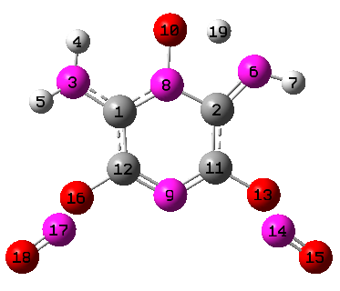 N -2.30759100 1.84454700 0.40252500

H -2.19111200 2.83397800 0.57001700

H -3.08580700 1.37211500 0.83455600

N 2.09900800 2.10175100 -0.41101300

H 3.04744800 1.83193400 -0.61724100

N -0.02977900 1.77822800 -0.00575000

N 0.05398700 -0.90804100 0.00304600

O 0.05246600 3.11497900 -0.00921700

C 1.15059400 -0.23908400 -0.23323300

C -1.07908200 -0.26964800 0.23514500

O 2.31973700 -0.89945600 -0.49059000

N 2.67719300 -1.78348200 0.61655400

O 3.58474800 -2.42374200 0.32691900

O -2.22037900 -0.97522000 0.51508800

N -2.64873200 -1.75644100 -0.64775700

O -3.54311200 -2.41739400 -0.36483800

H 1.23256000 3.07948100 -0.24109200

Frequencies[1/cm]

-1347.07 39.07 58.43 79.71 94.82 150.51 154.74 175.89

193.52 261.67 285.50 297.38 352.28 371.75 406.98 422.25

439.85 460.94 468.78 511.03 540.57 575.56 599.57 654.73

694.82 710.88 726.89 740.42 791.22 831.23 900.68 1014.03

1059.90 1074.56 1178.98 1210.93 1277.69 1299.11 1366.34 1450.85

1534.89 1582.60 1611.55 1678.82 1726.13 1898.77 1905.82 2120.55

3603.12 3695.93 3731.97

**TS-IM4isb**

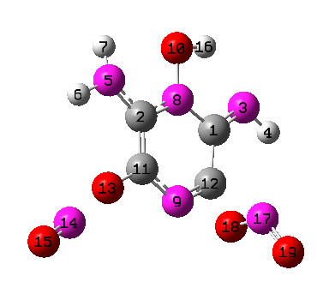 C 1.47836300 -0.85804000 0.16905900

C -0.91466200 -1.23974800 -0.22242900

N 2.58906900 -1.44125100 0.40448400

H 3.34719300 -0.79011600 0.57424900

N -1.87030700 -2.18765000 -0.41554900

H -2.82360500 -1.86147100 -0.40217000

H -1.68860700 -3.11287000 -0.05704500

N 0.36782700 -1.66017400 -0.02426100

N -0.07173000 0.98575400 -0.15836400

O 0.58253000 -3.00658500 0.07688700

C -1.10304700 0.12197600 -0.28503200

C 1.09454300 0.53296200 0.03222100

O -2.35569700 0.60595900 -0.53275400

N -2.88570900 1.30343100 0.64967200

O -3.88925800 1.79514200 0.39254100

H 1.54730000 -3.04088200 0.27524600

N 2.34552400 1.54200700 -0.28495700

O 2.16784300 1.54340600 0.99134800

O 2.61505900 2.52053100 -0.89681800

Frequencies[1/cm]

-827.07 47.15 75.77 96.58 108.97 136.75 156.63 163.33

233.29 242.57 284.83 294.15 339.48 358.73 367.25 377.92

427.21 435.13 466.36 491.65 505.55 519.85 602.29 669.95

681.08 695.46 706.55 723.88 758.06 812.17 896.29 1001.53

1092.91 1169.55 1197.60 1274.23 1322.53 1329.06 1439.15 1466.25

1556.09 1608.95 1650.19 1671.07 1685.56 1733.91 1906.40 3477.43

3615.31 3615.84 3738.40

**TS-IM5s**

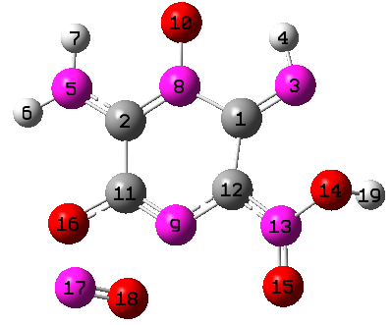 C 1.22001300 1.00824600 -0.21621700

C -1.14612900 1.22500500 0.22360600

N 2.24879300 1.56079000 -0.69002200

H 2.02448000 2.55228700 -0.83327500

N -2.23828300 1.99899400 0.27864600

H -3.09978200 1.60882400 0.62234000

H -2.07934100 2.99708800 0.23214800

N 0.01522900 1.79314400 -0.02143100

N -0.18009300 -0.98928600 0.35400200

O 0.08655700 3.06559900 -0.21751200

C -1.20471700 -0.22324800 0.40005900

C 1.03970000 -0.41113600 0.14032100

N 2.06752000 -1.26451900 0.18330500

O 3.31109900 -0.68221800 0.28966900

O 2.01482800 -2.47554400 0.24044000

O -2.42881000 -0.70643200 0.62574400

N -2.89367000 -1.92600100 -0.32290400

O -2.13162200 -2.21931200 -1.09025400

H 3.74854800 -0.81999500 -0.56370000

Frequencies[1/cm]

-408.84 40.36 63.53 83.99 108.85 127.95 154.88 210.53

242.48 271.79 284.09 321.39 342.66 372.13 409.19 418.69

450.76 471.83 505.39 537.10 547.70 597.85 634.34 686.37

706.20 728.60 732.40 743.28 829.49 934.76 943.29 985.81

1113.93 1196.57 1238.48 1287.81 1323.67 1362.96 1387.98 1451.88

1495.38 1589.78 1619.07 1655.33 1719.07 1752.15 2026.07 3447.48

3590.67 3746.68 3802.23

**TS-IM5ss**

C -1.57384200 0.72557600 0.09723600

C 0.75207200 1.48729900 -0.11569200

N -2.78313700 1.02701100 0.30909000

H -2.85740500 2.04604900 0.35257100

N 1.41297500 2.60777700 -0.09733300

H 2.41882400 2.62089000 -0.15868600

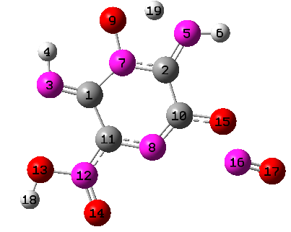 N -0.56949500 1.70542800 -0.04786900

N 0.35206700 -0.87877800 -0.17812400

O -0.86105900 3.00732500 0.06262400

C 1.17455400 0.09130700 -0.19318900

C -0.99114200 -0.62903900 -0.04808800

N -1.73148100 -1.73864300 -0.06663600

O -3.07561000 -1.56723900 0.04304500

O -1.33464700 -2.88904200 -0.17726000

O 2.50119800 -0.09471200 -0.29277000

N 2.94929700 -1.33717200 0.49065600

O 4.00139500 -1.61179000 0.17625500

H -3.39797000 -2.48195800 -0.00417100

H 0.40489000 3.30846800 0.00504100

Frequencies[1/cm]

-1436.30 36.26 63.81 78.03 97.94 100.66 154.46 209.15

236.60 244.12 275.37 356.72 360.32 383.72 410.98 443.46

462.57 476.97 522.84 553.73 577.47 635.20 667.23 701.06

714.37 719.51 740.94 773.84 849.42 897.28 947.94 1049.47

1066.26 1142.01 1201.47 1269.69 1320.32 1337.52 1356.71 1407.03

1450.32 1567.82 1656.33 1691.32 1733.39 1750.15 1973.85 2156.17

3503.46 3692.70 3777.82

**TS-IM6sa**

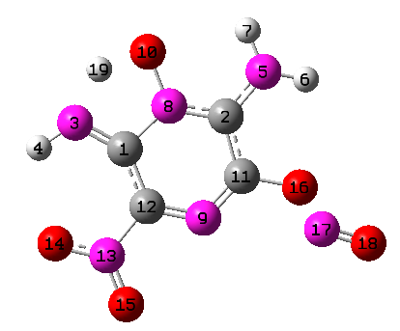 C -1.52934500 0.64261400 0.07134300

C 0.77930200 1.38871700 -0.12864100

N -2.66242100 1.24319600 0.23677900

H -3.49054800 0.66839100 0.28959500

N 1.64013800 2.41059700 -0.12626000

H 2.60463200 2.23283100 -0.35480500

H 1.27721800 3.35202800 -0.09349600

N -0.51636500 1.62345700 0.01797600

N 0.26597100 -0.93479800 -0.25034500

O -1.00289500 2.86227200 0.15159700

C 1.14151000 0.01907800 -0.27486300

C -1.01751300 -0.67128100 -0.07486400

N -1.93324400 -1.79444500 -0.04647800

O -3.11697000 -1.51655200 0.10686300

O -1.49401400 -2.91050100 -0.17032500

O 2.46849100 -0.23372800 -0.45861700

N 2.97205600 -1.19210800 0.57311500

O 4.03444400 -1.51181300 0.31008100

H -2.11043700 2.46326200 0.25055000

Frequencies[1/cm]

-1204.05 50.37 65.16 87.20 100.77 149.41 164.60 209.73

239.79 280.61 284.82 312.00 337.02 383.63 405.71 461.24

477.09 519.37 541.80 554.36 591.87 636.81 646.55 697.54

728.86 741.47 749.21 794.92 802.27 864.59 986.76 1000.92

1085.44 1174.12 1203.26 1227.08 1286.88 1365.75 1426.73 1435.33

1547.11 1560.66 1620.61 1674.83 1715.25 1746.76 1935.47 2119.49

3609.95 3678.65 3748.02

**TS-IM6sb**

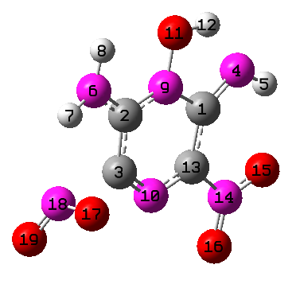 C 1.33730500 0.91674800 -0.06677900

C -1.12944100 1.09985700 0.03328800

C -1.12314900 -0.31977400 0.07524800

N 2.31721600 1.73224800 -0.15049500

H 3.21953300 1.27219000 -0.15239600

N -2.21578600 1.86660500 0.05213600

H -3.09230300 1.44819400 0.32474600

H -2.11059600 2.87098700 0.05714100

N 0.08471900 1.61793700 -0.05576200

N -0.08491200 -1.03820700 0.10295700

O 0.20421100 2.96376600 -0.10820300

H 1.21756100 3.02524400 -0.15334500

C 1.12614700 -0.49583800 0.03558100

N 2.25137700 -1.39540000 0.05358800

O 3.35974500 -0.87446800 -0.01374700

O 2.04687800 -2.58235700 0.13457600

O -2.58446200 -0.87745600 0.97337200

N -2.56348800 -1.07573000 -0.30582000

O -2.90427800 -2.10132700 -0.78804800

Frequencies[1/cm]

-889.13 61.85 87.63 99.81 114.54 143.11 147.45 221.85

242.04 285.59 312.49 330.59 361.72 372.30 374.23 441.34

456.75 497.91 529.22 534.27 630.88 660.16 676.97 725.77

731.45 734.76 741.57 782.98 806.89 860.87 953.25 1054.07

1128.66 1185.05 1256.19 1259.62 1328.52 1401.19 1411.14 1492.67

1551.38 1590.05 1628.17 1663.94 1684.55 1729.70 1753.52 2967.28

3601.59 3621.75 3731.26

**TS-IM7sa**

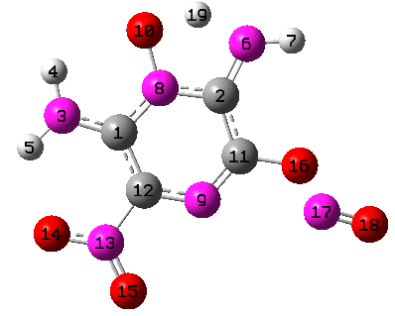 C -1.51589500 0.61340900 0.06138500

C 0.75905300 1.44281700 -0.12532300

N -2.78317100 0.99144900 0.22317500

H -2.97074000 1.98080200 0.29778900

H -3.49967200 0.28347700 0.26045600

N 1.34034200 2.60243400 -0.10549500

H 2.34050000 2.66745000 -0.21478500

N -0.60009100 1.60724900 0.01105500

N 0.34253700 -0.89450700 -0.23593000

O -0.94275700 2.89700600 0.13173800

C 1.18221900 0.08297100 -0.25799400

C -0.96207700 -0.67718500 -0.07231500

N -1.81182500 -1.84818800 -0.04815700

O -3.01774200 -1.65044000 0.09649700

O -1.30951000 -2.93537100 -0.16645900

O 2.51454300 -0.12682700 -0.41996300

N 3.01097300 -1.15749800 0.53840400

O 4.08252800 -1.44173200 0.27097100

H 0.24225200 3.24855200 0.03839200

Frequencies[1/cm]

-1417.84 49.50 65.44 85.85 97.63 141.92 162.31 218.62

254.60 276.90 290.01 341.63 362.60 384.40 410.24 464.44

474.21 512.64 537.49 566.53 605.27 617.45 641.34 703.47

718.79 737.53 745.12 781.40 789.53 879.20 966.08 1052.13

1081.46 1145.81 1193.11 1282.00 1343.31 1347.94 1404.75 1433.08

1537.12 1562.76 1630.06 1662.33 1702.11 1722.47 1936.12 2123.13

3590.62 3687.71 3730.71

**TS-IM7sb**

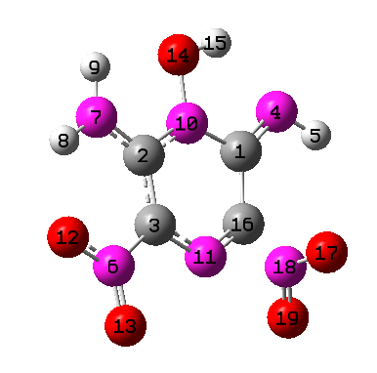 C 1.16247800 1.15127600 0.06016000

C -1.28839500 0.85016200 -0.05349800

C -1.07979500 -0.52909700 0.03886700

N 2.08101800 2.02653600 0.08619800

H 3.00650600 1.62810700 0.20508600

N -2.17189300 -1.45474200 0.03843400

N -2.44131700 1.51528600 -0.14512000

H -3.29387300 0.97337700 -0.14129800

H -2.43041100 2.52142400 -0.19184200

N -0.14621400 1.60080000 -0.05439800

N 0.16742100 -1.05706800 0.11930000

O -3.30744500 -0.97646100 -0.03338200

O -1.93510700 -2.63433700 0.10947700

O -0.30113700 2.95904100 -0.12046600

H 0.62707100 3.27830700 -0.05683200

C 1.16862100 -0.30482200 0.11299600

O 2.58442000 -0.84322100 0.99214000

N 2.62111300 -0.97528900 -0.28792100

O 3.15206300 -1.87939600 -0.83048400

Frequencies[1/cm]

-804.02 62.96 83.48 96.73 111.81 126.22 169.88 234.04

243.15 266.57 316.37 333.07 358.85 381.49 404.10 423.70

437.69 463.45 495.26 532.40 622.07 633.19 669.19 690.83

707.47 738.67 747.92 769.28 788.11 871.99 949.04 1096.35

1143.12 1191.04 1287.19 1293.29 1343.81 1370.21 1404.67 1480.82

1561.63 1585.75 1663.01 1686.21 1695.67 1709.80 1748.14 3515.66

3587.71 3608.90 3736.58

**2) Figure S2**. The potential energy profile including several unimportant pathways.



**Figure S2.** The potential energy profile of LLM-105 decomposition at the theoretical level of DLPNO-CCSD(T)/CBS//M06-2X-D3/6-311++G(d,p). The prefix “TS” denotes transition state while the suffix “i” and “s” denote that the stationary points were generated by the nitro-nitrate rearrangement and intramolecular H-shift, respectively. The suffix “a, b” stands for the sequence number. The highlighted parts denote NO2+products (red), OH+products (purple) and NO+products (blue). The pathways which are grey are unimportant channels that mentioned in the paper. Energies proposed in the previous work [16] were provided in parentheses. The energy unit is kcal/mol.

**3) Table S3** Rate coefficients (s-1) of various reaction channels for LLM-105 at 1-100 atm, 300-1500 K.

|  |  |  |  |  |  |  |
| --- | --- | --- | --- | --- | --- | --- |
| P=1atm | | | | | | |
|  | P1+NO2 | P2+NO | P3+NO2 | P5s+NO | P5ss+NO | P6sa+NO |
| 300 | 3.18E-34 | 3.82E-31 | 3.56E-50 | 4.21E-40 | 3.44E-45 | 1.32E-34 |
| 400 | 9.64E-22 | 4.47E-20 | 6.42E-36 | 1.62E-28 | 1.93E-33 | 1.76E-23 |
| 500 | 3.20E-14 | 2.18E-13 | 4.58E-27 | 2.43E-21 | 4.14E-26 | 9.89E-17 |
| 600 | 3.40E-09 | 6.59E-09 | 5.13E-21 | 2.02E-16 | 4.75E-21 | 3.46E-12 |
| 700 | 1.32E-05 | 1.06E-05 | 1.28E-16 | 7.94E-13 | 2.47E-17 | 6.53E-09 |
| 800 | 0.00627089 | 0.00271259 | 2.82E-13 | 4.34E-10 | 1.71E-14 | 1.98E-06 |
| 900 | 0.709572 | 0.199485 | 1.19E-10 | 6.11E-08 | 2.94E-12 | 0.000178333 |
| 1000 | 28.9678 | 6.07605 | 1.55E-08 | 3.25E-06 | 1.87E-10 | 0.0068223 |
| 1250 | 16887 | 2499.44 | 0.000102769 | 0.00404471 | 3.36E-07 | 5.27177 |
| 1500 | 765545 | 102513 | 0.0304026 | 0.360334 | 4.06E-05 | 385.538 |
|  | P6sb+OH | P7sa+NO | P7sb+OH | P8a+OH | P8b+NO2 |  |
| 300 | 6.26E-47 | 3.98E-34 | 8.89E-46 | 3.45E-34 | 4.01E-39 |  |
| 400 | 5.53E-34 | 6.57E-23 | 1.46E-32 | 4.26E-22 | 3.87E-25 |  |
| 500 | 7.78E-26 | 7.23E-16 | 3.52E-24 | 8.43E-15 | 9.74E-17 |  |
| 600 | 3.31E-20 | 5.20E-11 | 2.06E-18 | 6.48E-10 | 3.55E-11 |  |
| 700 | 4.46E-16 | 1.70E-07 | 3.27E-14 | 2.04E-06 | 2.95E-07 |  |
| 800 | 6.52E-13 | 7.48E-05 | 5.09E-11 | 0.000855619 | 2.33E-04 |  |
| 900 | 2.10E-10 | 0.00837798 | 1.63E-08 | 0.0920124 | 0.0386965 |  |
| 1000 | 2.30E-08 | 0.355029 | 1.68E-06 | 3.77755 | 2.19123 |  |
| 1250 | 0.000127915 | 259.968 | 0.00713067 | 2624.43 | 2384.02 |  |
| 1500 | 0.0374107 | 15337.5 | 1.53241 | 150087 | 1.54E+05 |  |
| P=10atm | | | | | | |
|  | P1+NO2 | P2+NO | P3+NO2 | P5s+NO | P5ss+NO | P6sa+NO |
| 300 | 3.18E-34 | 3.82E-31 | 3.56E-50 | 4.21E-40 | 3.44E-45 | 1.32E-34 |
| 400 | 9.64E-22 | 4.47E-20 | 6.42E-36 | 1.62E-28 | 1.93E-33 | 1.76E-23 |
| 500 | 3.20E-14 | 2.18E-13 | 4.57E-27 | 2.43E-21 | 4.13E-26 | 9.89E-17 |
| 600 | 3.40E-09 | 6.59E-09 | 5.13E-21 | 2.02E-16 | 4.75E-21 | 3.46E-12 |
| 700 | 1.32E-05 | 1.06E-05 | 1.28E-16 | 7.94E-13 | 2.47E-17 | 6.53E-09 |
| 800 | 0.00627129 | 0.00271267 | 2.82E-13 | 4.34E-10 | 1.71E-14 | 1.98E-06 |
| 900 | 0.709797 | 0.199524 | 1.19E-10 | 6.11E-08 | 2.95E-12 | 0.00017838 |
| 1000 | 29.0048 | 6.08171 | 1.55E-08 | 3.26E-06 | 1.87E-10 | 0.00683126 |
| 1250 | 17246.1 | 2548.37 | 0.00010672 | 0.00414424 | 3.46E-07 | 5.38943 |
| 1500 | 9.00E+05 | 120031 | 0.0390368 | 0.452739 | 5.12E-05 | 468.293 |
|  | P6sb+OH | P7sa+NO | P7sb+OH | P8a+OH | P8b+NO2 |  |
| 300 | 6.25E-47 | 3.98E-34 | 8.88E-46 | 3.45E-34 | 4.01E-39 | 6.25E-47 |
| 400 | 5.53E-34 | 6.57E-23 | 1.46E-32 | 4.26E-22 | 3.87E-25 | 5.53E-34 |
| 500 | 7.78E-26 | 7.23E-16 | 3.52E-24 | 8.43E-15 | 9.74E-17 | 7.78E-26 |
| 600 | 3.31E-20 | 5.20E-11 | 2.06E-18 | 6.48E-10 | 3.55E-11 | 3.31E-20 |
| 700 | 4.46E-16 | 1.70E-07 | 3.27E-14 | 2.04E-06 | 2.95E-07 | 4.46E-16 |
| 800 | 6.52E-13 | 7.48E-05 | 5.10E-11 | 0.000855669 | 2.33E-04 | 6.52E-13 |
| 900 | 2.10E-10 | 0.00838074 | 1.63E-08 | 0.0920414 | 0.0387152 | 2.10E-10 |
| 1000 | 2.31E-08 | 0.355523 | 1.68E-06 | 3.78262 | 2.19524 | 2.31E-08 |
| 1250 | 0.000132895 | 266.221 | 0.00738975 | 2686.54 | 2446.9 | 0.000132895 |
| 1500 | 0.048038 | 18360.2 | 1.94847 | 179334 | 1.85E+05 | 0.048038 |
| P=100atm | | | | | | |
|  | P1+NO2 | P2+NO | P3+NO2 | P5s+NO | P5ss+NO | P6sa+NO |
| 300 | 3.18E-34 | 3.82E-31 | 3.54E-50 | 4.19E-40 | 3.42E-45 | 1.31E-34 |
| 400 | 9.64E-22 | 4.47E-20 | 6.40E-36 | 1.62E-28 | 1.92E-33 | 1.76E-23 |
| 500 | 3.20E-14 | 2.18E-13 | 4.57E-27 | 2.42E-21 | 4.13E-26 | 9.88E-17 |
| 600 | 3.40E-09 | 6.59E-09 | 5.12E-21 | 2.02E-16 | 4.75E-21 | 3.46E-12 |
| 700 | 1.32E-05 | 1.06E-05 | 1.28E-16 | 7.93E-13 | 2.46E-17 | 6.53E-09 |
| 800 | 0.00627133 | 0.00271268 | 2.82E-13 | 4.34E-10 | 1.71E-14 | 1.98E-06 |
| 900 | 0.709819 | 0.199528 | 1.19E-10 | 6.11E-08 | 2.95E-12 | 0.000178368 |
| 1000 | 29.0086 | 6.08227 | 1.55E-08 | 3.26E-06 | 1.87E-10 | 0.00683168 |
| 1250 | 17283.3 | 2553.34 | 0.000107096 | 0.00415713 | 3.47E-07 | 5.40806 |
| 1500 | 9.17E+05 | 122247 | 0.040139 | 0.464429 | 5.29E-05 | 478.627 |
|  | P6sb+OH | P7sa+NO | P7sb+OH | P8a+OH | P8b+NO2 |  |
| 300 | 6.21E-47 | 3.98E-34 | 8.84E-46 | 3.45E-34 | 4.01E-39 |  |
| 400 | 5.51E-34 | 6.57E-23 | 1.46E-32 | 4.26E-22 | 3.87E-25 |  |
| 500 | 7.77E-26 | 7.23E-16 | 3.52E-24 | 8.43E-15 | 9.74E-17 |  |
| 600 | 3.31E-20 | 5.20E-11 | 2.06E-18 | 6.48E-10 | 3.55E-11 |  |
| 700 | 4.46E-16 | 1.70E-07 | 3.27E-14 | 2.04E-06 | 2.95E-07 |  |
| 800 | 6.52E-13 | 7.48E-05 | 5.09E-11 | 0.000855674 | 2.33E-04 |  |
| 900 | 2.10E-10 | 0.00838099 | 1.63E-08 | 0.0920443 | 0.0387171 |  |
| 1000 | 2.31E-08 | 0.355571 | 1.68E-06 | 3.78313 | 2.19565 |  |
| 1250 | 0.000133303 | 266.869 | 0.0074163 | 2692.98 | 2453.43 |  |
| 1500 | 0.0494076 | 18744.2 | 2.00185 | 183048 | 1.89E+05 |  |

**4)** **Table S4.** The computed RRKM/ME rate coefficients (s-1) of various reaction channels in the format of k=A·Tn·exp(-Ea/RT) at 1atm, 300-1500K.

|  |  |  |  |  |  |  |
| --- | --- | --- | --- | --- | --- | --- |
|  | A (s-1) | | | n | Ea (kcal/mol) | |
| R —> P1 + NO2 | | 2.55E45 | -8.75 | | | 80.32 |
| R —> P2 + NO | | 7.43E25 | -3.58 | | | 64.85 |
| R —> P3 + NO2 | | 1.03E6 | 1.35 | | | 80.83 |
| R —> P5s + NO | | 4.08E9 | -0.09 | | | 66.90 |
| R —> P5ss + NO | | 4.13E3 | 0.67 | | | 69.38 |
| R —> P6sa + NO | | 2.77E8 | 0.97 | | | 61.11 |
| R —> P6sb + OH | | 4.52E-5 | 4.27 | | | 72.77 |
| R —> P7sa + NO | | 3.67E22 | -2.67 | | | 67.77 |
| R —> P7sb + OH | | 1.51E8 | 1.03 | | | 76.97 |
| R —> P8a + OH | | 1.97E28 | -4.01 | | | 70.95 |
| R —> P8b + NO2 | | 2.58E45 | -8.73 | | | 85.53 |

**5) Figure S5.** Branching ratio of different channels at 10, 100atm, 300-1500K.



**Figure S5.1** The branching ratio of three kinds of reaction pathways are presented at 10 atm in 300-1500 K.



**Figure S5.2** The branching ratio of three kinds of reaction pathways are presented at 100 atm in 300-1500 K.

1. * Corresponding author:

   Feng Zhang

   Hefei National Laboratory for Physical Sciences at the Microscale, University of Science and Technology of China

   Hefei, Anhui 230029, China

   E-mail: [feng2011@ustc.edu.cn](mailto:feng2011@ustc.edu.cn) (FZ).