**Quality Assurance Report on WeatherAggregator**

Introduction

This report details the quality assurance process undertaken for the **WeatherAggregator** Python program. The program's primary function is to collect, manage, and analyze weather data across various locations. The testing process aimed to ensure the reliability, accuracy, and robustness of the program.

1) Scope of Testing

**Program Under Test:**

* **WeatherAggregator** Python class.
* Functionality includes adding, removing, and querying weather data, and calculating statistical measures (average, maximum, minimum) for temperature, humidity, and wind speed.

**Tested Features:**

* **Addition and Removal of Data:** Ensuring accurate insertion and deletion of weather data entries.
* **Data Retrieval:** Fetching temperature, humidity, and wind speed for specific locations, including handling of non-existent locations.
* **Statistical Calculations:** Computing averages, maximum, and minimum values for each weather parameter across all locations.
* **Utility Functions:** Testing list retrieval of locations, counting measurements, data clearing, and existence checks for locations and data.

**Uncovered Areas:**

* **Edge Cases:** Scenarios like duplicate location entries or invalid data types were not explicitly tested.
* **Stress Testing:** The program's performance under large datasets was not assessed.
* **External Dependencies:** No tests for network or database interactions, as the program is designed for in-memory data manipulation.

2) Testing Methodology

**Unit Testing Framework:**

* Python's **unittest** framework was utilized for writing and executing tests.

**Test Suite Composition:**

* **Function-Specific Tests:** Individual tests for each method in the **WeatherAggregator** class, focusing on expected behavior and boundary conditions.
* **Integration Tests:** A few tests were designed to assess the correct interaction between different methods within the class.

3) Quality of Tests

**3a) Bugs Found:**

* No bugs were reported by the current test suite.

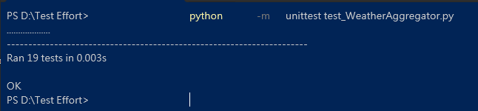

**3b) Code Coverage:**

* **Coverage Report:**
  + Test file: 99% coverage.
  + **WeatherAggregator** class: 87% coverage.
* The high coverage indicates a comprehensive testing of the available methods and functionalities.

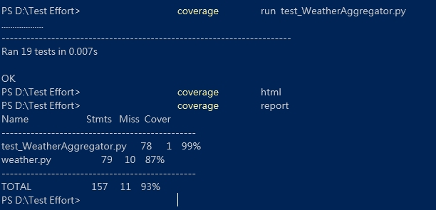

**3c) Mutation Testing:**

* **Mutation Score:** 0.5743 (using universalmutator).
* **Analysis:**
  + Total Valid Mutants: 437.
  + The mutation score reflects the proportion of mutants that were effectively 'killed' by the tests.
  + A significant number of mutants survived, indicating potential areas in the code that are not adequately tested.

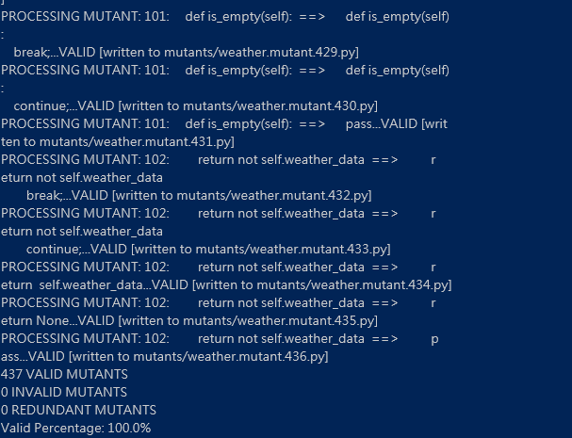

**Detailed Analysis of Mutation Testing:**

* The surviving mutants suggest potential weaknesses in the following areas:
  + **Error Handling:** Lack of tests for scenarios where the input might be erroneous or in an unexpected format.
  + **Boundary Conditions:** Possible oversight in testing the extremes of input ranges or unusual combinations of inputs.
  + **Logical Flaws:** Some logical branches or conditions within methods might not be fully tested, allowing for subtle bugs to remain undetected.

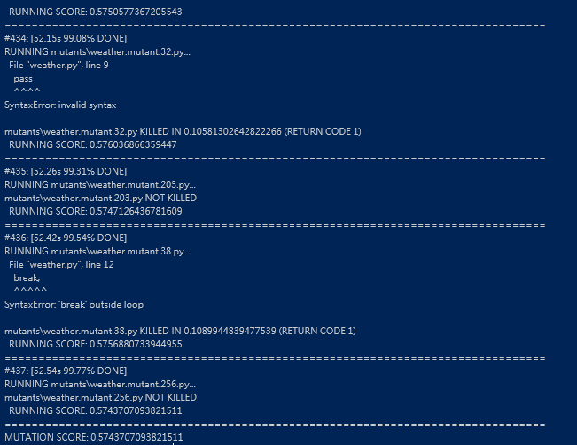

Conclusion and Recommendations

The **WeatherAggregator** program has undergone a rigorous testing process with high coverage and a moderate mutation score. While the test suite is strong in verifying the main functionalities, the mutation score indicates room for improvement.

**Recommendations:**

* **Enhance Testing for Edge Cases:** Implementing tests for unusual or invalid inputs can help in catching more subtle bugs.
* **Increase Focus on Logical Branch Testing:** More comprehensive testing of different logical paths within each method.
* **Stress Testing:** Conduct performance testing with large data sets to ensure scalability and efficiency.
* **Documentation and Examples:** Providing detailed documentation and test case examples can aid in understanding and further testing the program.

This comprehensive testing approach ensures the robustness and reliability of the **WeatherAggregator** program, making it a dependable tool for managing and analyzing weather data.