RETRAINING THE THROTTLES
Step by step. Do them in order. Each line says what to do and what you should see happen.
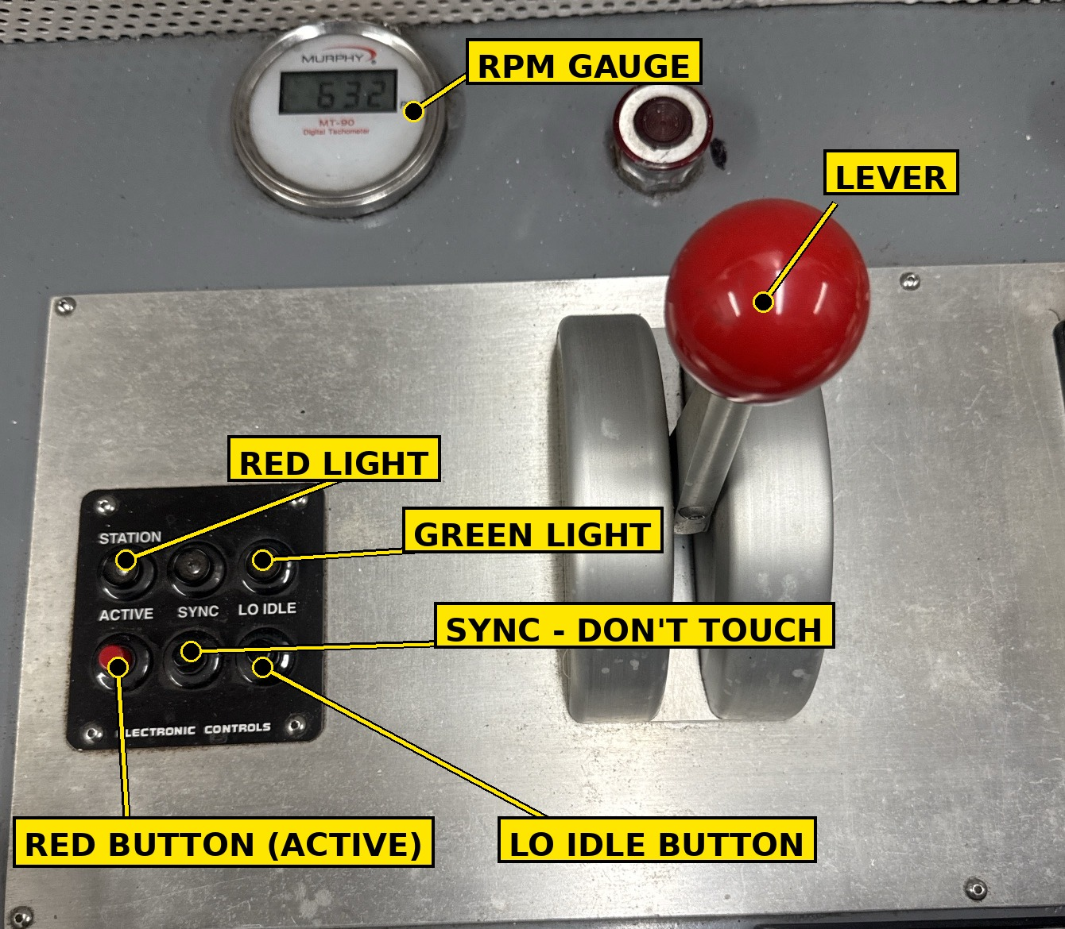 | THE ONLY THINGS YOU TOUCH  RED BUTTON — the one marked ACTIVE. Always a quick push, never held.  LO IDLE BUTTON — the one on the right. Always held down until you're told to let go.  THE LEVER — the red ball. You park it, then leave it alone while you push buttons.  SYNC — the middle button. Never touch it.  WHAT THIS DOES  The box that runs the engine has to learn where the lever sits at idle and at full. You park the lever in 4 spots and push the same two buttons at each one. That's it.

GET READY
# | DO THIS | YOU'LL SEE
1 | Boat tied up good — bow, stern and spring lines. | —
2 | Engine OFF. Key ON. (Don't start it.) | Panel has power. Engine is not running.
3 | Push the RED button (ACTIVE) once. | The RED light comes on and stays on.
LEVER SPOT 1 OF 4 — FORWARD IDLE
4 | Push the lever ahead to the FIRST NOTCH. Stop there. | Lever is at FORWARD IDLE.
5 | Push the LO IDLE button and HOLD IT DOWN. Don't let go. | After about 2 seconds the GREEN light starts flashing.
6 | Still holding LO IDLE, push the RED button (ACTIVE) once. Now let go of both buttons. | The GREEN light stops flashing. That reading is saved.
LEVER SPOT 2 OF 4 — FULL AHEAD
7 | Push the lever ALL THE WAY AHEAD. As far as it goes. | Lever is at FULL AHEAD.
8 | Push the LO IDLE button and HOLD IT DOWN. Don't let go. | After about 2 seconds the GREEN light starts flashing.
9 | Still holding LO IDLE, push the RED button (ACTIVE) once. Now let go of both buttons. | The GREEN light stops flashing. That reading is saved.
LEVER SPOT 3 OF 4 — ASTERN IDLE
10 | Pull the lever back through neutral to the FIRST NOTCH going astern. Stop there. | Lever is at ASTERN IDLE.
11 | Push the LO IDLE button and HOLD IT DOWN. Don't let go. | After about 2 seconds the GREEN light starts flashing.
12 | Still holding LO IDLE, push the RED button (ACTIVE) once. Now let go of both buttons. | The GREEN light stops flashing. That reading is saved.
LEVER SPOT 4 OF 4 — FULL ASTERN
13 | Pull the lever ALL THE WAY BACK. As far as it goes. | Lever is at FULL ASTERN.
14 | Push the LO IDLE button and HOLD IT DOWN. Don't let go. | After about 2 seconds the GREEN light starts flashing.
15 | Still holding LO IDLE, push the RED button (ACTIVE) once. Now let go of both buttons. | The GREEN light stops flashing. That reading is saved.
SAVE IT
16 | Put the lever back in NEUTRAL. Turn the key OFF. | Lights go out.
17 | Count to FIVE out loud. Then turn the key ON. | Panel comes back on.
18 | Now go back to step 3 and do every step again on the OTHER engine's lever. | —
19 | If the boat has another set of sticks (another steering station), do it all again there too. | —
CHECK IT — captain or pilot at the sticks for this part. The boat will push on the lines.
20 | Start the engine. Lever in NEUTRAL. Push the RED button once. | RED light on. Engine idling. RPM gauge shows normal idle.
21 | SLOWLY push the lever to full ahead, then SLOWLY back to neutral. | RPM climbs smooth, no jumps. Comes back to idle. No alarms.
22 | SLOWLY pull the lever to full astern, then SLOWLY back to neutral. | Same thing. Smooth, no alarms, back to idle.
23 | Smooth both ways, no alarms, idle came back where it was? DONE. Anything else? Go back to step 3 and do that lever over. | —
Dead band (optional): if the pilots want a little lever travel before the rpm starts to climb, push the lever a hair past the idle notch before you hold LO IDLE at spots 1 and 3. If nobody asked for it, don't.

