1. Run the clockers program

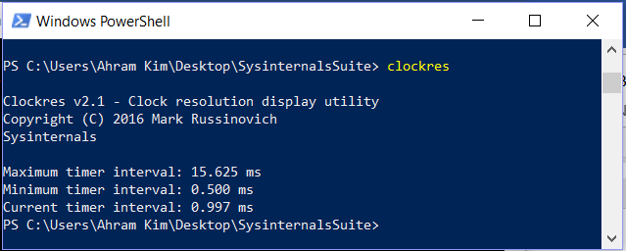

1. Startup the process explorer procexp

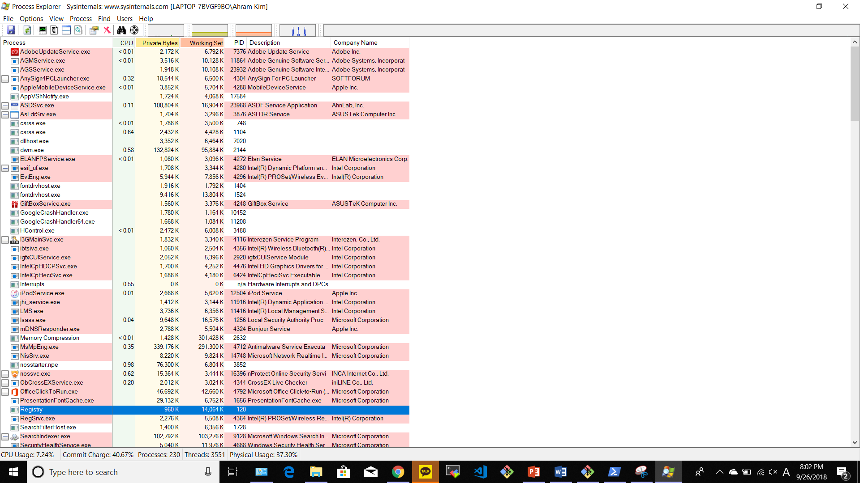

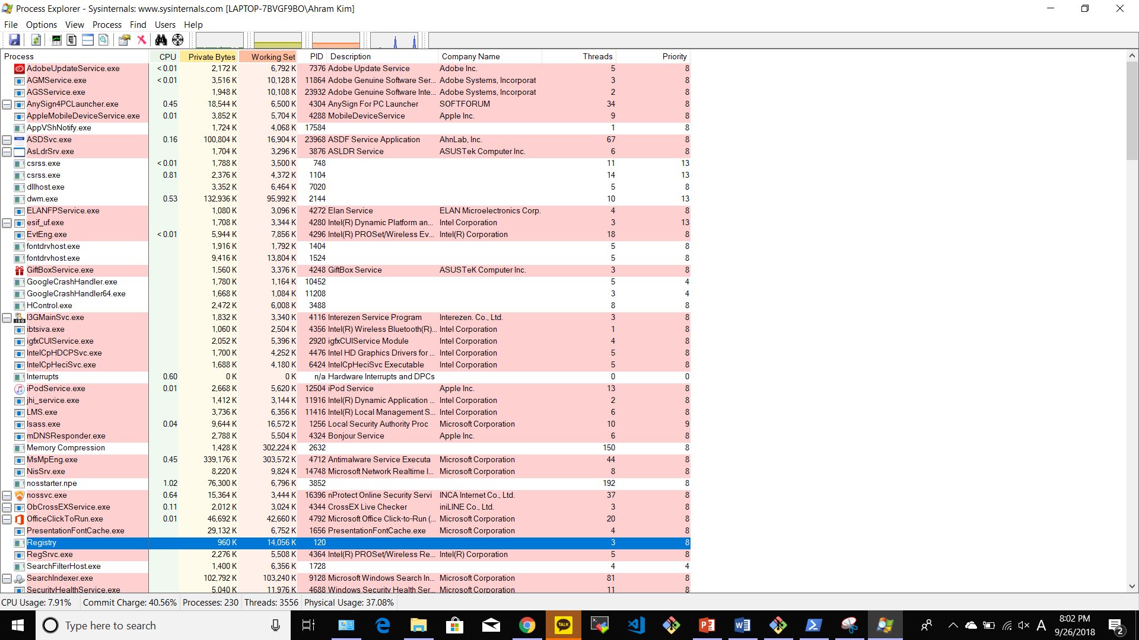

1. Find notepad in the process explorer

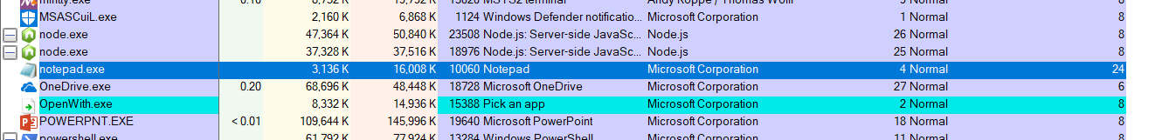

1. Check the priority of notepad (powershell)

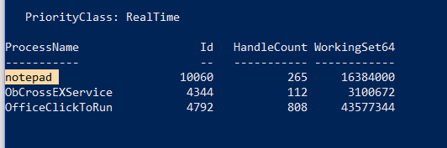

1. Check the priority of notepad (task namager)

