# Midterm 1 – Example of a Git Merge Conflict and its Resolution with a 3-way-merge

# GIT_VISUALIZATION_ALL_BRANCHES after completing Step 3 *:*

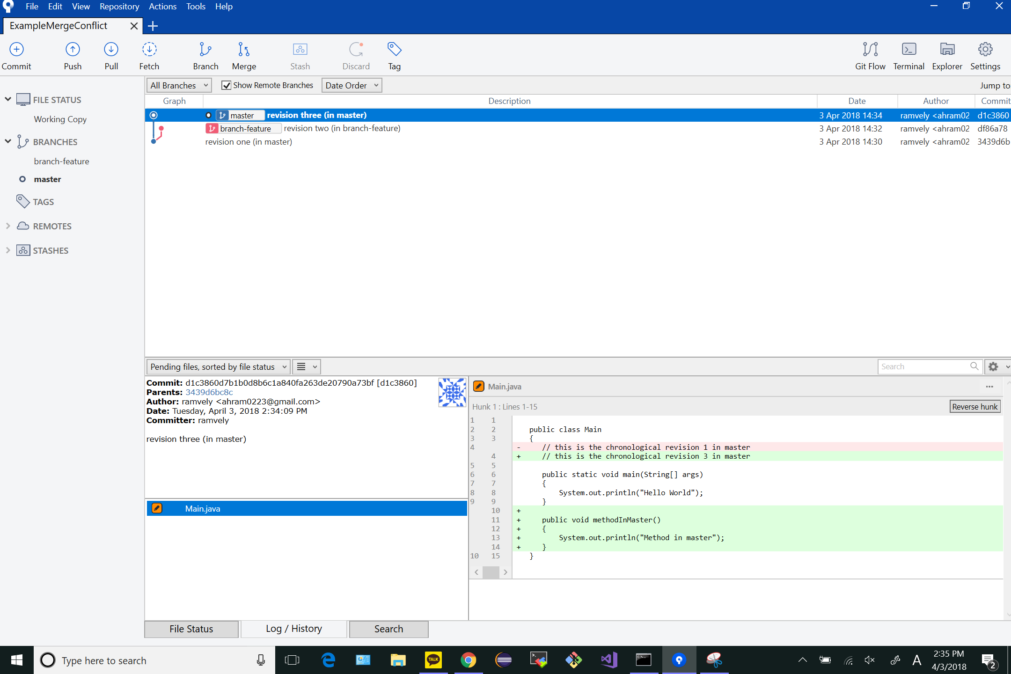

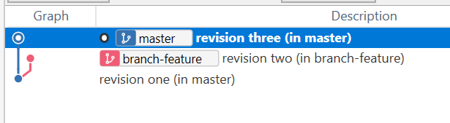

# GIT_COMMAND_LINE_OUTPUT after completing Step 4 *:*

# 

# GIT_MERGE_CONFLICT_VISUALIZATION after completing Step 5:

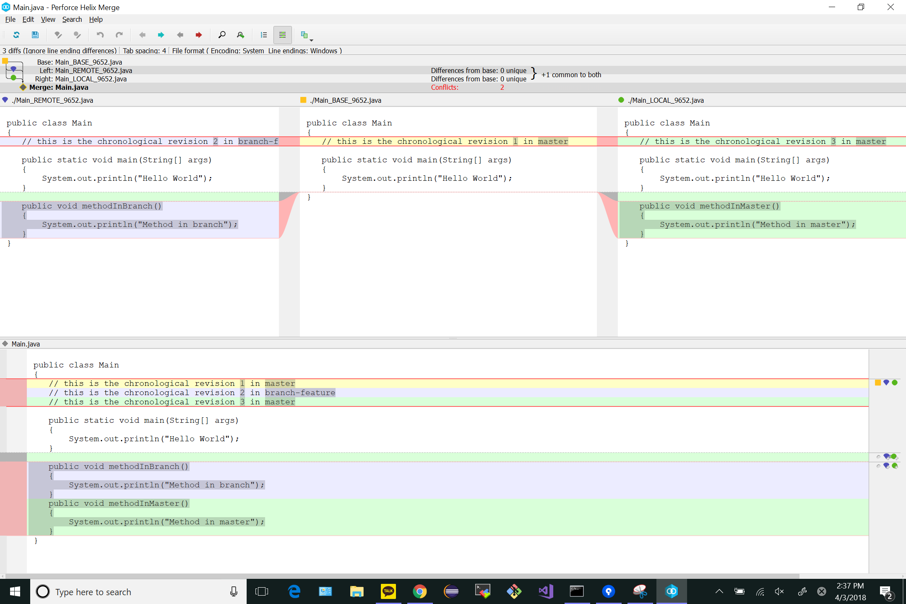

# GIT_MERGE_CONFLICT_VISUALIZATION after completing Step 6:

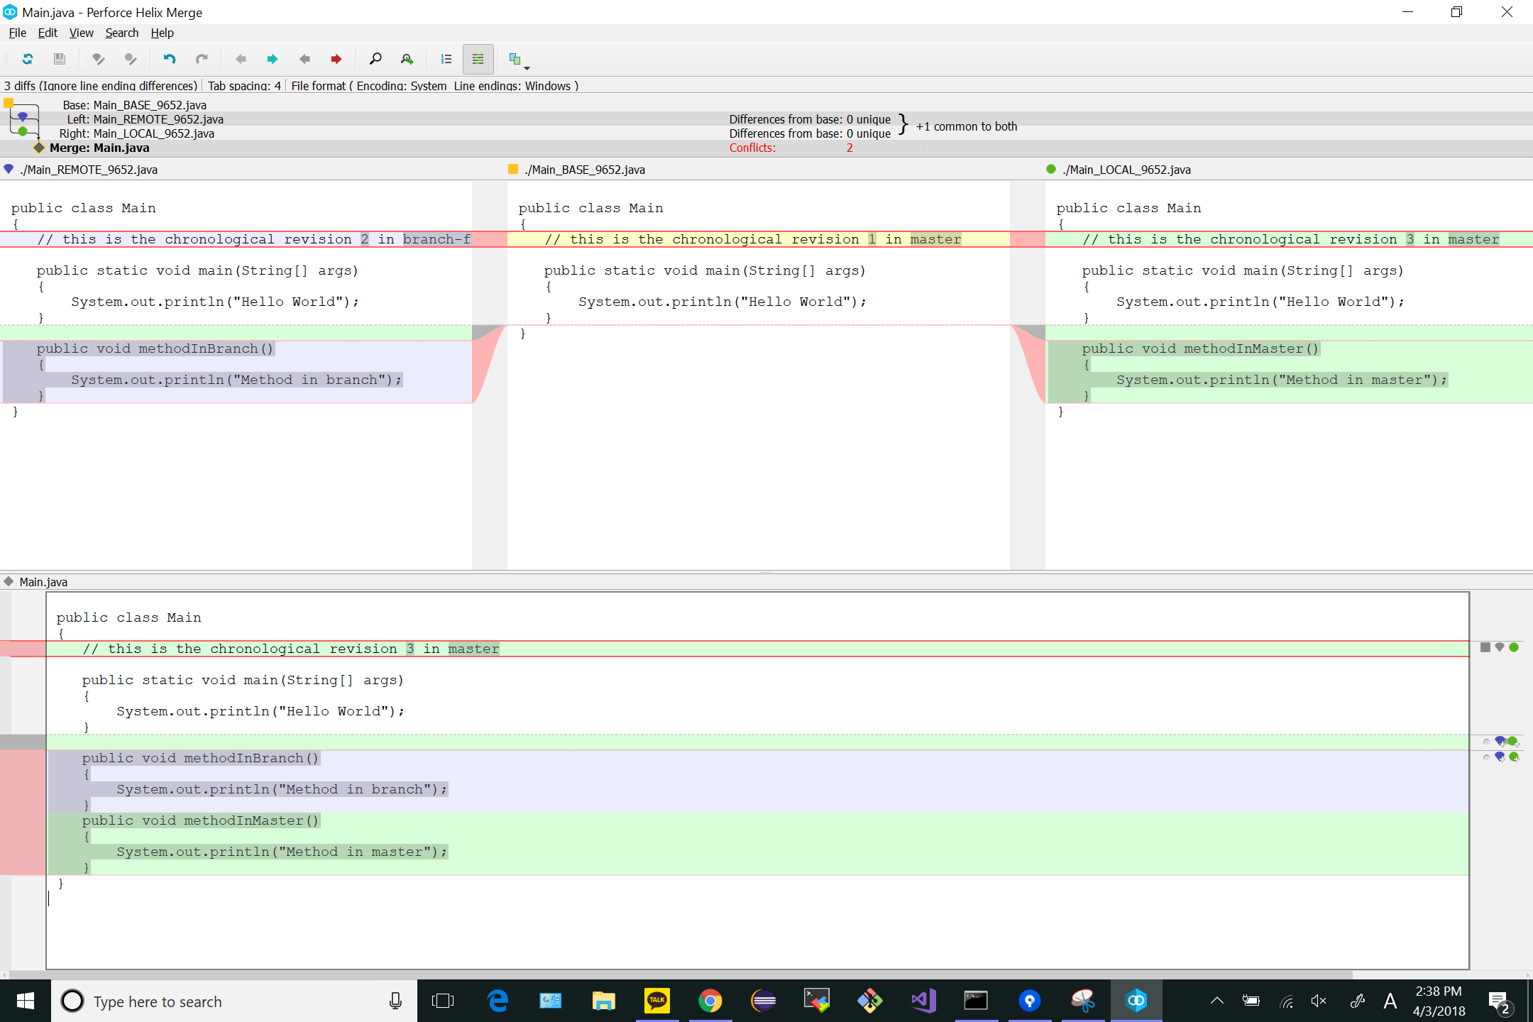

# GIT_COMMAND_LINE_OUTPUT after completing Step 8:

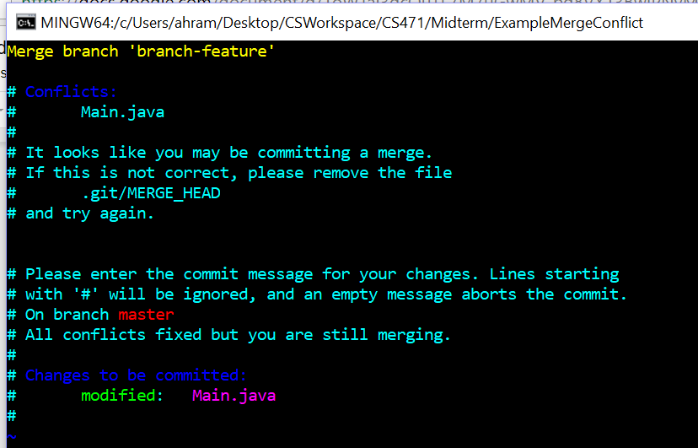

# GIT_CISUALIZATION_ALL_BRALNCHES after Step 8:

