# Midterm 1 – Git Rebase Example with Two Merge Conflicts

# GIT_VISUALIZATION_ALL_BRANCHES after completing Step 6*:*

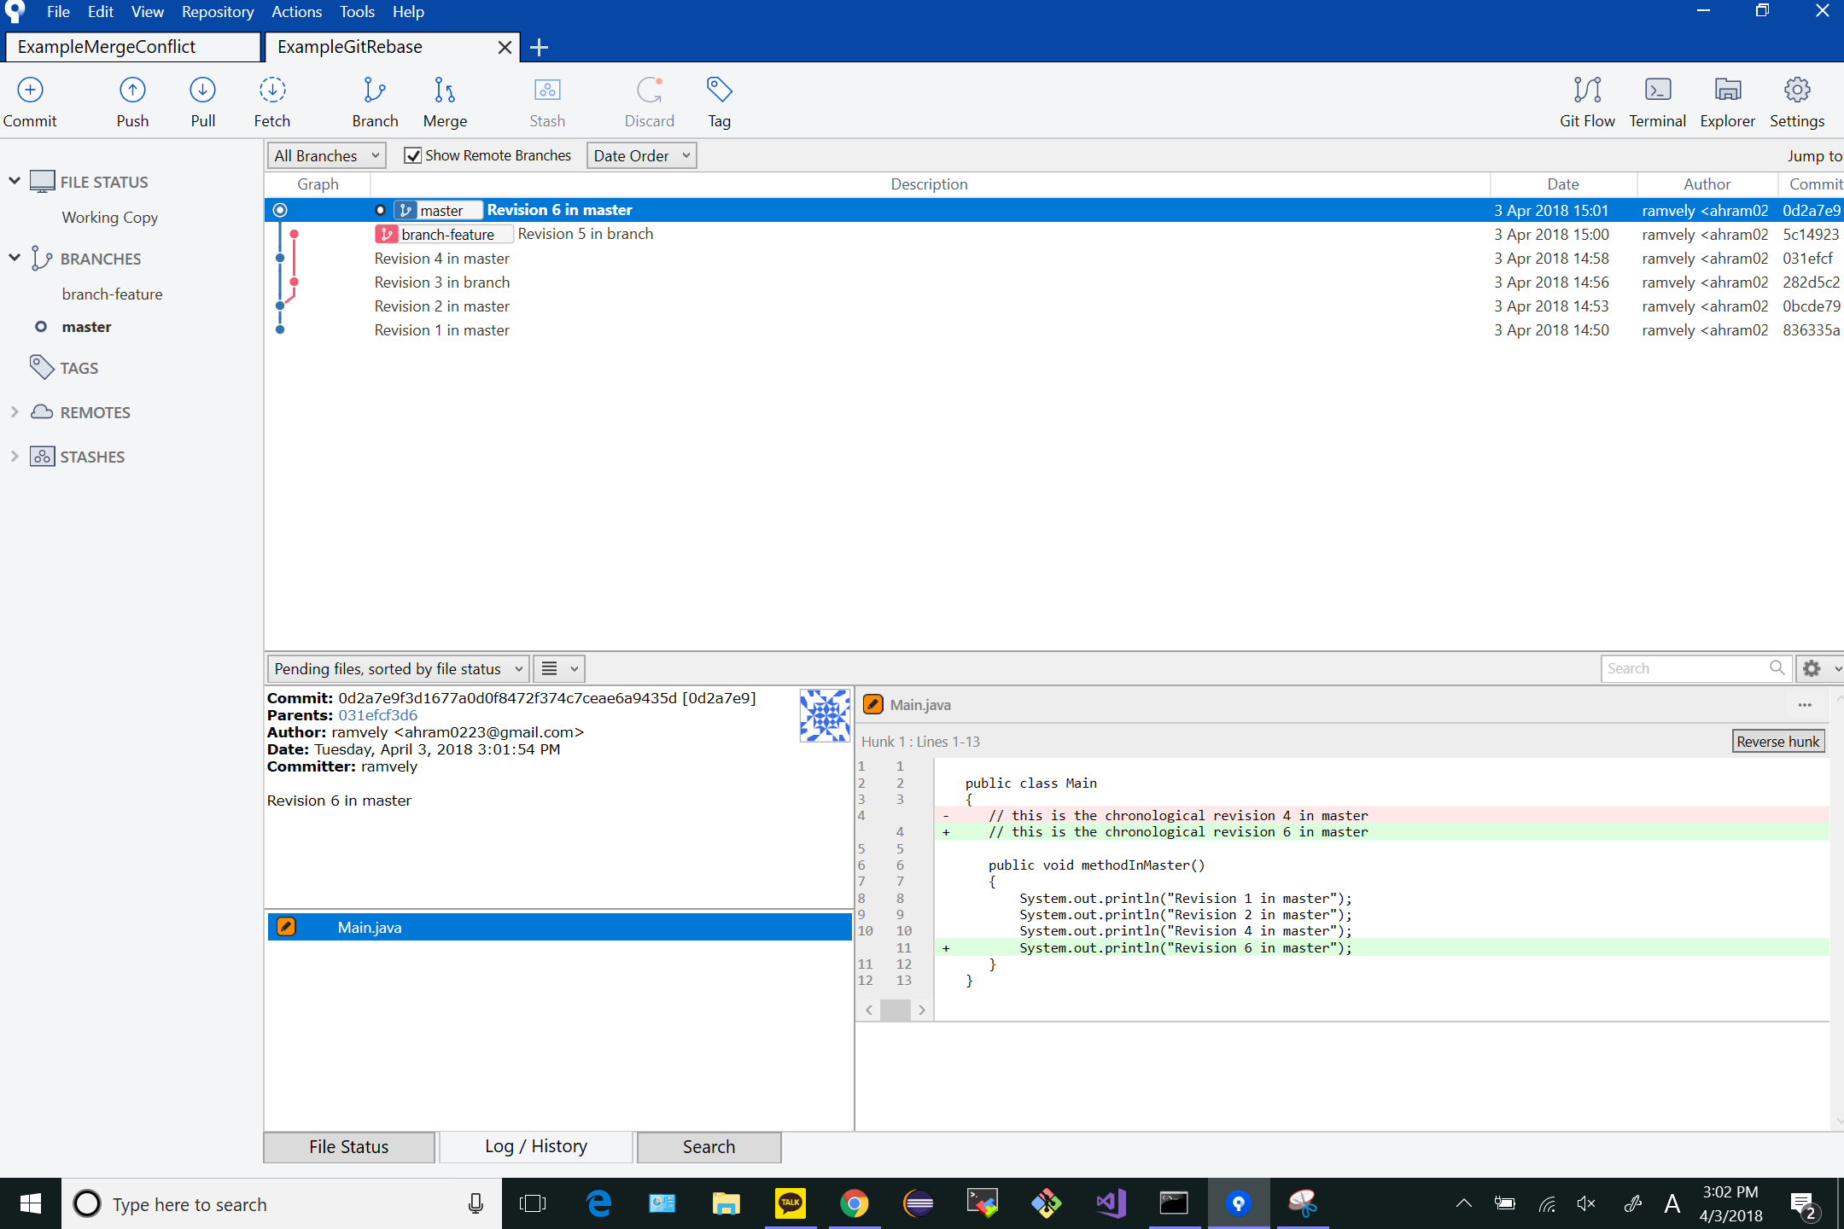

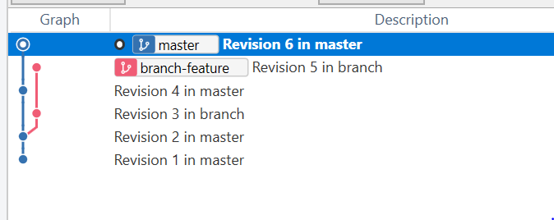

# GIT_COMMAND_LINE_OUTPUT after completing Step 7*:*

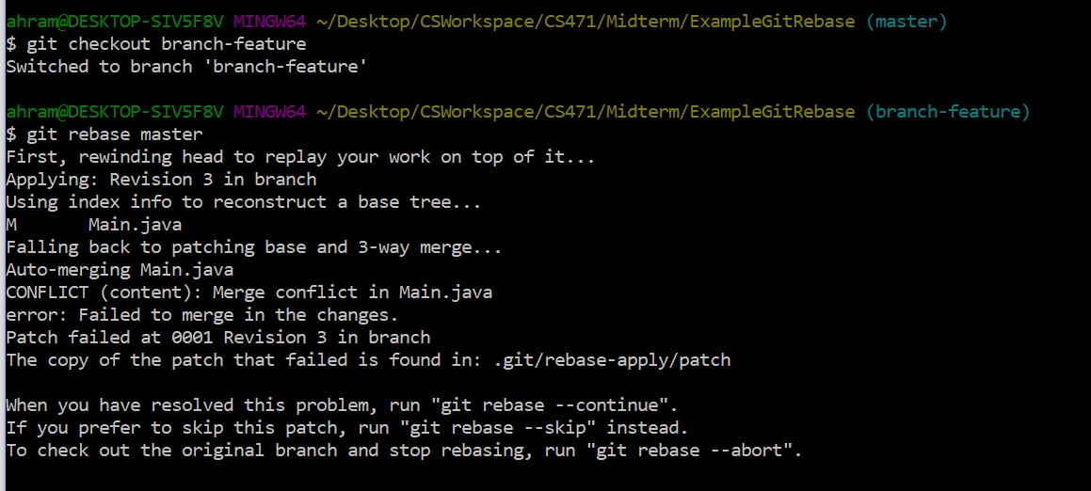

# GIT_MERGE_CONFLICT_VISUALIZATION after completing Step 9:

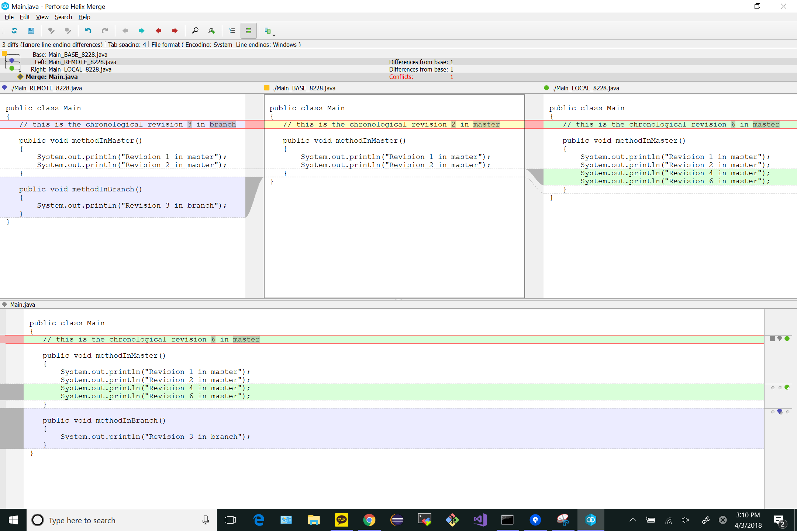

# GIT_COMMAND_LINE_OUTPUT after completing Step 10:

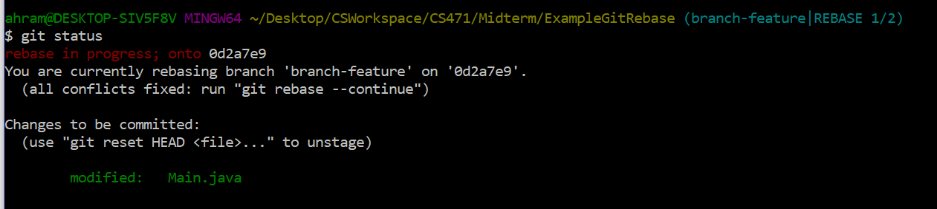

# GIT_COMMAND_LINE_OUTPUT after completing Step 11:

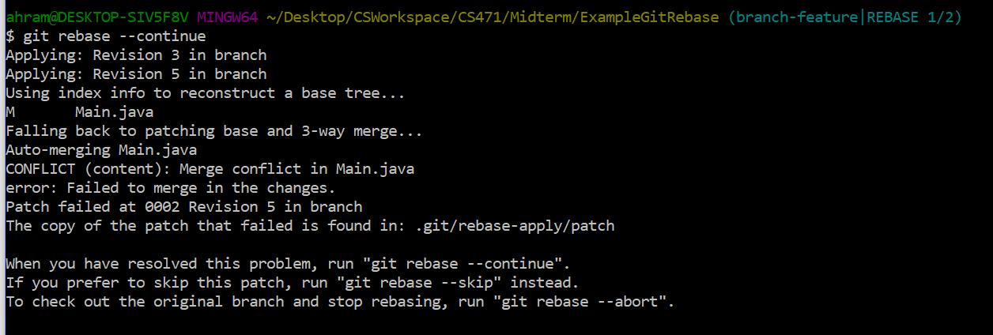

# GIT_MERGE_CONFLICT_VISUALIZATION after completing Step 12:

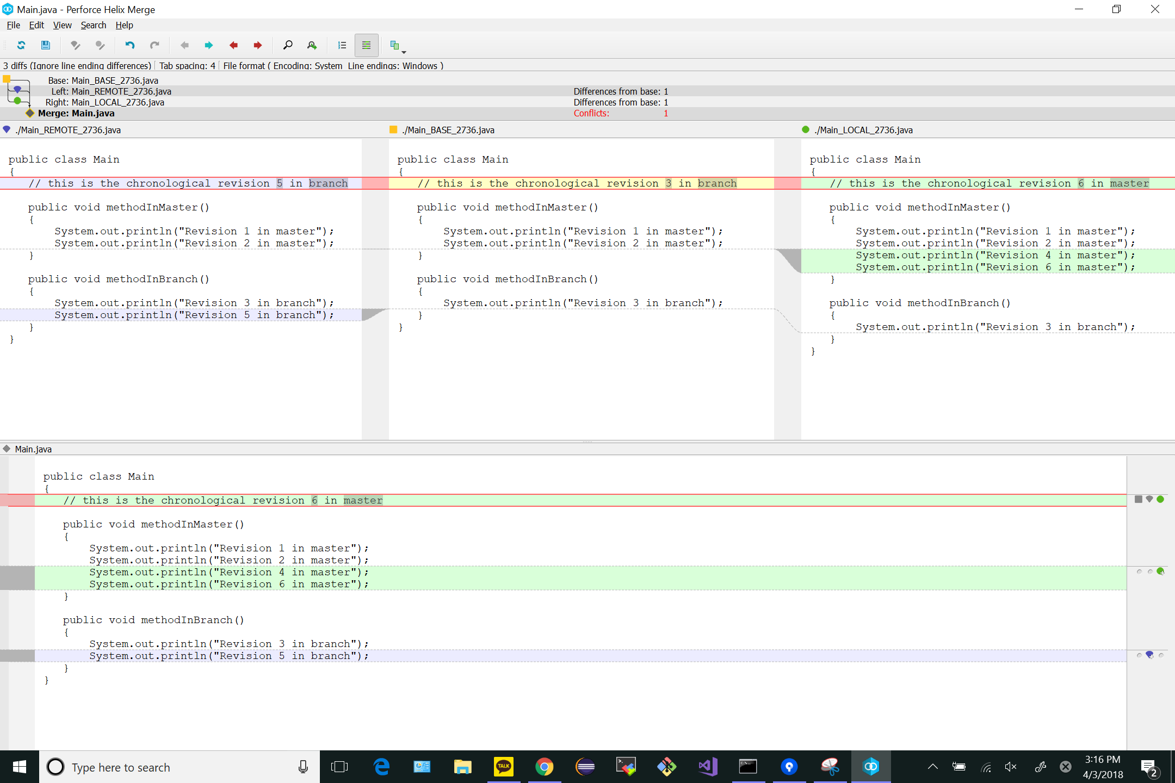

# GIT_COMMAND_LINE_OUTPUT after completing Step 13:

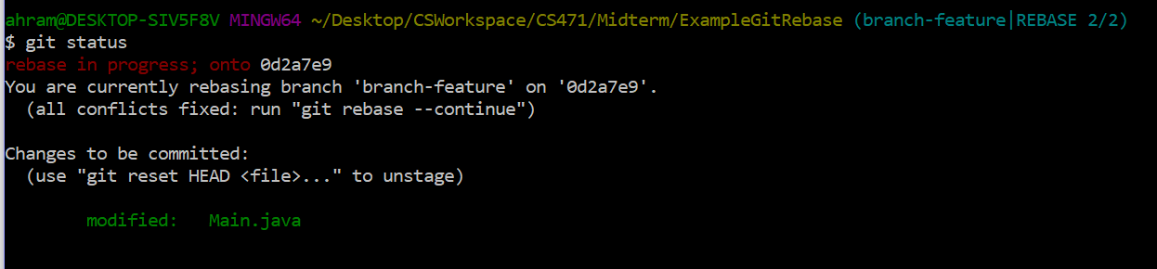

# GIT_VISUALIZATION_ALL_BRANCHES after completing Step 14:

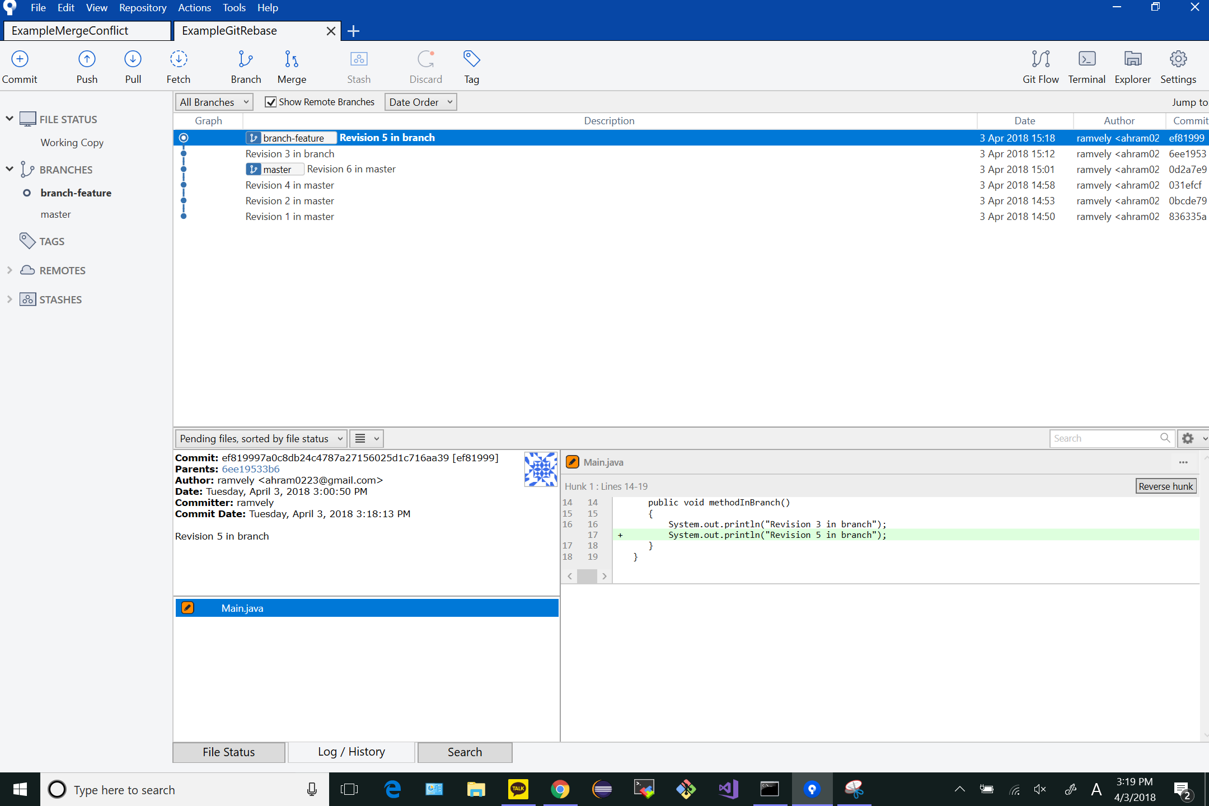

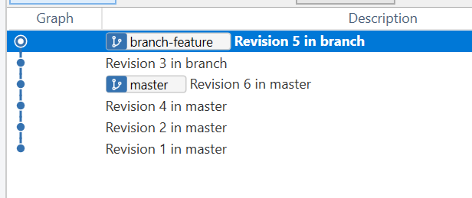

# GIT_VISUALIZATION_ALL_BRANCHES after completing Step 15:

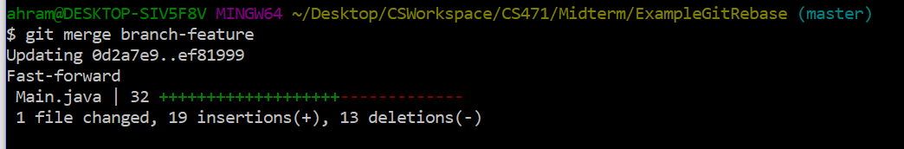

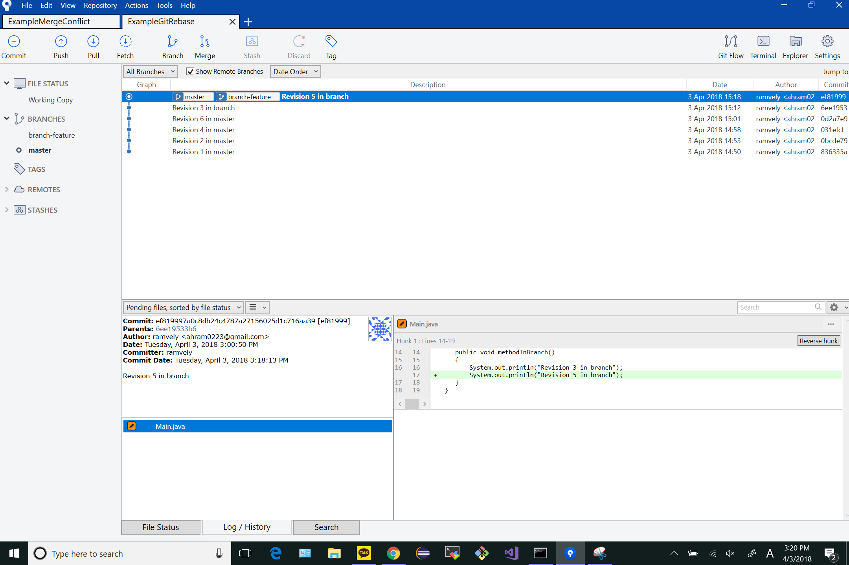

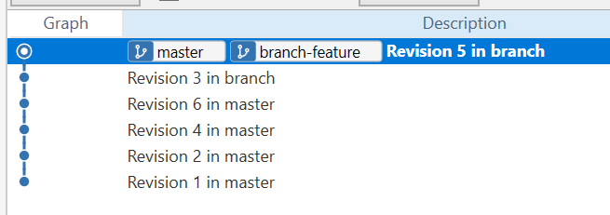

# GIT_VISUALIZATION_ALL_BRANCHES after completing Step 16:

