# Midterm 1 – Git Squash Example on a Branch Containing Multiple Related Commits, and Integrating the Resulting Commit into the Shared/Integration Branch

# GIT_VISUALIZATION_ALL_BRANCHES after completing Step 5*:*

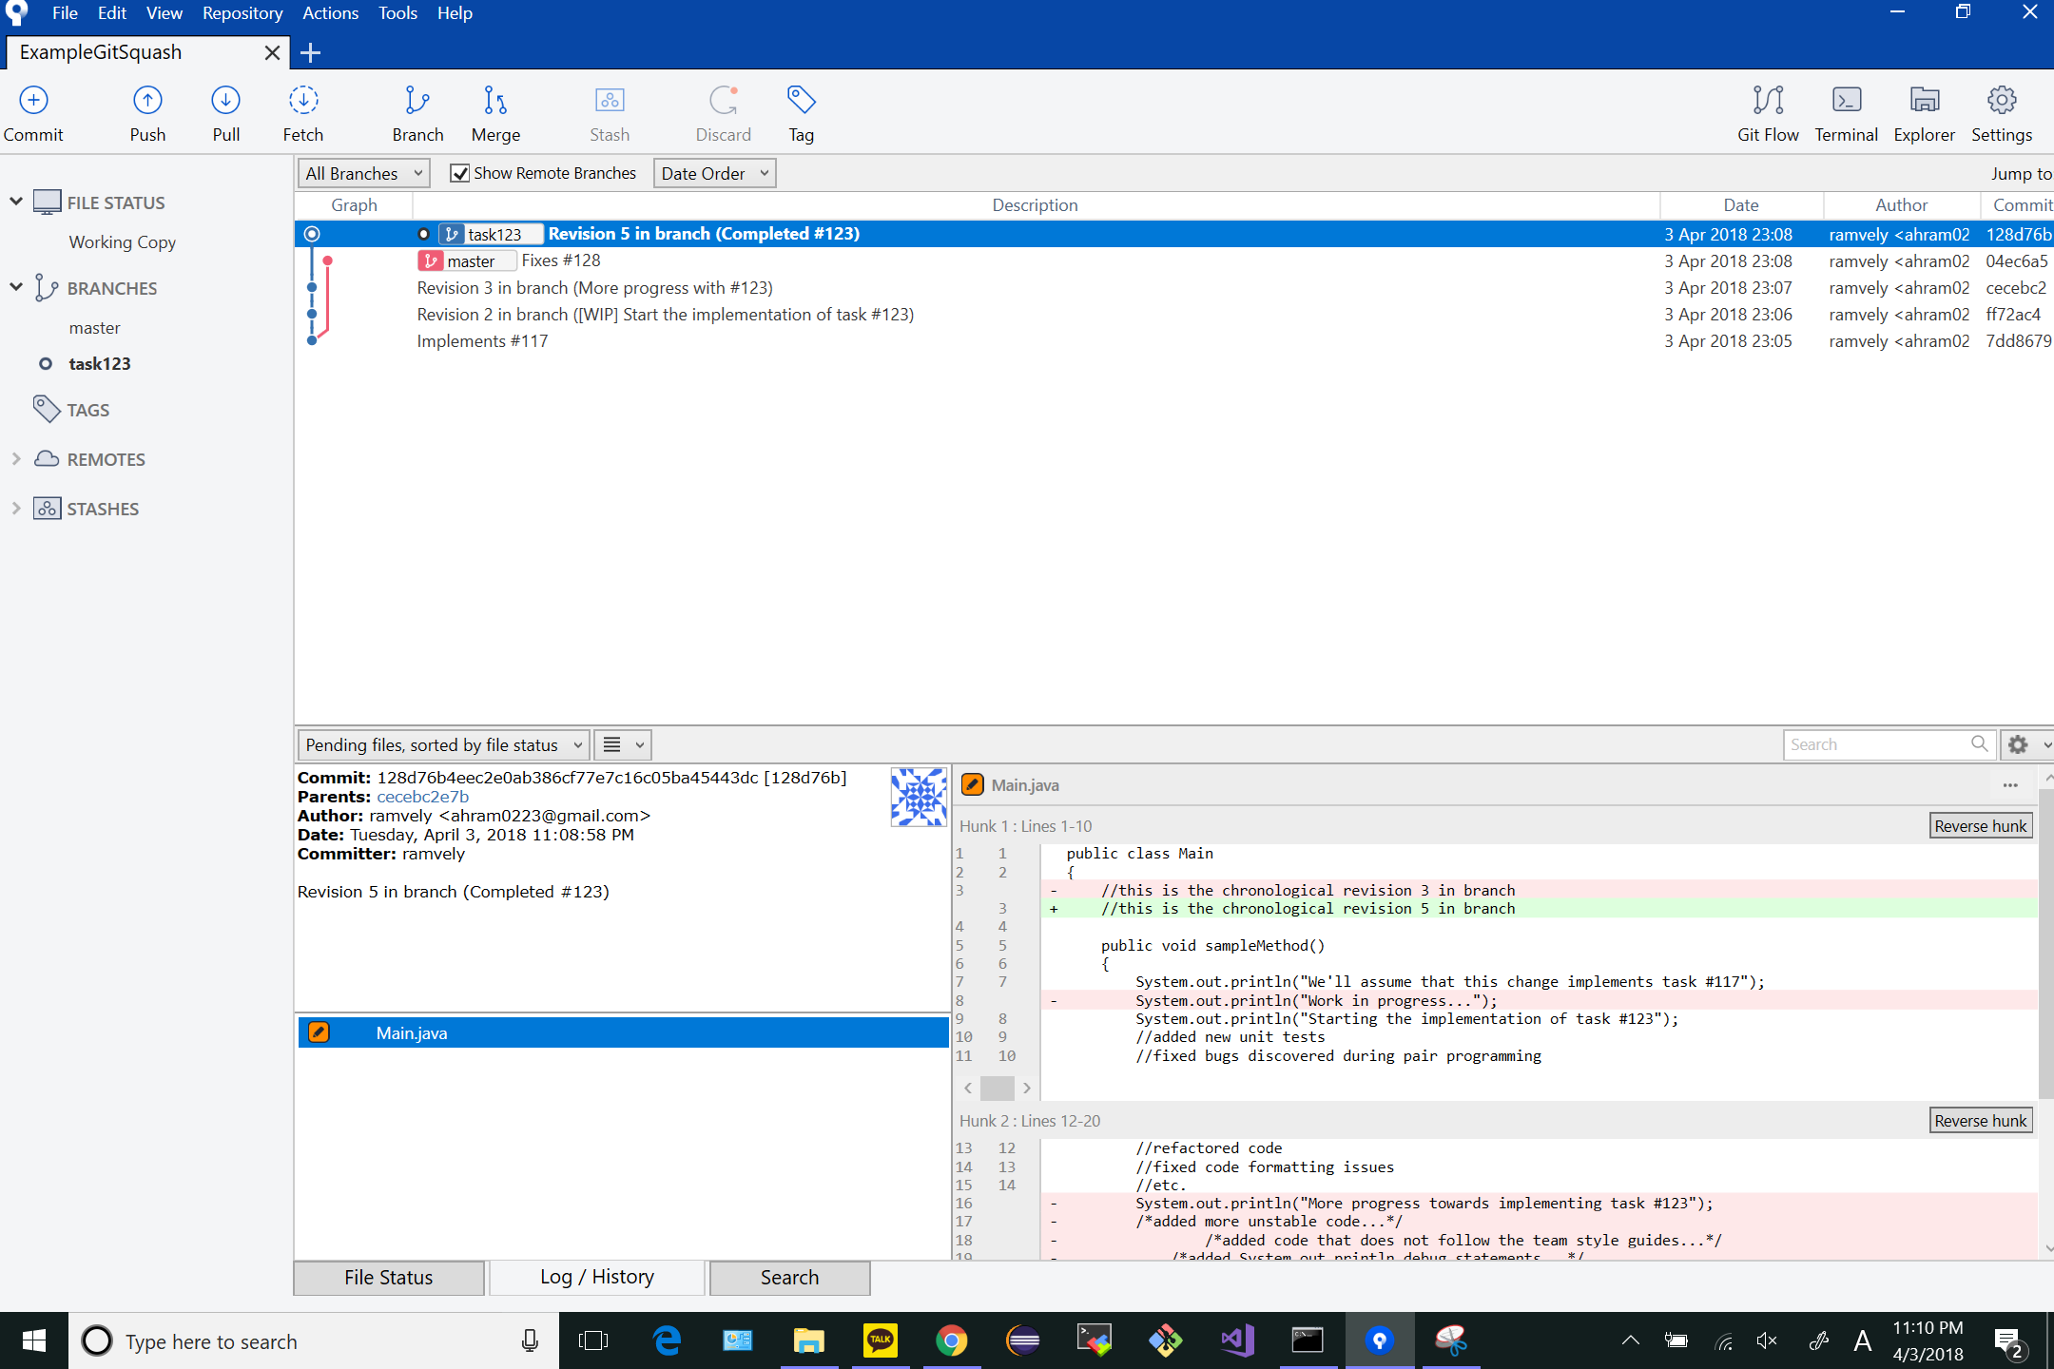

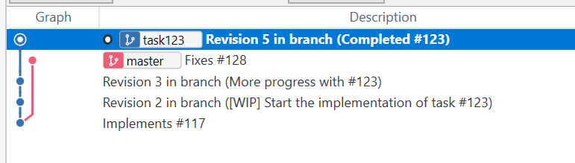

# GIT_COMMAND_LINE_OUTPUT after completing Step 7*:*

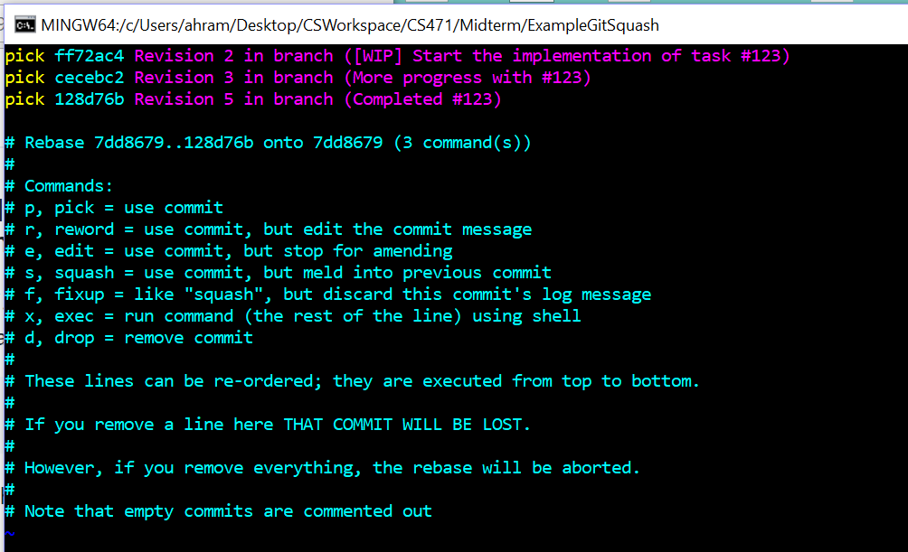

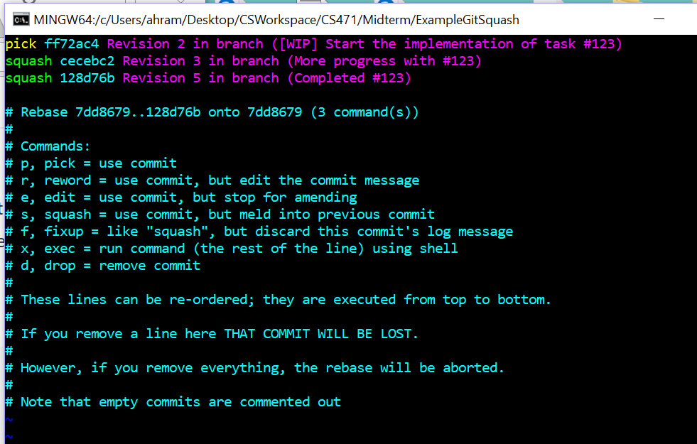

# GIT_VISUALIZATION_ALL_BRANCHES after completing Step 8:

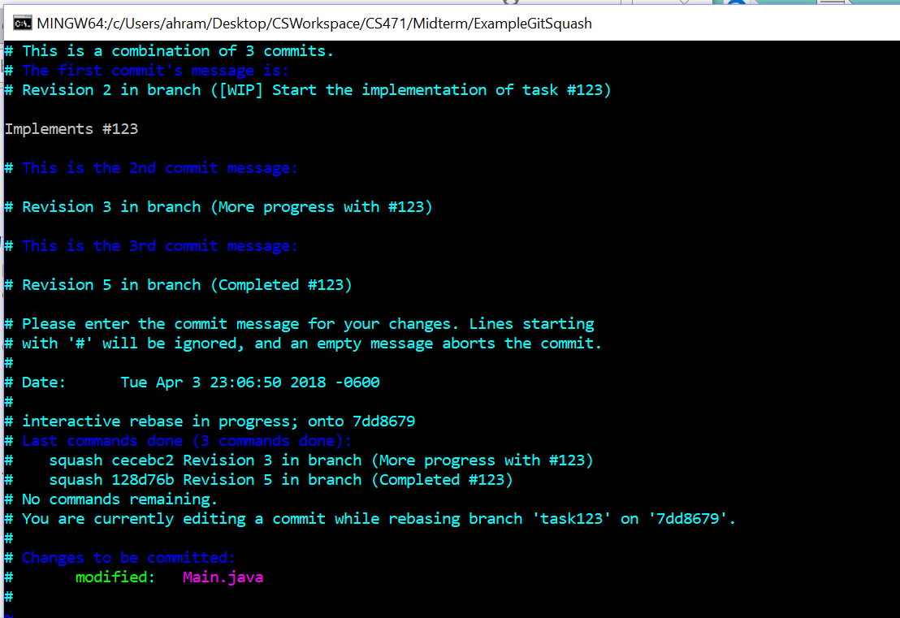

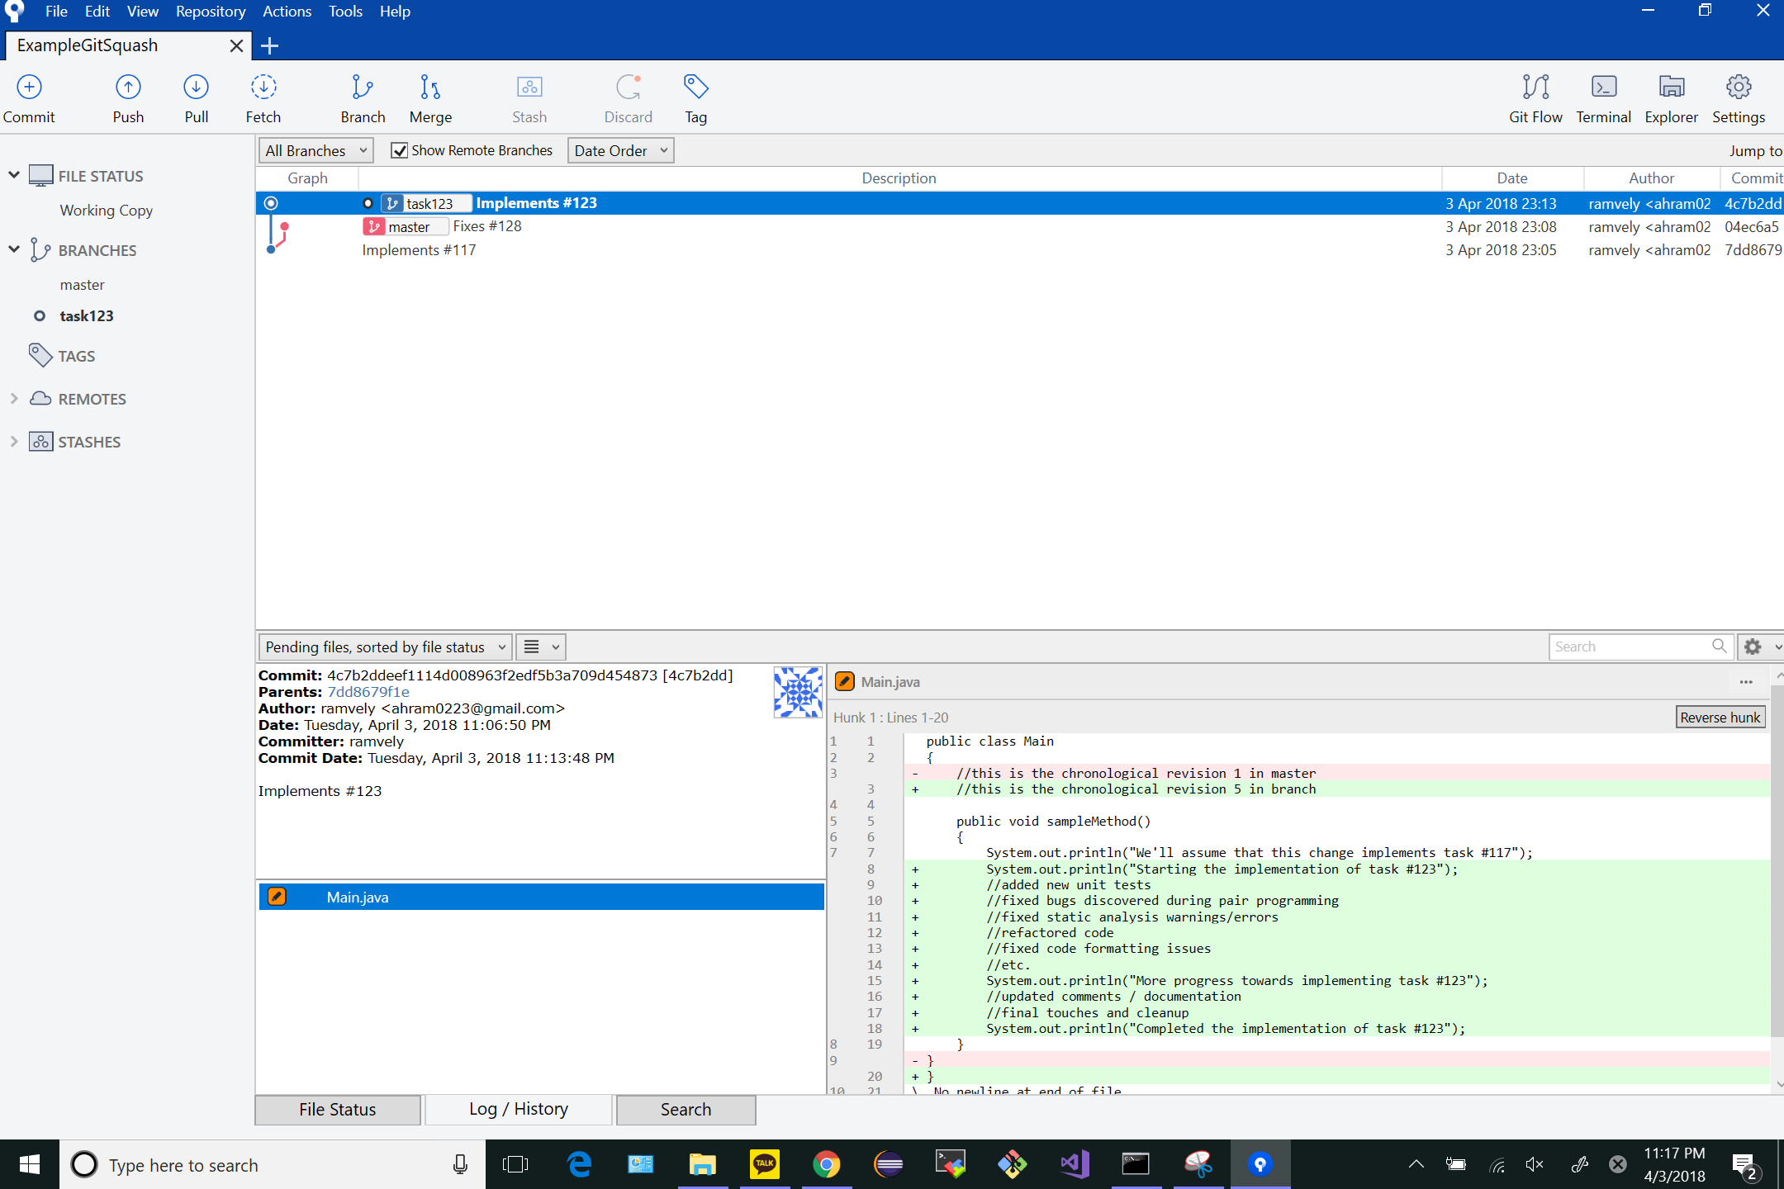

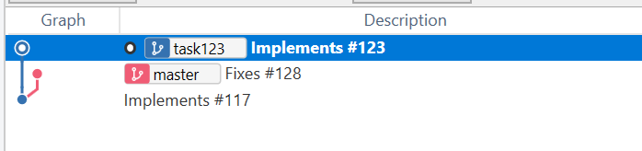

# GIT_MERGE_CONFLICT_VISUALIZATION after completing Step 10:

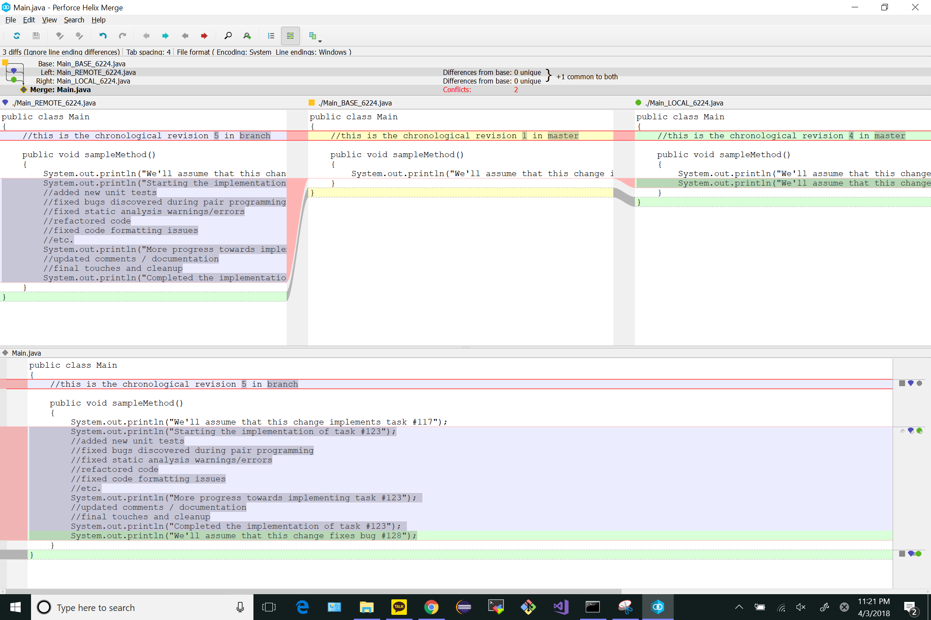

# GIT_VISUALIZATION_ALL_BRANCHES after completing Step 11:



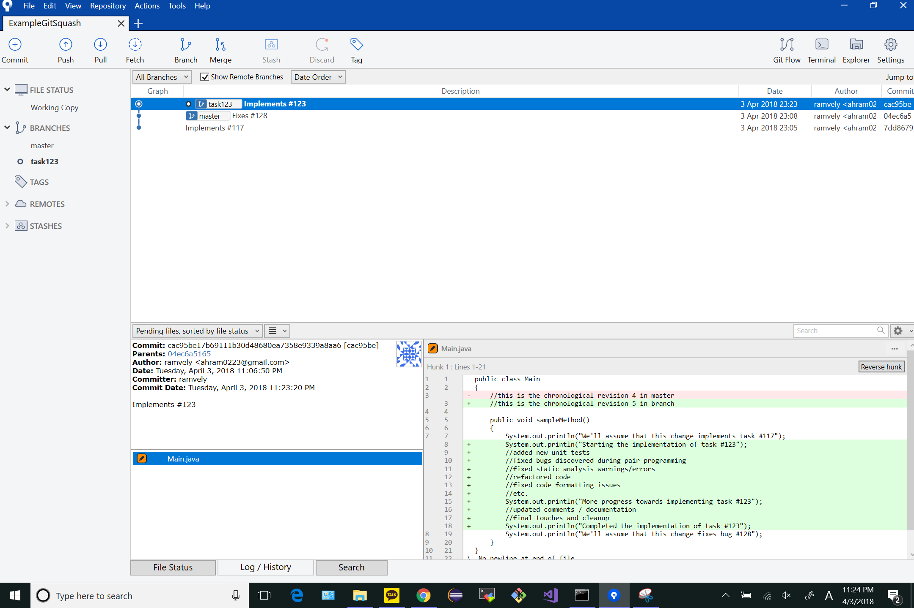

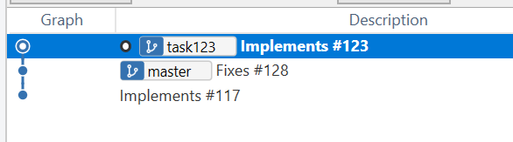

# GIT_VISUALIZATION_ALL_BRANCHES after completing Step 12:

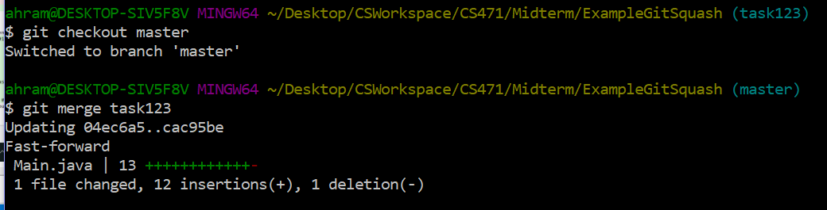

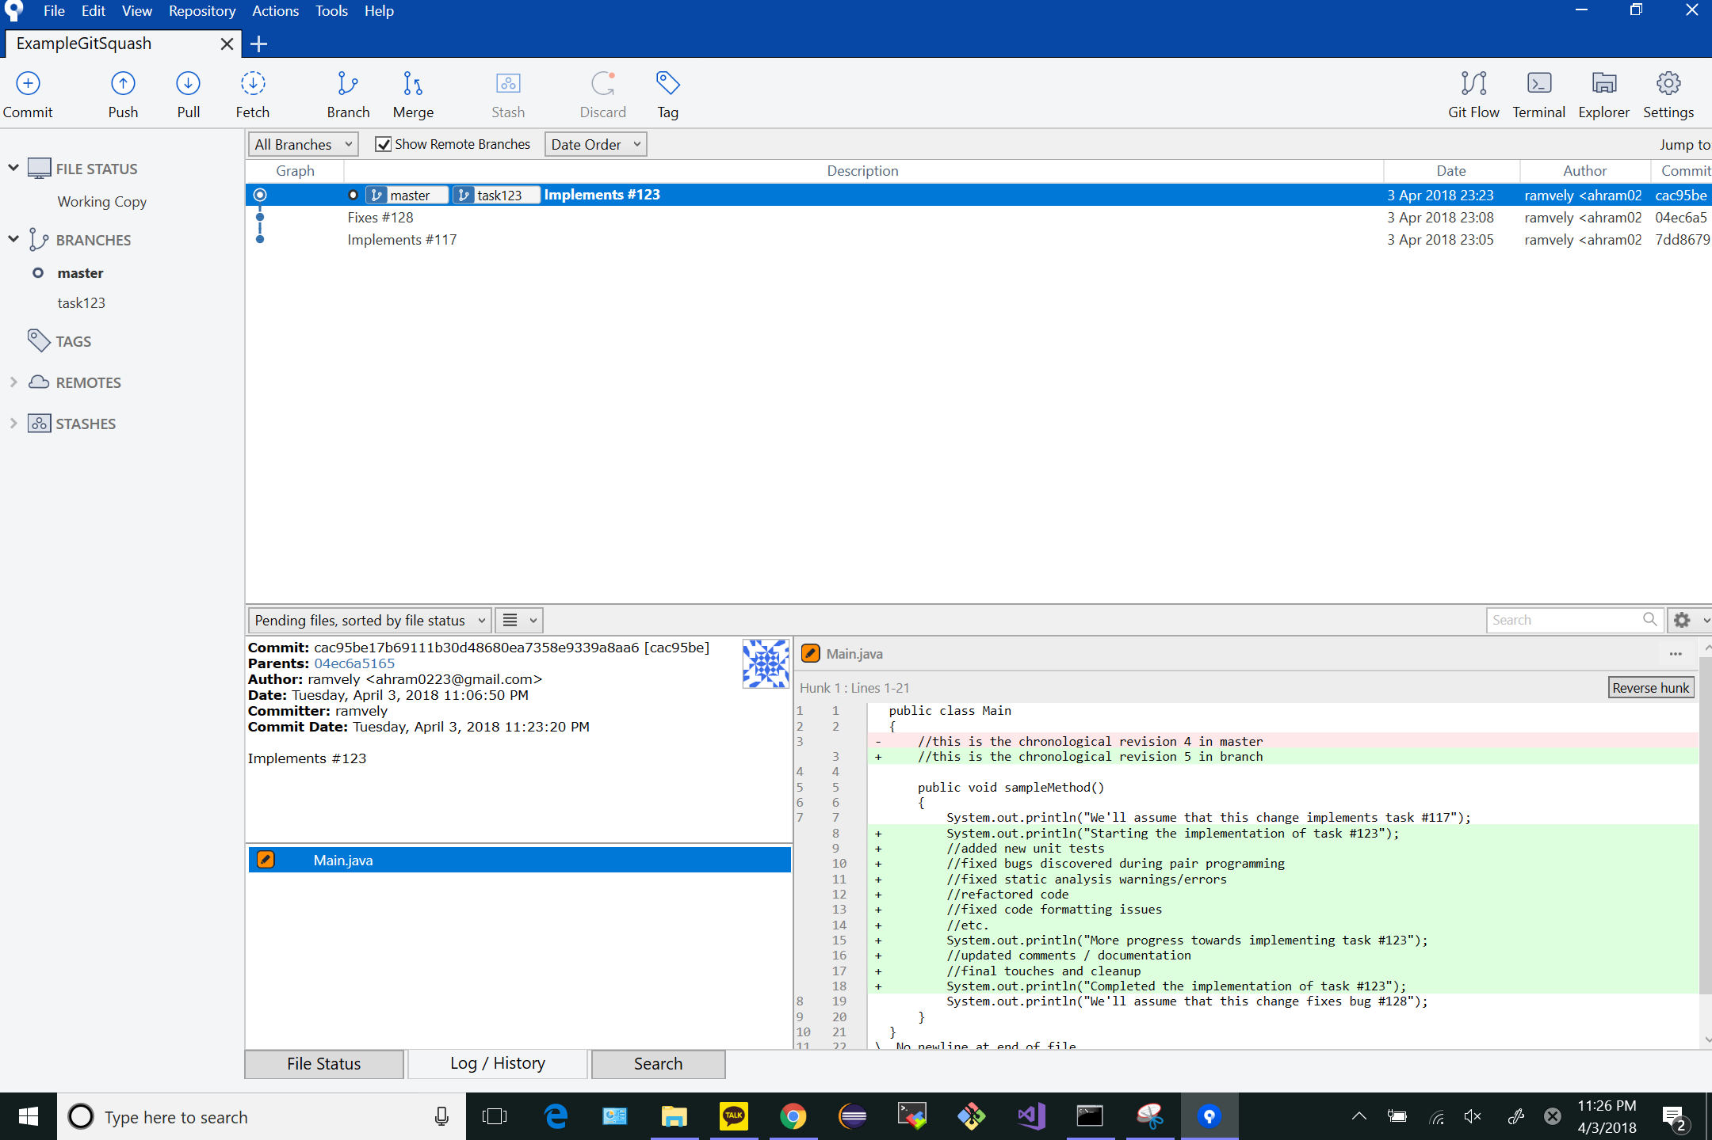

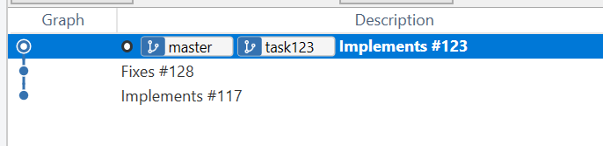

# GIT_VISUALIZATION_ALL_BRANCHES after completing Step 13:



