**Program excellence**

* + Graduating seniors score in the top 10% to 20% in the national Major Field Test for Computer Science compared to around 200 other CS departments.
  + Employer surveys and industry feedback affirms the quality of graduates over the long term.
  + Local employers prefer Boise State CS graduates over those from other programs in the region.

**Boise State’s CS graduates are in great demand**

* + High starting salaries (among top 2 or 3 majors nationally). Last year, the salaries ranged from 60K to 80K with the average around 70K.
  + Near 100% placement by graduation time.
  + Most students have offers before they graduate. Many get an offer up to a year before graduation!
  + About 90% of graduates remain in the Boise metro area.
  + Hundreds of software and tech companies in the Boise area all need more CS graduates
  + Students have been placed recently at Acquity group, Amazon, Balihoo, Boise Inc, Clearwater Analytics, Cradlepoint, First to File, Google, Healthwise, HP, Impact Sales, Keynetics, Kount, Micron, Microsoft, Tsheets, Whitecloud Analytics and many others.  
    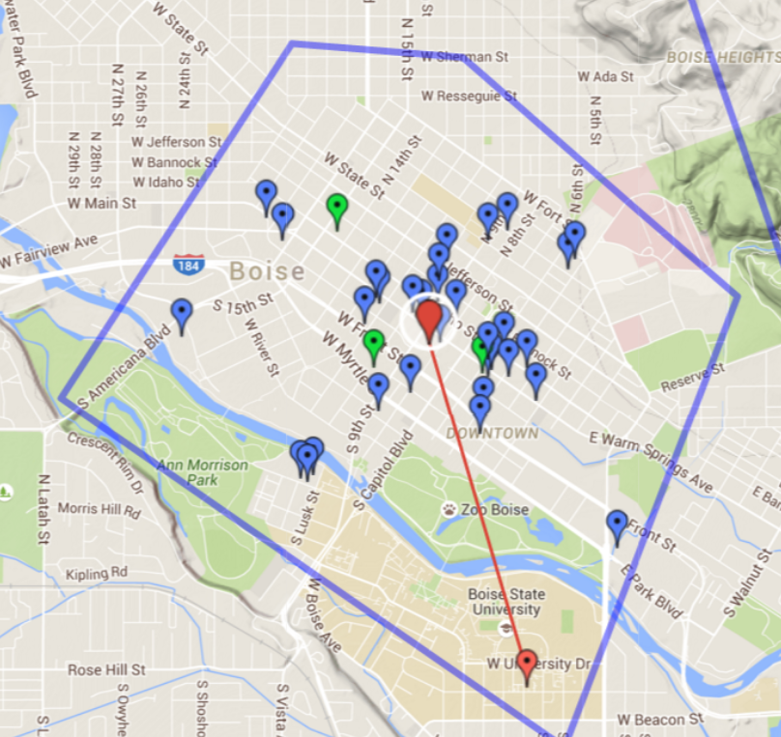

**Boise State's CS students are in high demand**

* + About 80% of junior/senior students have internships at local software companies.
  + Internship experience allows students to “hit the ground running.”
  + Easy access: many software/tech and other companies that hire interns are conveniently located near the new department building. See the map to the right get a sense of how close some of these companies are! The new department location is the larger orange placemark.

**Growth and Investment** 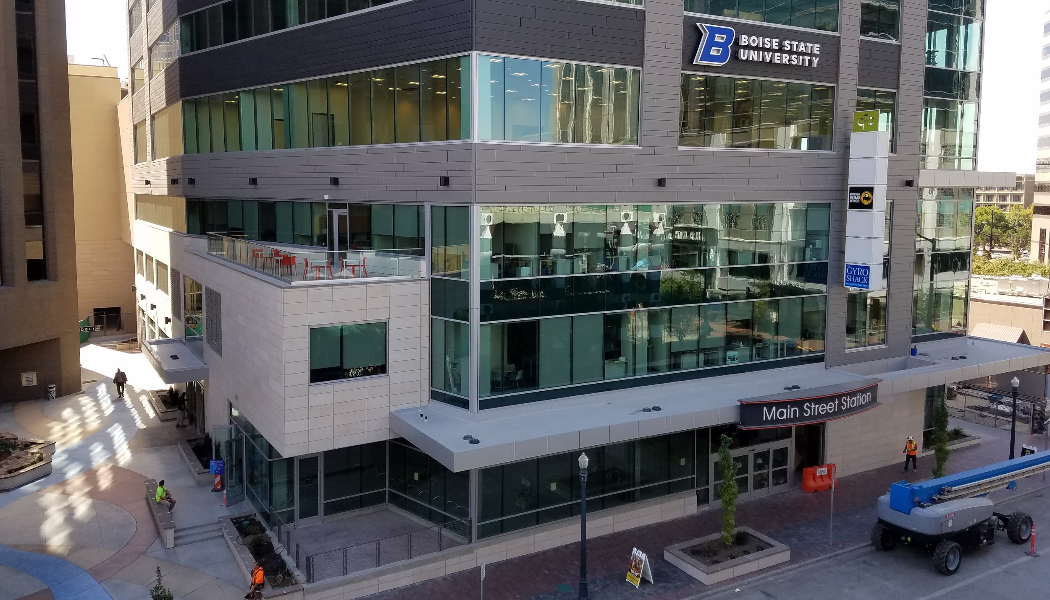

* Major investment recently by the University in the department. The budget has more than tripled. Eighteen new faculty joined in the last three years.
* CS tutoring center that is open seven days a week to especially help freshmen and sophomores.
* Enrollment has been on an upward trend for the last four years.
* Over the last three years, the number of CS graduates has tripled. Check out our current enrollment numbers [here!](http://coen.boisestate.edu/cs/about/facts/)
* Computer science is predicted by the Bureau of Labor to grow more than any other field over the next ten years.