Analysis of Algorithms
Mason Vail
CS 221

Example Algorithm: WrongSort

Section 1: Preliminary Analysis
The wrongSort() method begins with two initializations and a condition check for a while loop. Even if the array only had one element, those statements would execute. After the while loop is another if condition that would always get checked. Every call to wrongSort(), then, is going to have a minimum of 4 statements.
T(n) = 4 + ?
If there is more than one element in the array, the while loop will execute about n/2 times, where n is the length of the array, because the left and right indexes are moving toward the center of the array with each iteration. Every time through the loop, left and right are updated, the if condition is checked, and the while condition will get checked again. When the if condition is true, 3 statements are executed to swap. I'm assuming the if condition will be true about half the time, on average.
T(n) = 4 + (n/2)*(4 + 3/2) + ?
The next section is harder to figure out. There appear to be three sections inside the if – splitting the array into two halves, calling wrongSort(), again, with each half, and then re-joining the two halves back into the original array. Instantiating the new arrays is at least 2 statements (probably 4, since there is a calculation to figure out the size of each new array) and all n elements are getting copied into the new arrays. The for loops each have two statements up front – the initialization and first condition check – and have two statements in addition to whatever is inside – the increment statement and loop condition check. The same amount of work gets done after the calls to wrongSort(), to put the contents of leftSide and rightSide back into the original array. What I'm not sure about is how to account for the calls to wrongSort(). There are two calls, and each one passes in an array about half the size of the original array, which feels like an (n/2)*2 => n kind of thing. Each call to wrongSort() is going to repeat the cost of the call we're already in, which feels like a loop.
T(n) = 4 + (n/2)*(4 + 3/2) + 2 + 4*2 + n*(3) + (whatever happens with the calls to wrongSort())
So I'm thinking those calls are like wrongSort() is in a loop with itself, so everything in T(n), so far, is multiplied by n.
T(n) = n * (4 + (n/2)*(4 + 3/2) + 2 + 4*2 + 3n)
Reducing it down:
T(n) = n * (14 + 11n/4 + 3n) = n * (14 + 23n/4)
T(n) = (23/4)n^2 + 14n
The order, therefore, is predicted to be O(n^2).

Section 2: Collected Data
size statements
1000 104896
2000 227225
3000 355391
4000 489368
5000 623268
6000 763383
7000 903564
8000 1049665
9000 1189757
10000 1334896
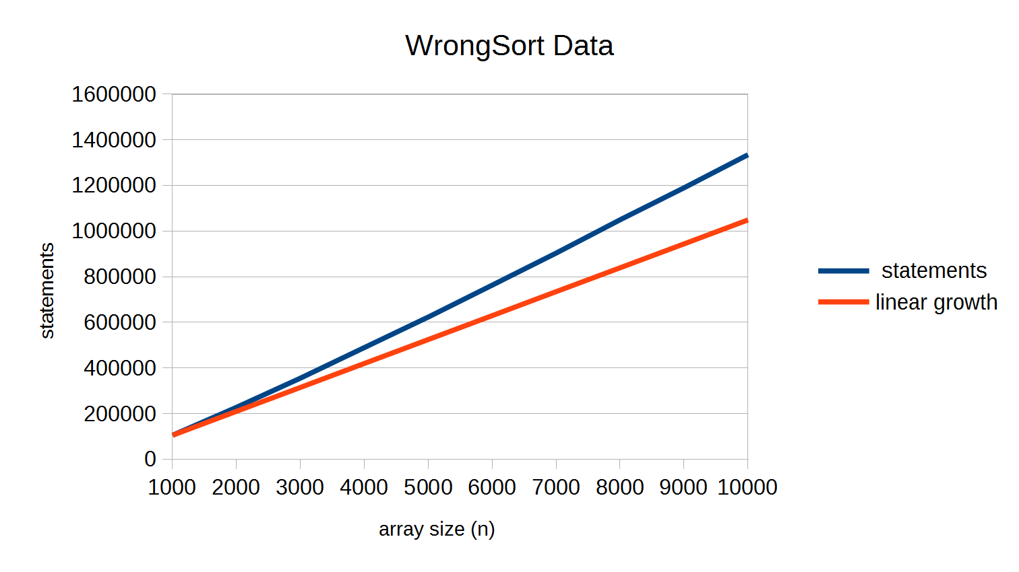

Section 3: Final Analysis
At first glance, I thought these results were flawed, because it looked linear, to me, and I was certain it couldn't be. On closer inspection, I realized that the ratio of statements to n was actually increasing, but slowly. I added a second line to show what the linear growth would look like if the ratio stayed the same after n = 1000 and it is clear that the actual count is separating from linear. So it isn't linear, but it definitely isn't O(n^2), either. The only order I know of between O(n) and O(n^2) is O(n log n), which grows slightly faster than O(n). I suspect that's what this is.
The difference between my prediction and my results seems to be related to what happens when the calls are made to wrongSort() with half of each list. I think by dividing the lists in half, each subsequent call does fewer comparisons than the previous call and the number of nested calls to wrongSort() is actually related to log n, and not n directly.
If I change my original predicted growth function to use 2 * log n for the nested calls multiplier (where the 2 is because there is a call to wrongSort() for both halves), I get
T(n) = (2 log n) * (14 + 23n/4) = (46n log n)/4 + 28 log n
Plotting this formula along with the collected data shows the formula isn't perfect, but it does have a similar curve, so I am confident in concluding that the order for this algorithm is O(n log n).
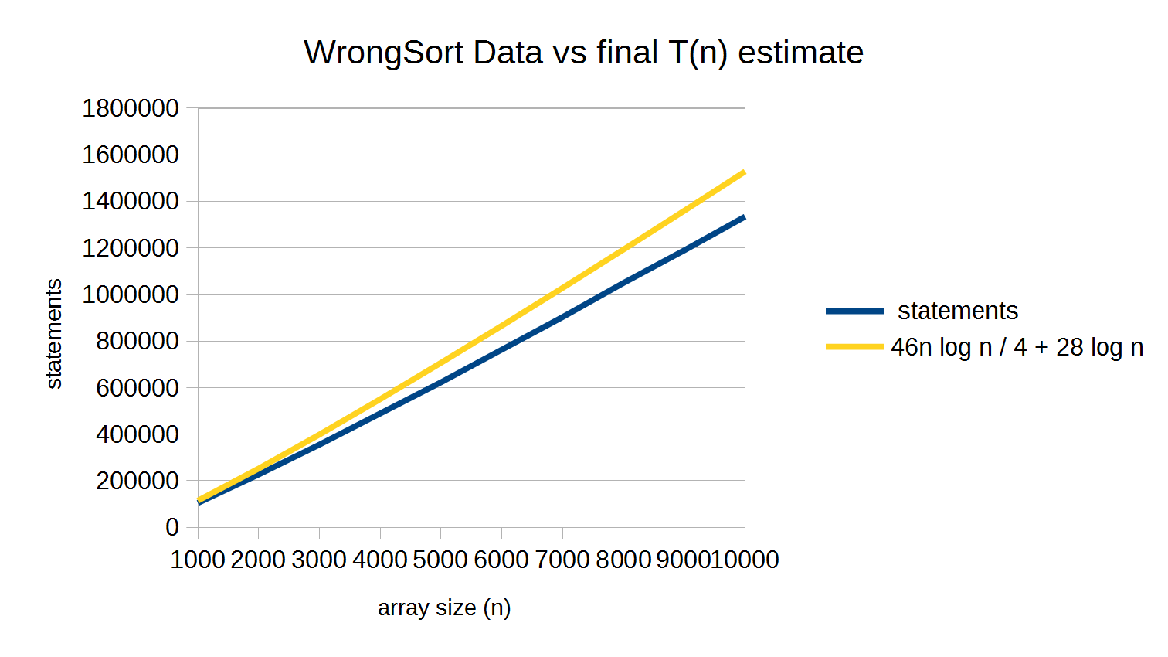

Algorithm 1: Find

Section 1: Preliminary Analysis

Section 2: Collected Data

Section 3: Final Analysis

Algorithm 2: Order

Section 1: Preliminary Analysis

Section 2: Collected Data

Section 3: Final Analysis

Algorithm 3 (Extra-credit): BieberSort

Section 1: Preliminary Analysis

Section 2: Collected Data

Section 3: Final Analysis

Algorithm 4 (Extra-credit): ConsecutivePairs

Section 1: Preliminary Analysis

Section 2: Collected Data

Section 3: Final Analysis

