**Cryptography Assignment - 3**

**Pramod Aravind Byakod**

**1: Solve 122 x = 3 mod 343. Show step-by-step calculations.**

343 = 2*122 + 99

122 = 1*99 + 23

99 = 4*23 + 7

23 = 3*7 + 2

7 = 3*2 + 1

Therefore GCD(343,122) = 1

1 = 7 - 3*2

1 = 7 – 3*(23 - 3*7)

1 = 10*7 – 3*23

1 = 10*(99 – 4*23) – 3*23

1 = 10*99 – 43*23

1 = 10*99 – 43(122 – 1*99)

1 = 10*99 – 43*122 + 43*99

1 = 53*99 – 43*122

1 = 53*(343 – 2*122) – 43*122

1 = 53*343 – 149*122

So x ≡ -149*3 mod 343

≡ -447 mod 343

≡ 239 mod 343

**Hence x = 239**

**2: Is your ID number invertible modulo m = 2^{64}?  
Let a be the least integer that is no less than your ID number and is invertible mod m. Use Sage xgcd to find the inverse of a modulo m.  
In a C++ program, assume that there is a variable x with type "unsigned long int" (64bits), and the product of a and x is 2018, what is x?**

My ID is 113436879.

Let’s consider a = 113436879

Using sage xcgd(113436879,2^64), we have the below results

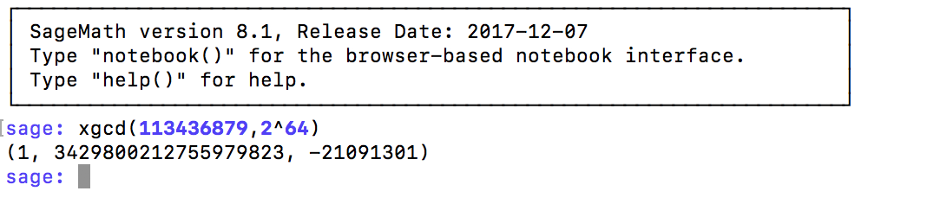

Therefore, from the above result, GCD(113436879,2^64)=1, x=3429800212755979823 and y=-21091301

Since GCD(113436879,2^64)=1, **113436879 is invertible modulo 2^64.**

**Inverse of 113436879 mod 2^64 is 3429800212755979823**

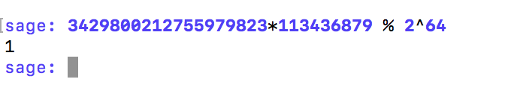

Given 113436879(x) = 2018 mod 2^64, we got to solve for x.

We have the old value of x, that is 3429800212755979823. Multiply this with 2018, we will get the new value of x.

x= 3429800212755979823*2018 = **6921336829341567282814**

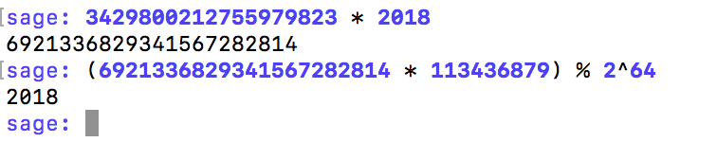

**3: Determine the unit group and the zero divisors of the ring Z/16Z.**

|  |  |  |
| --- | --- | --- |
| **a** | **b** | **GCD(a,b)** |
| 1 | 16 | 1 |
| 2 | 16 | 2 |
| 3 | 16 | 1 |
| 4 | 16 | 4 |
| 5 | 16 | 1 |
| 6 | 16 | 2 |
| 7 | 16 | 1 |
| 8 | 16 | 8 |
| 9 | 16 | 1 |
| 10 | 16 | 2 |
| 11 | 16 | 1 |
| 12 | 16 | 4 |
| 13 | 16 | 1 |
| 14 | 16 | 2 |
| 15 | 16 | 1 |

So, unit group of Z/16Z is (1,3,5,7,9,11,13,15)

And, Zero divisors of Z/16Z are (2,4,6,8,10,12,14)

**4: Determine the unit group and the zero divisors of the ring Z/15Z.**

|  |  |  |
| --- | --- | --- |
| **a** | **b** | **GCD(a,b)** |
| 1 | 15 | 1 |
| 2 | 15 | 1 |
| 3 | 15 | 3 |
| 4 | 15 | 1 |
| 5 | 15 | 5 |
| 6 | 15 | 3 |
| 7 | 15 | 1 |
| 8 | 15 | 1 |
| 9 | 15 | 3 |
| 10 | 15 | 5 |
| 11 | 15 | 1 |
| 12 | 15 | 3 |
| 13 | 15 | 1 |
| 14 | 15 | 1 |

So, unit group of Z/15Z is (1,2,4,7,8,11,13,14)

And, Zero divisors of Z/15Z are (3,5,6,9,10,12)