HW12

(Hoffstein book) 7.30 and 7.35

7.30. Alice and Bob decide to communicate using NTRUEncrypt with parameters (N, p, q) = (7, 3, 29). Alice’s public key is

h(x) = 3 + 14X − 4X^2 + 13X^3 − 6X^4 + 2X^5 + 7X^6.

Bob sends Alice the plaintext message m(x) = 1 + X – X^2 – X^3 – X^6 using the random element r(x) = −1 + X^2 – X^5 + X^6.

(a) What ciphertext does Bob send to Alice?

(b) Alice’s private key is f(x) = −1 + X – X^2 + X^4 + X^6 and F3(x) = 1 + X + X^2 + X^4 + X^5 – X^6. Check your answer in (a) by using f and F3 to decrypt the message.

(a)(b)

Code(Using Sagemath):

def center_lifts(a_x,q):

a_x_l=list(reversed(a_x.list()))

a_x_l_new=[]

for a_x_co in a_x_l:

a_x_co=a_x_co%q

if a_x_co>-q/2 and a_x_co<q/2:

a_x_l_new.append(a_x_co)

else:

a_x_l_new.append(a_x_co-q)

a_x_new=0

for i in range(len(a_x_l)):

a_x_new=a_x_l_new[i]*y^(6-i)+a_x_new

return a_x_new

N=7

p=3

q=29

Ro.<y>=ZZ[]

Rop.<yp>=Integers(p)[]

Roq.<yq>=Integers(q)[]

R.<x>=QuotientRing(Ro,y^N-1)

Rp.<xp>=QuotientRing(Rop,yp^N-1)

Rq.<xq>=QuotientRing(Roq,yq^N-1)

h_x=3+14*y-4*y^2+13*y^3-6*y^4+2*y^5+7*y^6 #public key: in Rq

m_x=1+y-y^2-y^3-y^6 #plaintext:in Rp

r_x=-1+y^2-y^5+y^6 #random polynomial r

#Encryption

e_x=Rq(p*r_x*h_x+m_x) #ciphertext: mod q

print 'e_x:',e_x

#Decryption

f_x=-1+y-y^2+y^4+y^6

a_x=Rq(f_x*Ro(lift(e_x))) #mod q

print 'f_x*e_x: ',a_x

a_x=Ro(lift(a_x))

a_x_cl=center_lifts(a_x,q) #center_lifts modulo q

print 'a_x_cl:',a_x_cl #in R

F3_x=1+y+y^2+y^4+y^5-y^6 #mod p

m_x=Rp(F3_x*a_x_cl)

print 'F3_x*a_x:',m_x

m_x=Ro(lift(m_x))

print 'm_x:',center_lifts(m_x,p)

print 'finished'

Result:

e_x: 14*xq^6 + 16*xq^5 + 20*xq^4 + 7*xq^3 + 19*xq^2 + 16*xq + 23

f_x*e_x: 24*xq^6 + 27*xq^5 + 7*xq^4 + xq^3 + 26*xq^2 + 3*xq + 27

a_x_cl: -5*y^6 - 2*y^5 + 7*y^4 + y^3 - 3*y^2 + 3*y - 2

F3_x*a_x: 2*xp^6 + 2*xp^3 + 2*xp^2 + xp + 1

m_x: -y^6 - y^3 - y^2 + y + 1

finished

So the ciphertext is: 14*x^6 + 16*x^5 + 20*x^4 + 7*x^3 + 19*x^2 + 16*x + 23

And the message after decrypt is m_x: -x^6 - x^3 - x^2 + x + 1, it is the same as the plaintext, so verified.

7.35. This exercise describes a variant of NTRUEncrypt that eliminates a step in the decryption algorithm at the cost of requiring slightly larger parameters. Suppose that the NTRUEncrypt private key polynomials f(x) and g(x) are chosen to satisfy f(x) = 1 + pf 0(x) ≡ 1 (mod p) and g(x) = pg0(x) ≡ 0 (mod p), and that NTRU encryption is changed to e(x) ≡ h(x) r(x) + m(x) (mod q). (The change is the omission of p before h(x).)

(a) Prove that if q is sufficiently large, then the following algorithm correctly decrypts the message:

• Compute a(x) ≡ f(x) e(x) (mod q) and center-lift to an element of R.

• Compute a(x) (mod p). The result is m(x).

Note that this eliminates the necessity to multiply a(x) by f(x)−1 (mod p).

(a) Suppose that we choose f 0, g0 ∈ T (d, d), and that we also assume that m is ternary. Prove that decryption works provided q > 8dp + 2. (Hint. Mimic the proof of Proposition 7.48.)

（a）

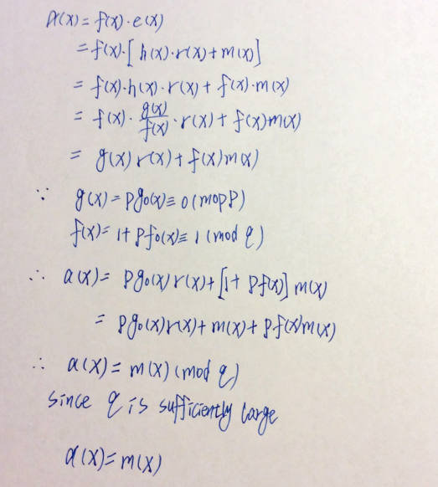

(b)

