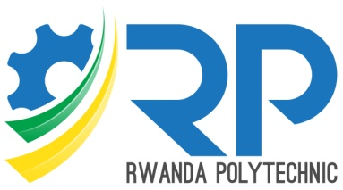

**IPRC TUMBA**

Integrated Polytechnic Regional College

P.O. Box 6638 Rulindo

Tel: +250 786000011

Email:info@iprctumba.rp.ac.rw

www.iprctumba.rp.ac.rw

**DEPARTMENT OF INFORMATION AND COMMUNICATION TECHNOLOGY**

**FERWAFA MATCH DAY REPORTING**

**MOBILE APPLICATION**

Case Study : Ferwafa

A project report submitted for partial fulfillment of the requirements for the award of

Advanced Diploma in Information and communication Technology

**Submitted by**

BYAMUGU Lewis (**19RP00680**)

And

NIYONASENZE Aliane (**19RP05407**)

**Supervised by**

MPORAZI Joel

**Academic year**

2021-2022

Northern Province, Rwanda

December 1,2022

**Code : FYP302/021/IT/006**