**Задание 1**

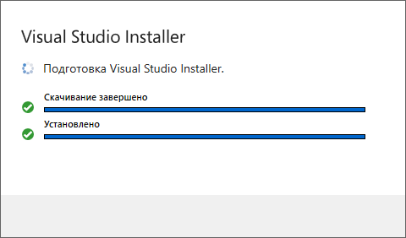

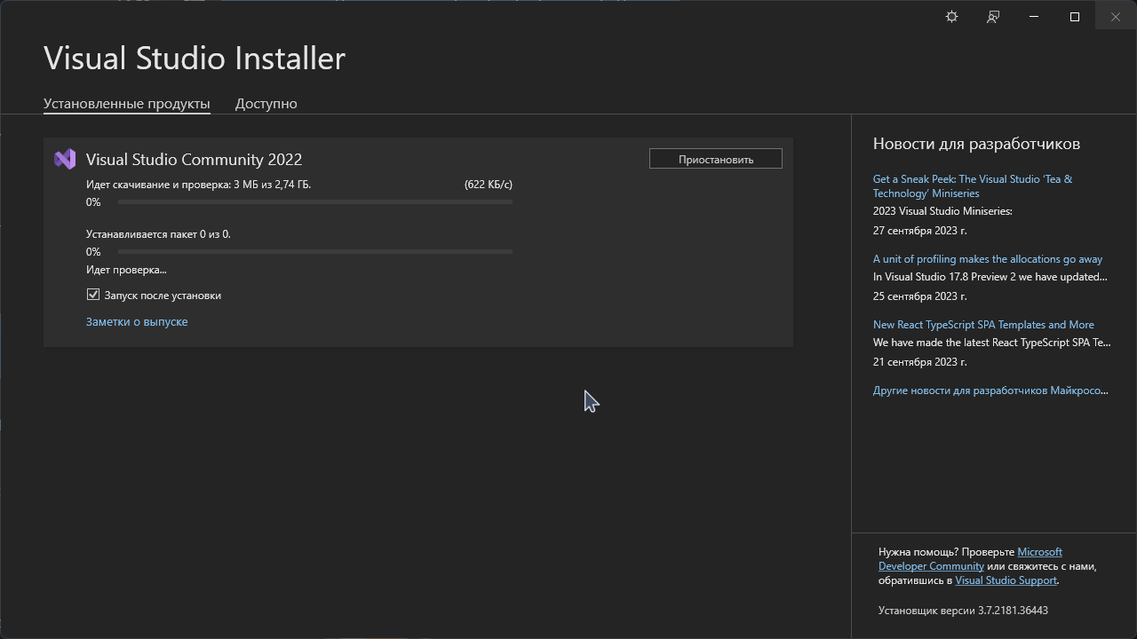

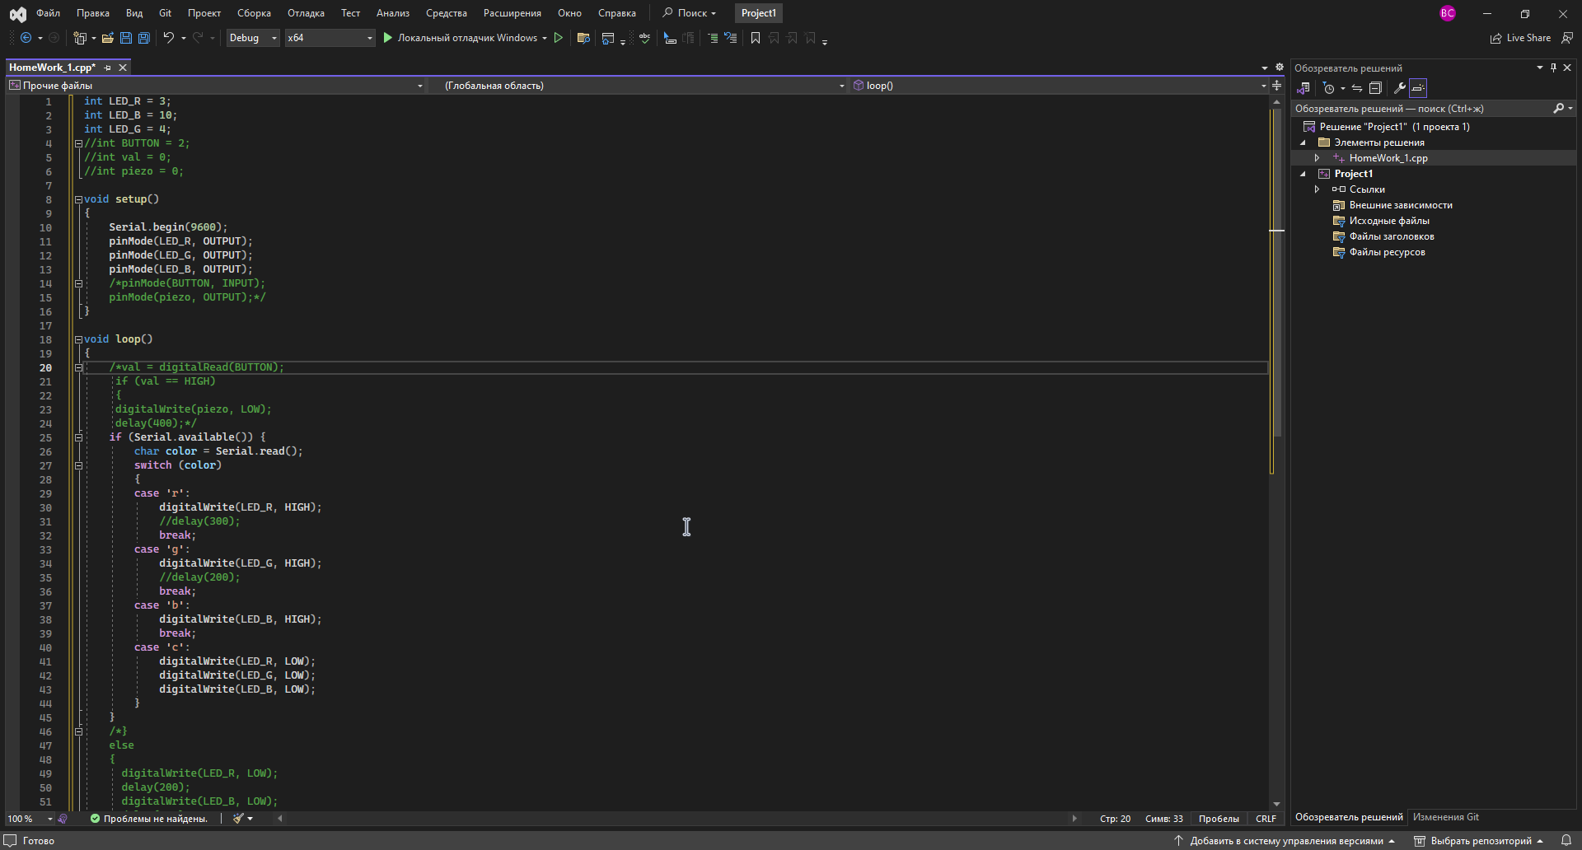

**Задание 2**

Online GDB -> <https://www.onlinegdb.com/online_c++_compiler>

Programiz -> <https://www.programiz.com/cpp-programming/online-compiler/>

JDoodle -> https://www.jdoodle.com/online-compiler-c++/