**Hypothesis**

**1. Course Pricing Hypothesis:** There might be a correlation between the pricing of Udemy courses and their popularity, as measured by the number of subscribers. Lower-priced courses may attract more subscribers compared to higher-priced ones.

**2. Course Content Quality Hypothesis:** Courses with higher numbers of lectures, longer content durations, and more reviews may be perceived as having higher quality content. This hypothesis assumes that learners are more likely to enroll in courses with comprehensive content and positive reviews.

**3. Subject Preference Hypothesis:** Certain subjects may be more popular among Udemy users compared to others. For example, courses related to technology or business may attract more subscribers than courses in less popular subjects.

**4. Course Difficulty Level Hypothesis:** There may be differences in subscriber engagement based on the difficulty level of the course. Courses labeled as "Beginner Level" might have more subscribers compared to courses labeled as "Expert Level" due to their accessibility.

**5. Clustering Hypothesis:** Clustering algorithms, such as KMeans, Agglomerative Clustering, and DBSCAN, may reveal distinct groups or clusters of Udemy courses based on their pricing, popularity, and other features. These clusters may provide insights into different segments of courses and their characteristics.

**Dataset Description:**

The dataset consists of information about Udemy courses and includes features such as price, number of subscribers, number of reviews, number of lectures, content duration, course subject, and level. There are both numerical and categorical variables in the dataset. The numerical variables are standardized, and missing values in the 'price' column are imputed with the mean.

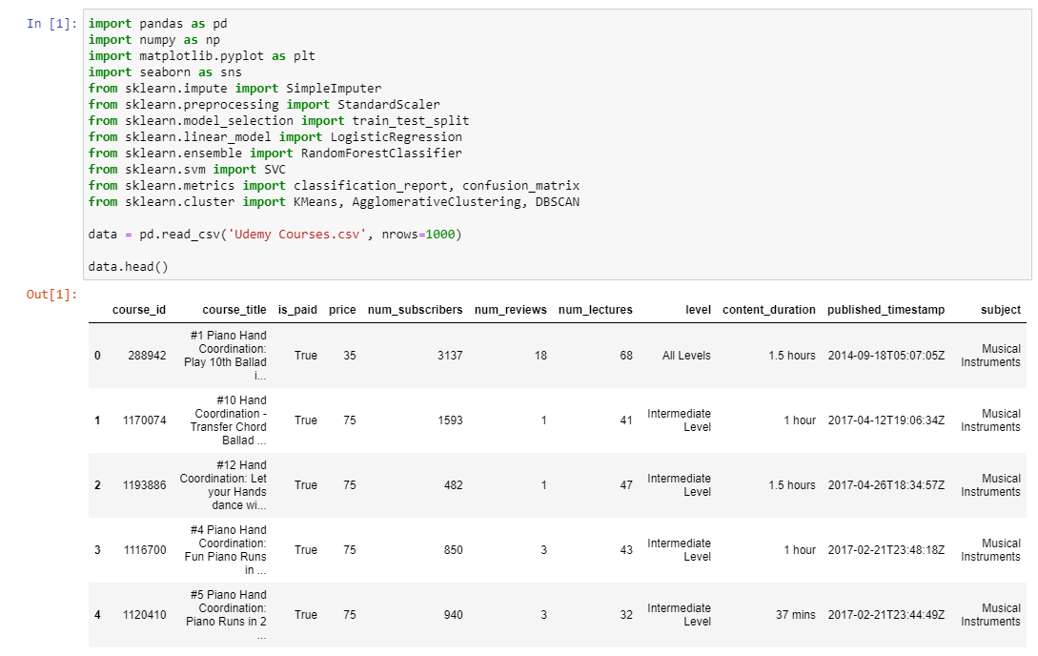

**Introduction:**

In the dynamic landscape of online education, platforms like Udemy play a pivotal role in democratizing access to knowledge and empowering learners worldwide. With a vast array of courses spanning diverse subjects and skill levels, Udemy offers a treasure trove of educational content catering to learners of all backgrounds and interests. However, amidst this abundance of courses, understanding the factors that contribute to a course's success and popularity is paramount for both learners seeking quality education and course creators aiming to optimize their offerings.

In this context, the analysis of Udemy course data emerges as a valuable endeavor, offering insights into the characteristics, trends, and dynamics of online learning. By delving into the dataset encompassing Udemy courses, analysts can uncover patterns, relationships, and predictive factors that shed light on the factors driving course engagement, satisfaction, and monetization. From pricing strategies to content quality, course subject preferences to learner demographics, the dataset encapsulates a wealth of information ripe for exploration and analysis.

In this analytical journey, we embark on a comprehensive investigation of the Udemy course dataset, leveraging a variety of data preprocessing, clustering, classification, and evaluation techniques. Our objective is twofold: firstly, to gain a nuanced understanding of the Udemy course landscape, unraveling the underlying patterns and trends that shape course popularity and success. Secondly, to develop predictive models that can forecast course payment status, enabling stakeholders to make informed decisions regarding course development, marketing strategies, and platform optimization efforts.

Through this analysis, we aim to unearth actionable insights that can inform strategic decision-making, empower course creators to refine their offerings, and enhance the learning experience for Udemy users. By harnessing the power of data-driven insights, we endeavor to unlock the full potential of online education, driving innovation and excellence in the digital learning ecosystem.

**Data Preprocessing:**

Data preprocessing plays a crucial role in ensuring the quality and usability of the dataset for analysis and modeling purposes. In this context, the preprocessing steps applied to the dataset serve to address data quality issues, standardize features, and prepare the data for further analysis.

The first step in data preprocessing involves handling missing values and data type conversions. The 'price' column, for example, undergoes data type conversion to numeric format, followed by missing value imputation using the mean value. This ensures that the data is uniform and complete, laying the groundwork for subsequent analysis.

Next, numerical features are standardized using techniques like StandardScaler, which scale the features to a common scale, eliminating disparities in feature magnitudes and improving the performance of machine learning models. Standardization ensures that all features contribute equally to model training, preventing bias towards variables with larger scales.

Categorical variables are encoded using methods like one-hot encoding, converting them into numerical format while preserving their categorical distinctions. This transformation enables the inclusion of categorical variables in machine learning models, allowing analysts to leverage their predictive power in model training.

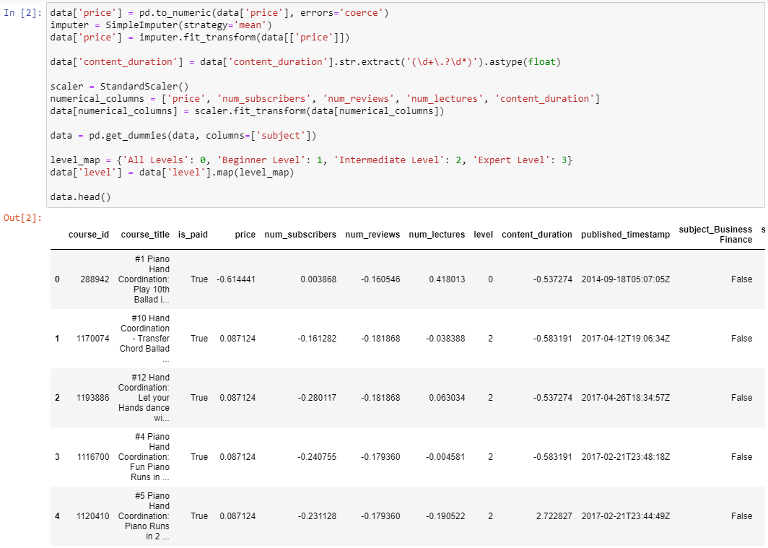

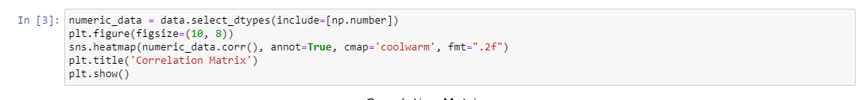

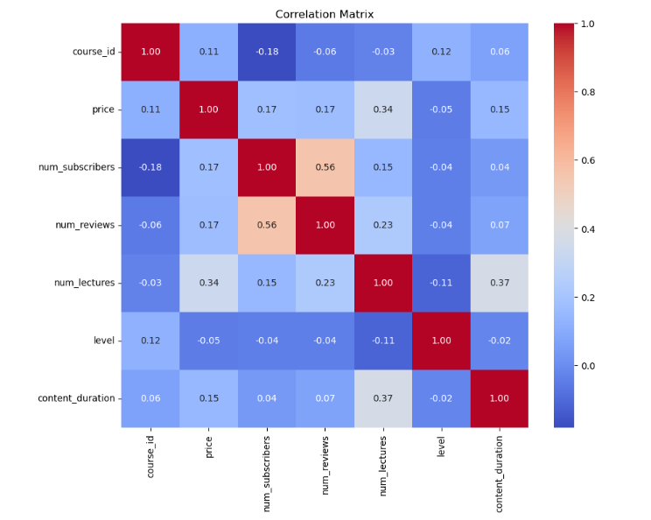

Furthermore, correlation analysis via a heatmap visualization provides insights into the relationships between numerical features, helping identify potential correlations and dependencies among variables. This analysis aids in feature selection and dimensionality reduction, guiding the selection of relevant features for modeling.

**Modelling:**

The modelling phase involves applying clustering and classification techniques to gain deeper insights into the dataset and make predictions based on the available features.

Clustering algorithms such as KMeans, Agglomerative Clustering, and DBSCAN are utilized to group similar courses based on their attributes. These algorithms reveal inherent structures and patterns within the dataset, enabling analysts to identify clusters of courses with similar characteristics. This segmentation enhances understanding and enables targeted analyses or interventions based on course clusters.

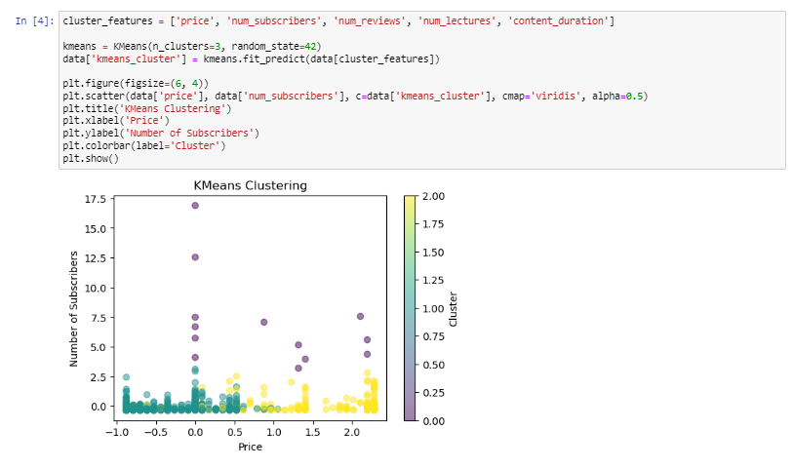

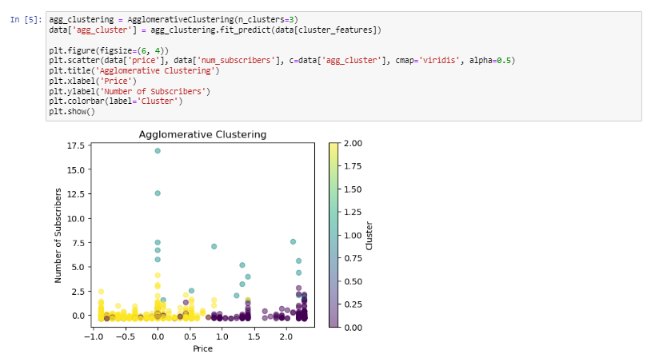

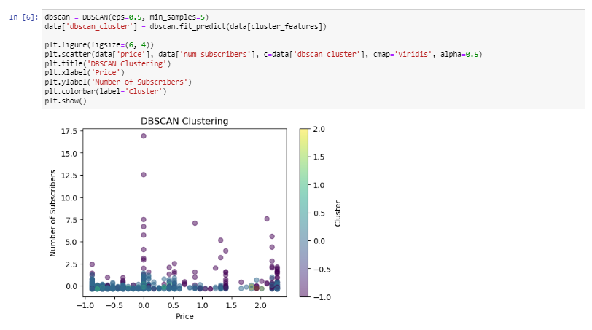

Classification models including Logistic Regression, Random Forest, and Support Vector Machine (SVM) are trained and evaluated to predict course payment status. These models leverage course features to classify whether a course is paid or not, providing insights into factors influencing course monetization. The models' performance metrics, such as classification reports and confusion matrices, offer valuable insights into model accuracy, precision, recall, and F1-score, aiding in model evaluation and comparison.

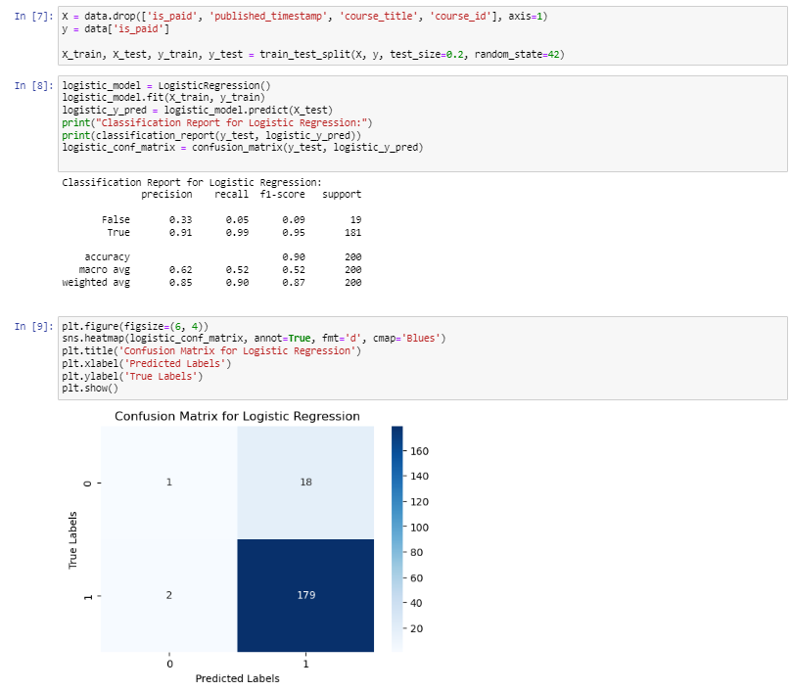

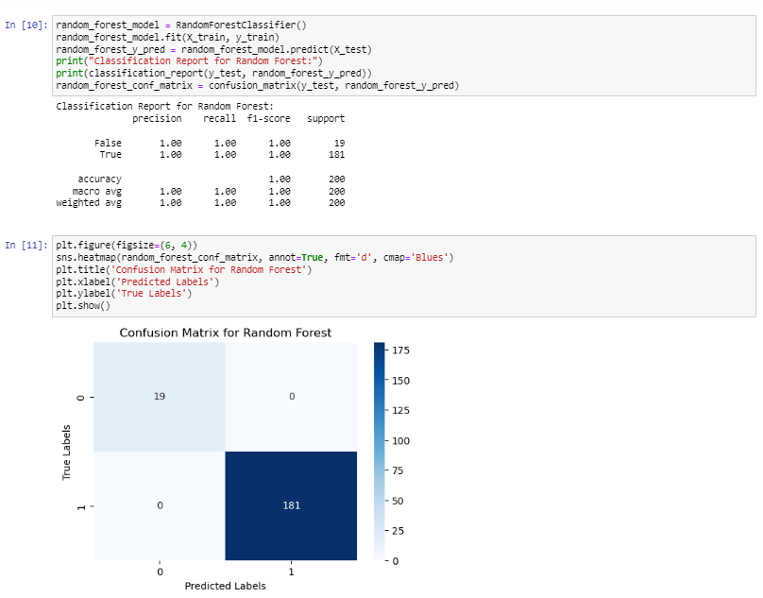

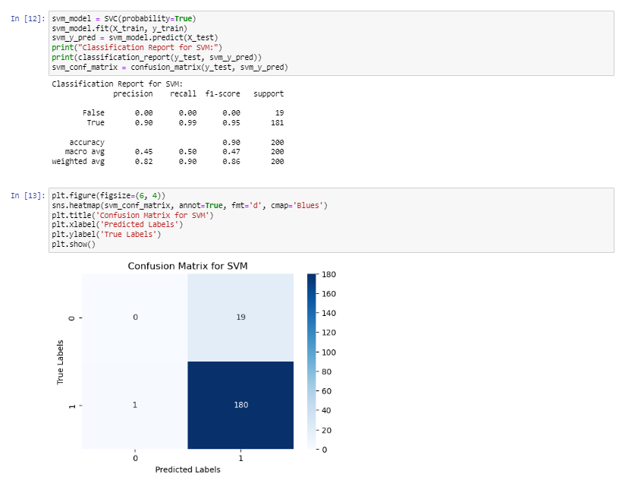

**Obtained Results:**

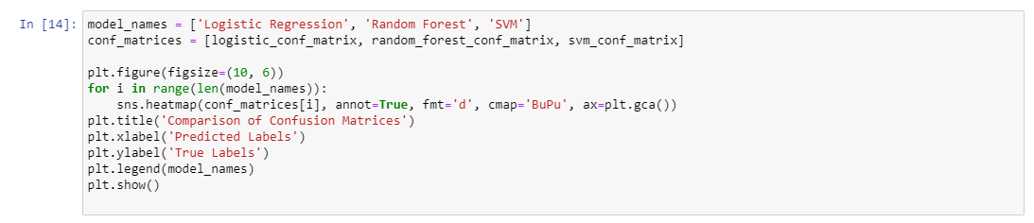

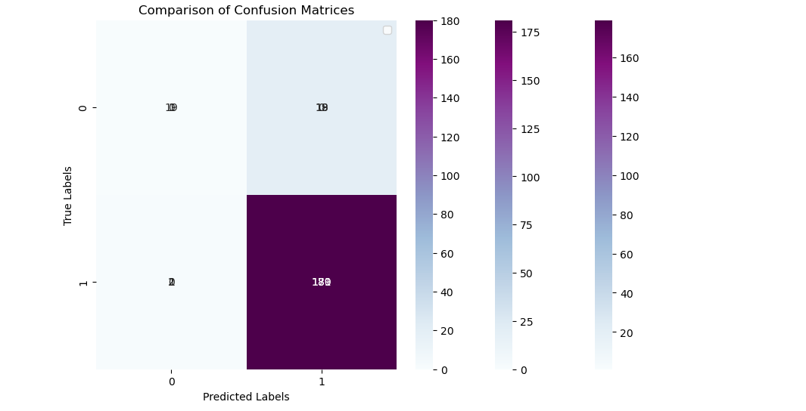

The results obtained from the analysis provide actionable insights into various aspects of Udemy courses, ranging from clustering patterns to classification performance.

The clustering plots visually depict the identified course clusters, showcasing the distribution and characteristics of courses within each cluster. These visualizations offer intuitive insights into course groupings and similarities, aiding in cluster interpretation and analysis.

Similarly, classification reports and confusion matrices provide detailed performance metrics for each classification model, highlighting their strengths and weaknesses in predicting course payment status. These metrics offer valuable information for stakeholders, enabling them to assess model performance and make informed decisions regarding course development, marketing strategies, and platform optimization efforts.

**Conclusion:**

In conclusion, the analysis underscores the importance of data preprocessing, modeling, and evaluation in deriving actionable insights from the dataset. Through effective preprocessing techniques and diverse modeling approaches, valuable insights into Udemy course characteristics and payment status are obtained. These insights can inform decision-making processes for course creators, platform optimization strategies, and educational content development efforts. Overall, the analysis demonstrates the utility of data-driven approaches in understanding and optimizing online learning platforms like Udemy.